Chapter 1 notes (All pre Mid-Term)
Freud
- Psychoanalytic theory
Skinner
- You have no power, it’s all about the environment you are born into.

New School of thought – Humanism
- Led by maslow and carl Rodgers
Canadians
- James Mark Baldwin
- Brenda Milner – neuropsychology shit
- Donald Hebb -

Cognition – mental abilities, mental imagery, problem solving, language development. Any Mental ability

Biological perspective – behaviour explained by physiological processes.
- If you manipulate very specific area of the brain you can see that specific areas are for fear etc.
Right side of brain is for left side motorability and vice versa

Central Premise: natural selection occurs for behavioural as well as physical characteristics.

Chapter 2
Jane Goodall -
Bennelheim – researching autism (bad mothering caused autism)
Descriptive stats - measures of BLANK tendency
Inferential stats**
- EXAM QUESTION correlation – READ in the textbook
  - Up and Up, Down and down is a positive correlation – studying hours down, grade down.
  - Down and Up, Up and Down – caffeine increases sleep decreases
  - “which order indicates weakest to strongest?”
- Meta-analysis – studies all the studies that are done on this topic.
- Placebo effect – when they think they have received something but they haven’t but then say they are better (serve non-alcoholic beer for a night when everyone thinks it’s real beer)
- Social desirability bias – a tendency to give socially approved answers to questions about oneself; for example: “Did you vote?”
- Response set – a tendency to respond to questions in a particular way (agree with everything, etc.).
- Halo effect – the tendency to let initial performance or liking affect future judgments of performance (I was 3 for the first half so the second half ill be 3)
- Experimenter bias – you think something because your hypothesis say it
  - The double blind (both the researcher and the people don’t know which pill they are getting)
- Ethical is different than legal

Chapter 3 (biology and genetics)
- Nervous tissue – Glia (specialized brain cells), neurons, soma, dendrites (neuron to neuron), axon
- Insulation and information transfer (neurons and stuff and how they work)
- Hodgkin and Huxley - first three points
- Stimulation – smell, sight, anything that happens
- Positively charged ions flow in and change the charge => action potential (change in the neurons electrical charge) => all or none, happens or it doesn’t
- Information sent from the presynaptic neuron, received from postsynaptic neuron
- Neural Networks
- …
- Table 3.1 Common Neurotransmitters and some of their funtions*** MEMORIZE!!****
- ACH – how nicotine works as a agonist and KIARY?? As an antagonist.
- Para – responsible for conserving energy, pupils co (opposite of dilate), decreased breathing
  - Sympathetic – pupils dilate, increased breathing
- Somatic- when you hear/see/feel something this is why

Research methods
- EEG,
- Legion a part of the brain… then you don’t do whatever it is (I’m not hungry… you never stop eating)
- Stimulating does the opposite (EAT then you possibly eat more (anorexia help))
- BRAIN AND BEHAVIOUR SLIDE ***MEMORIZE***
  - Hindbrain – vital funtions
    - Modulla
    - Pons
    - cerebelum
  - Midbrain
    - Dopamine – movement
    - Reticular activating system – develops attentions spans & pain and arousal
  - Forebrain – motion and cognitive thought
    - thalamus – info goes through this and directs it to the right spot
    - Hypothalumus – food hunger sex drive
    - Limbic – Well developed but not using cerebrum as much. (pre adolescent brain growth)
    - Cerebrum – complex higher order mental funtions
    - Cerebral cortex – outer layer of the cerebrum
  - Plasticity of the brain – Once you lose something you can often get it back EG stroke has bad speech but eventually learns to talk again. Use it or lose it.
- Left side controls right side (for field of vision, move right hand) vice versa – writing speech reading writing
- Right side controls right… special musical visual
- FOUR LOBES AND what they are responsible for ***memorize***
- Broca’s area – speech productions (saying words)
- Wernicke’s area is for understanding language (hearing words)
- Pituitary gland – master gland => growth hormone
- Thyroid – metabolic rate
- Adrenal – salt and carbs
- Pancreas – sugar
- Gonads – sex hormones
- Behavioral Genetics – influence of genetic factors on behavioral traits
  - All that bio crap
- Decreasing as genetic relatedness decreases (schizophrenia)… so it’s gotta be part genetic disease.
        - Correlation on the exam
- Epigenetics – look at their environment (identical twins), what is different about the two twins (THC/Marijuana, stress…)

Chapter 4
- Fechner – Absolute Threshold – When people pick up a e.g. smell “50% of the time.” 40 km for a candle on a dark night (can be detected) NOT BEING AWARE TO BEING AWARE
- Weber – JND – detected the stimulus but when do we notice a change. (depends on the proportional size) e.g a 10 pound barbell… add a 1 gram then another than another, take a while to notice. Eg. If instead you slowly add 1 pound and then at 3 pounds more you notice there is a change (that’s when the NBD is).
- Signal detection theory - ???
- Subliminal – it has some effect but fairly weak effect e.g. lipton iced tea thingy
- Sensory adaptation – cottage example cold at the start when you’re swimming but by the end of the two weeks you are used to it.
- Vision
  - Cornea – where light enters the eye
  - Lens – focuses light rays on the retina
  - Iris – darkness or brightnes of the room
  - Pupil regulates amount of light
  - Rods more active at night (or dark room)
  - Cones are for daylight and colour
- Receptor cells – black, white, light, colour (receprive fields)
- Light – rods cones – neural signals ie brain signals –travels along the optic nerve - brain. (Proper order)is whats asked
- ! FEATURE – once it travels across the nerve and gets into the brain it goes to the thalamus (“directs traffic”)
- Trichamatric theory – receptor cells that pick up on three colours red/green/blue. Eyes do the colour mixing, we perceive all the colours in the spectrum by mixing these colours
- Opponent process theory – not 3 colours but were looking at 6 receptor cells that are resonsible for red/green blue/yellow black/white. 3 pairs of antagonist colour.
- Current theory – both des mofos up there ^^
- Gestalt – we find shortcuts pre wired cognitively to take short cuts
- Page 153 – goes through the 6 pictorial cues that we use to understand depth
  - Texture gradient - flower one
  - Interposition
  - Relative size
  - Height and plane – near objects are low in the distant field. Objects lower, appear closer
  - Shading – sense that there is a hole
- Binocular – both eyes
- Monocular – one eye… Memorize the three terms (motion parallax, accommodation, pictorial depth cues)
- Retinal disparity – coordination, receive different information coordinating these pieces of info together
- Optical illusion – what actually is, is different from reality. There are cultural difference so what and how these people perceive the things are tied into culture learning and experience.
- Stimulus – sound waves, loudness amp., wavelength pitch., purity timbre..
  - Increase in frequency is a pitch increase
- KNOW the EAR PARTS/Pathway – where and what they do
  - Auditory receptors – go to the brain
- Which sense does not involve the thalum? SMELL (The thalamus is not involved in smell) ( so far Vision auditory and taste do)
- TASTE: Sweet sour bitter and salty
- Smell – no thalamus
- Touch – sensory receptors send information via spinal column thalamus sends it to the brain
- Temperature and pain do not go through the spinal chord! Cause of free nerve endings… for these things our body needs to know quickly for survival (hot stove, take your hand off)
- Gate control theory – way to alter your neural activity to block pain
- Kinethetic – allows you to coordinate
- Vestibualar – has to do with balance (semicircular canals function to maintain balance)

Midterm BS
- Know all concepts in blue, summary end of chapters, mind tap, concept checks (answers at the back).
- Names Theories
- NO NUMBERS/VIDEOS
- Studies from class
Chapter 1
- GO from a chart for types of psychology.
- 7 themes
Chapter 2
- What is an ivy, advantages and disadvates
- Case study
- Standard deviation
- What does it mean to be statistically significant
Chapter 3
- CAT SCAN MRI crap
- Specific parts of brain, only the ones we went through
- Sides of brains and what they are responsible for
- Gratuitary gland is master gland
- Twin study conceptually
- DEFINITION 2nd last point
Chapter 4
- Within psyhophysics, absolute threshold and the other one
- Retina – neural impulse, thalamus, brain
- Pictorial depth cues the 6 of them …
- hearing amplitude
- Pathways
- Definition of kinisethic and vestibular
- Difference Vesticular and semicircular canals

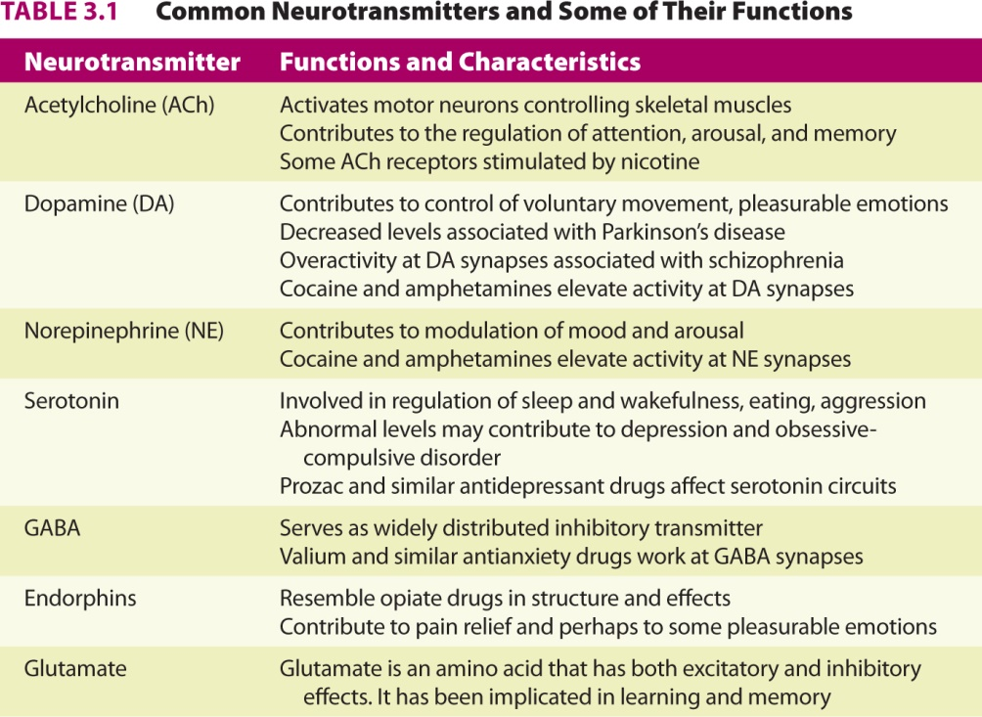

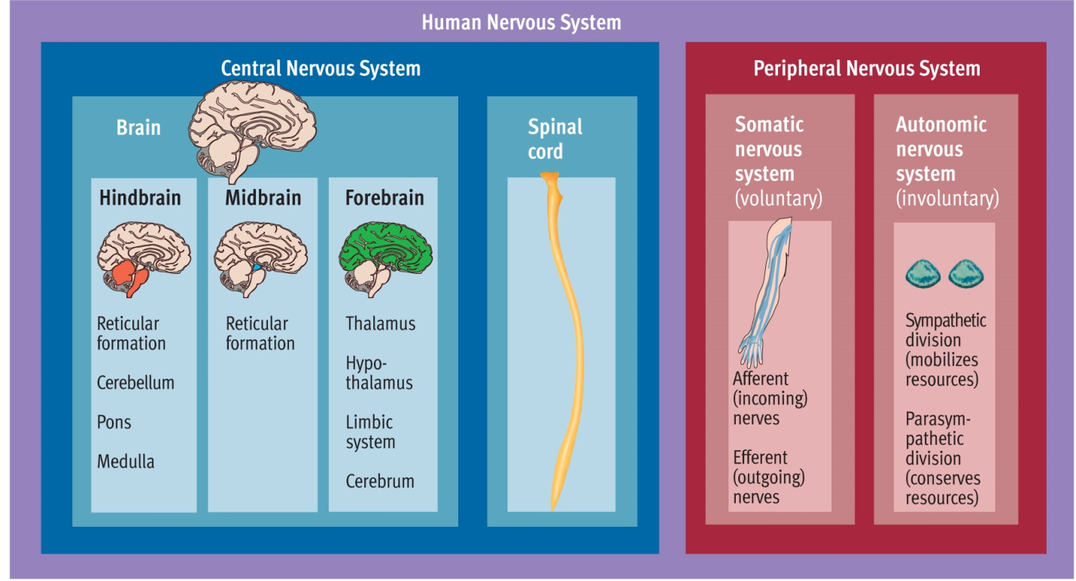
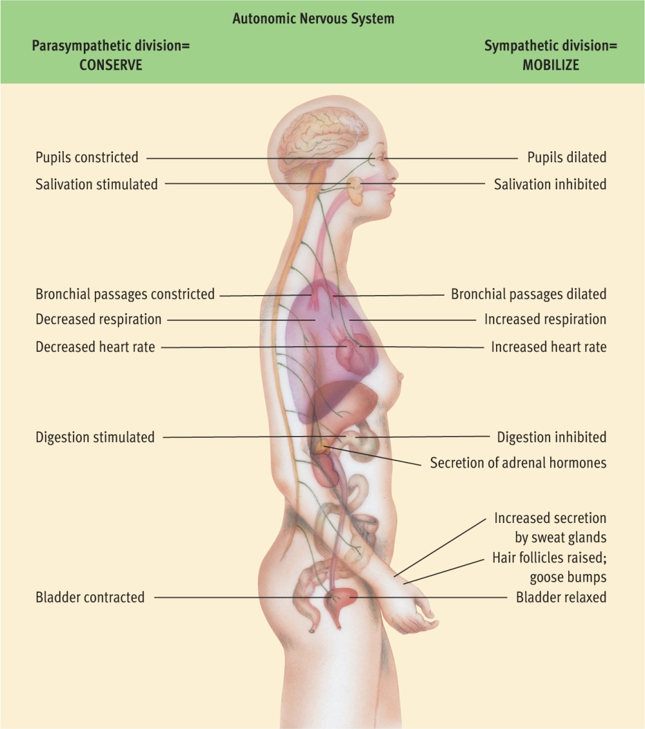

- Electroencephalography (EEG) – monitoring electrical activity of the brain
- Damage studies/lesioning – observing consequences of damage to certain areas
- Electrical stimulation (ESB) – stimulating a portion of the brain and observing effects
Brain imaging:
- Computerized tomography – computer enhanced X-ray
- Positron emission tomography – radioactively tagged chemicals serve as markers of blood flow or metabolic activity in the brain that are monitored by X-ray
- Magnetic resonance imaging – uses magnetic fields, radio waves, and computer enhancement to image brain structure



