ECOR 1010 – Introduction to Engineering

Zachary nguyen
Assignment #7
Assignment Title: Matrix Operations with MATLAB
TO Marking TA:
Name: Joseph Salvatore
Email: Joseph.Salvatore@cmail.carleton.ca

Lab Section: L7
Room: ME2556 – Carleton University

FROM:
Email: zacharynguyen@cmail.carleton.ca
Student Number: 101033389

Number of Figures and Tables (Including handwritten ones): [Total Number of Figures and Tables]
Last Date and Time of Revision: DD/MM/YYYY @ HH:MM (AM/PM)

Introduction
The purpose of this laboratory is to discover various utilities of the software MATLAB such as matrix operations solving linear systems and even plotting functions.

Materials and Methods
For this experiment the MATLAB software will be used in order to solve linear systems and even used in real life applications such as the trajectory of a guidance system for a boat. AutoCAD will also be used to draw a diagram of a circuit with the direction of the current.

Results
In part 1 exercise 1 MATLAB is unable to perform the dot product of L and H since the matrices don’t have the same size same goes for the operation J’-K. The total distance travelled by the boat is 64.5613 km and had a final vector of 4 km East and 9 km North. Thus the navigational system did not perform as plan since the boat doesn’t return to the original position [0,0]. For part 2 question number 3, it is possible to solve the system using pinv() to find the value of x. After solving the system, it was determined that 4.1349 tons of coal A and 1.6876 tons of coal B were burnt. The intensities of currents found were I₁=-2.7974, I₂= -3.1281 and I₃= -1.2225. The reason for the negative signs for the currents means that the current is going in the non-conventional direction. Finally the value of E was 32.1493.

Discussion
Following the multiple exercises done with MATLAB it can be concluded that MATLAB brings many advantages. This software allows to solve very big matrices questions in much shorter period of time than by hand. It also prevents small calculation errors that can be done by human while performing row/column operations or matrix multiplications etc. MATLAB also allows quick function graphing and has a very simple user interface. In addition, MATLAB is a very basic coding language that is simple to pick and does not require much expertise to learn and master. Nonetheless, it has its downside which would be that a simple typo while writing a matrix can go unnoticed and all the solutions are false. For example typing a matrix A=[1 ; 2 ;3] instead of typing A=[1; 2 ;4]. A small mistake will not be recognized by MATLAB.

Conclusions

To conclude, the multiple functions of MATLAB were explored and it was determined that MATLAB is an efficient and simple program to use when dealing with vectors and matrices. It can even be used in real life situations such a boat pathing or traffic management

APPENDIces- Figures and Tables
Figure 1: Code for Part 1 Questions 1-3
%Exercise 1

H= [8;5;-6];
I= [0;1;-3];
J= [8 4 -7];
K= [6;3;0;1];
L= [10;8];

p= 0.32;
q=2.35;
r=-0.4;

>> dot ( H,I)

ans =

23

>> p*K

ans =

1.9200
0.9600
0
0.3200

>> dot(L,H)
Error using dot (line 33)
A and B must be same size.

>> J' - K
% # PART 1 exercise 2
Matrix dimensions must agree.

a=[0; 0];
b=[1 ;10];
c=[10 ;1];
d=[5 ;-19];
e=[-13 ;7];
f=[1; 10];

vector= [[0 0];[1 10];[11 11];[16 -8];[3 -1];[4 9]];

x= vector(:,1);
y= vector(:,2);
plot (x,y);

xlabel('Displacement: East');
ylabel('Displacement: North');
title('Boat Tracker Zachary Nguyen');

distance= norm(a)+norm(b) +norm(c)+norm(d)+norm(e)+norm(f)

distance =

64.5613

>> %3.
x = [-3:0.01:3];
y= sin(x.^2) + ((10-4*x+x.^2) ./ (7+2*x.^2));
plot (x,y);

Graph 1 : Graph for Part 1 Question 2

Graph 2: Graph for Part 1 Question 3

%a)

F= [3 9; 7 -1; 3 0; 6 8; 9 5;5 2];
G= [-9 3 8 5 -1 2; 7 -1 -2 9 3 3];
Q= [2 -7 2; 1 0 7; -5 3 5];
U= [1 0; 0 1];

>> (F * G)*r

ans =

-14.4000 0 -2.4000 -38.4000 -9.6000 -13.2000
28.0000 -8.8000 -23.2000 -10.4000 4.0000 -4.4000
10.8000 -3.6000 -9.6000 -6.0000 1.2000 -2.4000
-0.8000 -4.0000 -12.8000 -40.8000 -7.2000 -14.4000
18.4000 -8.8000 -24.8000 -36.0000 -2.4000 -13.2000
12.4000 -5.2000 -14.4000 -17.2000 -0.4000 -6.4000

%b)
>> W= F -G'

W =

12 2
4 0
-5 2
1 -1
10 2
3 -1
%c)
>> plot ( [1 2 3 4 5 6]', sort(W))
>> xlabel( 'X- Values');
>> ylabel( ' Sorted W');
>> title(' x vs Sorted W - Zachary Nguyen');

%d)
>> U * G

ans =

-9 3 8 5 -1 2
7 -1 -2 9 3 3

%e)
>> F * U

ans =

3 9
7 -1
3 0
6 8
9 5
5 2
%f)
>> Q * H

ans =

-31
-34
-55
%g)
>> (q * G) + (p* F')

ans =

-20.1900 9.2900 19.7600 13.6700 0.5300 6.3000
19.3300 -2.6700 -4.7000 23.7100 8.6500 7.6900

Graph 3: Graph for Part 2 Question 1

Figure 3: Code for Part 2 Questions 2-6
% Number 2
A= [9 2 5; 6 4 1; 2 7 2];
B=[4;3;1];

>> x= inv(A) * B

x =

0.4969
0.0314
-0.1069

% # Number 3
>> x=inv(B)*C
Warning: Matrix is singular to working precision.

x =

NaN
NaN
NaN
NaN
NaN
NaN

>> x= pinv(B) * C

x =

49.1667
-25.8333
34.1667
-80.8333
39.1667
-15.8333

>> B*x - C

ans =

1.0e-13 *

-0.2842
-0.1421
0.8527
-0.4263
-0.0711
0

% Verify if Bx=C
>> B*x

ans =

75.0000
-60.0000
115.0000
-120.0000
55.0000
-65.0000

% YES Bx=C

% # Number 4

A= [26.6 30.2;
3100 6400;
240 340];

C= [162; 23619; 1566];

>> x=A\C

x =

4.1349
1.6876

>> A*x

ans =
1.0e+04 *

0.0161
2.3619
0.1566
%5.
Z= [-11 6 5;6 -7 1; -5 -1 14];
Y= [5.89; 3.89; 0];

>> Z

Z =

-11 6 5
6 -7 1
-5 -1 14

>> Y

Y =

5.8900
3.8900
0

>> x=inv(Z) *Y

x =

-2.7974
-3.1281
-1.2225
% 6.
A=[1 0 1; 0 3 3; 3 8 9];
b=[1 2 2];

>> c= b * A * b'

c =

101

>> E= c/pi

E =

32.1493

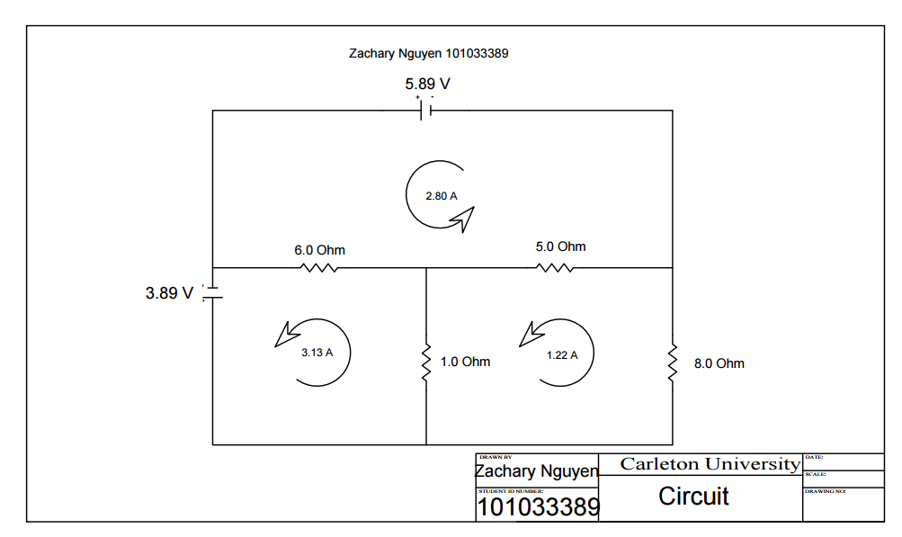
Figure 4: Drawing of circuit Part 2 Question 5

