Lecture 3 –
Earth is about 4.6 billion years old
-little atmosphere early on because most of the original gas envelope disappeared because of high heat radiating the planet

New atmosphere comes from volcanoes
-mostly CO2 and water vapour
- clouds reflected 60%
-clouds trap energy as well

Water began accumulating in liquid about 4BYA to form oceans

Earth’s total mantle mass is 4.5x 10^27cm
Water of oceans has mass of 1.4x 10^24
Mantle lost 0.031% of mass as H2O to produce oceans

Alternate source of Earth’s ocean water is comet-like balls of ice
Earth would receive 0.0025mm of water/year

Ocean is roughly pH 8.1
Ph is a log scale measure of activity of hydrogen ion

Oceans became salty from Cl- ion
2Na + Cl2 = NaCl2

Area covered by oceans may be decreasing because continents are growing (less room for oceans)

First fossil life = 3.8BYA
Heterotrophs (earliest forms) = ate organic compounds
Autotrophs (2.3BYA) = oxidized inorganic compounds through chemosynthesis
Single celled plants (2.1BYA) – coincided with appearance of significant amount of oxygen
1.8BYA = oxygen levels reached 10% present levels

Ocean basins are divided into 3 regions:
Continental margins
Continental slope
Deep-sea basins

Density ranges from 1.02200 to 1.03000g/cm3 in the open ocean
Density determines the positions and motions of water masses in the ocean

Density increases with depth
The in situ density sigma in deep trenches is about 5% greater than at the ocean surface

Pycnocline = zone of rapidly increasing density
Forms a very stable barrier to mixing with low-density water below
Pycnocline = layer where the density gradient is greatest
High gravitational stability

Pycnocline develops as result of combined effects of zones of rapid vertical changes in:
Temperature (thermocline)
Salinity (halocline)
Pycnocline is absent in high latitudes

Thermocline (metalimnion) is thin layer in lake or ocean in which temperature changes more rapidly with depth than it does in the layers above or below

Halocline is caused by a strong vertical salinity gradient within a body of water

Equatorial regions – there is a shallow zone of low salinity water near surface

At all latitudes there is:
Gain from solar radiation
Loss from back radiation
Conduction
Evaporation

Langley is a calorie of heat flow through 1cm2 of ocean surface

After losing its moisture, dry air mass descends – occurs in subtropical regions of northern and southern hemisphere
As it descends, it is warmed by compression. Upon reaching the surface it moves away from the tropics, toward either the equator or higher altitudes
Hadley cell = air that completes the loop and flows back to the equator. Thermally driven unit that extends in both directions – named after G.Hadley – 1735

Intertropical convergence zone (ITCZ) = between subtropical high pressure belts, horse latitudes, equatorial low pressure belt – results from the low density of the rising air column above the equator
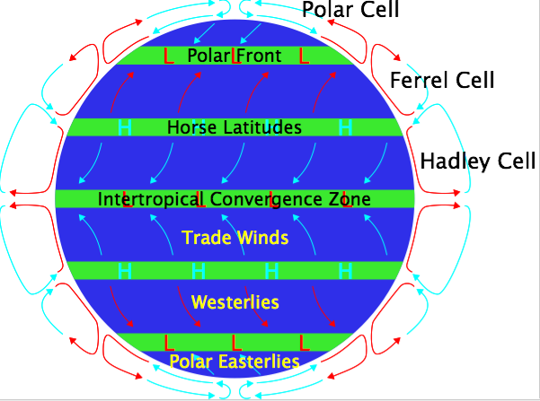

Horse latitudes are where trade winds die
This would stall Spanish ships – they would throw cargo overboard to lighten the ships load which would allow the sails to pull the ship out

ITCZ:
Key component of the global circulation system
Migrates seasonally due to solar forcing
Significant impact on seasonal precipitation patterns

Equatorial and ITC zones are the wettest regions on the planet
Equatorial region lacks a dry season and is constantly hot and humid

Air that moves from subtropical high pressure belts towards the equatorial low pressure belt constitute trade winds
Air that descends in subtropical regions at higher latitudes forms westerlies
Air moving away from poles produces polar easterlies

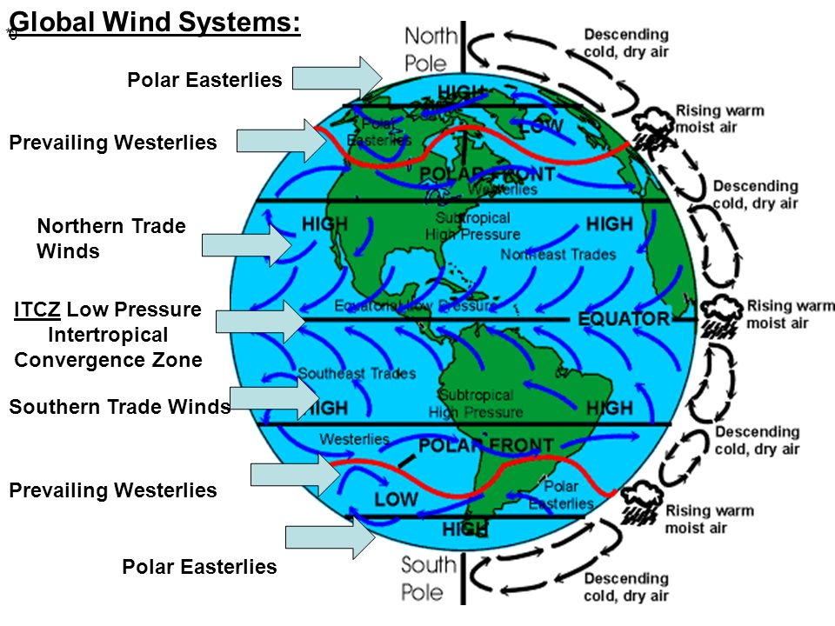

Veer to the right in the Northern hemisphere
Veer to the left in Southern hemisphere
Due to CORIOLIS EFFECT

Trade winds blow out of the northeast because the air mass moves south from the subtropical region

A westerly wind air mass moves from 30o latitude in a northerly direction to 60o latitude

Idealized pressure belts and wind systems are modified as result of two factors:
Tilt of Earth’s axis of rotation produces seasons
Air over continents gets colder in winter and warmer in summer than the air over adjacent oceans

Continents develop atmospheric high pressure cells in summer and low pressure cells in winter

Warm front: contact between a warm air mass moving east into an area occupied by cold air
Cold front: contact between a cold air mass moving east into an area occupied by warm air

Temperature and salinity of surface waters determined by:
Solar radiation
Rate of evaporation
Precipitation

Currents are driven by energy from the sun
Wind driven
Thermohaline

Gyres – ocean currents formed by global wind patterns
Rotate clockwise in N.H
Rotate counter-clockwise in S.H

Gulf stream is the western boundary current of the North Atlantic

