Flow through venturi meter

Summary:
The purpose of this lab is to get an understanding of real flow and to apply Bernoulli's equation to get static pressure, dynamic pressure and stagnation pressure. To get the measurements a device called Venturi tube was used. Fluid enters the wide end of the tube and passes through a smaller throat which causes an increase in velocity and a decrease in pressure. This process is used to measure the velocity or volumetric flow rate of a fluid.
After the calculations, the venturi coefficient (C_{v}) for flow 1 was determined to be 0.936 and C_{v} for flow 2 was determined to be 0.878. The static pressure at the throat for flow was calculated to be 96.655 KPa and for flow 2 it was 97.440 KPa. The dynamic pressure at the throat for flow 1 and flow 2 was determined to be 4.76 KPa and 3.94 KPa respectively. The stagnation pressure at the throat was calculated to be 101.380 KPa.

Nomenclature:

Symbol | Name | Units
$$A$$ | Area | m²
$$ρ$$ | Density | Kg/m³
$$P$$ | Pressure | KPa
$$v$$ | Velocity | m/s
$$h$$ | Height | m
$$c_{v}$$ | Venturi coefficient | Unit less
$$Q$$ | Volume flow rate | m³/kg

Flow Analysis:

The actual flow rate can be determined by using the Bernoulli equation along a stream line far away from the apparatus to the first pressure tap the velocity of the incoming air can be measured.
$$P_{atm}+\frac{1}{2}ρv_{1}^{2}+ ρgz_{1}= P_{inlet}+\frac{1}{2}ρv_{2}^{2}+ ρgz_{2}$$ | (1)
$$V_{inlet actual}=\sqrt{\frac{2(P_{atm}-P_{static})}{ρ_{air}}}$$ | (2)
The velocity at the inlet is calculated by using the difference in height in manometers. This will give equation 3 which can be used to calculate the flow rate.
$$P_{atm}-P_{inlet}=ρg(h_{inlet}-h_{atm})$$
$$V_{inlet actual}=\sqrt{\frac{2(ρg(h_{inlet}-h_{atm}))}{ρ_{air}}}$$
$$Q_{actual}=V_{inlet actual}{ A}_{inlet}$$ | (3)

Bernoulli's equation will be used to measure the ideal flow rate through the Venturi tube.
$$P_{inlet}+\frac{1}{2}ρv_{1}^{2}+ ρgz_{1}= P_{throat}+\frac{1}{2}ρv_{2}^{2}+ ρgz_{2}$$ | (4)
Rearranging the equation and solving for the difference in velocities between the inlet and throat, and using the continuity equation an expression for $v_{throat}$ can be derived.
$$Q_{inlet}= Q_{throat}$$
$$v_{inlet}A_{inlet}=v_{throat}A_{throat}$$
$$v_{inlet}=\frac{v_{throat }A_{throat}}{A_{inlet}}$$
$$v_{throat}=\sqrt{\frac{\frac{2\left(P_{atm}-P_{static}\right)}{ρ_{air}}}{1-{\left(\frac{A_{throat}}{A_{inlet}}\right)}^{2}}}$$ | (5)
The venturi coefficient is calculated by comparing the actual volume flow rate with the theoretical volume flow rate.
$$C_{v}=\frac{Q_{actual}}{Q_{ideal}}$$ | (6)

The stagnation pressure in the throat can be determined by adding static pressure and dynamic pressure in the throat.
$${P_{stagnation}=P}_{throat}+\frac{1}{2}ρv_{throat}^{2}$$ | (7)

The dynamic pressure inside the throat can be calculated by using Bernoulli’s equation.
$$P_{dynamic}=\frac{1}{2}ρ_{air}v_{throat}^{2}$$ | (8)

The static pressure can be evaluated by using the readings from the pressure taps.
$$P_{static}=P_{atm}+ ρ_{fluid}g\left(h_{atm}-h_{static}\right)$$ | (9)

The Ideal static pressure head through the venturi can be calculated by using Bernoulli’s equation. A streamline from the room to the desired pressure tap will be used.
$$P_{atm}+\frac{1}{2}ρv_{atm}^{2}+ ρgy_{atm}= P_{static tap}+\frac{1}{2}ρv_{static tap}^{2}+ ρgy_{static tap}$$ | (10)
$$P_{atm}= P_{static tap}+\frac{1}{2}ρv_{static tap}^{2}$$ | (11)
$$Q_{ideal}=A_{static tap}{ v}_{static tap}$$ | (12)
The final equation will to determine the Ideal static pressure will be the following equation
$$P_{static tap}=P_{atm}-\frac{1}{2}ρ{\left(v\right)}^{2}$$ | (13)

Actual static pressure inside the tube can be determined by using the equation 14.
$$P_{tap}=P_{atm}-ρg(h_{tap}-h_{atm})$$ | (14)

Experimental Setup and Procedure:
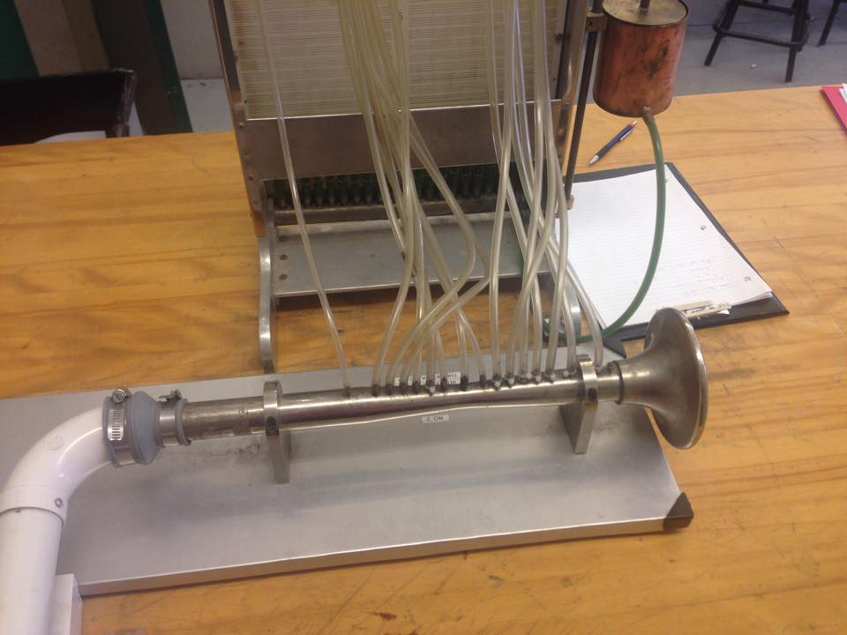
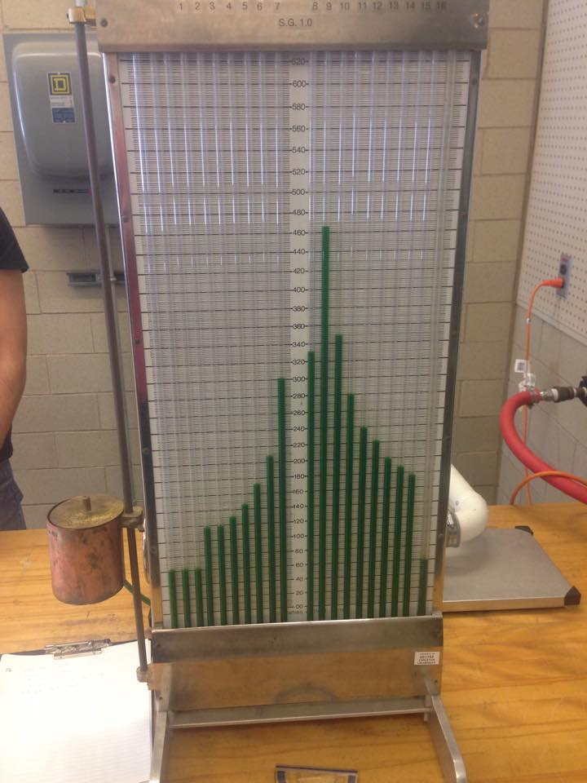
Figure 1 Venturi meter used to calculate pressure and velocity of a fluid passing through it

This experiment was conducted according to the lab manual provided for us. The number on the apparatus used was 2. The inlet diameter was recorded to be 1.020 inches and throat diameter of 0.640 inches.

Results and Discussion:
The data collected during the lab are in table 1 and table which can be found in appendix 2. Table 1 shows the height of different flows inside the Venturi tube. While table table 2 shows the distance of each tap from inlet and the throat of the Venturi tube. The calculations done during this lab are based on Bernoulli's equation and continuity equation. During the calculations a few assumptions were made. Such as the fluid was considered incompressible, the friction of the fluid with the Venturi tube wall was ignored. Also, the density of air was considered to be 1.225 kg/m³ . In order to determine the actual flow rate of the two flows, velocity at the inlet was first calculated using equation 2 and this value was put in equation 3 to get the actual flow rate. The actual flow rate for flow 1 was calculated to 0.01713 m³/s and for flow 2 was 0.015788 m³/s. Equation 5 was used to determine the velocity at the throat and this value was multiplied by area of throat to get the ideal flow rate. The ideal flow rate for flow 1 was calculated to be 0.01829 m³/s and for flow 2 0.01665 m³/s. These flow rates were used to calculated the venturi coefficients' "C_{v}". Venturi coefficient is a ratio of discharge between the actual flow rate and the ideal flow rate. The venturi coefficient for flow 1 was calculated to be 0.9365 and for flow 2 was 0.878.These values were obtained using equation 6.The dynamic pressure for flow 1 was calculated to be 4.76 KPa and for flow 2 3.94 KPa using equation 8. The static pressure for the two flows were calculated using equation 9. The static pressure for flow 1 was calculated to be 96.655 KPa and for flow 2 it was 97.4402 KPa. The stagnation pressure which sometimes is referred to as total pressure is the sum of dynamic and static pressure. Stagnation pressure occurs when fluid particles are slowing down and eventually come to rest. The stagnation pressure for flow 1 at venturi tube throat was calculated to be 101.415 KPa and for flow 2 it was 101.380 KPa.

Figure 2 Static Pressure distribution in a Venturi tube for Flow 1

Figure 3 Static Pressure distribution in a Venturi tube for Flow 2

The graphs in figure 1 and figure 2 show the distribution of actual static pressure and ideal static pressure of the both flows verses the number of taps in the venturi tube. The actual static pressure was calculated using equation 14 and ideal static pressure was determined by using equation 13. The calculated values for flow 1 and flow 2 are in table 3 and 4. The ideal static pressure is higher than the actual static pressure because of the assumptions that were made during the calculations of ideal pressure. The friction between the fluid and the venturi tube was neglected and this has resulted in a little difference in ideal static pressure compared to the actual static pressure.
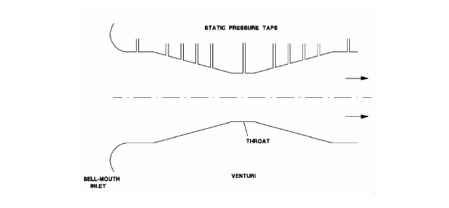

The velocity at the inlet of the tube is less compared to the throat. This is because the area at the throat gets smaller causing an increase in the velocity of the fluid.

Conclusion:
In conclusion the venturi coefficient was calculated to be 0.93 for flow 1 and 0.87 for flow 2. The ideal static pressure and actual static pressure deferred a little. This was due to considering the fluid incompressible and ignoring the friction between the fluid and the wall of venturi tube. In order to get a more precise result the effect of friction should be considered when calculating ideal static pressure using Bernoulli's equation.
The result calculated for the velocity of the fluid at each tap with different area made sense. The velocity values increased as area of the tube decreased. Also, the dynamic pressure inside the tube increased as the velocity increased, showing that as kinetic energy of the fluid increases the dynamic pressure increases. The calculated stagnation pressure at the throat of the venturi tube for both flows was close to atmospheric pressure showing that the fluid has same energy when it is inside the venturi tube or when it is outside the tube.

References:
Available (online) "http://www.valvias.com/discharge-coefficient.php" (11/03/2015)

Appendix:

Sample calculations
Actual volumetric flow-rate
$$Q_{actual 1}=V_{inlet actual}{ A}_{inlet}$$
$$Q_{actual 1}=\sqrt{\frac{2(ρg(h_{static}-h_{atm}))}{ρ_{air}}} π {\frac{d}{2}}_{inlet}^{2}$$
$$Q_{actual(1)}=\sqrt{\frac{2\left(1000\right)(9.81)(0.13-0.064)}{1.225}} π {\left(\frac{0.025908}{2}\right)}^{2}$$
$$Q_{actual (1)}=0.01713 \frac{m^{3}}{s}$$
$$Q_{actual(2)}=\sqrt{\frac{2\left(1000\right)(9.81)(0.12-0.064)}{1.225}} π {\left(\frac{0.025908}{2}\right)}^{2}$$
$$Q_{actual(2)}=0.015788 \frac{m^{3}}{s}$$
Ideal volumetric flow-rate
$$Q_{idel 1}=v_{throat}A_{throat}$$
$$Q_{ideal 1}=\sqrt{\frac{\frac{2\left(P_{inlet}-P_{throat}\right)}{ρ_{air}}}{1-{\left(\frac{A_{throat}}{A_{inlet}}\right)}^{2}}} π{\frac{d}{2}}_{throat}^{2}$$
$$Q_{ideal(1)}=\frac{√((2(100.67754-96.65544))/1.225)}{0.84507}*0.0002075$$
$$Q_{ideal (1)}=0.01829 \frac{m^{3}}{s}$$
$$Q_{ideal(2)}=\frac{√((2(100.77564-97.44024))/1.225)}{0.84507}*0.0002075$$
$$Q_{ideal(2)}=0.01665 \frac{m^{3}}{s}$$
Venturi Coefficient
$$C_{v}=\frac{Q_{actual 1}}{Q_{ideal 1}}$$
$$C_{v(1)}=\frac{0.01713}{0.01829}$$
$$C_{v(1)}=0.936$$
$$C_{v(2)}=\frac{0.015788}{0.01798}$$
$C_{v(2)}=0.878$

Dynamic pressure at the Venturi throat
$$P_{dynamic}=\frac{1}{2}ρ_{air}v_{throat}^{2}$$

$V_{throat}$= $\frac{\sqrt{\frac{{2(P}_{inlet }-P_{throat}}{ρ^{2}}}}{1- {\frac{A_{throat}}{A_{inlet}}}^{2}}$

$V_{throat}$= $\frac{\sqrt{6566.693}}{0.84507}$
$$P_{dynamic(1)}=\frac{1}{2}(1.225){\left(88.15\right)}^{2}$$
$$P_{dynamic(1)}=4.76 KPa$$
$$P_{dynamic(2)}=\frac{1}{2}(1.225){\left(80.273\right)}^{2}$$
$$P_{dynamic(2)}=3.94 KPa$$

Static pressure at the Venturi throat
$$P_{static}=P_{atm}+ ρ_{fluid}g\left(h_{atm}-h_{static}\right)$$
$$P_{static(1)}=101325+ (1000)(9.81)\left(0.064-0.54\right)$$
$$P_{static(1)}=96.655 KPa$$
$$P_{static(2)}=101325+ (1000)(9.81)\left(0.064-0.46\right)$$
$$P_{static(2)}=97.440KPa$$

Stagnation Pressure at the Venturi throat
$${P_{stagnation}=P}_{Static}+P_{dynamic}^{}$$
$$P_{stagnation\left(1\right)}=96.655+4.76$$
$$P_{stagnation\left(1\right)}=101.415 KPa$$
$$P_{stagnation\left(2\right)}=97.440+3.94$$
$$P_{stagnation\left(2\right)}=101.380 KPa$$

Ideal Static Pressure of Flow 1
$$P_{static tap}=P_{atm}-\frac{1}{2}ρ{\left(V\right)}^{2}$$
$$P_{static tap}=101325-\frac{1}{2}\left(1.225\right){\left(32.515\right)}^{2}/1000$$
$$P_{static(1)}=100.677 KPa$$
Ideal Static Pressure of Flow 2
$$P_{static tap}=P_{atm}-\frac{1}{2}ρ{\left(V\right)}^{2}$$
$$P_{static tap}=101325-\frac{1}{2}\left(1.225\right){\left(29.948\right)}^{2}/1000$$
$$P_{static(2)}=100.775 KPa$$

Table 1: Flow heights with respect to their tap
Static Tap # | Flow 1 height (m) | Flow 2 height (m)
1 | 0.13 | 0.12
2 | 0.131 | 0.12
3 | 0.144 | 0.132
4 | 0.162 | 0.148
5 | 0.172 | 0.174
6 | 0.232 | 0.208
7 | 0.345 | 0.298
8 | 0.38 | 0.328
9 | 0.54 | 0.46
10 | 0.394 | 0.346
11 | 0.316 | 0.28
12 | 0.268 | 0.24
13 | 0.244 | 0.218
14 | 0.22 | 0.198
15 | 0.208 | 0.186
16 | 0.192 | 0.176
17 | 0.064 | 0.064
18 | 0.064 | 0.064

Table: 2 Tap distance from inlet and throat
Static Tap # | Intake (cm) | Throat (cm)
1 | 0 | 11.7
2 | 2.4 | 9.3
3 | 4.3 | 7.4
4 | 5.4 | 6.3
5 | 6.6 | 5.1
6 | 8 | 3.7
7 | 9.3 | 2.4
8 | 10.3 | 1.4
9 | 11.7 | 0
10 | 13.4 | 2
11 | 15.7 | 3.3
12 | 17.2 | 4.6
13 | 18.3 | 5.7
14 | 19.6 | 7.1
15 | 21 | 8.3
16 | 23.6 | 10.8

Table 3 Actual and Ideal static pressure for flow 1
Static Tap # | Actual static pressure (KPa) | static pressure (KPa)
1 | 100.67754 | 100.6774424
2 | 100.66773 | 100.6774424
3 | 100.5402 | 100.2907452
4 | 100.36362 | 100.0596317
5 | 100.26552 | 99.73198047
6 | 99.67692 | 99.21572137
7 | 98.56839 | 98.51530866
8 | 98.22504 | 97.77249564
9 | 96.65544 | 97.16806737
10 | 98.0877 | 98.2793001
11 | 98.85288 | 99.07942903
12 | 99.32376 | 99.63275026
13 | 99.5592 | 99.96763424
14 | 99.79464 | 100.2857668
15 | 99.91236 | 100.4896592
16 | 100.06932 | 100.6774424
Table 4 Actual and Ideal static pressure for flow 2
Static Tap # | Actual static pressure (KPa) | Ideal static pressure (Kpa)
1 | 100.67754 | 100.7756451
2 | 100.66773 | 100.7756451
3 | 100.5402 | 100.447591
4 | 100.36362 | 100.2515261
5 | 100.26552 | 99.9735635
6 | 99.67692 | 99.53559562
7 | 98.56839 | 98.94140121
8 | 98.22504 | 98.31123654
9 | 96.65544 | 97.79847043
10 | 98.0877 | 98.74118359
11 | 98.85288 | 99.41997215
12 | 99.32376 | 99.88938166
13 | 99.5592 | 100.1734801
14 | 99.79464 | 100.4433676
15 | 99.91236 | 100.6163395
16 | 100.06932 | 100.7756451

Table 5 have area and velocity values for both flows in their corresponding tap.
Table 5: Area and velocity of the two flows across the venturi tube
Static Tap # | area (m²) | velocity 1 (m/s) | velocity 2 (m/s)
1 | 0.000527 | 32.51518027 | 29.9483871
2 | 0.000527 | 32.51518027 | 29.9483871
3 | 0.000417 | 41.09232614 | 37.84844125
4 | 0.000377 | 45.45225464 | 41.86419098
5 | 0.000336 | 50.9985119 | 46.97261905
6 | 0.000292 | 58.68321918 | 54.05068493
7 | 0.000253 | 67.72924901 | 62.3826087
8 | 0.000225 | 76.15777778 | 70.14577778
9 | 0.000208 | 82.38221154 | 75.87884615
10 | 0.000243 | 70.51646091 | 64.94979424
11 | 0.000283 | 60.54946996 | 55.76961131
12 | 0.000326 | 52.56288344 | 48.41349693
13 | 0.000364 | 47.07554945 | 43.35934066
14 | 0.000416 | 41.19110577 | 37.93942308
15 | 0.000464 | 36.9299569 | 34.01465517
16 | 0.000527 | 32.51518027 | 29.9483871


