Think big
Why do we work?
- To make money to life
- Purpose
- Build skill sets
- Self worth

Job Analysis
Job Analysis – The procedure for determining the tasks, duties, and responsibilities of each job, and the human attributes (in terms of knowledge, skills, and abilities) required to perform it .
- The process by witch info about jobs is systematically gathered an organized.
Way do organizations gather this information?
- To inform humans to what there required to do when given the job they have applied to.
Uses of Job Analysis
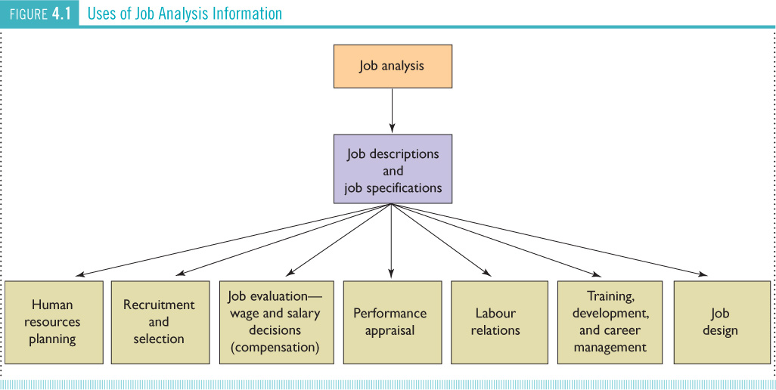
Human resources planning – Knowing the actual requirements of an organizations various jobs is essential for planning future staffing needs. Combine this with knowledge and skills of your current employees you can determine which jobs can be filled.
Recruitment and selection – Job description and job specification information should be used to decide what sort of person to recruit and hire.
- When you need to hirer
Performance Management – To be legally defensible, the criteria used to assess employee performance must be directly related to the duties and responsibilities identified through job analysis.
- If you are going to be promoted
Labour Relation – Job description are generally subject to union approval before being finalized. Once approved there could be significant change to the job descriptions.
Training, Development, and Career Management – Helping employee fill in the gaps to improve on the skills that need to work on.
Steps in Job Analysis
- Review relevant background information
- Select jobs to be analyzed
- Collect data on job activities
- Verify/ modify data if required
- Write job description and job specifications
- Communicate and update information as needed
Step 1. Background Information
What do we mean by relevant background information?
- The function, goals, and objectives of the organization
- The organizational structure
- How info is obtained
- How authority is distributed
Back ground info about the job not the person
The review of relevant background information, such as organization charts, process charts, and existing job descriptions.
Step 2. Select job to be analyzed
How do we determine which jobs are to be analyzed?
Job Design
- The process of systematically organizing work into tasks that are required to preform a specific job.
Work Simplification – An approach to job design that involves assigning most of work (such as planning and organizing) to supervisors and manger, while gibing lower- level employees narrowly defined tasks to perform according to methods established and specified by management.
Industrial engineering – A field of study concerned with analyzing work methods; making work cycles more efficient by modifying, combining, rearranging, or eliminating tasks; and establishing time standards.
Job enrichment – Any effort that makes an employees job more rewarding or satisfying by adding more meaningful tasks and duties.
Ergonomics – You adjust the job to make it less harsh on the human body.
Step 3. Collect Job Analysis Information
- Interviews
- Questionnaires
- Observations
- Participant diary/ long
- National occupation classification (NOC)
Note: when conducting job analysis, the objective is to gain a better understanding of the job itself, not to evaluate the qualification of the current incumbent. Job analysis is not a performance review
NOC
- reference tool for writing job descriptions and job specifications
- compiled by the federal government (HRSDC)
- contains comprehensive, standardized descriptions of about 40,000 occupations and the requirements for each
- NOC and its counselling component, The Career Handbook, both focus on occupations rather than jobs
- an occupation is a collection of jobs that share some or all of a set of main duties
- Text pages 103-105 provide a more detailed discussion of the NOCS and provide an example of a NOC Job Description for Specialists in HR
Step 4: Verifying information
Verify with:
- Workers currently performing the job
- Supervisors
Increases validity and reliability
- Inconsistencies, concerns can be addressed
- Participants will be more honest

Step 5: Writing job descriptions and job specification
- Jon description – A list of the duties, responsibilities, reporting relationship, and working conditions of a job one product of a job analysis.
- Job specifications – A list of the human requirements that is the requisite knowledge, skills, and abelites needed to perform the job another product of a job analysis.
Step 6: communication and preparedness for revisions
- Communicate to all relevant stakeholders
- Anticipate modifications
Restructuring
New product development
Technological changes
Competitors
Competency- Based Job Analysis
- Job analysis that focuses on competencies rather than a list of duties - - WHY???
Competencies: demonstrable characteristics that enable performances of a job.
- Examples
General (reading, writing)
Leadership (strategic thinking, motivating)
Technical competencies for specific jobs
- A thought experiment: in your head, list your top-three competencies.

Problems Associated with Job Analysis
- Job analysis that is neither updated nor reviewed
- Jon description or specification that is too vague
- Contamination and deficiency
- Time and costs of job analysis
Help Wanted!
- As we saw in step 5 of the Job Analysis process, the information gained from thorough and effective Job Analysis informs the writing of job descriptions and job specifications
- Job descriptions and job specifications influence who will apply to your organization -> who will be hired -> support/detract from org’s strategy -> promote/hinder org success.
- Ex. Apple dose not have one set role for their employees they are looking for someone that can do everything. But in fido they set the role in a tradition way.
Job Descriptions and Job specifications
Discussion Question:
- Is it advisable for companies to have very detailed job ads? Why or Why Not?
- Make it detailed enough that people know what they are applying for.
Job Descriptions and Job Specifications
- Detailed job descriptions and specifications (aka Realistic Job Previews) reduce the probability of:
- Forming an inaccurate psychological contract
- Misrepreanting the job or the duties
- Selecting the wrong candidate (poor fit)
- Having to read a lot of applications
- Some Legal considerations:
Human Rights Legislation
- Not legally required but highly advisable
- Essential job duties should be clearly identified
- The only criteria examined should be knowledge, skills, and abilities required for the essential duties of the job.
Employment Standards and Health and Safety
- For entry level (or very physical job)l identify actual physical and metal demands.
A note on Job Design
- Job design is not only about organizing work into tasks to serve the organization, it also involves organizing tasks in such a way as to motivate employees whenever possible. (what task go together for a job)
- Example: The “McJob” criticism
The Evolution of Jobs and Job Design
Job Specialization
- Brake jobs down to a few task
- Make it simple
- work simplification
- industrial engineering
Behavioral Aspects
- job enlargement, job rotation, job enrichment, team based job design
Ergonomic Aspects
- physical needs of workers
Job Characteristics Model
Components of a Job
- Skill variety (the use of different skills) mick dicks let there employee rotate during there shifts to do different things and learn how to do everything.
- Task identity (completing an entire piece of work)
- Task significance (work contributes to a greater good)
- Autonomy (decision making authority over oneself) is letting others do task the way they wont to do it.
- Feedback
The idea is to try and use all these things in a job
A few words about teams(will be one midterm)
- Information on teams can be found in the Team Project Reading posted on D2L
- This information is part of the course material and is therefore “testable”
- Reviewing the short Team Project Reading will also be helpful in preparing your Team Contract
- Group Roles
- Group Norms – the time it take to respond to an email
- What can you do to make sure your team functions effectively?
Tuckman’s 5-Stage Theory of Group Development


