  - Human Resources Management
Human Resources Management (HRM)
- the management of people in organizations to drive successful organizational performance and achievement of organization’s strategic goals
Human Capital
- the knowledge, education, training, skills, and expertise of an organization’s workforce
- invest in yourself
Functional Areas of HR
- Job analysis and job design
- Compensation
- Recruitment and selection
- Talent management and succession planning
- Employee engagement, motivation and wellness
- Performance appraisals
- Discipline and discharge
- Labor relations
Changing Attitudes at Work
Fred Taylor
Had this idea that efficiency was the key to success. So, he in up this idea in the work place.
The Hawthorne Studies
- Studies conducted at the Hawthorne plant of Western Electric that were concerned with the impact of fatigue, rest pauses, and lighting on employee productivity
- The studies illustrated how psychological and social processes affect productivity and work adjustment
- This method was trying to change the way employees worked there employer was giving them breaks with helped them do better at there job. They are not robots they are humans.
Diagram in power point shows how Hawthorne studies improved the workplace and how works started to do a enjoy work.
Human Resources Movement: Evolutionary Phases
Phase 1 - early 1900’
- personnel administration (payroll, benefits)
- Job was to make sure procedures were followed
- There working conditions where poor
Phase 2 – 1930’s to 1950’s
- Efficiency increased but wage did not go up
- union liaison, compliance with new laws
- orientation, performance appraisal, employee relations
Phase 3 – 1960’s to 1980’s
- human resources management
- Outsourcing* of many administrative functions (ex, Air Canada, IBC, BMO, TELUS, ect…)
- emphasis on contribution and proactive management of people
- a lot of people where being laid off b/c buss realized that they can get there products made cheaper in different country’s and get them shipped back to the buss.
* “Outsourcing: the practice of contracting with outside vendors to handle
specific business functions on a permanent basis” (pg.4).
Phase 4 – 1990’s to present
- every line manager must posses basic HR skills
- help achieve strategic objectives
- new roles: activist, change steward, talent manager/organizational designer, operational executor and business ally
HR as Strategy
“Strategy- the formulation of organizational missions, goals, objectives and action plans for achievement that explicitly recognize the competition and the impact of outside environmental forces.”
Strategy- The company’s plan for how it will balance its internal strengths and weaknesses with external opportunities and threats to maintain a competitive advantage.
Ex. Google can be every innovated they can send people an invit for a job interview if they see someone fit based off of what they are reaseaching on there search engine

Environmental Influences on HRM
External Influences
Economic conditions
Affects supply and demand for product and services. This can lead to more employee’s b/c we have more demand for a product and services. Or it can lead to less employees b/c the company done not have enough work for the staff due to the economic down turn.
Productivity – the ratio of an organization’s outputs (goods and serveries) to its inputs (people, capital, energy, and materials.)
Primary Sector – jobs in the agriculture, fishing and trapping, forestry and mining.
Secondary sector – jobs in manufacturing and construction
Tertiary or service sector – Jobs in the public administration, personal and business services, finance trade, public utilities.
Labor market issues
- increasing workforce diversity: visible and ethnic minorities; women; Aboriginal population; people with disabilities
- generational differences:
  - Traditionalists (pre-1946)
  - Baby Boomers (1946 to 1964) people in this age group is working longer
  - Generation X (1965 to 1980) these ppl have different needs they might be starting out so they have different needs. Workers are trying to learn how to work with them.
  - Generation Y (1981 to present)
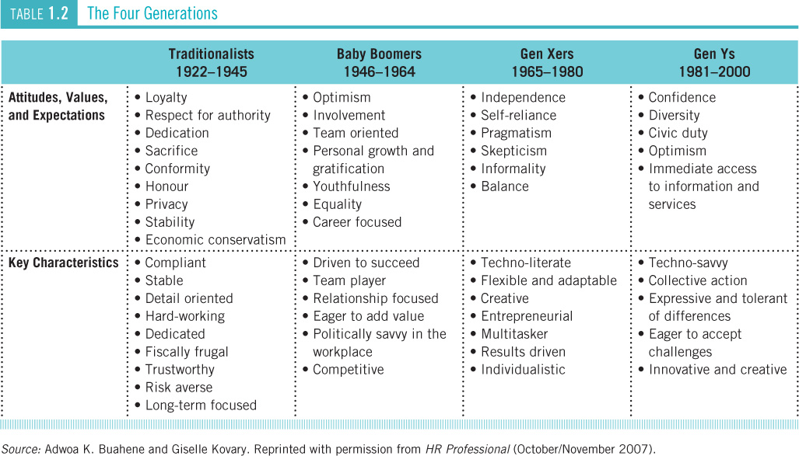

- higher overall level of education, however higher level of functional illiteracy
- Canada is a every educated country but are literate rates are every poor
- increased non-standard or contingent workers
  - part-time
  - term/temporary/standby
  - home
  - self-employed
- Council of Ontario Universities Report
Diversity is the increasing in Canada workforce
The employment rate for woman is going up. Work places are offering woman flexible work hours and child care.
The aboriginal population is growing but they still are having a hard time finding jobs.
Age is becoming a big factor in the work place some people like working with different age groups and some don’t.
Generation x – individuals born between 1965 and 1980. They were the first technology literate generation.
Generation y – Individuals born since 1980. This group is techo-savvy but they will need new approaches to work and career management to be challenged and not get bored.
Technology
- new technologies: social media, videoconferencing
- concerns over data control, accuracy, right to privacy, and ethics
- computerized monitoring of e-mail, voice mail, telephone conversations, computer usage, and behavior
Organizations use technology today to benefit their business. It can feel like everyone is in the same room when they are all connected on these social media platforms. But company’s do have to monitor employee behavior when using them.
Government
Ensure policies and practices comply with new and changing laws covering:
  - human rights
  - employment standards
  - labour relations
  - occupational health and safety
  - workers’ compensation

We have different human rights in Canada depending on what part of Canada you are working in ( 10 provinces and 3 territories).
Different rights in Canada are employment standards, labor relations, health and safety, and workers compensation legislation.
Globalization
Global trends:
  - firms extend business operations abroad
  - emergence of one world economy
  - increased international competition
  - multinational corporations: conduct business around the world, seek cheap skilled labour
HR professionals must become familiar with employment legislation in other countries and manage ethical dilemmas.
The emergence of a single global market for most products and services
HR professionals need to become familiar with employment legislation in other counties and need to manage ethical dilemmas when larboard standards are substantially lower than those in Canada.
Environmental concerns
- Environmental Concerns: Climate change, global warming, sustainability, pollution, carbon footprints, extinction of wildlife species, ecosystem fragility
Internal Influences
Organization culture
- Consists of the core values, beliefs, and assumptions that we widely shared by members of an organization.
Ex.
- Online retailer Zappos, company motto: “powered by service” (zappos.com)
- Prides itself on exceptional customer service: telephone number at the top of every page, live help chat, 24/7 customer service, 365-days for returns and free shipping.
- Recently Zappos call centre hired 250 new employees, they had 25,000 applicants (the job only pays $11/hour).
- How does Zappos attract so many applicants? The way the job is designed. They gave there employees a chose to leave if they don’t wont the job anymore after they where given traing. It was a test to see if the employees cared about the company or just the pay check

Organization climate
- The prevailing atmosphere that exists in an organization and its impact on the employees
- Weather impacts managements leadership style and employee motivation

Management practice

