Company Analysis: McDonald’s International Franchising Activities

Neil Gill, 101010920
Section B
Professor Shaukat

3, November, 2016

Objective
McDonald’s is a widely successful global brand that, despite their attractive business model for franchising in concept, has been plagued recently by friction between franchisees and corporate over their newest turnaround plan for the company. In this report the McDonald’s involvement in international franchising and their business model as it relates to franchisees will be defined in depth and analyzed to explore why their franchise oriented model is failing one of its major components, the franchisees.
Company Profile
The McDonald’s corporation is one of the world’s largest international limited fast food restaurant chains (Adams, 2013). It has a vast presence of 36 5252 restaurants internationally, of which approximately 80% of which are franchised (Statista, 2016). The company was founded in 1955 by Ray Croc and operates under the mission statement that they aspire to “Be the customer’s favourite place and way to eat and drink”(McDonald’s,2016). This mission statement is supported by three key aspects of their operations. First, Mcdonald's attempts to provide a universal experience in all of it’s restaurants to ensure consistency, quality and customer satisfaction no matter the location. Second, they implement a “Plan to win” strategy, wherein they aim to constantly improve their product, price, place, people and promotion that they offer to enhance consumer experiences. Finally, McDonald’s builds their business model off of a “Three Legged Stool” model. This model entails that they balance the needs and interests of owners, operators (franchisees) and employees equally, believing that if all their needs are met and considered, then they can in turn better fulfill the needs of consumers.
Recently, in terms of performance, McDonald’s has been seeing steadily falling sales over the past few years. Going from $ 28 106 000 000 in revenues in 2013, to $ 25 413 000 000 in revenues in 2015 (Appedix A)(McDonald’s Corp., 2015). This steady slide in revenue has been ongoing for the past few years and, although it is concerning to shareholders of the company, it has had negligible impact on McDonald’s global dominance of the fast food market. One will note that in the McDonald’s financial reports the revenues recorded by franchised restaurants in 2015 was $ 8 925 000 000 which accounts for a major portion of McDonald’s revenue stream (Appendix A) (McDonald’s Corp., 2015). This highlights the importance that franchisees have for McDonald’s business model as they are established as an essential portion of the revenue stream which will benefit shareholders. Currently, McDonald’s is rated as the 9th most valuable brand globally (Forbes, 2016) and has been rated as the #1 international fast food chain (Forbes, 2012). This observed market dominance is supported by a local survey I have conducted. This survey consisted of 15 respondents, including friends who are regular consumers of fast food. The respondents were surveyed on which fast food restaurant is their preferred one given a choice of four major fast food chains in Ottawa. The results of the survey were that 57% of respondents preferred McDonald’s to its competitors (Appendix B). This sample only confirms the trend of McDonald’s market dominance that is being seen globally in the fast food industry.
International Franchising
International franchising is an arrangement (the franchise agreement) where, outside of a company’s domestic country, one party (the franchisor) grants another party (the franchisee) certain rights regarding its brand. First, the franchisee is given rights to use the company's trademark, certain business systems of the company and certain production processes. This is all with the goal of producing and marketing a good to certain specifications which are defined by the franchisor. The franchisee will pay a one time franchise fee and be expected to contribute some of their capital to the startup costs of the franchise. Throughout the life of the franchise agreement, the franchisee is expected to pay the franchisor a percentage of their gross sales revenue as a royalty. There are many advantages to franchising internationally for the franchisee. Through franchising, a franchisee will have immediate name recognition and tried and tested products ready to go to market. They will also receive standard building design and decor which will not have to be planned or fully financed by them. Finally, franchisees are well briefed by the franchiser regarding detailed techniques to run and promote the business, they are also given aid in training employees and ongoing help in the promotion and upgrading of their products.

McDonald’s International Franchising Activities
The relationship between McDonald’s corporate and their franchisees is very tightly interwoven. As stated before, franchisees are very important to McDonald’s revenues and profits globally as they make up a significant portion of the revenue stream. The “Three Legged Stool” business model that McDonald’s employs ensures that franchisees always get input and consideration in the corporate decision making process which allows corporate to better fulfill their needs. Corporate also gives McDonald’s franchisees a great deal of autonomy in terms of their restaurants. Many international franchisees have made adjustments to the menu and decor of the standard McDonald’s restaurant to better fit the local customs and cultures of their different, diverse markets. This also allows corporate and the franchisees to share the risks and benefits of the franchisees autonomous decisions (Forbes, 2012).
Upon entering a franchise agreement with McDonald’s, franchisees are subject to number of capital requirements and fees. Upon purchase of a McDonald’s franchise, the minimum down payment is dependent on whether the franchise is an existing restaurant or one yet to be built. For existing restaurants, franchisees must make a down payment of 25% of the total cost. For a new location to built, a franchisee must cover 40% of the total cost with their down payment. These payments and any future repayments of the purchase fee must be made in equity and be paid off completely in no less than seven years (McDonald’s, 2016). In terms of operating costs, royalties are to be paid to the McDonald’s corporation through a monthly service fee which consists of 4% of the gross sales of the location and monthly rent, which is a variable percentage of gross sales dependent on the location of the restaurant (McDonald’s, 2016).
In franchising with McDonald’s, franchisees are subject to two major agreements, the general franchise agreement and the collective purchasing agreement. The general franchise agreement with McDonald's states that the franchisee must provide a portion of their initial down payment towards start up costs such as the purchase of signs, equipment, seating, etc. (Neilson, 2013) It also states that the McDonald’s corporation secures the lease for the land and the building (Neilson, 2013). Finally, it states that the franchisee must contribute to the company’s revenue stream through royalty payments (Neilson, 2013). The collective purchasing agreement is the agreement that franchisees purchase their food, packaging, equipment, etc. only through company approved independent suppliers and distribution centres. The company strictly enforces its’ high standards in this matter and has quality centers internationally to monitor scrutinize its’ franchises and corporate restaurants alike (Neilson, 2013). McDonald’s is also currently including their franchisees in a company wide turnaround plan to boost falling. This consists of remodeling McDonald’s restaurants, adding new menu items, self service kiosks, etc. (Neilson, 2013).
Although McDonald's has a solid franchising model, in practice many franchisees have raised concerns and grievances with McDonald’s corporate. There has been much concern to do with franchisee, company relations, which have never been so poor in McDonald’s history (Business Insider, 2015). Franchisee morale is also incredibly low and their future outlooks are bleak with franchisees being quoted saying that “The system is broken.” and “We will continue to fall and fail.” (Business Insider, 2015). It is clear that franchisees are feeling frustrated with corporate as they feel as if the company is not considering them in decisions and that is negatively impacting their franchises (Business Insider, 2015). These tensions stem from a root problem that franchisees are observing, a lack of consistent leadership. This feeling is the result of observations regarding the company’s current turnaround plan. Franchisees feel that these initiatives seem to have no direction or cohesion and when they fail, they bear the brunt of the cost. This can be seen even more clearly through the lense of the McCafe initiative, which required the purchase of $15000 to $20000 espresso machines for franchisees, an investment that bore little or no fruit for many franchisees but was pushed on them regardless (Bloomberg, 2015). Franchisees also feel that McDonald’s, in their current state of reinvention is “...trying to be too many things to too many people.” (Egan, 2015). This lack of focus not only creates initiatives that come out in a state of mediocrity, but is also taking away from McDonald’s original focus of limited fast food (Bloomberg, 2015). This is even visible to consumers as was discovered from a personal interview I conducted with a friend who is a regular consumer of McDonald’s. He stated that “It feels like they’re trying to appeal to many niches at the same time with their initiatives, but they just end up with mediocre offerings for those niches and slower service overall.” (B. Richmond, personal communication, 2016). Franchisees feel that McDonald’s is simply throwing ideas at the wall to see what sticks, but the cost is coming out of franchisee pockets and is leading some to insolvency (Bloomberg, 2015).
Analysis of International Business Environment
McDonald’s has many key markets across the globe and these markets all prove to have unique and culturally diverse business environments for franchisees and McDonald’s as a company to navigate. In its major markets of Asia, franchisees have had varying degrees of success in recent years. In India they have seen improved growth due to the introduction of more vegetarian and chicken options to suit the majority religion of Hinduism in the market. In China franchisees face consumer revolt against the brand due to the results of an undercover investigation into certain franchises that revealed major food safety scandals. In Japan, McDonald’s as a brand suffers from a loss of consumer trust due to a food safety scandal regarding a Chinese supplier and cost cutting by franchisees that made the customer experience less convenient and pleasant.
In Europe, McDonald’s has also seen varying degrees of success, but for the most part has been performing well. The introduction of tailored menu items for different cultural groups lead to improved revenues. A key example of this is the introduction of the McBaguette in France, which lead to the market growing to McDonald’s most profitable international market (Financial Times, 2015). However, in certain parts of Eastern Europe (Namely Russia and Ukraine), McDonald’s faces consumer confidence issues regarding food safety and modernized, clean kitchens and equipment which has slightly offset its’ success in the region (Financial Times, 2015). McDonald's has also has it’s success partially offset by recessions hitting certain parts of Europe, namely Greece and Italy, reducing consumer spending (Financial Times, 2015)
In Latin America, franchisees have followed in their international colleagues footsteps in terms of culturally relevant menu items. Franchisees in the region have added many healthier options to their menu, even including traditional beans and rice meals. This has led to some growth in the market, but not an extraordinary amount. Franchisee success in Latin America has been generally dragged down by poor macroeconomic conditions plaguing many countries within it, such as recessions, currency deflations and political instability which has created a difficult business environment to succeed in (Financial Times, 2015)
Recommendations
Overall, McDonald’s franchising strategy is not bad in concept, it is well suited to the international business environment, however recently McDonald’s corporate has not been acting in a way such that they would reflect this effective franchising model they have set for themselves. I would recommend McDonald's to continue to offer franchisees greater autonomy in their international franchises as it is an excellent way to keep the brand flexible, and as demonstrated in their international markets, an excellent way to adapt the menu to suit local tastes and improve revenue and growth. However, to maintain growth and consumer loyalty in these international markets, McDonald’s must invest more in it’s quality control and tighten quality control with international food suppliers especially. As mentioned before, food safety issues can be disastrous for consumer trust and can even cause significant losses in established markets such as Japan. Consumer trust is also much harder to win back once it has been broken, it would be better if the company were to ensure that it was not broken in the first place. Another suggestion to McDonald’s would be to test their innovations and initiatives before forcing them on franchisees. A good place to experiment would be corporate restaurants and willing franchises that can afford to. The costs of the current strategy fall heavily on the franchisees and as stated previously, this leads friction between franchisees and corporate and can even result in franchisee exit by insolvency or franchisee revolt, neither of which are good outcomes for the company. Finally, McDonald’s must listen more to franchisee feedback as they suggest they do in their business model. Their current ignorance towards franchisee needs and their problems with the current corporate strategy are causing great friction between franchisees and corporate and make franchising with McDonald’s seem less attractive to prospective franchisees. Currently, McDonald’s is taking it’s “Three Legged Stool” model and appears to be sawing furiously away at one of the legs, that being that franchisees. If McDonald’s continues down this path it will inevitably suffer as one of the main pillars of its business model will be resentful, demoralized and uncooperative. It should follow these recommendations as it is imperative that they repair corporate relationships and business dealings with franchisees to a more acceptable state. Their stool cannot stand with only two legs.

Appendix
A.
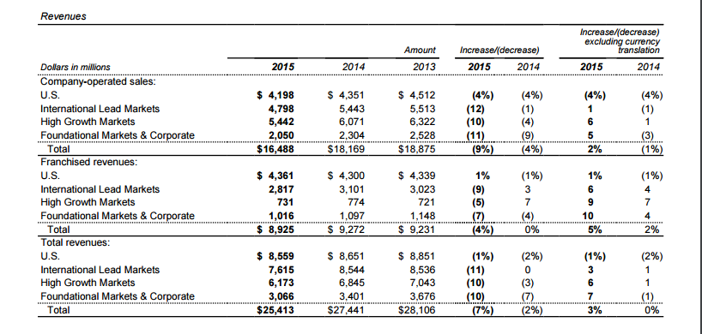
B.
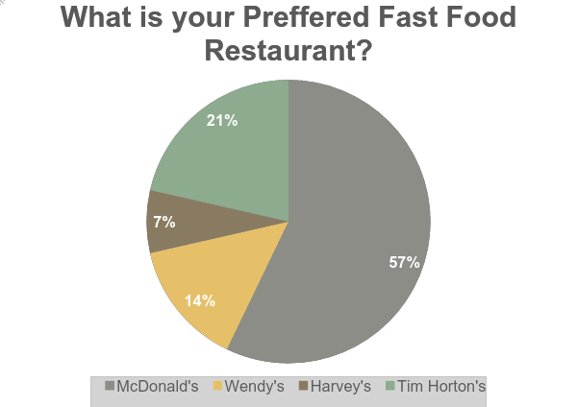
*Survey of 15 respondents
References
McDonald's Corp. (2015). McDonald's Corp. Annual Report. Washington, DC. Retrieved from:http://corporate.mcdonalds.com/content/dam/AboutMcDonalds/Investors%202/2015%20Annual%20Report.pdf
Top 10 Global Fast Food Chains. (2012). Retrieved November 03, 2016, from http://www.forbes.com/pictures/feji45hfkh/top-10-global-fast-food-brands-2/#23b751a92976
The History of the Golden Arches™. (n.d.). Retrieved November 03, 2016, from http://www.mcdonalds.ca/ca/en/our_story/our_history.html
Purchasing Your Franchise. (n.d.). Retrieved November 03, 2016, from http://www.mcdonalds.ca/ca/en/our_story/corporate_info/franchising/purchasing_your_franchise.html
Nielson, S. (2013, December 23). What is a franchise and how do McDonald's franchise agreements work? Retrieved November 03, 2016, from http://marketrealist.com/2013/12/franchise-mcdonalds-franchise-agreements-work/
Mourdoukoutas, P. (2012, April 20). McDonald's Winning Strategy, At Home And Abroad. Retrieved November 03, 2016, from http://www.forbes.com/sites/panosmourdoukoutas/2012/04/20/mcdonalds-winning-strategy-at-home-and-abroad/#526cf2cb70da
McRevolt: The Frustrating Life of the McDonald's Franchisee. (2016, September 16). Retrieved November 03, 2016, from http://www.bloomberg.com/features/2015-mcdonalds-franchises/
McDonald’s and its challenges worldwide: A market-by-market look. (2015, January 29). Retrieved November 03, 2016, from https://www.ft.com/content/f8ac22fc-a7c1-11e4-8e78-00144feab7de

McDonald's: Number of restaurants worldwide | Statista. (2016). Retrieved November 03, 2016, from https://www.statista.com/statistics/219454/mcdonalds- restaurants-worldwide/
Jones, A. (2014, July 18). Must-know: A company overview of McDonald’s. Retrieved November 03, 2016, from http://marketrealist.com/2014/07/must-know- company-overview-mcdonalds/
International Franchising. (n.d.). Retrieved November 03, 2016, from http://www.globalnegotiator.com/international-trade/dictionary/international-franchising/
Egan, M. (2015, July 17). Not loving it: McDonald's franchisees are depressed. Retrieved November 03, 2016, from http://money.cnn.com/2015/07/17/investing/mcdonalds-franchisees-survey/index.html
The World's Biggest Public Companies. (2016). Retrieved November 03, 2016, from http://www.forbes.com/companies/mcdonalds/
Nielson S. (2013, December, 25). McDonald's global business model, the "three-legged stool" Retrieved November 03, 2016, from http://marketrealist.com/2013/12/mcdonalds-global-business-model-three-legged-stool/

