ECOR 1010 – Introduction to Engineering

[Type Authors¹]
Assignment #1
Assignment Title: Engineering Reporting- Fuel Consumptions and CO2 Emissions
TO Marking TA:
Name: [Email]
Email:

Lab Section: A
Room: ME2256 – Carleton University

FROM:
Email: [Email]
Student Number

Number of Figures and Tables : 2 figures and 3 Tables
Last Date and Time of Revision: Click here to enter a date.

Introduction
To travel from Halifax, Nova Scotia to Vancouver, BC two different mediums are considered; driving by car and riding an airplane. Both mediums pose environmental impacts at different levels, but fuel consumption has to be taken into account to identify the more energy efficient medium. Car and airplane manufacturers contradict each other by concluding that their own products (car or airplane) obtain lower fuel consumptions. This laboratory aims to verify the medium that consumes the least amount of fuel and releases the least amount of carbon dioxide. Using the statistics of a sedan, a minivan, and an aircraft, (Table 2 and 3 in Appendices) a conclusion can be calculated theoretically.

Materials and Methods
The materials used in this experiment are the statistical features of the aircraft and automobiles which are found on Table 1 and 2 in Appendices. The same steps of calculations are carried out for each of the aircraft, the car-sedan, and the minivan. To begin with, fuel consumption is determined through the distance travelled and the fuel used. This value can be used to find the fuel consumption per person using the number of passengers. Then, the fuel consumption, the total distance travelled, and the fuel price are used to determine the total fuel cost for the vehicle and per person over the total distance. After that, the total and per person CO2 emission are obtained through the fuel consumption, total distance travelled, and CO2 emissions per L of fuel. As for the time taken, the distance, velocity, time, and a specific assumption are taken into consideration. Finally, the number of trees to offset CO2 emissions/year/person is calculated through the total mass of CO2 production per person and the CO2 fixed by average CO2 per year. The theoretical application to the methods for the aircraft is found in figures 1 and 2 calculations in Appendices.

Results
The fuel consumption for aircraft model is 761.2 L/100km and the per capita fuel consumption resulted in 3.045 L/100km. Meanwhile the fuel consumption for the car-sedan is 6.06 L/100km and the per capita fuel consumption is 1.52L/100km. Moreover, the fuel consumption for the mini-van is 8.06L/100km and the per capita fuel consumption is 1.15L/100km. Furthermore the total amount ${CO}_{2}$of emissions for the aircraft totalled up to $1.119×{10}^{5}$ kg and the per capita value is 447.6 kg CO2/ person. Meanwhile, the ${CO}_{2}$ emission for the car-sedan is 6.06 L/100km and the per capita fuel consumption is 1.52L/100km. Moreover, the ${CO}_{2}$ emissions for the mini-van is 8.06L/100km and the per capita fuel consumption is 1.15L/100km. Table 3 in Appendices displays the results for all vehicles.

Discussion
The results portray a higher fuel consumption and higher ${CO}_{2}$ emissions obtained by the airplane compared to the cars. The airplane has a larger engine that requires large amounts of fuel. Even when the fuel consumption is considered for 250 passengers, the result will still be higher than both car fuel consumptions per person (Table 3, Appendices). As for CO2 emissions, airplane CO2 emissions (2.53 kg/L) are slightly higher than the car CO2 emissions (2.35kg/L). Although the CO2 emissions per litre are close values, the mass of CO2 emission for the trip will be higher for the airplane since more fuel is consumed per person. Table 3 displays the difference between the fuel consumption and CO2 emission values in the three types of transportations.

Conclusions
The results show that the fuel consumption per person for the cars are half as much as the airplane; therefore, the car manufacture is safe to claim that driving poses a lower impact to the environment as portrayed in the calculations.

APPENDIces- Figures and Tables

Table 1: “BlueSky” model E-1010 airplane specifications.
Statistics and key numbers used in E-1010 aircraft calculations in figures 1 and 2
Aircraft model | Max. no. of seats | Max. range* | Max. takeoff weight | Max fuel capacity** | Cruise speed @ 35,000 feet ***
E-1010 | 250 | (Km) | (Kg) | (kg) | (Km/h)
E-1010 | 250 | 4 755 | 67 775 | 32 389 | 896

Table 2: Useful Information
This table provides the statistics that are needed to perform the methods and calculations to find the main goal, which is the fuel consumption and CO2 emission for the aircraft, car-sedan, and minivan.
Automobile fuel price | 1.06 | $/L
Fuel density (aircraft and automobile) | 0.80 | kg/L
Aircraft reserve fuel | 10.60 | %
Automobile average speed | 86.00 | km/hr
Aircraft fuel price | 0.81 | $/L
Automobile CO2 emission | 2.35 | kg/L
Airplane CO2 emission | 3.16 | kg CO2/kg Fuel
Halifax to Vancouver distance by car | 5 816 | km
CO2 fixed by the average tree per year | 50.0 | lb CO2/tree/year

Table 3: Calculation Summary Table
This table presents the results of the aspects of fuel, travel, consumption, and environmental-affecting aspects for the E-1010 aircraft, the car-sedan, and the minivan.

 | Fuel Consumption L/100 km | Fuel Cost for the vehicle to travel the distance ($) | Fuel Consumption per person: 100% occupied seats L/100 km | Fuel Cost per person: 100% occupied seats ($) | CO2 Emission (kg) |  | Total Travel Time (hr) | Total Travel Time |  | No. of trees to offset CO2 emission /yr/person
 |  |  |  |  | Total | per person: 100% occupied seats | Total Travel Time (hr) | hr | min | No. of trees to offset CO2 emission /yr/person
E-1010  250 passengers | 761.2 | 2.932*10^4 | 3.045 | 117.3 | 1.119*10^5 | 447.6 | 5.897 | 5.000 | 53.82 | 19.74
Car– Sedan 4 passengers | 6.06 | 374 | 1.52 | 93.4 | 828 | 207 | 149 | 148 | 46.9 | 9.13
Minivan 7 passengers | 8.06 | 497 | 1.15 | 70.9 | 1.10*10^3 | 157 | 149 | 148 | 46.9 | 6.92

Figure 1: Part 1 Calculation for “BlueSky” model E-1010 airplane
The first part of the methods of calculation used to achieve the results for aircraft E-1010 (Table 3) are provided below

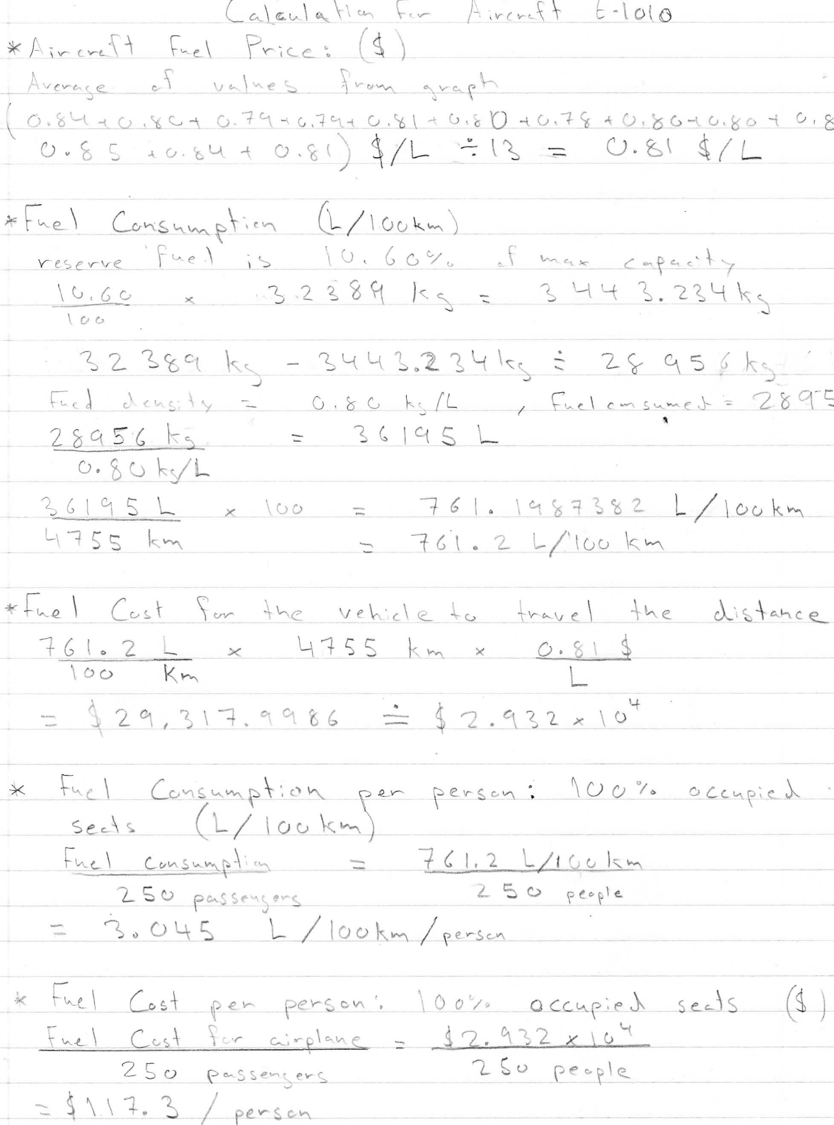

Figure 2: Part 2 Calculation for “BlueSky” model E-1010 airplane
The second part of the methods of calculation used to achieve the results for aircraft E-1010 (Table 3) are provided below


