Laboratory 2 – Servo System Simulation
  - SYSC 3600-A

Saphia Dixon - 100793753
Collin Wilson - 100780988

Contents

1.0 Introduction 1
2.0 Position Feedback Design 1
2.1 System Model 1
2.2 Transfer Function 2
2.3 Comparison 3
2.4 Transfer Response 3
2.5 Final Value Theorum 4
2.6 Experimental 5
3.0 Rate Feedback Design 6
3.1 System Model 6
3.2 Transfer Function 7
3.3 Comparison 7
3.3 Transfer Response 8
3.4 Final Value 8
4.0 Design Comparison 8
4.1 Positional vs Rate Feedback Step Response 8
4.2 Rate Feedback Critical Response 10
5.0 Conclusion 11

Introduction
The purpose of this report is to examine a control system using transfer functions to characterize the system response. The system under examination is a servomechanism as described in the pre-lab documentation. This report will detail the analysis and simulation results for two variants of the servomechanism referred to as the Positional Feedback and the Rate Feedback designs.

Position Feedback Design
The purpose of this subsection is to analyze and simulate the transfer function for the Positional Feedback system.

2.1 System Model
Given a time domain description of the system, the Laplace transform was applied and the system transfer function was described using block notation. Shown below in Figure 1 is the block diagram for the system.
Figure 1 Positional Feedback System (Ref: Lab Material)
The input to the system is the angle phi1 of the input potentiometer. The output from the system is the angle phi2 to the output potentiometer.
Shown on the next page in Figure 2 is the Matlab Simulink block diagram of the Positional Feedback system.
Figure 2 Positional Feedback System Simulink Diagram (Ref: Lab Material)

2.2 Transfer Function
A transfer function in terms of H(s) can be formed to represent the entire system. Inspection of the block diagram from Figure 1 indicates there are two nested feedback systems. We can analyze and simplify the two nested feedback system to derive a single transfer function response.
The first nested feedback system response block is defined from Eo (Figure 1) to Omega. The transfer function for this feedback system is;

H_{INNER}(S) = (1)

The resulting block diagram of the positional feedback system is now simplified to (See Figure 3)

Figure 3 Reduced Positional Feedback System (Ref: Lab Material)
The second feedback system response block is defined from Ei (Figure 1) to phi2. As we can see K1 is a scalar from phi1, therefore the final transfer function for the entire system is;

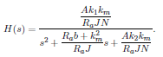
(2)

The transfer response for the system is analytically described by H(s).

2.3 Comparison
To verify that the system model and the transfer function are identical, the systems were simulated and any differences noted. Shown below in Figure 4 is a Matlab Simulink block diagram of each system with a step function input.
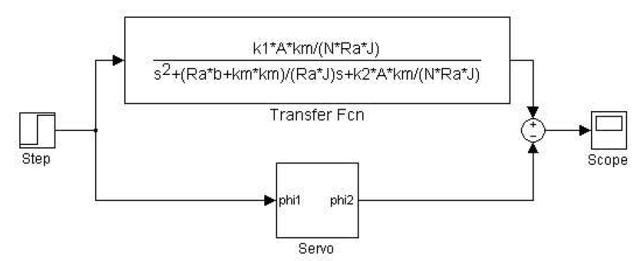
Figure 4 Positional Feedback Comparisons (Ref: Lab Material)
The difference between the Matlab Simulink transfer function and the system IO model are minimal. Errors of approximately 1.5x10⁻¹⁴ were observed. The observed errors were expected due to mantissa truncation for double precision computing in Matlab.

2.4 Transfer Response
The transfer function equation (2) fits the form of the characteristic equation for a second order differential system.
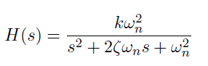
(3)

Using the transfer function we can solve for the undamped natural frequency w_{n}, the static gain k, and the damping ratio ζ:
$w_{n}= \sqrt{\frac{k_{2}AB}{N}}= {\left(\frac{k_{2}Ak_{m}}{NRaJ}\right)}^{\frac{1}{2}}$ (4)
$k=\frac{k_{1}}{k_{2}}$ (5)

$ζ= \frac{Rab+ {k_{m}}^{2}}{2∙{\left(\frac{k_{2}Ak_{m}}{NRaJ}\right)}^{\frac{1}{2}}}$ (6)

2.5 Final Value Theorum
We can calculate the expected final value for $∅_{2}\left(t\right)$using Final Value Theorem for Laplace given the input $∅_{1}\left(t\right)=u(t)$ where $u\left(t\right)$ is the step function.
$∅_{1}\left(t\right)=u\left(t\right) ∴L\{∅_{1}\left(t\right)\}=\frac{1}{s}$ (8)

$FVT= \lim_{t→∞}{s∅_{2} \left(t\right)}$ (9)

$FVT= \lim_{t→∞}{∅_{2} (t)}= \lim_{s→0}{{ s∅}_{2} \left(s\right)}= \lim_{s→0}{s\left[H\left(s\right)\frac{1}{s} \right]}$ (10)

$\lim_{s→0} s({\frac{\frac{k_{1}AB}{N}}{s^{2}+Cs+\frac{k_{2}AB}{N}})\frac{1}{s} = \frac{\frac{k_{1}AB}{N}}{\frac{k_{2}AB}{N}}}$ (11)
Since k₁ = k₂ therefore the FVT = 1. We can expect our system will always approach the DC gain.
Shown below in Table 1.0 is the calculated final value for each of the A gain cases of 4, 17, 35 and 300.
Table 1.0 Gain Final Values.
Case | A | Final value
1 | 4 | 1
2 | 17 | 1
3 | 35 | 1
4 | 300 | 1

The values in Table 1.0 are expected to approach 1 as per the Final Value Theorem.

2.6 Experimental
Using cases provided in the supplied lab documentation and the system equations from (4)(5) and (6), the system response are shown below in Table 2.
Table 2.0 Positional Feedback Cases
Case | A | ζ | w_{n} | W_{d} | Behaviour
1 | 4 | 2.0700 | 0.2472 | 0 + 0.4480i | Damped
2 | 17 | 1.0041 | 0.5096 | 0 + 0.0461i | Damped
3 | 35 | 0.6998 | 0.7312 | 0.5223 | Underdamped
4 | 300 | 0.2390 | 2.1407 | 2.0768 | Underdamped

The positional feedback cases behavior are noted in the table. We see when zeta is greater than 1 we have a damped response. When zeta is less than one, we can expect oscillations in our response.
Shown below in Figure 5 to 8 are the simulated responses for each of the cases. It is important to note the system parameters used to simulate the system are found in Appendix A - System Parameters.
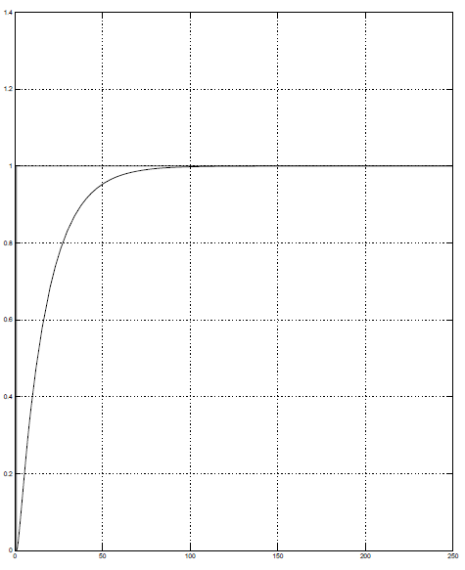
Figure 5 Gain Case A=4 (damped)
In Figure 5, with a low gain (A=4), the system takes almost 100 seconds to stabilize the output. There are no overshoots or oscillations.
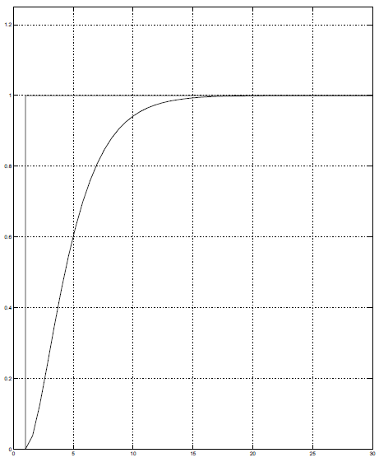
Figure 6 Gain Case A=17 (damped)
In Figure 6, with a low gain (A=17), the system takes almost 30 seconds to stabilize. Here the gain has improved the response of the system. Note there are no overshoots or oscillations.
Figure 7 Gain Case A=35 (Underdamped)
In Figure 7 with a moderate gain (A=35), we see a slight overshoot and the system stabilizes around 13 seconds. Here we see an overshoot which represents undesirable characteristic of the system.
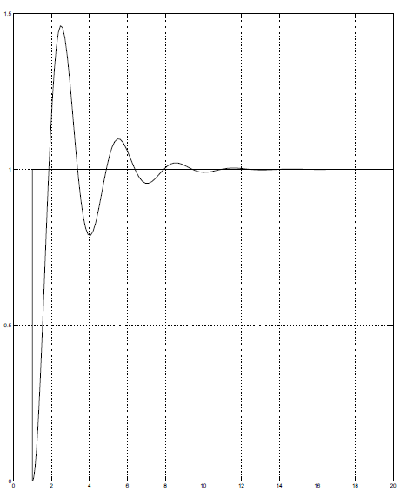
Figure 8 Gain Case A = 300 (Underdampled)
In Figure 8 with a high gain (A=300), we see a large overshoot and the system stabilized around 12 seconds. The rate of change of the system is rapid, but the stabilization of the response is oscillatory and may be undesirable.

Rate Feedback Design
The purpose of this subsection is to analyze and simulate the transfer function for the Rate Feedback system.

3.1 System Model
Modifications to the original system diagram leads to (Figure 9) a new block diagram for the Rate Feedback system.
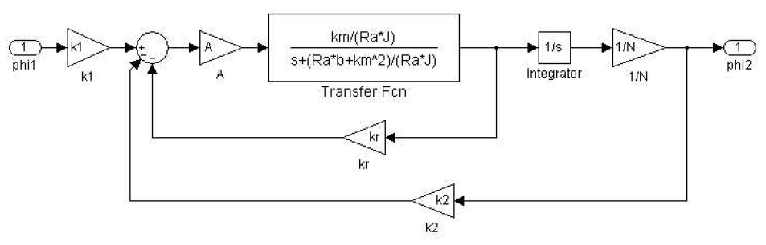
Figure 9 Rate Feedback System (Ref: Lab Material)

3.2 Transfer Function
A transfer function in terms of H(s) can be formed to represent the entire system. Inspection of the block diagram from Figure 9 indicates there are two feedback systems. We can analyze and simplify the two feedback system to derive a single transfer function response.
$H\left(s\right)= \frac{\frac{k_{1}Ak_{m}}{RaJN}}{s^{2}+\left(\frac{Rab{k_{m}}^{2}}{RaJ}+\frac{Ak_{m}k_{r}}{RaJ}\right)s+\frac{k_{2}Ak_{m}}{RaJN}}$ (12)

H(s) represents the final transfer block for the Rate Feedback system.

3.3 Comparison
To verify the system model and the transfer function are identical, the system was simulated and the differences inspected. Shown below in Figure 10 is a Matlab Simulink block diagram of each system and with a step function input.
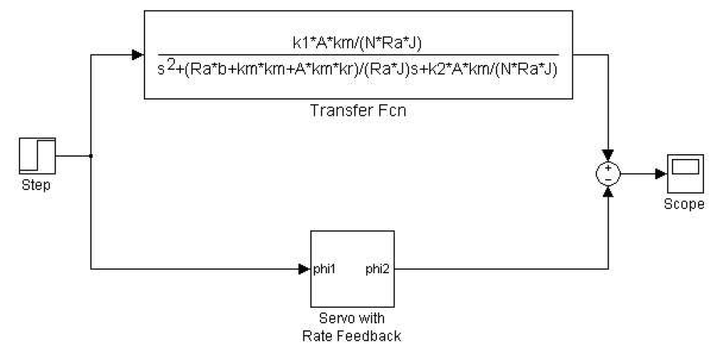
Figure 10 Rate Feedback System Comparison (Ref: Lab Material)
The differences noted were almost zero. (Same reasons as provided Section 2.2)

3.3 Transfer Response
The transfer function (equation 12) fits the form of the characteristic equation for a second order differential system (equation 3).
Using the transfer function we can solve for the undamped natural frequency w_{n}, the static gain k, and the damping ratio ζ. Note the natural frequency (equation 4) and the gain of the system (equation 5) is the same as for the Positional Feedback system, however the damping ratio is;
$ζ= \frac{Rab+ {k_{m}}^{2}+Ak_{m}k_{r}}{2RaJ∙{\left(\frac{k_{2}Ak_{m}}{NRaJ}\right)}^{\frac{1}{2}}}$ (13)

3.4 Final Value
Using the same methodology as per Section 2.4, we see the Final Value Theorem for the system (equation 12) with a step response input can be solved analytically.

$\lim_{s→0} s({\frac{\frac{k_{1}AB}{N}}{s^{2}+(C+k_{r}AB)s+\frac{k_{2}AB}{N}})\frac{1}{s} =\frac{\frac{k_{1}AB}{N}}{\frac{k_{2}AB}{N}}}$ (14)

Since k₁ = k₂ therefore the FVT = 1. We can expect our system will always approach the DC gain.

Design Comparison

4.1 Positional vs Rate Feedback Step Response
Now we will compare the Positional Feedback versus the Rate Feedback system to a step response. Shown below in Figure 11 is a Matlab Simulink Diagram of the test setup.
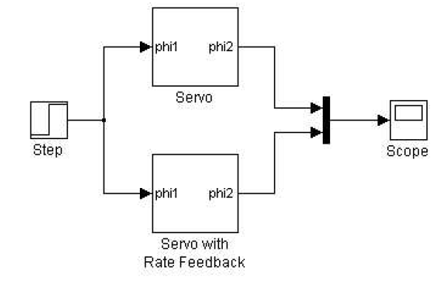
Figure 11 Systems Comparison (Ref: Lab Material)
It is important to note the system parameters used to simulate the system are found in Appendix A System Parameters. Given a high again (A=300) and zeroing the rate feedback (Kr= 0) we see the response of the system in Figure 12.

Figure 12 System Compare (Kr=0)
Note by setting Kr=0, this is the same as removing the rate feedback gain from the system. Thus the Positional Feedback and the Rate Feedback responses are identical. The system stabilizes around 12 seconds with oscillations.
We will now consider two additional cases, then Kr=0.2 and when Kr=4.
Figure 13 System Compare (Kr = 0.2)
In Figure 13 we see with the Rate Feedback gain set to 0.2, we have an underdamped response that stabilizes around 8 seconds. This represents an improvement. However as per the lab guidelines the oscillations are undesirable so the response is not ideal.
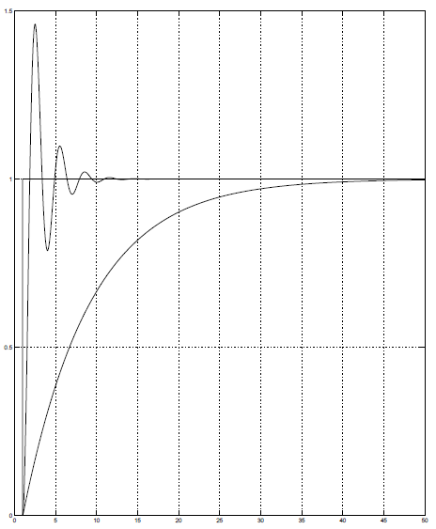
Figure 14 System Compare (Kr=4)
In Figure 14 we see with the Rate Feedback gain set to 4, we have a damped response. As per the lab guidelines this is undesirable as the response of the system is slow (Stable around 26 seconds) and would require the user to wait until the results have stabilized.
The ideal value of Kr would be to solve for the critical response for the system.

4.2 Rate Feedback Critical Response
Using the calculated zeta (equation 13) for the rate feedback system we can compute the critical response by solving for Kr and setting zeta to the critical response (zeta =1).
$k_{r}= \frac{2RaJ∙{\left(\frac{k_{2}Ak_{m}}{NRaJ}\right)}^{\frac{1}{2}}-Rab-{k_{m}}^{2}}{Ak_{m}}$ (5)

Solving equation (5) using the system parameters in Appendix A, Kr = 0.7110.
Simulating the system using parameters from Appendix A and with a high gain (A=300), we get the following response;

Figure 15 Critical Response.
Note in Figure 15 that the Rate Feedback does not oscillate. This is desired as the response for the system changes at a maximum rate and stabilizes around 5 seconds without oscillation.
To verify the value is reasonable, the system was simulated with a Kr 5% lower than critical value of 0.7110. A small overshoot above step response of 1 was observed in the plot.

Conclusion
The purpose of the report was to detail the analysis and simulation results of a servomechanical system. The results indicate that although the positional feedback system produced a desired result, the system oscillations may be undesirable. The rate feedback system represented an improvement to the system where the rate of change was improved, but the oscillations were eliminated.

Appendix A – System Parameters

(Ref: Lab Material)

See Appendix A for system parameter assumptions
See Appendix A for system parameter assumptions

