Chapter 5 -- Curve Sketching:
- vertical and horizontal asymptotes
- Increasing/decreasing intervals
- Concave up or concave down
- Newton's method for critical points and various intercepts
- All of these ideas can be generalized for functions of 2 (planar functions) and even 3 variables

5.1 -- Solving inequalities that involve polynomials (incl. quotients)

- Recall, polynomial of x, is an expression involving x and multiples of its power only (including x^0)
- will help us to graph functions...once solved, we'll be able to find interval in which the graph of a differentiable function has certain properties
- Why polynomials? Because many, many functions can be approximated using polynomials
  - Taylor polynomial approximation (widely used in science, engineering, and pocket calculator)
    - Ex: approximation for y =sinx given by Taylor polynomial of degree 2n-1: (give image)
    - Generally true that larger degree, better approximations for Taylor polynomials and their related series
- First step in solving polynomial inequalities is factoring of polynomial p(x). Since all our polynomials have real coefficients, if can be shown that factors are of exactly two types (and/or):
  - Type 1 (or linear) factor:
    - a1x-a2
  - Type 2 (or quadratic irreducible) factor:
    - ax^2 + bx + c, where b^2 -4ac < 0
Where a1,a2,b,c are real numbers. So, in summary, every polynomial (with real coefficients) can be factored into a product of Type 1 and/or Type 2 factors and their powers
For purpose of solving inequalities we call real points x where p(x)=0 breakpoints (or real roots, or zeroes). Remember, type 2 factors have no breakpoints (no real roots, discriminate is negative)...breakpoints come from type 1 factors only

- The sign decomposition table of a polynomial
  - Allows us to essentially read off the solution of an inequality
  - Know structure and how organized using correct terminology
  - You must first determine size of SDT
    - (r+1) by (s+1) (rows by columns, excluding margin and headers)
      - r = the total number of different breakpoints of p(x)
      - s = (the total number of different breakpoints of p(x)) + (the total number of different type 2 factors of p(x))
  - Know how to fill in
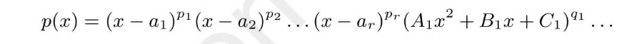
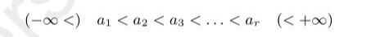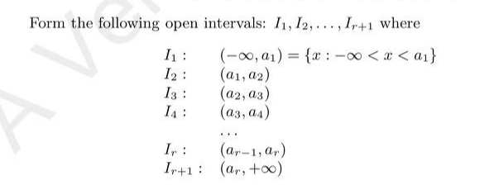

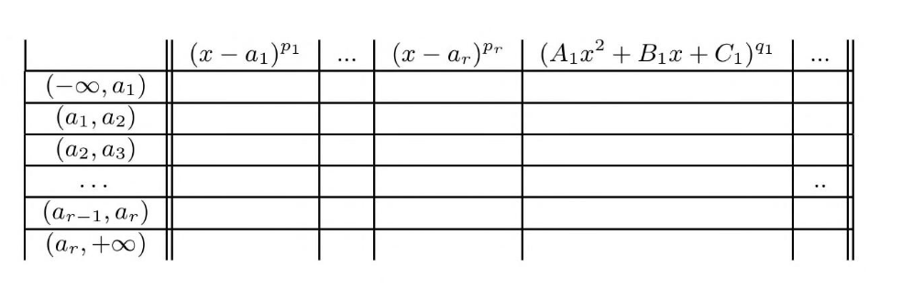
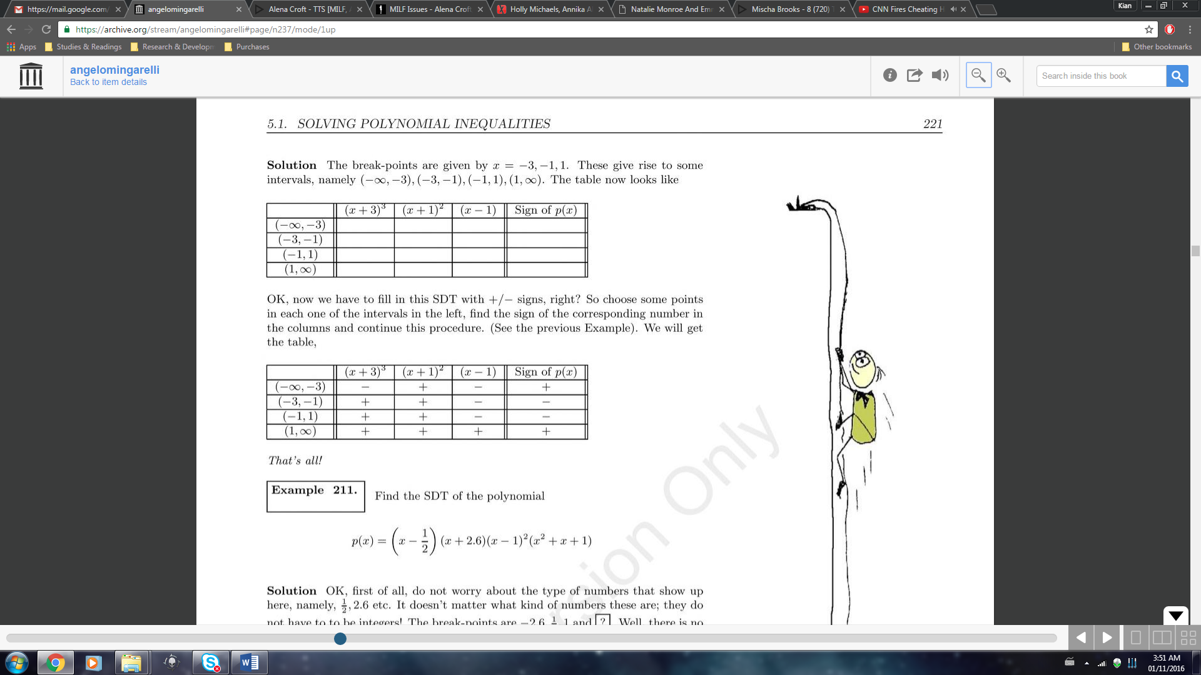
Be careful for leading coefficients…can be negative!
  - How to solve inequalities
    - 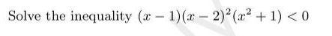… (x-1)(x-2)^2 (x^2+1) < 0 is given by the set of all possible points x inside the interval (-infinity, 1)
    - Two+? The solution is the union of those two+ intervals, that is, the solution of the inequality … is given by the set of all points x where x is either in the interval …, or, in the interval … can be written as ( .,.] U [.,.] U [3,.)
    - 

