

EZ Drive Electric
Vehicle
Direct Current Motor
Report 1 of 5

To Professor
From -
Date of Submission:
CCDP 2100A

TABLE OF CONTEXT

- INTRODUCTION…………………………………………………………………………...1
1.1 Electric Car: Social, Environmental and Economic Context……………………….................1
2.0 TECHNICAL OVERVIEW……………………………………………………………....…2
2.1 The Electric Car…………………………………………………………………………...…..2
2.2 Group Component……………………………………………………………………..………3
2.3 Individual Subtopic: Internal Combustion Engine……………………………………………5
2.3.1 Combustion………………………………………………………………………….5
2.3.2 Biogeochemical Cycle………………………………………………………………8
3.0 CONCLUSION…………………………………………………………………………..…12
GLOSSARY OF TECHNICAL TERMS…………………………………………………..…13
REFERENCES............................................................................................................................14

1.0 INTRODUCTION
This design report is being submitted to the course professor, Dr. Marlene Lundy, for the CCDP 2100A requirements. The purpose of this assignment is to explore a more affordable way of transportation that will ultimately be better for the environment. The EZ Drive team is proposing the electric car as a solution to vehicles creating greater than half the carbon monoxide, nitrogen oxide and a quarter of hydrocarbons released into the air per year [1].
This report will be focusing on the subtopic of the traditional internal combustion engine (ICE) and its downside compared to the electrically propelled engine. Throughout the report, two questions related to the subtopic will be answered using specific engineering principles to help explain and answer the questions in full detail. The following section will explain the context of the electric car and explain its economic and environmental impact. The Technical Overview will then describe what the electric car is, how the electric car will work, provides the EZ Drive’s group component and the answering of the individual research questions that correlate to the subtopic ICE engine. The conclusion will close with a summary of the findings and explanations described throughout the report. The key terms used in the following sections will be located in the Glossary to provide a more thorough understanding.
1.1 Electric Car: Social, Environmental and Economic Context
An electric car is a mode of transportation that is very safe for the environment and a great way to save money. These motors are powered by rechargeable battery packs which take between 4 to 8 hours to charge fully or 30 minutes to charge to 80% by quick charging if the car offers this feature. Although the charging time may be longer compared to fueling a traditional car engine, the cost to charge the electric car is much cheaper than purchasing the fuel. Electric cars also do not have to pay for as much for maintenance as a traditional (ICE) engine. Since the motor is fully electric, it means that oil and filter changes will not apply [2]. Another great attribute of the electric car is its environmental benefits because it does not emit any tailpipe pollutants. The efficiency of an electric car is also far greater than that of an ICE because it only coverts 17%-21% into electrical energy, while an electric car converts 59%-62% [3].
2.0 TECHNICAL OVERVIEW
The following section will provide an overview of the electric car that the EZ Drive team has specialized in. It will contain the subtopics each member from the group specialized in as well as an individual component explaining the Internal combustion engine relative to the electric car engine.
2.1 The Electric Car
An electric car is a type of vehicle that is made up of an electric battery for energy storage, an electric motor and a controller as shown in figure 1. The battery is charged either through a plug from a home or a charging station made specifically for electric vehicles [4]. These batteries can be made up of Lithium Ion, Nickel Metal Hydride, Lead Acid or Ultracapacitors all having their strengths and weaknesses [5]. The battery energy is transferred to the controller using connecting cables. The controller measure how much the pedal is compressed and supplies the electric engine with the correct amount of power needed. This type of controller is typically known as a two-quadrant controller for forwards and backwards. Some more expensive electric vehicles use regenerative breaking which utilize the kinetic energy and return power back to the battery. If the electric vehicle uses regenerative breaking the controller is known as a 4-quadrant controller for collecting energy while forward and while backwards. The power that is then collected by the engine from the controller is then sent to the transmission to turn the wheels on the car [4].

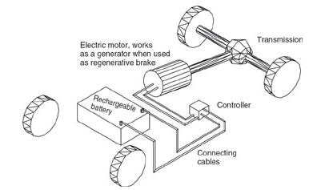
Figure 1: Electric Car Base [4]

The rest of section 2 will show each members’ subtopics along with their questions and engineering principles. It will then move into the individual subtopic of the internal combustion engine in which this design report will be focusing on.
2.2 Group Component
It is important to look at each component of the electric car to get a full understanding of how the miraculous piece of technology works. Power storage, energy transfer, power regeneration and aerodynamics are all key components that make the electric car what it is today. After looking at these components it is then important to see how it compares to the internal combustion engine. Table 1 shows a chart that breaks down what each member in the EZ Drive group specialized in, questions that relate to their subtopics and the engineering principles that apply to each.
Table 1: Electric Car: Team EZ Drive Subtopic

Name and Subtopic | Relevance | Research Questions (2) | Engineering Principles
Seth Klein - Internal Combustion Engine (ICE) | More people are driving than ever before and that means more pollution. There are too many downsides to the ICE engine for it to be the most effective engine. | How does the internal combustion engine work?  How much does the internal combustion engine pollute? | Combustion  Biogeochemical cycle
Neal Wallisch - Motors | The motor transfers electrical energy into kinetic energy propelling the vehicle forward. | How is the electrical energy transferred into kinetic energy?  What is the relationship between the power put into the system and what is outputted? | Relationship between current and torque.  Efficiency
Keegan Gauthier - Batteries | The battery stores the electricity necessary to power the vehicle. The vehicle relies solely on stored electricity for power, therefore eliminating the need for fossil fuel use with that vehicle. | How does the battery supply power to the vehicle  What is the range of a fully charged battery? | Alternating to Direct Current  Work-Energy theorem
Jake Anderson -  Regenerative  Braking | Higher efficiency. The car will effectively self charge and allow for longer trips. | How does the velocity of a vehicle affect the regenerative braking process?  How does the motor transform kinetic energy into electricity used to charge the battery? | Kinetic Energy  Faraday’s Law
Zachery Barber - Aerodynamics | High Speed Efficiency. This is relevant because by reducing the amount of work the motor does the further the car will travel. Applying active aerodynamic features and using specific materials will help achieve this. | How can active aerodynamic innovations be used to increase efficiency?  What material would be best suited for manufacturing this car? | Downforce  Density

2.3 Individual Subtopic:
The subtopic that is being focused on is the internal combustion engine. It is important to look at the internal combustion engine so it is easy to find the downsides compared to an electric engine. It is also important to look at the internal combustion because of its major differences to the electric engine. It is easier to understand how the engine works with electricity if the knowledge about the internal combustion engine is known. The two research questions are:
- How does the internal combustion engine work?
- How does the internal combustion engine pollute?
The engineering principles that help answer these questions are combustion and the biogeochemical cycle. The principles will be explained and applied in the next two sections below.
2.3.1 Combustion
Combustion is a chemical process in which oxygen and fuel react together to create a micro explosion that gives off heat and a byproduct of exhaust as shown in figure 2. The gasoline that is put into the car is called the fuel and the oxygen would be the oxidizer. While the combustion process occurs, a new substance is made. This substance is called exhaust which was produced by the reaction that happened between the oxidizer and the fuel. The fuel used in the engine is made up of small hydrocarbons that are then burned to produce exhaust made of hydrogen and oxygen, as well as, carbon and oxygen (Carbon Dioxide).
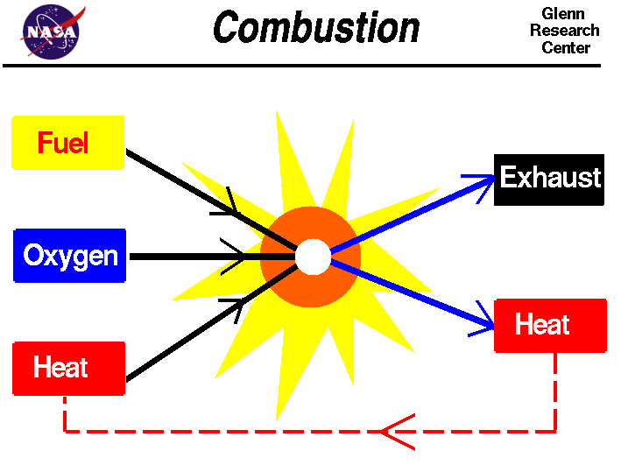
Figure 2: Combustion Process [6]
Although fuel and oxygen are stored together in a gasoline tank, for combustion to occur, heat must be added. In figure 3, the spark plug is the part of the engine that adds heat to start the reaction [6]. There are 2 main types of combustion engines 4 stroke and 2 stroke. Since cars are being talked about in this report, the 4-stroke engine is being focused on, as the 2-stroke engine is used in smaller engine machines. The four-stroke engine is broken into 4 main components: intake, compression, combustion and power stroke, and exhaust. The 4-stroke ICE engine is made up of a fixed cylinder with a vertically moving piston. The air and fuel mixture enters through the intake valve where it is then compressed by the crankshaft and ignited by the spark plug found in Figure 3. When the micro explosion happens due to combustion, the expanding gases push on the piston causing the crankshaft to rotate. The car then moves forward powered by an arrangement of gears located in the Powertrain. When giving the car a large amount of gas, it causes the crankshaft to increase its number of rotations which bares the term revolutions per minute (RPM) shown by the Tachometer.
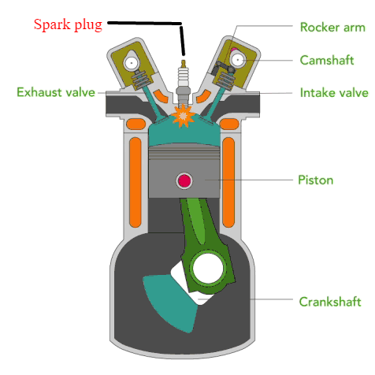
Figure 2: Mod. Internal Combustion Engine [2]
Another type of combustion engine is the compression ignition diesel engine. This engine is different from the original spark ignition gasoline engine because of the way the fuel is ignited to start the combustion process. Inside a spark ignition engine, the intake valve brings in a mix of air and fuel, which is then ignited by the spark plug to start the combustion. After the combustion occurs, the heat an exhaust push down on the piston to turn the crankshaft. In a dedicated diesel engine, air is the only thing brought in through the intake valve and the engine then supplies the hot compressed air with the fuel to cause the ignition. In Figure 4, it shows the 2 engines side by side to illustrate the difference between the 2 engines [7].
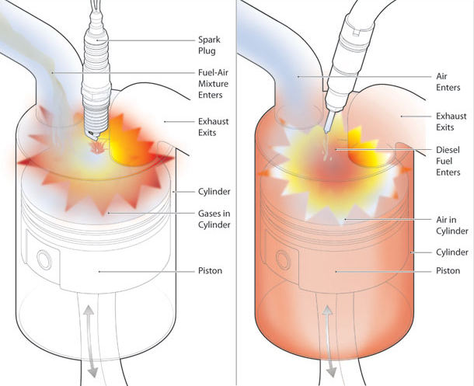
Diesel Engine
Spark Ignition
Figure 4: Mod. Spark Ignition vs Diesel Engine [8]
2.3.2 Biogeochemical Cycle
The biogeochemical cycle is the pathway that a chemical will take through the different components of the earth [9, p. 58]. These components are broken down into biotic and abiotic. Biotic is described as living things like the plants, animals, people. Abiotic is described as non-living things like the chemicals and non-living environment in which we live in [10, p. 89]. In this case, the chemical that is being dealt with is carbon dioxide. Referring to figure 3, after the combustion process occurs, the exhaust is released through the exhaust valve and released into the environment. As explained in the first principle explanation, the exhaust coming from the ICE engine is made up of hydrogen and oxygen, carbon dioxide, hydrocarbons, and a small bit nitrogen oxide. These substances are then released through the tailpipe into the environment. In Figure 5, the exhaust and other fossil fuels are released into the atmosphere and becomes a Greenhouse gas.

A Greenhouse gas is a type of gas that allows sunlight to enter the atmosphere. When the sun shines onto the earth, the sunlight is reflected off the surface and back towards space called infrared radiation. The Greenhouse gases consume the infrared radiation and keeps the heat trapped in our atmosphere [11]. Figure 5 below shows the largest Greenhouse gas contributors in the United States, as well as, where the pollutants are coming from. As you can see, carbon dioxide is the main Greenhouse gas emitted into the atmosphere, while, transportation is the second largest contributor.
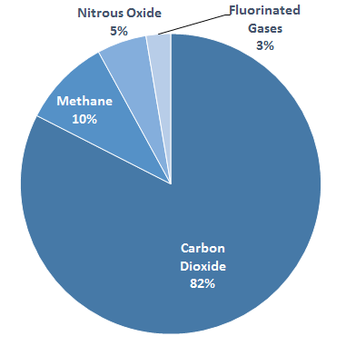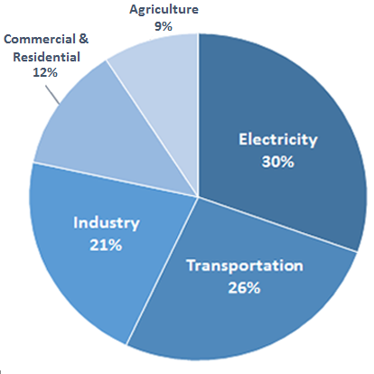
Figure 5: Emission Statistics [12]
To fully understand how carbon dioxide effects the environment, the carbon dioxide biogeochemical cycle must be looked at. As the plants absorb large amount of C0₂ (caused by pollution) through assimilation, it removes the natural cooling effects the plants have on the environment causing the earth to heat up. As the plants and animals die through organic decomposition the fossil fuels are then returned to the and the process repeats.

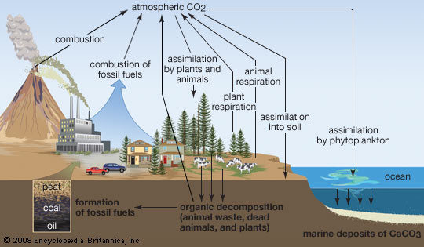
Figure 6: Carbon Cycle [13]
In the Figure 6 it shows that the carbon dioxide levels are the highest they have ever been sitting at around 400 parts per million (ppm). This is due to the overwhelming effect that the automotive industry has on the environment and the atmosphere. Cars and trucks in the United States using internal combustion engines account for over one-fifth of the total global warming pollution alone [14].

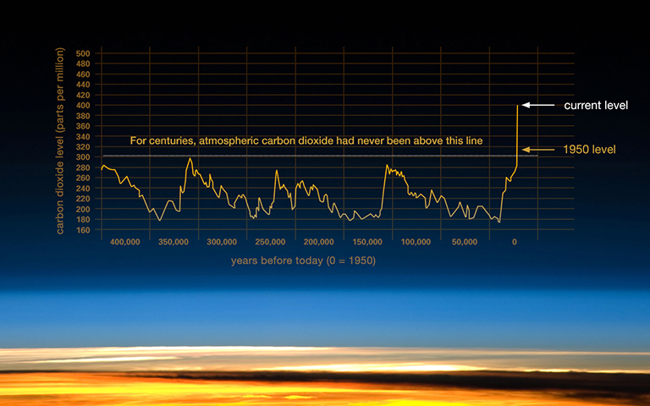
Figure 7: Carbon Dioxide Levels [14]
3.0 CONCLUSION
The Electric car proposed by the EZ Drive team is a technological advancement that will ultimately better society and makes the earth a much cleaner and safer place to live. An electric car makes owning a car more affordable and eliminates carbon dioxide, nitrous oxide, and many dangerous hydrocarbons out of the environment. It was important to study how the ICE engine worked and polluted to show many of the downsides that people might not be aware of. With the increasing amount of C0₂ in the atmosphere today, the electric car is not only the vehicle of the future but also the solution to it.

GLOSSARY

Pollutant – A substance that is released into the environment causing harmful effects.
Ultracapacitor – Used to store electricity and has a very large energy density. Very fast for charging and can support millions of charges without having to be replaced therefore, making it very effective in hybrid and electric cars [15]
Oxidizer – A chemical that reacts with fuel to create a burning.
Hydrocarbons – A chemical compounds that are made up of hydrogen and carbon atoms that originate from crude oil [16].
Fossil Fuels – An energy source formed from the decomposition of living organisms over many years. This produces coal, oil, and natural gas.
Infrared radiation – Very close to the microwave region of the magnetic spectrum. Invisible rays of light that is between red and violet on the light spectrum. This type of light is that is felt with nerves and can be associated with heat from the sun, fire, or any other type of heat that is felt [17].

REFERENCES

[1] U.S Department of Energy, "All-Electric Vehicles", Fueleconomy.gov, 2016. [Online]. Available: https://fueleconomy.gov/feg/evtech.shtml. [Accessed: 07- Dec- 2016].
[2] J. Hirsch, "The pros and cons of electric cars and plug-in hybrids", Global-factiva-com., 2011. [Online]. Available: https://global-factiva-com.proxy.library.carleton.ca/ga/default.aspx. [Accessed: 07- Dec- 2016].
[3] Union of Concerned Scientists, "Cars, Trucks, and Air Pollution", Union of Concerned Scientists, 2016. [Online]. Available: http://www.ucsusa.org/clean-vehicles/vehicles-air-pollution-and-human-health/cars-trucks-air-pollution#.WDnGiPkrKUm. [Accessed: 07- Dec- 2016].
[4] Larminie and J. Lowry, Electric vehicle technology explained, 2nd ed. Hoboken: John Wiley & Sons, 2012.
[5] U.S Department of Energy, "Alternative Fuels Data Center: Batteries for Hybrid and Plug-In Electric Vehicles", Afdc.energy.gov, 2016. [Online]. Available: http://www.afdc.energy.gov/vehicles/electric_batteries.html. [Accessed: 07- Dec- 2016].
[6] National Aeronautics and Space Association, "Combustion", Grc.nasa.gov, 2016. [Online]. Available: https://www.grc.nasa.gov/www/k-12/airplane/combst1.html. [Accessed: 07- Dec- 2016].
[7] Office of Energy Efficiency & Renewable Energy, "Internal Combustion Engine Basics", Energy.gov, 2016. [Online]. Available: http://www.energy.gov/eere/energybasics/articles/internal-combustion-engine-basics. [Accessed: 07- Dec- 2016].
[8] Carmudi Philippines Journal, "Diesel Vs. Gas Engine", Carmudi.com.ph, 2016. [Online]. Available: https://www.carmudi.com.ph/journal/wp-content/uploads/2015/01/DieselVSGas3b.jpg. [Accessed: 07- Dec- 2016].
[9] E. Martin and R. Hine, A dictionary of biology, 7th ed. Oxford: Oxford University Press, 2015, p. 58.
[10] S. Mayhew and S. Mayhew, A dictionary of geography, 5th ed. Oxford [England]: Oxford University Press, 2015, p. 89.
[11] EIA Brochures, "Greenhouse Gases, Climate Change, and Energy", Eia.gov, 2016. [Online]. Available: http://www.eia.gov/oiaf/1605/ggccebro/chapter1.html. [Accessed: 07- Dec- 2016].
[12] United States Environmental Protection Agency, "U.S. Greenhouse Gas Inventory Report: 1990-2014 | Greenhouse Gas (GHG) Emissions | US EPA", Epa.gov, 2016. [Online]. Available: https://www.epa.gov/ghgemissions/us-greenhouse-gas-inventory-report-1990-2014. [Accessed: 07- Dec- 2016].
[13] Distributed Active Achievement Center For Biochemical Dynamics, "ORNL DAAC for Biogeochemical Dynamics", Daac.ornl.gov, 2016. [Online]. Available: http://daac.ornl.gov/. [Accessed: 07- Dec- 2016].
[14] National Aeronautics and Space Association, "The Relentless Rise of Carbon Dioxide", Climate.nasa.gov, 2016. [Online]. Available: http://climate.nasa.gov/climate_resources/24/. [Accessed: 07- Dec- 2016].
[15] PC Magazine, "ultracapacitor Definition from PC Magazine Encyclopedia", Pcmag.com, 2016. [Online]. Available: http://www.pcmag.com/encyclopedia/term/58224/ultracapacitor. [Accessed: 07- Dec- 2016].
[16] United States Environmental Protection Agency, "What are Total Petroleum Hydrocarbons (TPH)? | Urban Environmental Program in New England | US EPA", Www3.epa.gov, 2016. [Online]. Available: https://www3.epa.gov/region1/eco/uep/tph.html. [Accessed: 07- Dec- 2016].
[17] National Aeronautics and Space Association, "Infrared Waves - Mission:Science", Missionscience.nasa.gov, 2016. [Online]. Available: http://missionscience.nasa.gov/ems/07_infraredwaves.html. [Accessed: 07- Dec- 2016].

