X`

HW4 General Mills Valuation
Name: Cedric Kim
Course: RSM429
Instructor: Matthew Bamber
Date: November 2, 2016
Word Count: 1934

General Mills is a global consumer foods company with numerous products including snacks, frozen meals, yogurt & dairy and beverages. This report will examine and forecast its core business drivers to value the firms using abnormal earnings and discounted earnings method.
Sales & Growth Value (Exhibit 1.)
A significant challenge lies in its Sales & Growth. Primarily driven by changing consumer demand and a highly competitive environment, General Mills has seen its revenues decline by 9, 3, and 11% respectively in the past 3 years. Revenues are driven by its core product segments- Meals, Snacks and Cereal.
In the base scenario, we forecast an overall growth of 1.57% in the first 3 years with a decline to 1.12% and 1% thereafter. While there are material headwinds in changing consumer demand (away from meals & snacks- sugary/high calorie/fat to healthier, natural & organic options), this reversal back to growth is driven by various factors including the EPIC acquisition, (natural & organic processed foods) recent R&D efforts and growth in GM’s Yogurt & dairy segment. We forecast Meals & Snacks to continue to nominally fall due to consumer substitution while GM’s impressive Cereal product line (Cheerios, Lucky Charms, Cinnamon Toast Crunch) will continue to attract consumers.
Optimistic Scenario builds on the base case forecasts while assuming further sales drivers from emerging markets in Asia & Latin America. Overall, Optimistic Scenario forecasts an increase in 4.33% per year and 3.24% thereafter. In this case, we forecast favorable reception in China & Brail to established cereal and food brands. In addition, this case also assumes consumer shift in attitude away from GM’s sugary high calorie cash cow snack brands will be delayed and limited.
In the Pessimistic Sales case, not only will consumers taste diverge away from our products but convenience store sales will be greatly affected by numerous external influences. These adverse factors include online grocery services (amazon groceries, Walmart deliveries, various small delivery services) and increased store presence in rural areas. In this case, consumers receive greater utility through online orders and the “convenience” of convenience stores fall out of favor. Finally, this case forecasts relatively flat cereal sales at -0.3%- -1% decreases.
Operating Expenses (Exhibit 9.)
In the cases forecasted, operating expenses addresses various dimensions of its GM’s cost structure. These include sales & marketing costs, possibility of rising labour costs and the effectiveness of GM’s productivity programs.
In the base scenario, Project Century and Project HMM (Holistic Margin Management) will provide modest supply chain efficiencies thereby improving cost of sales by under 1%. We believe GM’s current track record of 2 successful years in cost improvement programs is indicative of competence in providing additional future cost opportunities. Furthermore, this scenario forecasts marginal benefits from project catalyst- a sales & marketing cost cutting program implemented the previous year. Finally, this case projects various divestitures, acquisitions and impairment charges using historical experience and spread uniformly at $50 in annual expenditures. Overall these efforts forecasted projects a decline in 1.5% in Operating expenses over an 8 year period.
In the Optimistic scenario, favorable terms of the base case is repeated with additional 1% savings in each program. In addition, productivity gains and savings in overhead are effective in longer duration. In addition, Project Compass is forecasted to enhance international supply chain management & overhead costs. As a consequence, gross margins and operating margins are higher in China, Brazil and India segments. In short, the optimistic case adds 1.5% incremental savings to the base case from a variety of outlined forecasts, leading to an overall cost savings of 3.2% over a 10 year period.
In the Pessimistic Scenario, Project Catalyst not only is less effective and delayed, but is forecasted to cause additional one time investment to initiate the project. In addition, Project Compass and HMM fail to materialize in cost savings. These inefficiencies translate to a forecasted 1% increase in Sales & Marketing costs. In addition, rising labour costs are forecasted and cause 1.2% additional corrosion in Cost of Sales. In totality, these movements effectively increase operating costs by 2% over the base scenario.
Tax & Interest Rates
Tax and Interest Rates remain largely constant throughout the scenarios forecasted- at 33% and running 3 year averages respectively- based on historical effective rates. However, in the pessimistic case, we forecast changes in policies increasing tax rates by an additional 2%.
Cost of Equity
The primary model used to derive cost of equity was the Capital Asset Pricing Model along with data extracted from respected third party sources. The risk free rate was sourced from the current 10 year Treasury bill. It is evident that these securities represent a riskless investment (backed by the US government) while the term of the bill is pertinent to the valuation period (around 13-15 year). The Market Premium was found by the difference in this bill and SP500’s return in the past 3 years. Finally the consumer food industry Beta was taken from New York University Stern Finance Data (appendix). The consumer foods beta at 0.73 is in alignment and justified with the products and business model of this industry. While there are relatively inelastic products such as staple foods, (bread, rice, cereal & baking products) other products such as snacks, candy and processed foods are swayed by market forces and ever-changing consumer behavior. This methodology provides a cost of equity of 6.8%. This is a sensible in comparison to its competitors (Heinz, Kraft, and Nestle) as well as the industry as a whole.
Company | Ke
Kraft | 6.20%
Heinz | 7.70%
Nestle | 5.95%
General Mills | 6.80%

Abnormal Model
Based on the outlined forecasts and derivation of cost of equity, the base Abnormal Earnings model values GM’s shares at $56, 5 dollars less than its current price. The expected return was derived as cost of equity multiplied by the book value of equity. Intuitively, this is the amount required by the investors during a given period. As a result, the excess amount of net income over the expected return (normal earnings) was identified as abnormal earnings. These earnings in aggregate along with the terminal value was discounted to present value to obtain the value of the firm. The terminal value in this case consisted of a net income derived from 1% growth in sales and flat operating expenses from 2021 outlined in the forecast assumptions mentioned. This terminal value is justified given its track record and the various modest benefits from investments we are forecasting. What this valuation of $56 expresses is not only the required abnormal earnings but the expectation of the market is closely aligned with these current forecasts. (Similarly priced at $61 a share).
Optimistic scenario yields a valuation of $69, -$8 greater than its current market price. Combined benefits of both sales and productivity gains boost GM’s net earnings by almost 20% over the base scenario in an 8 year growth period. Terminal value was determined by building on the forecasts of the base scenario mentioned with incremental savings benefits in Project Compass & Cataylst – (1% less in Cost of Sales).
What is intriguing is the large variation of the pessimistic valuation. Valued at $16, its discrepancy to the current price is the largest in the models or other scenarios. This is driven by compounding of adverse factors included in the forecast. Not only are sales projected to decrease overall by 2% over 5 years and -1% terminal decline but marginal increases in operating expenses and tax rates corrode into earnings- providing minimal excess income over normal earnings.
Valuations
 | Pessimistic | Base | Optimistic
A/E Method | $ 15.6 | $ 56.5 | $ 68.6
DE Method | $ 35.6 | $ 58.7 | $ 80.4
Current Price | $ 61.4

Weighted Average Cost of Capital
The Weighted Average Cost of Capital (WACC) was utilized to discount cash flows. This methodology assumes the existing capital structure of General Mills to obtain financing and similar to the abnormal earnings method, cost of equity was derived from the Capital Asset pricing Model. However, the beta in this case (obtained from Stern Finance) was unlevered and readjusted to reflect General Mill’s Debt to Equity ratios- providing a significantly more accurate discount rate. Sourced from the balance sheet and Morningstar bong yields of GM, debt was also taken into consideration and adjusted for after tax costs. As a result, this adjustment was reflected in the cost of equity and WACC was computed to be at 5.96%. This figure represents a variation from the discount rate used in the abnormal earnings model. This is attributed to the fact that WACC takes into account debt financing- at 5.1% yields.

Item | Rate | Calculation/Source
Equity % | 84% | Balance Sheet
Debt % | 16% | Balance Sheet
Tax Rate | 33% | Running 3 year Tax Rate
Industry Unlevered B | 0.60 | Stern Finance Data
Equity Beta | 0.68 | Ubeta*(1+(1-t)D/E)
Ke | 6.45% | CAPM
10 yr treasury | 1.81% | Risk Free Rate
Kd | 5.10% | Bond Yield- Morningstar
risk premium | 6.84% | SP500 (3 yrs) - rf
WACC | 5.96%

Discounted Earnings Model, Valuation differences
Similar to the abnormal earnings model, the forecasts outlined in various cases were implemented and hence determined earnings in this model. However, this is simply discounted back by the calculated weighted average cost of capital in contrast to calculating excess earnings.
At base scenario, the intrinsic value per share was determined at $59, similar to that of the abnormal model and the current price. This valuation reflects similar market sentiment and forecasts as our base case. What is intriguing is the stark difference in valuation between abnormal and discounted earnings model in pessimistic and optimistic scenarios, with a greater variance in the pessimistic projection. These differences, as highlighted in the table below are not only due to the difference in discount rate calculations but the methodology of valuation itself. Broadly, the AE (Abnormal Earnings) model is more conservative in its valuation due to the excess income required to make incremental impact-resulting in valuation in scenarios are lower for AE. When our pessimistic scenario adjusts greater headwinds (higher COGS, operating expenses), the effect is compounded as excess earnings remains very limited. As a result, these differences are reflected in the large difference of $20 per share between AE and the Discounted Earnings Model. In contrast, the optimistic scenario yields valuations of 69 and 80 respectively, illustrating the conservative nature of the AE model.
Sensitivity Analysis, Risk Factors
In the developed models, there are significant forecast assumptions in the business models revenue and cost structure that have significant impacts on intrinsic valuation. Utilizing the base scenario as our starting point, percentage fluctuations in revenue and operating impacts have a substantial impact on share price as illustrated in the table below. The value in this analysis is its effectiveness as a tool for assessing the impact of current cost cutting initiatives such as project catalyst, compass and HMM embedded in our forecast. In addition, we can address risks of underperformance in growth, productivity improvements and external forces such as rise in taxes or labour wage increases can be measured. What is evident are less absolute impacts on the AE model- explained by its methodology and conservative valuation method (excess income). Based on the analysis, the most apparent risk factors lie in the business’s growth followed by tax rate fluctuations and Cost of Goods sold. Due to our assumptions that we cannot influence external forces such as taxes, it is evident that the success or failure of the firm will lie in executing cost savings and driving growth in its product through marketing, acquisitions or R&D in natural/organic products.
Impact on Share Price | Abnormal Earnings Model | Discounted Earnings Model
1% + Revenue | +3.2 | +4.2
1% - Revenue | -2.1 | -1.9
1% + in COGS | -1.5 | -1.2
1% - in COGS | +1.7 | +1.5
1% + in SG&A | -1.4 | -1.1
1% - in SG&A | +1.6 | +2.1
1% + in Tax Rate | -2.6 | -3.1
1% - in Tax Rate | +3.0 | +3.7

Recommendation- SELL
In our examination of this firm, we have considered many internal and external variables relevant to its business model. These variables were used to create a detailed segmented bottoms up forecast of different possible scenarios. Using these assessments GM was valued using discounted earnings model as well as an abnormal earnings model. The evaluation undertaken illustrate a clear large downside risk illustrated in pessimistic and base case scenarios. Driven by productivity risks, consumer demand headwinds and rising costs, models indicate intrinsic values from $36-59. What is further concerning is the growth and benefits required to not only offset these risks but to increase its intrinsic value beyond its trading price. With our optimistic assumptions forecasting growth rates of 4.33% and success of operational efficiency initiatives only translating to $70 per share, it is apparent that investors are ultimately paying a small premium for few prospects.

Appendix
Segmented Revenue Growth Model
Base Case Growth Exhibit 1.
 | Base Case Growth
 | Sales ($USDM) | 2012 | 2013 | 2014 | 2015 | 2016 | 2017 | 2018 | 2019 | 2020 | 2021
US Retail
 | Meals | 2,944.3 | 3,030.6 | 2,772.4 | 2,674.3 | 2,393.3 | 2,441.2 | 2,490.0 | 2,539.8 | 2,590.6 | 2,642.4
 | Cereal | 2,345.4 | 2,340.8 | 2,410.2 | 2,330.1 | 2,312.8 | 2,359.1 | 2,406.2 | 2,454.4 | 2,503.4 | 2,553.5
 | Snacks | 1,823.8 | 1,717.2 | 1,997.8 | 2,134.4 | 2,094.3 | 2,094.3 | 2,094.3 | 2,094.3 | 2,073.4 | 2,052.6
 | Baking Products | 1,831.7 | 1,845.7 | 2,096.1 | 1,969.8 | 1,903.4 | 1,922.4 | 1,941.7 | 1,961.1 | 1,980.7 | 2,000.5
 | Yogurt and Other | 1,659.7 | 1,680.6 | 1,328.4 | 1,398.4 | 1,302.7 | 1,341.8 | 1,382.0 | 1,423.5 | 1,466.2 | 1,510.2
International
 | Europe | 1,988.5 | 2,214.6 | 2,188.8 | 2,126.5 | 1,998.0 | 1,998.0 | 1,998.0 | 1,978.0 | 1,958.2 | 1,938.7
 | Canada | 990.0 | 1,210.5 | 1,195.3 | 1,105.1 | 929.5 | 948.1 | 967.1 | 986.4 | 1,006.1 | 1,026.2
 | Asia/Pacific | 810.1 | 899.1 | 981.8 | 1,023.5 | 995.7 | 1,035.5 | 1,076.9 | 1,120.0 | 1,164.8 | 1,211.4
 | Latin America | 404.8 | 876.0 | 1,020.0 | 873.1 | 709.0 | 737.4 | 766.9 | 797.5 | 829.4 | 862.6
Convenience Stores & Foodservice |  | 1,783.4 | 1,959.0 | 1,918.8 | 1,995.1 | 1,923.8 | 1,943.0 | 1,962.5 | 1,982.1 | 1,952.4 | 1,923.1
 | Total | 16,581.7 | 17,774.1 | 17,909.6 | 17,630.3 | 16,562.5 | 16,820.8 | 17,085.5 | 17,337.1 | 17,525.3 | 17,721.2
Base Case Growth %
US Retail
 | Meals |  | 3% | -9% | -4% | -11% | 2% | 2% | 2% | 2% | 2%
 | Cereal |  | 0% | 3% | -3% | -1% | 2% | 2% | 2% | 2% | 2%
 | Snacks |  | -6% | 16% | 7% | -2% | 0% | 0% | 0% | -1% | -1%
 | Baking Products |  | 1% | 14% | -6% | -3% | 1% | 1% | 1% | 1% | 1%
 | Yogurt and Other |  | 1% | -21% | 5% | -7% | 3% | 3% | 3% | 3% | 3%
International
 | Europe |  | 11% | -1% | -3% | -6% | 0% | 0% | -1% | -1% | -1%
 | Canada |  | 22% | -1% | -8% | -16% | 2% | 2% | 2% | 2% | 2%
 | Asia/Pacific |  | 11% | 9% | 4% | -3% | 4% | 4% | 4% | 4% | 4%
 | Latin America |  | 116% | 16% | -14% | -19% | 4% | 4% | 4% | 4% | 4%
Convenience Stores & Foodservice |  |  | 10% | -2% | 4% | -4% | 1% | 1% | 1% | -2% | -2%
 | Overall |  | 7% | 1% | -2% | -6% | 1.56% | 1.57% | 1.47% | 1.09% | 1.12%

Optimistic Case Growth Exhibit 2.
Optimistic Growth |  | 2012 | 2013 | 2014 | 2015 | 2016 | 2017 | 2018 | 2019 | 2020 | 2021
US Retail
 | Meals | 2944.3 | 3030.6 | 2772.4 | 2674.3 | 2393.3 | 2465.1 | 2539.1 | 2615.2 | 2693.7 | 2774.5
 | Cereal | 2345.4 | 2340.8 | 2410.2 | 2330.1 | 2312.8 | 2451.6 | 2598.7 | 2754.6 | 2864.8 | 2979.4
 | Snacks | 1823.8 | 1717.2 | 1997.8 | 2134.4 | 2094.3 | 2157.1 | 2221.8 | 2288.5 | 2357.2 | 2427.9
 | Baking Products | 1831.7 | 1845.7 | 2096.1 | 1969.8 | 1903.4 | 1941.5 | 1980.3 | 2019.9 | 2060.3 | 2101.5
 | Yogurt and Other | 1659.7 | 1680.6 | 1328.4 | 1398.4 | 1302.7 | 1380.9 | 1463.7 | 1551.5 | 1613.6 | 1678.1
International
 | Europe | 1988.5 | 2214.6 | 2188.8 | 2126.5 | 1998 | 2097.9 | 2202.8 | 2312.9 | 2382.3 | 2453.8
 | Canada | 990 | 1210.5 | 1195.3 | 1105.1 | 929.5 | 976.0 | 1024.8 | 1076.0 | 1129.8 | 1186.3
 | Asia/Pacific | 810.1 | 899.1 | 981.8 | 1023.5 | 995.7 | 1045.5 | 1097.8 | 1152.6 | 1187.2 | 1222.8
 | Latin America | 404.8 | 876 | 1020 | 873.1 | 709 | 744.5 | 781.7 | 820.8 | 845.4 | 870.7
Convenience Stores & Foodservice |  | 1783.4 | 1959 | 1918.8 | 1995.1 | 1923.8 | 2020.0 | 2121.0 | 2227.0 | 2293.9 | 2362.7
 | Total | 16581.7 | 17774.1 | 17909.6 | 17630.3 | 16562.5 | 17279.9 | 18031.6 | 18819.1 | 19428.1 | 20057.7

Pessimistic Case Growth Exhibit 3.
 | Pessimistic Growth | 2012 | 2013 | 2014 | 2015 | 2016 | 2017 | 2018 | 2019 | 2020 | 2021
US Retail
 | Meals | 2944.3 | 3030.6 | 2772.4 | 2674.3 | 2393.3 | 2321.5 | 2251.9 | 2184.3 | 2118.8 | 2055.2
 | Cereal | 2345.4 | 2340.8 | 2410.2 | 2330.1 | 2312.8 | 2220.3 | 2131.5 | 2046.2 | 2025.8 | 2005.5
 | Snacks | 1823.8 | 1717.2 | 1997.8 | 2134.4 | 2094.3 | 2115.2 | 2136.4 | 2157.8 | 2179.3 | 2201.1
 | Baking Products | 1831.7 | 1845.7 | 2096.1 | 1969.8 | 1903.4 | 1903.4 | 1903.4 | 1903.4 | 1903.4 | 1903.4
 | Yogurt and Other | 1659.7 | 1680.6 | 1328.4 | 1398.4 | 1302.7 | 1302.7 | 1302.7 | 1302.7 | 1302.7 | 1302.7
International
 | Europe | 1988.5 | 2214.6 | 2188.8 | 2126.5 | 1998 | 1938.1 | 1879.9 | 1823.5 | 1768.8 | 1715.8
 | Canada | 990 | 1210.5 | 1195.3 | 1105.1 | 929.5 | 910.9 | 892.7 | 874.8 | 857.3 | 840.2
 | Asia/Pacific | 810.1 | 899.1 | 981.8 | 1023.5 | 995.7 | 1000.7 | 1005.7 | 1010.7 | 1015.8 | 1020.8
 | Latin America | 404.8 | 876 | 1020 | 873.1 | 709 | 701.9 | 694.9 | 687.9 | 681.1 | 674.3
Convenience Stores & Foodservice |  | 1783.4 | 1959 | 1918.8 | 1995.1 | 1923.8 | 1885.3 | 1847.6 | 1810.7 | 1774.5 | 1739.0
 | Total | 16581.7 | 17774.1 | 17909.6 | 17630.3 | 16562.5 | 16300.0 | 16046.6 | 15802.1 | 15627.4 | 15457.9

Income Statement & Abnormal Earnings Models (USD$M)
Exhibit 4. - Income Statements
Condensed Income Statement (Base)
 | 2011 | 2012 | 2013 | 2014 | 2015 | 2016 | 2017 | 2018 | 2019
Revenues | 14880.2 | 16657.9 | 17774.1 | 17909.6 | 17630.3 | 16563.1 | 16820.8 | 17085.5 | 17337.1
Operating Expenses (COGS+SGA) | 12105.7 | 14095.5 | 14922.3 | 14952.2 | 15553.0 | 13855.7 | 13853.0 | 13991.6 | 14122.0
Interest Expense (forecasts: Assumed int * Op. Net DEBT) | 346.3 | 351.9 | 316.9 | 302.4 | 315.4 | 303.8 | 297.7 | 291.8 | 285.9
Income pre-tax | 2428.2 | 2210.5 | 2534.9 | 2655.0 | 1761.9 | 2403.6 | 2670.0 | 2802.2 | 2929.2
Tax | 721.1 | 709.6 | 741.2 | 883.3 | 586.8 | 755.2 | 872.2 | 915.3 | 956.8
Net Income | 1798.3 | 1567.3 | 1855.2 | 1824.4 | 1221.3 | 1697.4 | 1759.7 | 1848.3 | 1933.7
Condensed Income Statement (Optimistic)
Revenues | 14880.2 | 16657.9 | 17774.1 | 17909.6 | 17630.3 | 16563.1 | 17279.9 | 18031.6 | 18819.1
Operating Expenses (COGS+SGA) | 12105.7 | 14095.5 | 14922.3 | 14952.2 | 15553.0 | 13855.7 | 13823.9 | 14425.2 | 15055.3
Interest Expense (forecasts: Assumed int * Op. Net DEBT) | 346.3 | 351.9 | 316.9 | 302.4 | 315.4 | 303.8 | 307.2 | 308.8 | 306.6
Income pre-tax | 2428.2 | 2210.5 | 2534.9 | 2655.0 | 1761.9 | 2403.6 | 3148.8 | 3297.5 | 3457.2
Tax | 721.1 | 709.6 | 741.2 | 883.3 | 586.8 | 755.2 | 1028.5 | 1077.1 | 1129.3
Net Income | 1798.3 | 1567.3 | 1855.2 | 1824.4 | 1221.3 | 1697.4 | 2082.1 | 2181.8 | 2289.2
Condensed Income Statement (Pessimistic)
Revenues | 14880.2 | 16657.9 | 17774.1 | 17909.6 | 17630.3 | 16563.1 | 16300.0 | 16046.6 | 15802.1
Operating Expenses (COGS+SGA) | 12105.7 | 14095.5 | 14922.3 | 14952.2 | 15553.0 | 13855.7 | 14018.0 | 13800.1 | 13589.8
Interest Expense (forecasts: Assumed int * Op. Net DEBT) | 346.3 | 351.9 | 316.9 | 302.4 | 315.4 | 303.8 | 307.2 | 308.8 | 306.6
Income pre-tax | 2428.2 | 2210.5 | 2534.9 | 2655.0 | 1761.9 | 2403.6 | 1974.8 | 1937.7 | 1905.7
Tax | 721.1 | 709.6 | 741.2 | 883.3 | 586.8 | 755.2 | 691.2 | 678.2 | 667.0
Net Income | 1798.3 | 1567.3 | 1855.2 | 1824.4 | 1221.3 | 1697.4 | 1245.5 | 1221.0 | 1200.0

Valuation Exercise

Exhibit 5. Re Calculation
Shares Outstanding
Risk free | 1.81%
beta | 0.73
Market Premium | 7%
re | 6.80% |  | Market Cap ($thousands) | 36300
 |  |  | Shares outstanding | 591.3978
Shares Outstanding (USD$M) |  |  |  | 61.38
Current Price | 61
Over (Under) Valued | 2,914
Value of Firm | 33,386

Exhibit 6.
Abnormal Earnings Models (USD$M)
Abnormal Earnings Model
Base Case | 2016 | 2017 | 2018 | 2019 | 2022 | 2023 | 2024 | 2025 | 2026 | 2027 | 2028 | 2029 | 2030
Equity | 5307.1 | 7009.9 | 7209.3 | 7755.6 | 9429.4 | 9523.7 | 9618.9 | 9715.1 | 9812.2 | 9910.4 | 10009.5 | 10109.6 | 10210.7
Net Income | 1697.4 | 1759.7 | 1848.3 | 1933.7 | 2116.6 | 2158.9 | 2202.1 | 2246.1 | 2291.1 | 2336.9 | 2383.6 | 2431.3 | 2479.9
Normal Earnings | 361.1 | 476.9 | 490.5 | 527.6 | 641.5 | 647.9 | 654.4 | 660.9 | 667.5 | 674.2 | 681.0 | 687.8 | 694.7
Abnormal Earnings | 1336.3 | 1282.8 | 1357.9 | 1406.0 | 1475.1 | 1511.0 | 1547.7 | 1585.2 | 1623.5 | 1662.7 | 1702.7 | 1743.5 | 1785.3
Terminal Value |  |  |  |  |  |  |  |  |  |  |  |  | 37168.3
Total Abnormal Value | 1336.3 | 1282.8 | 1357.9 | 1406.0 | 1475.1 | 1511.0 | 1547.7 | 1585.2 | 1623.5 | 1662.7 | 1702.7 | 1743.5 | 38953.5
Valuation | 33386.5
Current Price | 61.4
Intrinsic Value | 56.5
Over (Under) Valued | 4.9

Abnormal Earnings Model
Optimistic Case | 2016 |  | 2017 |  | 2018 |  | 2019 |  | 2022 |  | 2023 |  | 2024 |  | 2025 |  | 2026 |  | 2027 |  | 2028 |  | 2029 |  | 2030
Equity | 5307.1 |  | 7009.9 |  | 7209.3 |  | 7755.6 |  | 9429.4 |  | 9523.7 |  | 9618.9 |  | 9715.1 |  | 9812.2 |  | 9910.4 |  | 10009.5 |  | 10109.6 |  | 10210.7
Net Income | 1697.4 |  | 2082.1 |  | 2181.8 |  | 2289.2 |  | 2504.6 |  | 2554.7 |  | 2605.8 |  | 2657.9 |  | 2711.0 |  | 2765.3 |  | 2820.6 |  | 2877.0 |  | 2934.5
Normal Earnings | 361.1 |  | 476.9 |  | 490.5 |  | 527.6 |  | 641.5 |  | 647.9 |  | 654.4 |  | 660.9 |  | 667.5 |  | 674.2 |  | 681.0 |  | 687.8 |  | 694.7
Abnormal Earnings | 1336.3 |  | 1605.2 |  | 1691.4 |  | 1761.6 |  | 1863.1 |  | 1906.8 |  | 1951.4 |  | 1996.9 |  | 2043.5 |  | 2091.0 |  | 2139.6 |  | 2189.2 |  | 2239.9
Terminal Value |  |  |  |  |  |  |  |  |  |  |  |  |  |  |  |  |  |  |  |  |  |  |  |  | 46632.7
Total Abnormal Value | 1336.3 |  | 1605.2 |  | 1691.4 |  | 1761.6 |  | 1863.1 |  | 1906.8 |  | 1951.4 |  | 1996.9 |  | 2043.5 |  | 2091.0 |  | 2139.6 |  | 2189.2 |  | 48872.6
Valuation ($Mil) | 40565.7
Current Price | 61.4
Intrinsic Value | 68.6
Over (Under) Valued | -7.2
Abnormal Earnings Model
Pessimistic Case |  | 2016 |  | 2017 |  | 2018 |  | 2019 |  | 2022 |  | 2023 |  | 2024 |  | 2025 |  | 2026 |  | 2027 |  | 2028 |  | 2029 |  | 2030
Equity |  | 5307.1 |  | 7009.9 |  | 7209.3 |  | 7755.6 |  | 9522.7 |  | 9713.2 |  | 9907.4 |  | 10105.6 |  | 10307.7 |  | 10513.9 |  | 10724.1 |  | 10938.6 |  | 11157.4
Net Income |  | 1697.4 |  | 1245.5 |  | 1221.0 |  | 1200.0 |  | 1191.5 |  | 1215.3 |  | 1239.6 |  | 1264.4 |  | 1289.7 |  | 1315.5 |  | 1341.8 |  | 1368.7 |  | 1396.0
Normal Earnings |  | 361.1 |  | 476.9 |  | 490.5 |  | 527.6 |  | 647.9 |  | 660.8 |  | 674.0 |  | 687.5 |  | 701.3 |  | 715.3 |  | 729.6 |  | 744.2 |  | 759.1
Abnormal Earnings |  | 1336.3 |  | 768.6 |  | 730.5 |  | 672.4 |  | 543.7 |  | 554.5 |  | 565.6 |  | 576.9 |  | 588.5 |  | 600.2 |  | 612.2 |  | 624.5 |  | 637.0
Terminal Value |  |  |  |  |  |  |  |  |  |  |  |  |  |  |  |  |  |  |  |  |  |  |  |  |  | 13261.5
Total Abnormal Value |  | 1336.3 |  | 768.6 |  | 730.5 |  | 672.4 |  | 543.7 |  | 554.5 |  | 565.6 |  | 576.9 |  | 588.5 |  | 600.2 |  | 612.2 |  | 624.5 |  | 13898.4
Valuation ($Mil) |  | 27184.7
Current Price |  | 61.4
Intrinsic Value |  | 15.6
Over (Under) Valued |  | 45.8

Exhibit 7. WACC Calculation & Stern Data
Item | Rate | Notes
Equity % | 84% | Balance Sheet
Debt % | 16% | Balance Sheet
Tax Rate | 33% | Running 3 year Tax Rate
Industry Unlevered B | 0.60 | Stern Finance Data
Equity Beta | 0.68 | Ubeta*(1+(1-t)D/E)
Ke | 6.45% | CAPM
10 yr treasury | 1.81% | Risk Free Rate
Kd | 5.10% | Bond Yield- Morning Star
risk premium | 6.84% | SP500 (3 yrs) - rf
WACC | 5.96%

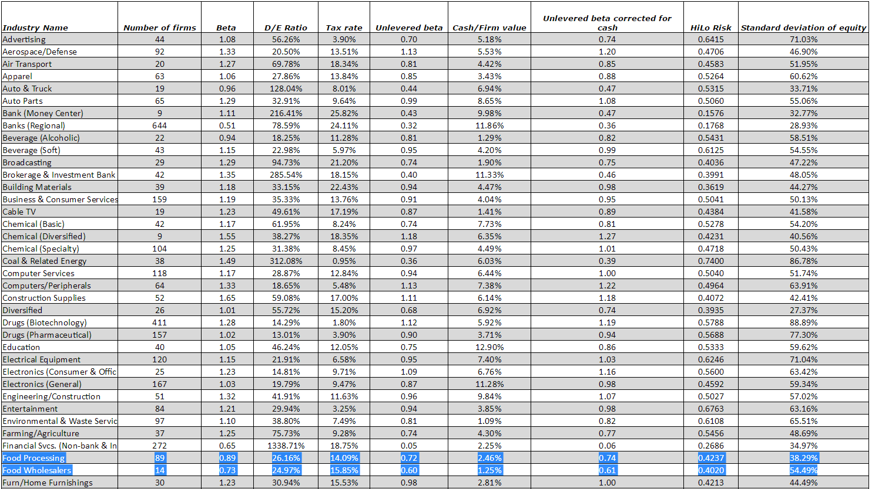
Exhibit 8.
Discounted Earnings Models
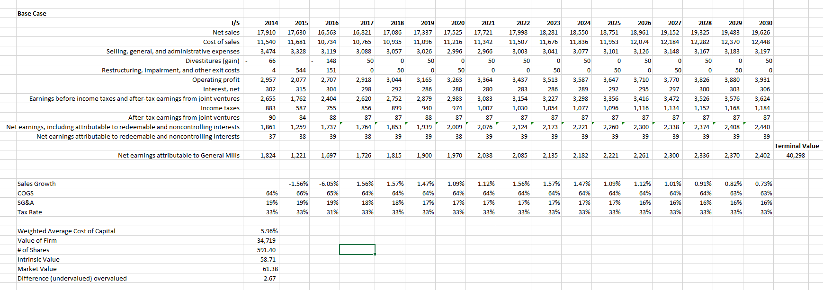
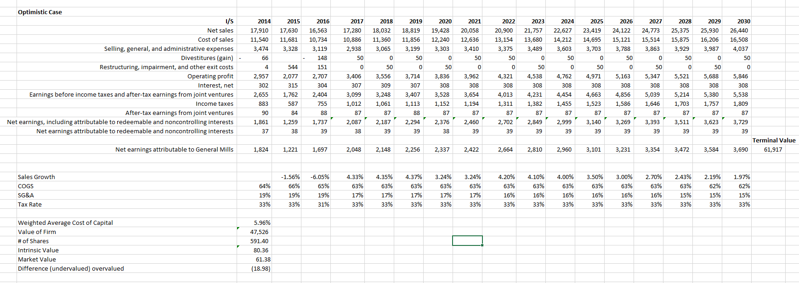
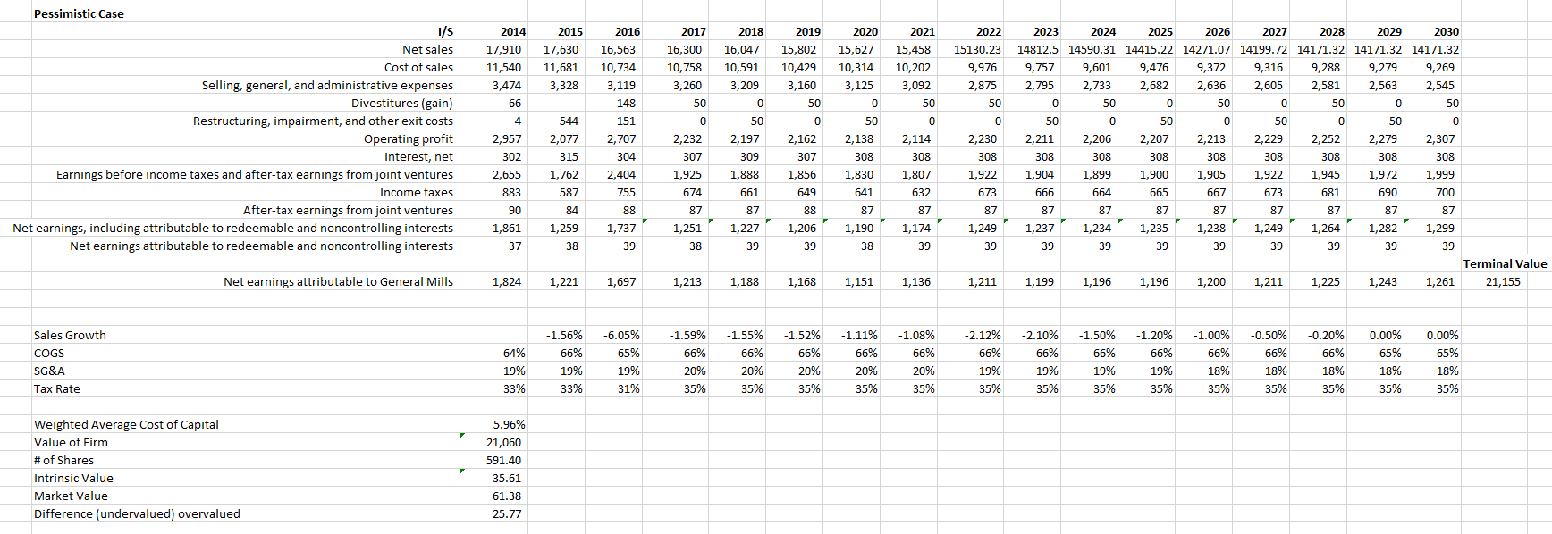
Operations Forecast
Exhibit 9.
Base Case
I/S | 2011 | 2012 | 2013 | 2014 | 2015 | 2016 | 2017 | 2018 | 2019 | 2020 | 2021
Sales | 14880.2 | 16657.9 | 17774.1 | 17909.6 | 17630.3 | 16563.1 | 16820.753 | 17085.54 | 17337.08 | 17525.26 | 17721.22
COGS | 8926.7 | 10613.2 | 11350.2 | 11539.8 | 11681.1 | 10733.6 | 10765.282 | 10934.75 | 11095.73 | 11216.16 | 11341.58
SG&A | 3192 | 3380.7 | 3552.3 | 3474.3 | 3328 | 3118.9 | 3087.711 | 3056.834 | 3026.266 | 2996.003 | 2966.043
Divestitures | -17.4 |  |  | -65.5 |  | -148.2 | 0 | 0 | 0 | 0 | 0
Restructuring & impairment | 4.4 | 101.6 | 19.8 | 3.6 | 543.9 | 151.4 | 0 | 0 | 0 | 0 | 0
Operating profit | 2774.5 | 2562.4 | 2851.8 | 2957.4 | 2077.3 | 2707.4 | 2967.7601 | 3093.962 | 3215.084 | 3313.09 | 3413.597
Interest, net | 346.3 | 351.9 | 316.9 | 302.4 | 315.4 | 303.8 | 297.724 | 291.7695 | 285.9341 | 280.2154 | 274.6111
EBITDA | 2428.2 | 2210.5 | 2534.9 | 2655 | 1761.9 | 2403.6 | 2670.0361 | 2802.192 | 2929.15 | 3032.874 | 3138.986
Income taxes | 721.1 | 709.6 | 741.2 | 883.3 | 586.8 | 755.2 | 872.15656 | 915.3248 | 956.7951 | 990.6762 | 1025.337
After Tax Income | 96.4 | 88.2 | 98.8 | 89.6 | 84.3 | 88.4 | 87.433333 | 86.71111 | 87.51481 | 87.21975 | 87.14856
After Tax Income inc min int | 1803.5 | 1589.1 | 1892.5 | 1861.3 | 1259.4 | 1736.8 | 1797.8795 | 1886.867 | 1972.355 | 2042.198 | 2113.649
non-controlling income | 5.2 | 21.8 | 37.3 | 36.9 | 38.1 | 39.4 | 38.133333 | 38.54444 | 38.69259 | 38.45679 | 38.56461
Net Income | 1798.3 | 1567.3 | 1855.2 | 1824.4 | 1221.3 | 1697.4 | 1759.7462 | 1848.323 | 1933.662 | 2003.741 | 2075.084
COGS% | 60% | 64% | 64% | 64% | 66% | 65% | 64% | 64% | 64% | 64% | 64%
3 year running average |  |  |  |  |  | 65%
SG&A | 21% | 20% | 20% | 19% | 19% | 19% | 18% | 18% | 17% | 17% | 17%
Tax Rate | 30% | 32% | 29% | 33% | 33% | 31% | 33% | 33% | 33% | 33% | 33%
3 year running average (Tax) |  |  |  |  |  | 33%

