ITM FINAL s
5,6,7,8,10,12

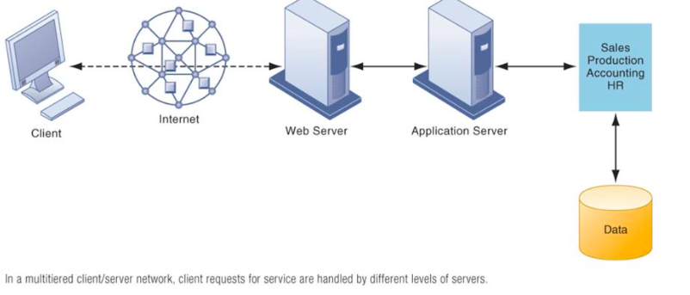
CHAPTER FIVE

APPLICATION SERVER:

AUTONOMIC COMPUTING:

BLADE SERVERS: A server architecture that houses multiple server modules "blades"

SERVICE PLATFORM: perspective refers to analyzing the actual services enabled by new technology tools. For example, a new PC might save an employee one hour per day in wait time for information, dramatically increasing his value to the firm.

CONSUMERIZATION of IT: new information technology that first emerges in the consumer market spreads into business organizations

eXtensible Markup Language (XML): file format used to create common information formats and share both the format and the data on the World Wide Web, intranets, and elsewhere using standard ASCII text.

GRID COMPUTING: is a computer network in which each computer's resources are shared with every other computer in the system.

HTML (Hypertext Markup Language): Communications standard used for transferring Web pages

Uniform resource locators (URLs): Addresses of Web pages

Web servers: Software for locating and managing Web pages

RSS: Rich Site Server used to bring you the latest news from your favourite sites.

HYBRID CLOUD: a mix of on-premises, private cloud and third-party, public cloud services

JAVA: programming language

OPERATING SYSTEMS

CHROME OS: lightweight operating system for cloud computing using netbooks that are manufactured by google partners such as Acer and Samsung.
iOS: Apples operating system, features multi-touch interface, where uses employ one or more fingers to manipulate objects.
UNIX & LINUX: an inexpensive and robust open-source operating system (manage the resources activities of the computer)

ANDROID: an open-sourced for mobile devices

MULTICORE PROCESSOR: an integrated circuit to which two or more processors core have been attached for enhanced performance, reduced power consumption, and more enhanced simultaneous processing of multiple task
LEGACY SYSTEMS: older transaction processing systems created for mainframe computers
- Multi core processors, and blade servers, are two ways in which server power can be radically increased without increasing the foot print or the power requirements.

MOORE’S LAW: The amount of digital information is roughly doubling every year. The cost of storage is falling at an exponential rate of 100 percent per year

MULTITIERED (N-tier) CLIENT/SERVICE ARCHITECTURE: the work of the entire network is balanced over several different levels of servers, depending on the kind of service being requested

GRID COMPUTING: involves connecting geographically remote computers into a single network to create a virtual supercomputer.

ON-DEMAND COMPUTING: a type of pay as you go way to charge firms for using their clouds

OPEN-SOURCE SOFTWARE: is computer software with its source code made available with a license in which the copyright holder provides the rights to study, change, and distribute the software to anyone and for any purpose.

PRIVATE CLOUD: is operated solely for an organization
PUBLIC CLOUD: is owned and maintained by a cloud service provider such as Amazon, made available to the general public.
HYBRID CLOUD: computing model where they use their own infrastructure for their most essential core activities and adopt public clouds for less essential core activities (large firms)

SERVER:

SLA Service Level Agreement:

SOA Service Oriented Architecture:

SAN Storage Area Network:

Total cost of ownership (TCO)

The Law of Mass Digital Storage: The value of a network grows exponentially as a function of the number of network members

SLIDE NOTES:

DEFINING IT INFRASTRUCTURE
- General-purpose mainframe and minicomputer era: 1959 to present
- Personal computer era: 1981 to present
- Client/server era: 1983 to present
- Enterprise computing era: 1992 to present
- Cloud Computing and Mobile Computing era: 2000 to present

Technology Drivers of Infrastructure Evolution
- Has been interpreted as:
- The power of microprocessors doubles every 18 months
- Computing power doubles every 18 months
- The price of computing falls by half every 18 months
- Nanotechnology uses individual atoms and molecules to create computer chips and other devices

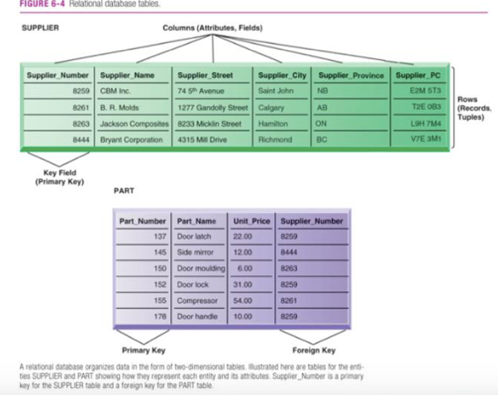
CHAPTER 6IX
Byte: Group of bits that represents a single character | Field: Group of words or a complete number
Record: Group of related fields | File: Group of records of same type
Database: Group of related files | Entity: Person, place, thing, event about which information is maintained
Attribute: Description of a particular entity | Key field: Identifier field used to retrieve, update, sort a record
Data redundancy: The presence of duplicate data in multiple data files so that the same data are stored in more than one place or location | Data inconsistency: The same attribute may have different values.

Database management systems: is software that permits an organization to centralize data, manage efficiently, and provide access to the stored data by application programs.

CAPABILITIES:
- Data Definition Language:
  - Specifies structure of the database
- Data Dictionary
  - Stores definition of data elements and their characteristics
- Querying and Reporting
  - Data manipulation language
  - Structured query language (SQL)

OPERATIONS:
- Select: Creates subset of rows that meet specific criteria
- Join: Combines relational tables to provide users with information
- Project: Enables users to create new tables containing only relevant information
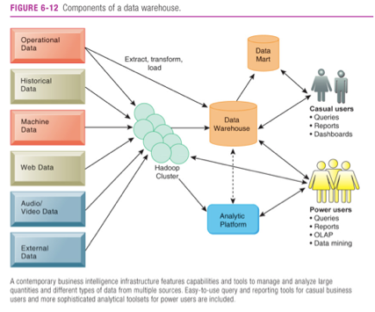

Hadoop
- Designed to handle big data
- an open source software framework managed
- enables distributed parallel processing of huge amounts of data across inexpensive computers

Text Mining
- Extracts key elements from large unstructured data sets (e.g., stored e-mails)

Web Mining
- The discovery and analysis of useful patterns and information from the World Wide Web

Sentiment analysis
- Mines text comments in e-mail, blog, social media conversation, or survey to detect favourable and unfavourable opinions about specific subjects

CHAPTER 7

WHAT IS A COMPUTER NETWORK?
- Two or more connected computers
- CLIENT/SEVER COMPUTING: desktop or laptop computers called clients are networked to powerful sever computers that prove the client computers with a variety of serves and capabilities.

NETWORK INTERFACES (NICs): To connect to a network, a computer uses a network interface card (NIC). A NIC controls the wired and wireless connections of a computer to exchange information with other computers and the Internet.

NETWORK OPERATING SYSTEMS: routes and manages communications on the network and coordinates rework resources.
SOFTWARE-DEFINED NETWORK (SDN): new networking approach in which many of these control functions are manages by one central program, which can run on inexpensive commodity servers that are separate from the network devices themselves.

CORPORATE NETWORK INFRASTRUCTURE

LANs: Local Area Networks

Powerful servers:
- Website
- Corporate intranet, extranet
- Backend systems

Packet switching
- Method of slicing digital messages into parcels (packets), sending packets along different communication paths as they become available, and then reassembling packets at destination
- Previous circuit-switched networks required assembly of complete point-to-point circuit
- Packet switching more efficient use of network’s communications capacity

Transmission Control Protocol/Internet Protocol (TCP/IP)
- Common worldwide standard that is basis for Internet
Different layers:
- Application layer
- Transport layer
- Internet layer
- Network interface layer

- A network switch (also called switching hub, bridging hub, officially MAC bridge) is a computer networking device that connects devices together on a computer network, by using packet switching to receive, process and forward data to the destination device

CHAPTER 8 SECRUITY

VIRUSES: Rogue software programs that attach to other programs in order to be executed, usually without user knowledge or permission
  - Deliver a “payload”
  - Can spread by email attachments

WORMS: Programs that copy themselves from one computer to another over networks
  - Can destroy data, programs, and halt operation of computer networks

SQL injection attacks
- Hackers submit data to Web forms that sends rogue SQL query to database to perform malicious acts (e.g. delete segments of the database)

Spyware
- Keylogging records keystrokes made on a keyboard; can steal passwords, etc.

Hackers:
  - individuals who attempt to gain unauthorized access to a computer system
  - Cracker: a hacker with criminal intent

Cyber-vandalism:
  - intentional disruption, defacement, or destruction of a Web site or system

Denial of Service (DoS) Attacks: Hackers flood a server with false communications in order to crash the system
Distributed DoS: uses numerous computers to launch a DoS
Often use Botnets
  - Deliver 90% of world spam, 80% of world malware
  - Grum botnet controlled 560,000 to 840,000 computers

CHAPTER 10 ECOMMERCE
ECOMMERCE: The use of the Internet and the Web to transact business, digitally enabled transactions.
• Began in 1995 when advertisements were allowed
FACTS:
• Online Canadian consumer sales grew to an estimated $15+ billion in 2012.
• More than 2.4 billion people globally are now connected to the Internet
• 97 per cent of Canadians in the top income quartile have access to the Internet in their homes, but that number drops to 54 per cent for those in the bottom quartile.
WHY IS E-COMMERCE IS DIFFERENT
EBIQUITY: it can be everywhere at all times, “ketspace” – marketplace extended beyond traditional boundaries
Global Reach: Technology reaches worldwide, no national boundaries. Commerce is enabled across cultural and national boundaries
Universal Students: One set of technology standards, namely internet technology. Same technology standards makes it easier to communicate.
Richness: Video, Audio text marketing messages integrated into a single marketing message
Interactivity: Technology works through interaction with the user
Information Density: Technology reduces information costs and raises quality
Personalization: Technology allows personalized messages to be delivered
Social Technology: Technology Supports content generation and social networking.

KEY CONCEPTS:
INFORMATION ASYMMETRY: exist when one party in a transaction has more information that is important for the transaction then the other party.
MENU COST: (merchants cost of changing prices), greater price discrimination, and the ability to change prices dynamically based on market conditions.
DYNAMIC PRICING: the price of a product varies depending on the demand characteristics of the customer or the supply situation of the seller
DISINTERMEDIATION: selling direct to customers for lower cost

Types of E-Commerce
Business-Customer: electronic commerce involved retailing products and services to individual shoppers EX) Chapters.Indigo.ca, sells books, decor, and music to individual consumers
Business-Business: electronic commerce involves sales of good and services among businesses. EX) ChemConnect a website for buying and selling chemicals and plastics
Consumer-Consumer: examples include ebay and kijiji

WHY IS E-COMMERCE IS DIFFERENT

EBIQUITY: it can be everywhere at all times, “ketspace” – marketplace extended beyond traditional boundaries

Unstructured Decisions
•Novel, non-routine decisions requiring judgment and insights
Structured Decisions
•Routine decisions with definite procedures
Semi-structured Decisions
•Only part of decision has clear-cut answers provided by accepted procedures

- Intelligence
- Discovering, identifying, and understanding the problems occurring in the organization
- Design
- Identifying and exploring solutions to the problem
- Choice
- Choosing among solution alternatives
- Implementation
- Making chosen alternative work and monitoring how well solution is working

BUSINESS INTELLIGENCE: Infrastructure for collecting, storing, analyzing data produced by business. Databases, data warehouses, data marts
Business analytics
- Tools and techniques for analyzing data
- OLAP, statistics, models, data mining
Business intelligence vendors
- Create business intelligence and analytics purchased by firms

Six Elements in the Business Intelligence Environment
1.Data from the business environment
2.Business intelligence infrastructure
3.Business analytics toolset
4.Managerial users and methods
5.Delivery platform – MIS, DSS, ESS
6.User interface
Predictive analytics
•Use patterns in data to predict future behavior
•E.g. Credit card companies use predictive analytics to determine customers at risk for leaving
Data visualization
•Help users see patterns and relationships that would be difficult to see in text lists
Geographic information systems (GIS)
•Ties location-related data to maps
Expert systems: an intelligent technique for capturing tacit knowledge in a very specific and limited domain of human expertise.
- capture the knowledge of skilled employees in the form of a set of rules in a software system that can be used by others in the organization.

Classical Model of Management
- formal functions of planning, organizing, coordinating, deciding, and controlling

