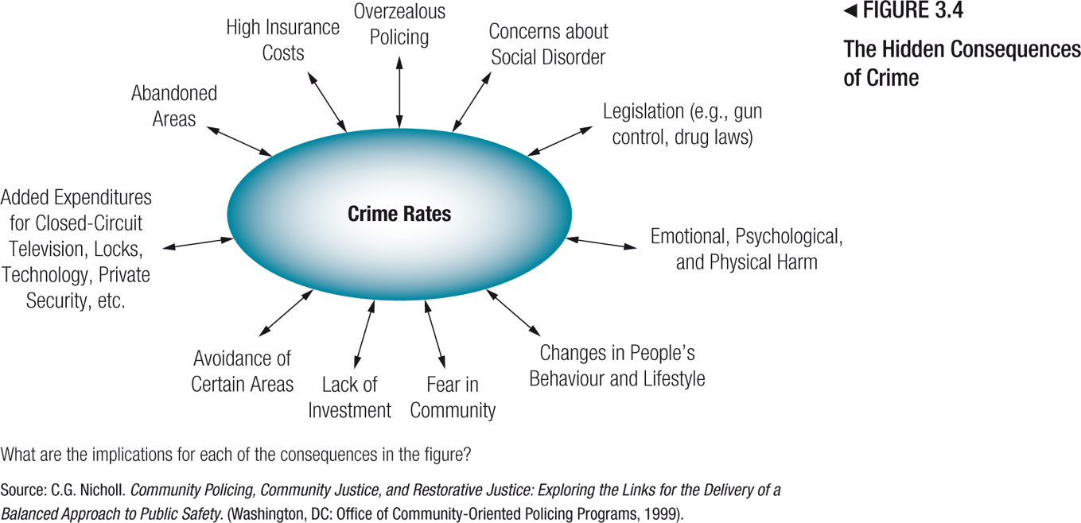
-Annual cost of the Criminal Justice System is $31 billion per year.
-There are many hidden costs
-If “other costs are included, it balloons to nearly $100 billion per year.

Cost of Domestic Violence
-Total cost of spousal violence for men and women.
Includes:
- Criminal and civil justice system costs
- Costs associated with pain and suffering
- Health care costs (injury, meds, psychological assistance, etc.)
- Third-party costs (impact on families, employers, etc.)

Victims of Crime
Prevalence:
-Over ¼ of Canadians report victimization
-Highest in Western Canada
Reporting:
-High-rates of non-reporting
-Only ⅓ reported to police
-Majority of sex assaults (88%) not reported
Demographic:
-Majority of victims under age 30
-Males 18-24 most likely victims of violence
-Single women more likely victims of violence than married women
At-risk Groups:
-Aboriginals victimized at higher rate

Fear of Crime
-Canadians are not concerned of being a victim of crime, they don’t fear their safety
-Greater in areas where there is a high proportion of low income families, visible minority, and lone-parents.
-Residents who identity social disorder in their neighbourhood also report higher levels of fear of crime
-Citizens 65 and older tend to be more fearful of crime, as are the persons, who have been previously victimized

Victims in the Criminal Justice System
-Page 48: Role of victim is set out in federal and provincial legislation
-Typically, notifying victims if the offender is being released
-Critiques: psychological harm not adequately addressed, too much emphasis on the rights of offenders

Revictimization
-The negative impact on victims of crime caused by the decisions and actions of criminal justice personnel.
-Crime affects victims physically, psychologically, emotionally, financially, and socially.
-After the initial trauma of the crime, victims can be made to feel worse by the actions of criminal justice officials.
1. The justice system can seem complex and confusing.
2. Criminal justice personnel are not always sensitive to the needs of victims.
3. Victims do not receive sufficient information about developments in the case.
4. Victims are excluded from key decisions through the criminal justice process.
5. Many still hold victims responsible for their crimes. → judge in manitoba made remarks on how a women carried herself and what she was wearing trying to blame her for the sexual assault she was a victim of.
-Some argue that empowering victims by involving them in the CJS introduces undue emotion and increases punitiveness.
-Police lack sensitivity training
-Victim impact statements → victims or their relatives express their feelings about the situation at hand and how this has impacted their lives.

Addressing Victim Needs - Programs and Services
-Growth of services over the last two decades
-Criminal justice-based services, such as victim services, available in most communities
-Community-based services, such as shelters, crisis lines, hospital and mental-health services, self-help groups, and translation services
-Issue: adequacy of these services, difficult for male victims to find help
-Few victims (3%) take advantage of services
-Barriers to access
-Failure of police to provide information to crime victims
-Language and access difficulties for immigrant or visible minority women

Compensation
-Most common form of compensation is through insurance (IMPORTANT)
Criminal Injury Compensation: financial remuneration paid to crime victims
Restitution: a court-ordered payment that the offender makes to the victim to compensate for loss of or damage to property
-Criminal injury compensation programs operate in most regions across Canada.
-However, they do not operate in the territories. Given the high rates of crime and victimization, this is concerning.
-Criminal justice agencies can also be held accountable by victims through civil court (sue for damages for action of CJS personnel).
-Examples include excessive force, wrongful conviction, failure of corrections to manage the risk posed by offenders.
-Ashley Smith → Strangled herself in a women's prison in Kitchener while prison guards looked in.
-Wrongful conviction:
-Jamie Nelson → Served 3 ½ years for sexual assault, when he was done his time it was brought forth that this women accused many other men of the same thing. He wanted to get compensation but getting transcripts for the case it would have cost A LOT of money and he did not see the point.
-Romeo Phillion → Served 30 years for a murder he did not do

The Community and the Criminal Justice System
Canadians:
“The justice system is only for people with money”
“Too many offenders get parole, and many parolees reoffend” → Release rate on parole has declined
“The justice system is biased in favour of offenders”
“The justice system is too lenient”
“Punishments are not harsh enough”
“I don’t trust police, judges, and especially lawyers” → Police get a higher approval rate than judges by the public and lawyers get the lowest (page 53).
“I don’t have confidence in the justice system”
“Crime and recidivism rates are high” → Decline in crime rates
-Public sentiments of the justice system and justice system actors.
-Sentiments are not related to crime rate or victimization.
-No relationship between the severity of criminal justice sanctions and public confidence in the CJS.
-Public confidence is complex and multifaceted.
-What explains public sentiments?
1.Overdependence on the CJS (unmet expectations, fear, NIMBY)
2.Media

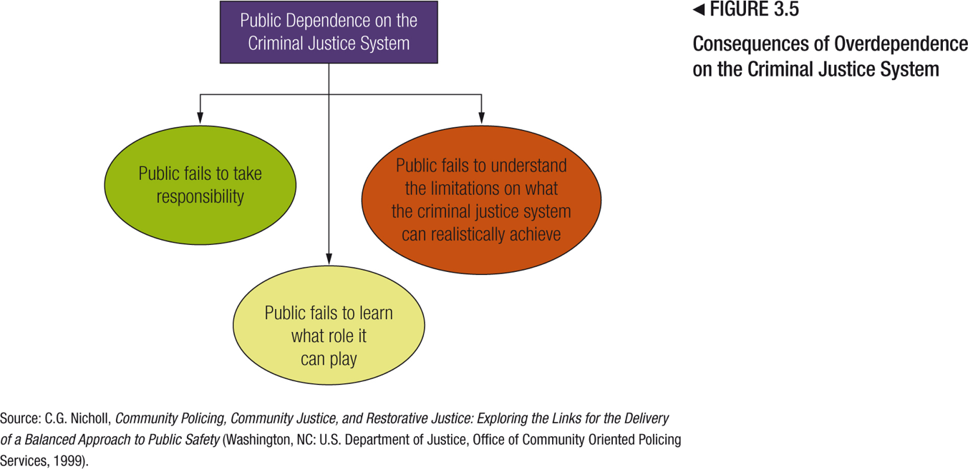

-Overdependence leads to public misunderstandings about their role, and limits of the CJS.

NIMBY
Not In My Backyard: the resistance that communities display in response to correctional systems efforts to locate programs and residences for offenders in a specific area.

Media
-Popular crime shows oversimplify complex issues of crime and justice
-News media focus on negative rather than positive criminal justice outcomes
-Media tendency to focus on sensational cases, while criminal justice agencies fail to educate an uninformed or misinformed public about crime
-Findings examining efforts to educate the public are mixed.
-Some studies were unable to determine whether initiatives to educate the public about corrections improved public confidence in the CJS.
-Other studies have found that programs/materials designed to provide the public with facts about the CJS resulted in higher confidence levels.
Electronic:
-Forms of electronic communication allow users to post and share ideas, information, videos, and photographs
-The speed at which information can travel through social media transcends traditional media and the justice system.
-It has had an impact on communities, those engaging in disruptive activity, and criminal justice personnel.
-Increasing surveillance and scrutiny, especially of police.
-Not all CJS personnel are subject to this kind of surveillance (probation officers, judges, Crown counsel, corrections officers, parole board members)

-Name and shame campaign emerged, fuelled by social media.
-Cell phone and PDA images used to to identify and expose rioters, often to police.
-Harsh public reactions (“court of Facebook”) described as a “lynch mob mentality.”
-Judged by public without due process or Charter protections (lost jobs, expelled from university, lost sponsorships, reputation, etc.).
Case of Nathan Kotylak
-Vancouver hockey riot
-Crown continue to lay charges two years after the riots.
-Raises questions about whether, and how, the more damaging elements of this phenomenon can be monitored and controlled.

“Anonymous” and Hacktivism
-Use the Internet as a platform to hold alleged offenders and the criminal justice system accountable.
-Reveal the identities of offenders and compel those in the justice system to take action where perceived injustices have occurred.
-Combined with social media, this example underscores the growing involvement of the community in criminal justice matters. Through technology, the public (whether serendipitous observers and recorders or online social justice activists) are becoming increasingly more involved in the criminal justice system, with profound implications to criminal justice autonomy and accountability, due process, and Charter rights.

What does man look like in the natural state?
T. Hobbes (1588-1679)
-The natural state was a state of war, all against all
-Everyone is greedy and out to get what they can take, this made people very insecure and vulnerable.
- “In the natural state life is solitary, poor, nasty, brutish, and short.”
-Development of society and civilization which saved man from that dangerous existence → social contract
-People agreed to give up some freedom in turn for protection for the state. (Social contract)
-Pessimistic view
Human nature = bad
Civilization = good
J. Rousseau (1712-1778)
-Enlightenment thinkers
-Doesn’t completely disagree from Hobbes → pays attention to the individual's capacity for empathy
-Optimistic view
- “Man is born free, and everywhere he is in chains.”
Civilization = Bad
Human nature = Good

Two Models of the Criminal Process
-Crime control and and due process
-Represent underlying values under the models

Crime control:
-CJS protection of the public through the apparition, deterrence, etc.
-Responsible of their actions
-Administration of justice should be swift, sure, and efficient
-Strong presumption of guilt
-A lot of confidence in the police and prosecution → will screen out innocent people early in the process
-Packer → Criminal law resembles a factory assembly line, each step proceeds in an efficient way, with respect to errors and mistakes by police and prosecutors, the crime control model tends to be tolerant.
-Minor violations (ex. Parking tickets)
-Security certificates → being in standard jails without evidence being given to them

Due Process:
-Emphasizes a legal assumption of innocence
-Procedural fairness
-The rights of the accused are emphasized
-Packer → An obstacle force, the rights of the accused
-Discretion of police and prosecutors are limited by the suspect or accused
-Emphasizes errors or mistakes by police and/or prosecution
-Intolerant of errors by police and prosecution (s. 24(2) → evidence can be excluded if the ministry of justice has to be brought into disrepute)
-Criminal law process is emphasized
(Might be asked to state 3/4 differences between these 2)

Conflicts as Property - Article (Christie)
-Criticizing our modern legal system
-Conflicts can be a good thing, they can bring people together
-Lawyers are good at stealing conflicts, advocates a return to more community restorative justice.

