ECOR 1010 – Introduction to Engineering

Zachary robert morrison
lab 2
Assignment Title: Units, Dimensions & Significant Figures
TO Marking TA:
Name: Marking T.A for lab section 3
Email: ...@....ca

Lab Section: L3
Room: ME2556 – Carleton University

FROM:
Email: zachmorrison@cmail.carleton.ca
Student Number: 101034027

Number of Figures and Tables (Including handwritten ones): 8
Last Date and Time of Revision: 02 October 2016

Introduction
Engineers should have the mathematical understanding on how to be able to understand the three unit systems in order to avoid fatal mistakes, as well as having the technical knowledge of using CAD software to get ideas across in a more universal and efficient way. This lab will explore methods of converting between units, calculations of surface area and volume, and a small design using IntelliCAD from figure 15.25 from the textbook.

Materials and Methods
In order to calculate the efficiency of a pump, the equation listed at the end of the paragraph was used where in the formula, Q represents the volume flow rate while ΔP represents the pressure change caused by the pump and input power is the input power. Along with this, a table of unit conversions to be able to convert each variable to a common unit system. To calculate surface area, thee surface area of each individual side was calculated, then summed. As well, the total volume of each part was calculated similarly. Finally, the software, IntelliCAD was used to make a sketch.
$$n=\frac{Q∆P}{Input Power}$$

Results
From figures 1 and 2 in the appendix, it shows that the efficiency of the pumps in declining order is 1,3,2 with efficiencies of 70%, 68%, 14% respectively. From figures 3 to 7, the surface area and volume of part one is 187.937 cm² and 101.75 cm³ respectively, part two is 483.3982 cm² and 328 cm³ respectively, and finally part 3 is 307.078 cm² and 179.939 cm³ respectively.

Discussion
The most ideal pump would be pump one with an efficiency of 70% with pump three a close second at 68% and pump two being extremely low at 14%. The part that would cost the least to coat would be part one with part three being second and part two being the most expensive. It should be noted that calculating the volume for this exercise was irrelevant considering that volume has no part in the cost of the coating although volume should be considered when pricing cost of the material itself.

Conclusions
This lab practiced the mathematical method of converting units between the three unit systems in order to calculate a potential real world situation. Also, this lab covered methods used to calculate surface area in order to understand how it would relate to cost. Finally, a necessary tool for an engineer is the use of computer aided design software, and the lab provided an introduction to line drawing.

APPENDIces- Figures and Tables
Figure 1
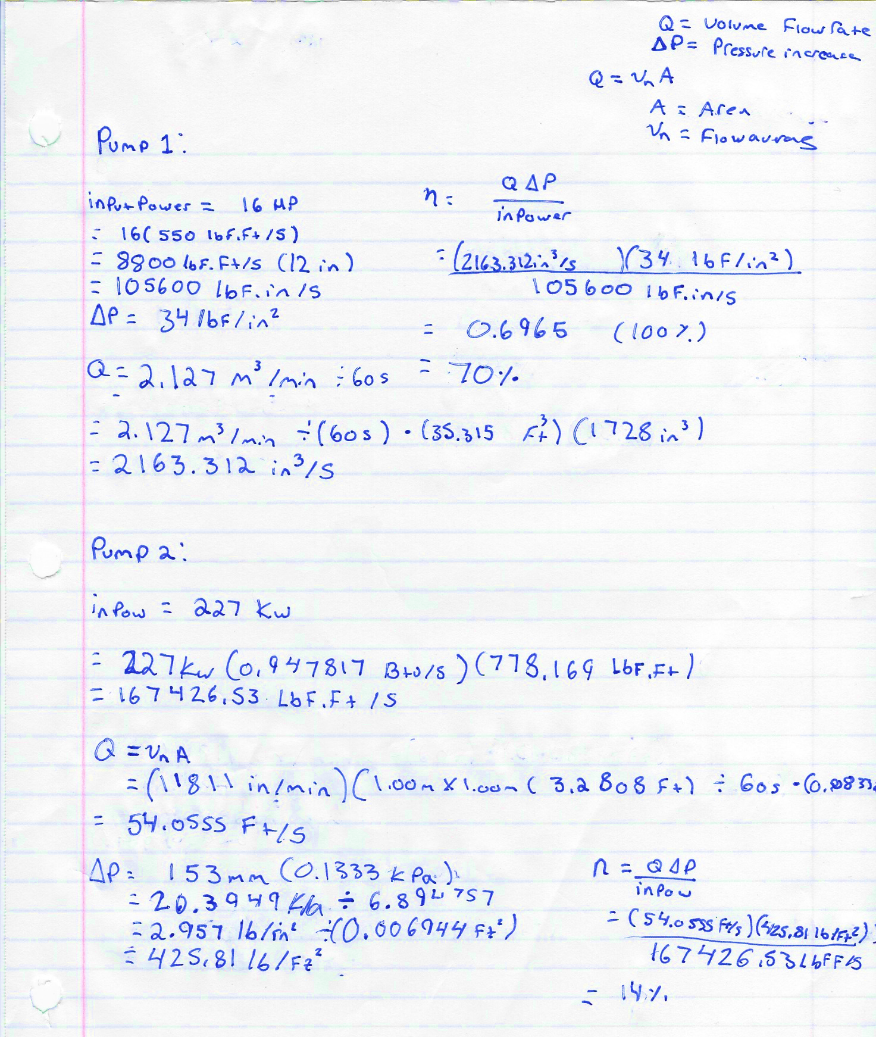
Figure 2
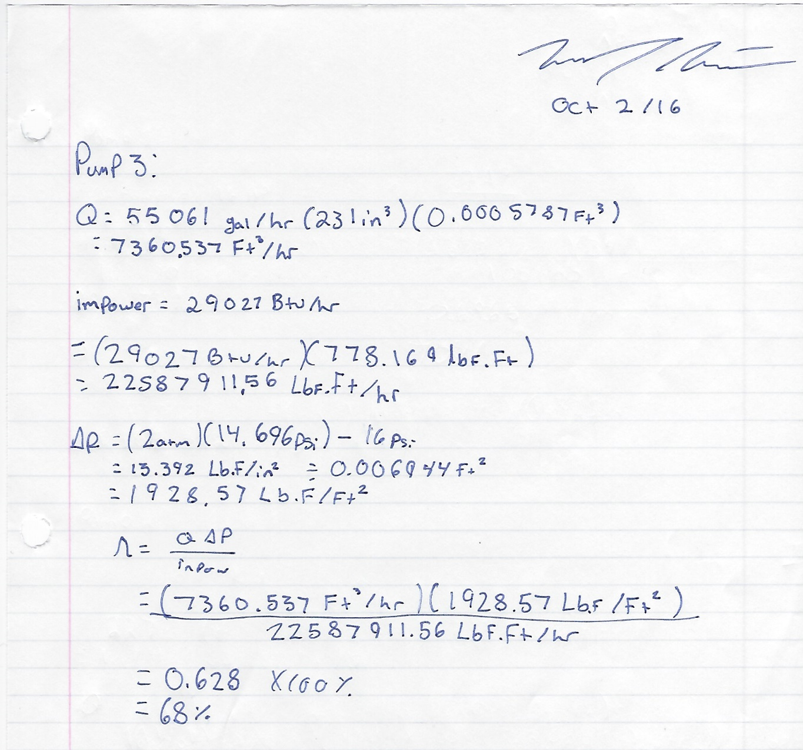

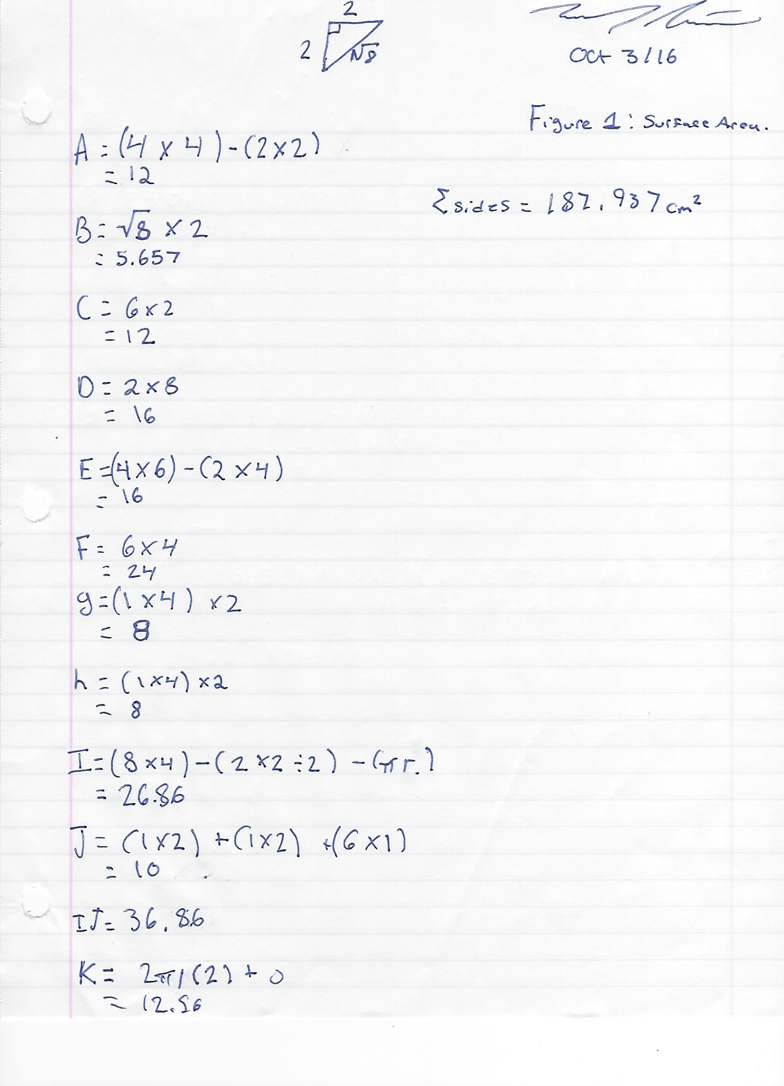
Figure 3

Figure 4
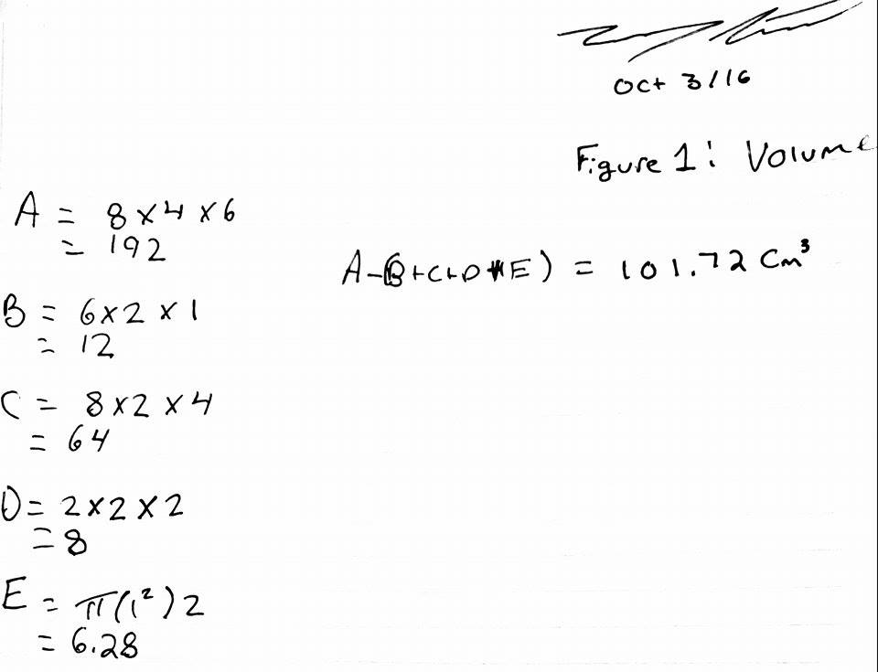

Figure 5
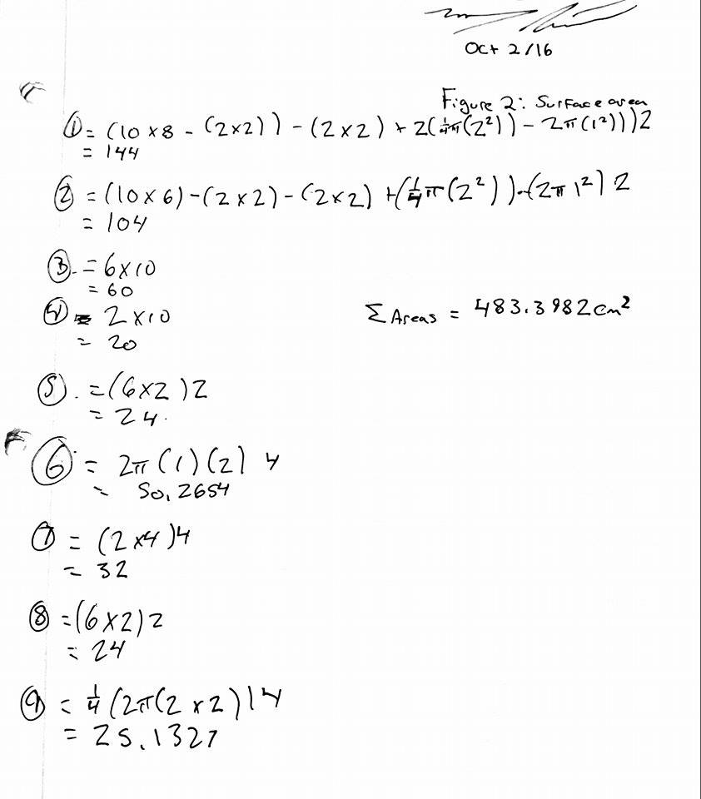

Figure 6
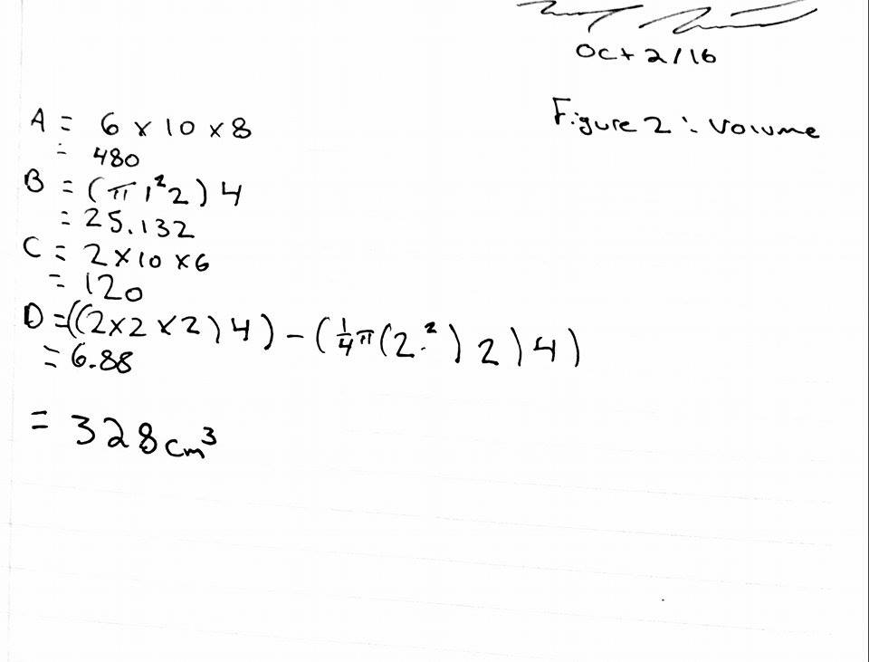

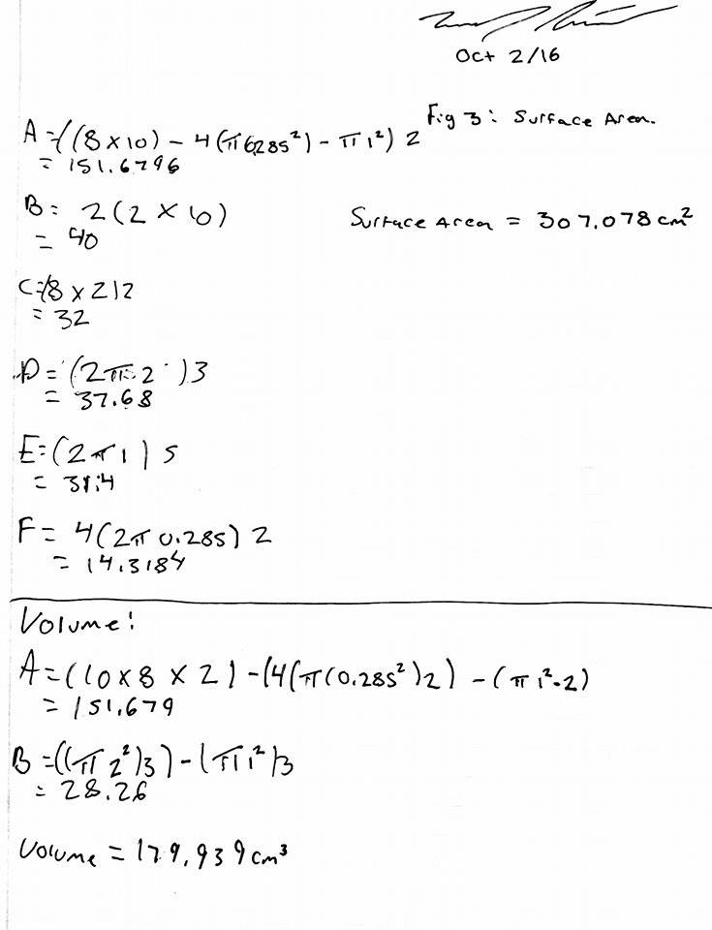
Figure 7

Figure 8


