ECOR 1010 – Introduction to Engineering

[Type Authors¹]
Assignment Lab 2
Assignment Title: Using Key Engineering Skills to Complete 3 tasks

Lab Section: [Email]
Room: – Carleton University

Number of Figures and Tables (Including handwritten ones): 7
Last Date and Time of Revision:

Introduction
Engineers face an abundance of problems and tasks in their time on the job. Many tasks include designing objects, determining dimensions, or simply making calculations. The objective of this lab is to complete three essential tasks using skills that engineers are required to use. These three tasks were broken up into Part 1, Part 2, and Part 3. In Part 1 data about 3 different pumps were given in multiple units to determine which of the three pumps is the most efficient. Part 2 included 3 objects in danger of corrosion that must be covered in a protective coat. In order for this to happen the surface area and volume of all three objects were calculated. Finally to complete Part 3 a drawing from the ECOR 1010 textbook was replicated to get the user used to the programs. By completing these three tasks, many essential and useful engineering skills were required.

Materials and Methods
In order to complete Part 1 of this lab, each set of given data for each of the pumps were converted to SI units. Using the efficiency formula all units were cancelled out (see Figures 1 and 2) to solve for “n” a unitless ratio of efficiency. The three efficiencies were compared as a percentage to determine which of the pumps is the most efficient. Part 2 was done by sectioning each object into different pieces and calculating the surface area and volume by one section at a time as seen in Figures 3,4, 5 and 6. Part 3 was completed in AutoCAD by following directions in Chapter 15 of the textbook to create the final drawing as seen in Figure 7.

Results
After conducting the calculations in Part 1 as seen in Figures 1 and 2, Pump 1 was shown to be the most efficient of all the pumps with a 71% efficiency. The least efficient pump was Pump 2 with a 49% efficiency. Part 2 was calculated for each object separately (see Figures 3,4,5 and 6) finding volumes and surface area for each. Objects 1, 2, and 3 had surface areas of 187.9464cm², 483.4131cm², and 318.8851cm² respectively. The volumes for Objects 1, 2, and 3 are 93.7168cm³, 315.4333cm³, and 179.8043cm³ respectively.

Discussion
Part 1 of this lab shows that the pumps ranked from most efficient to least efficient are Pump 1, Pump 3, and Pump 2. That is a large margin as Pump 1 is over 20% more efficient than Pump 2 (Figure 1). Challenges faced in Part 1 was converting several units correctly to get the answers. After calculating Part 2 of this lab, Object 1 which had the highest number of faces ended up with the least surface area (Figure 3). All objects had surface areas that were larger than their volumes as expected. Challenges faced in Part 2 was making assumptions of sides that are not shown for any given object.

Conclusions
By using essential engineering skills Parts 1, 2, and 3 were able to be completed successfully. In conclusion, it was found that the most efficient pump by a large margin is Pump 1. After finding the results in Part 2, these shapes are able to be covered in the protective coatings to prevent rust with the calculated surface areas and volume. This lab helped gain a better understanding of the job that engineers may do on the job and they may be useful soon for future engineers.

APPENDIces- Figures and Tables
All Final Answers are Boxed
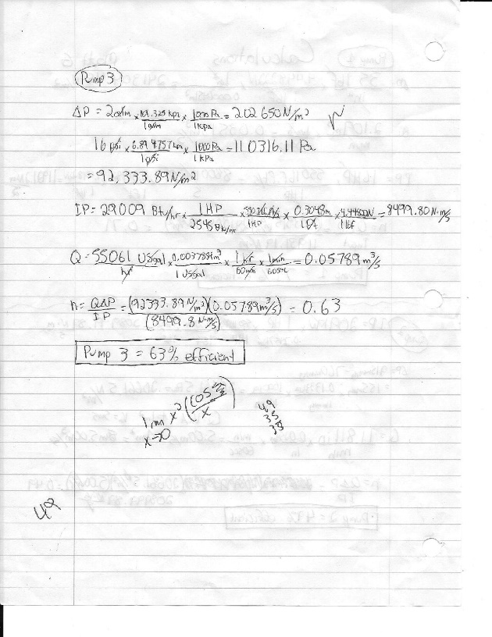
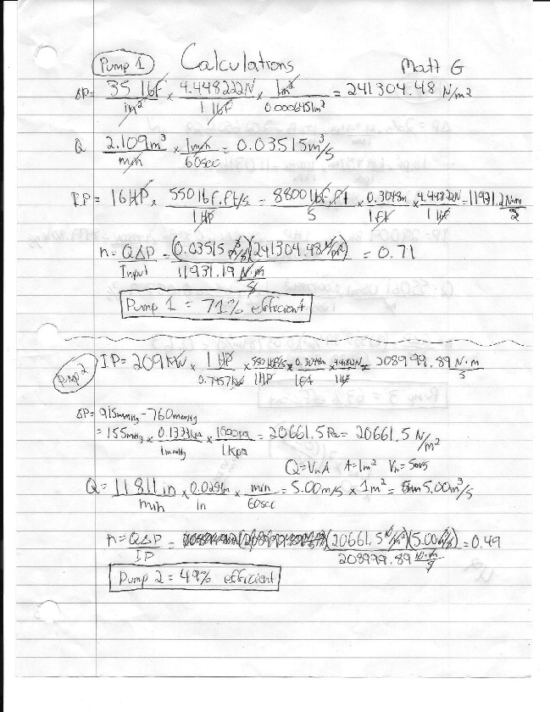
Figure 1: Pump 1/Pump2 Calculations Figure 2: Pump 3 Calculations

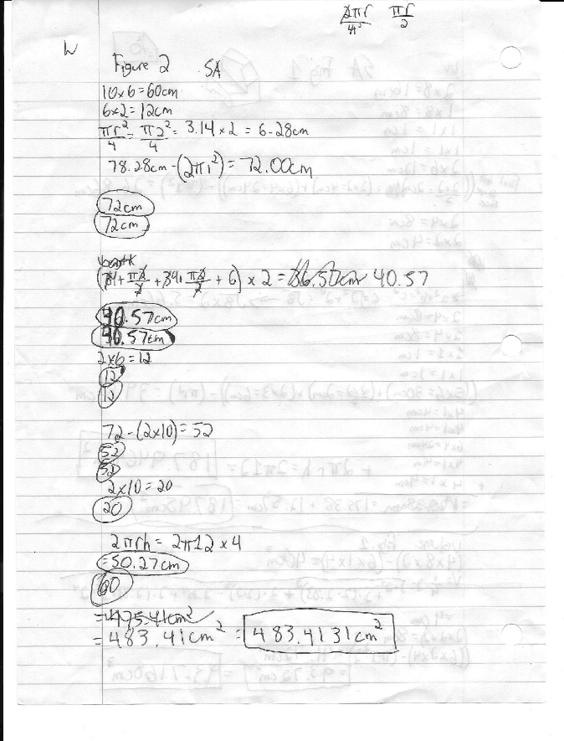
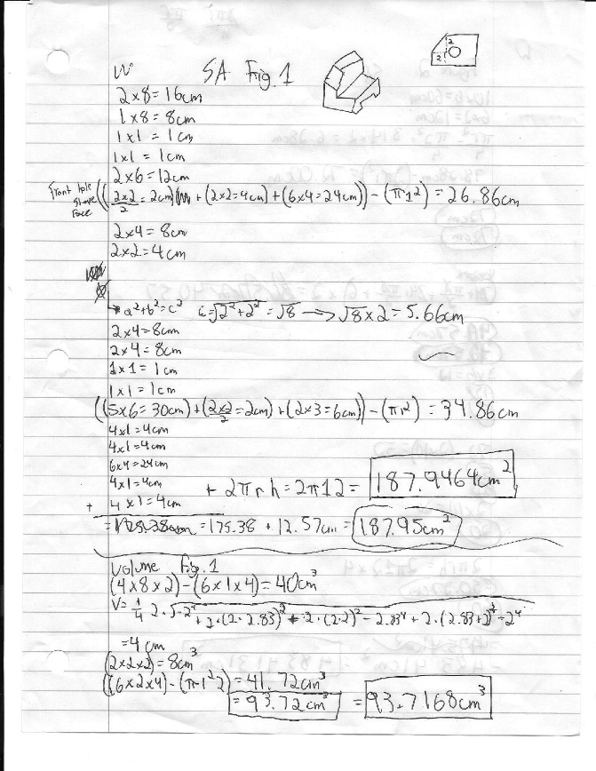
Figure 3: Object 1 SA and Volume Figure 4: Object 2 SA

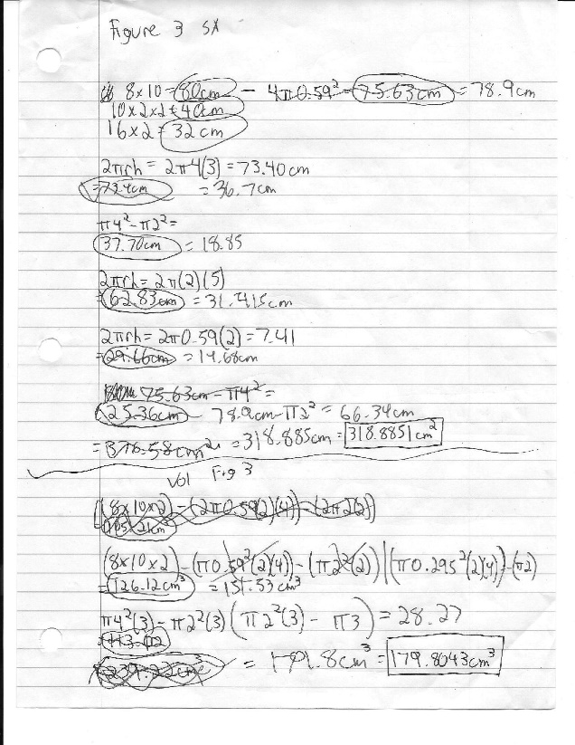
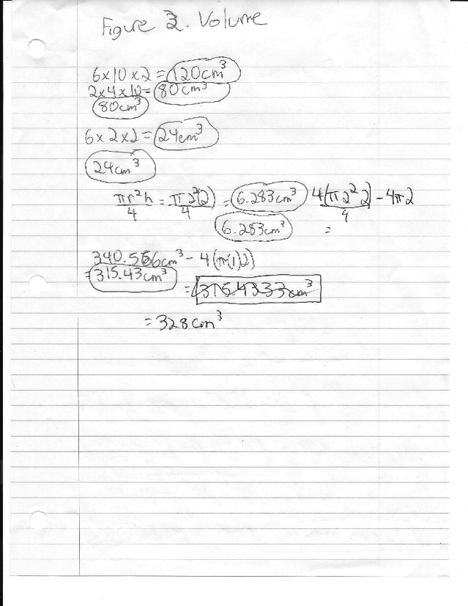
Figure 5: Object 2 Volume Figure 6: Object 3 SA and Volume

Figure 7: AutoCAD Drawing


