Carleton University

Laboratory Report
Course #: PHYS 1003 Experiment #: 5
Thermocouple

Zhi Qiao
(101026761)

Date Performed: December 2, 2016
Date Submitted: December 2, 2016
Lab Period: Fri AM, A10
Partner: Pengliang Zhang
Station #:14
TA: S.J
Purpose
In this experiment, the concept of thermoelectricity and to the insulated calorimeter are introduced. Students are asked to measure the temperature of solid CO2, which is basing on the temperature dependence of the electrostatic potential across junctions between different metals. The experiment is divided into two parts: first, determinate the calibration curve, and second, determinate the temperature of solid CO2.
Theory
The emf between two different metals:
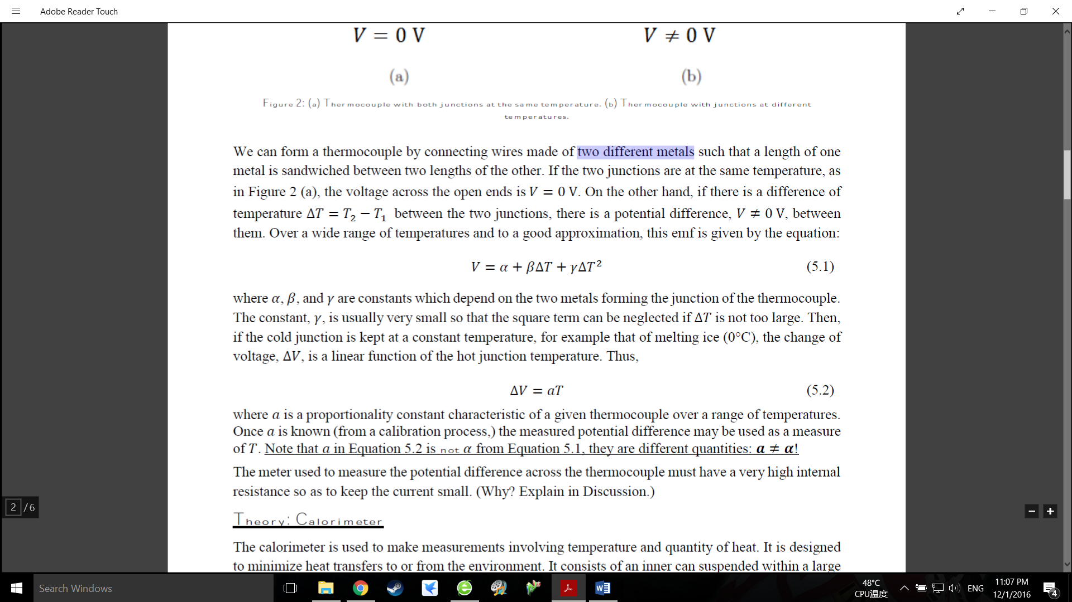
The change of voltage:
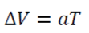
ΔT= The difference of temperature
𝛼, 𝛽, 𝛾= constants depend on the two metals forming the junction of the thermocouple
𝑎 = proportionality constant characteristic of a given thermocouple over a range of temperatures

Consistency Test:
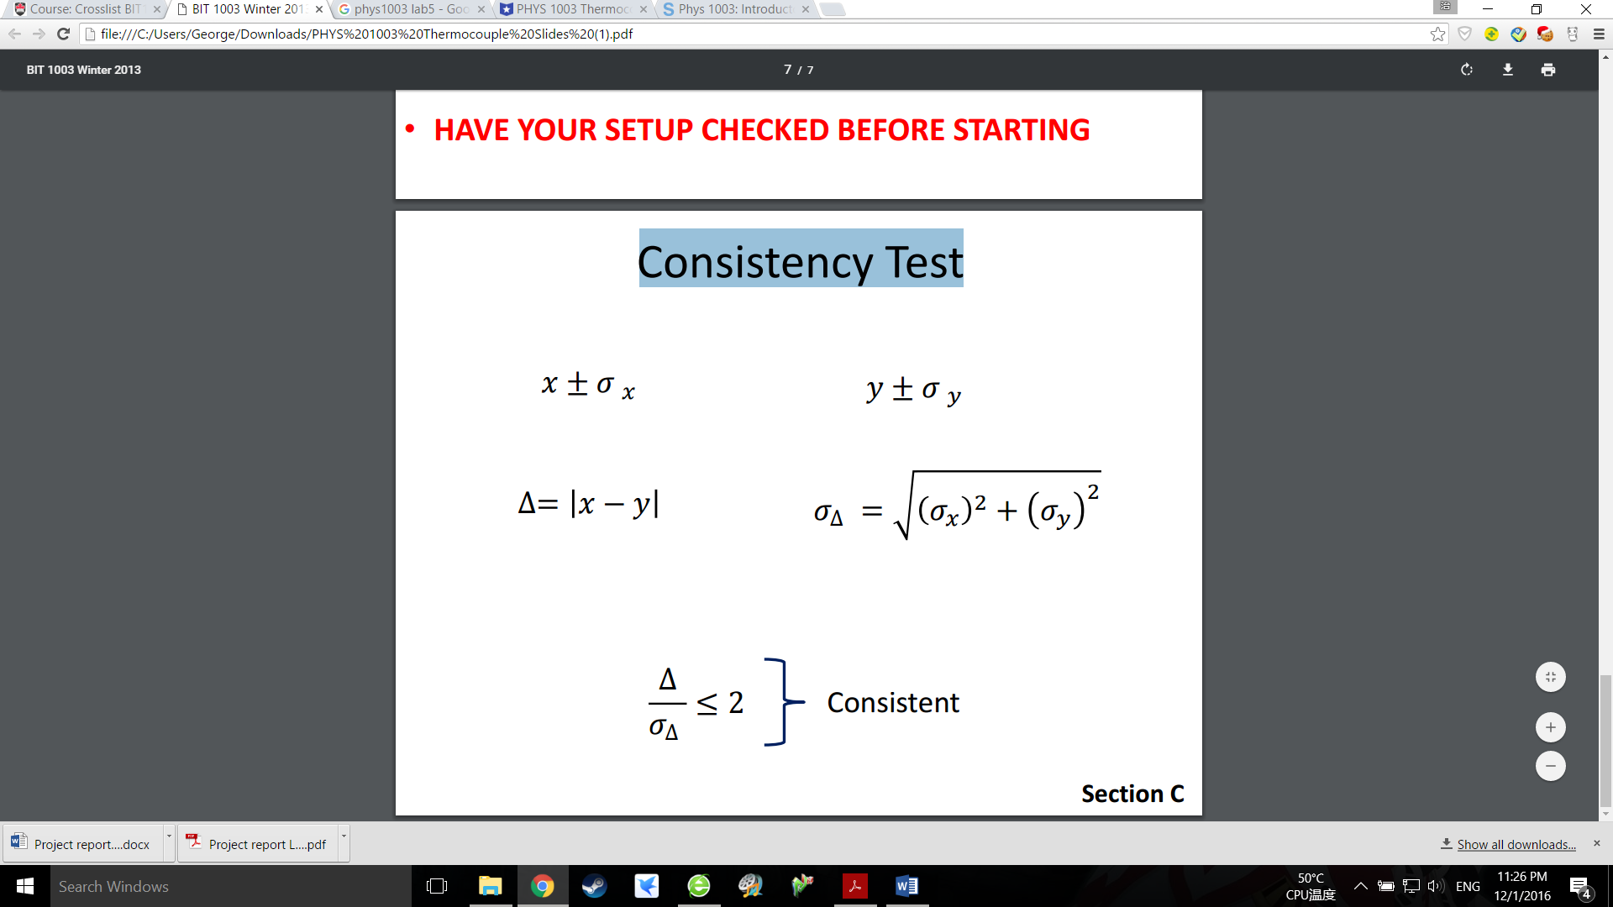

Apparatus
Experiment instrument:
Power Supply (Error = 0.02 mV), Temperature Probe (Error = 0.3℃), glass junction (2), solid CO2.

Data collection: LoggerPro

Discussion
Do you expect Equation 5.2 to provide accurate extrapolation of ∆𝑉 at 𝑇 = 100°𝐶? Which is better: using Equation 5.2 or using the graphical extrapolation?

• Do you expect Equation 5.2 to be accurate when finding sublimation temperature of dry ice? Why or why not?

• What results were you expecting for each of your consistency tests? Why? Did you obtain what you expected?

• What type of thermocouple are your using? Is Equation 5.1 an adequate representation of the
temperature and voltage dependence for this type of thermocouple?

• What is the purpose of putting ice into the cold junction? Can the experiment be done without it?

• Why did you need to stir the water in the hot junction and occasionally shake the cold junction can?

• Why was the alcohol slurry necessary?

• Why is solid CO2 is referred to as ‘dry ice’? Is there such a thing as ‘wet ice’? Is it possible to skate on dry ice? Why or why not?

