ECOR 1010 – Introduction to Engineering

Colin haggerty
Assignment #7
Assignment Title: Matrix Operations with MATLAB

TO Marking TA:
Name: Eric Labrecque
Email: EricLabrecque@cmail.carleton.ca

Lab Section: L14
Room: ME2256 – Carleton University

FROM:
Email: colinhaggerty@cmail.carleton.ca
Student Number: 101040651

Number of Figures and Tables (Including handwritten ones): 4
Last Date and Time of Revision: 02 December 2016 @ 11:56PM

Introduction
MATLAB is a wildly useful tool for engineers to help with dealing with vector and matrices. The point of this lab is to answer a series of questions regarding linear systems using MATLAB to ultimately improve ability in the use of the program.

Materials and Methods
MATLAB and intelliCAD were the programs used for the questions. Many of the questions can be figured out by putting their values into MATLAB to get an answer. By following the readings in the textbook and the lecture slides from class, the operations like plotting graphs, making figures, and solving more complicated questions can be done. Question 5 needed intelliCAD to draw the figure of a circuit with the figures found from answering the question, the knowledge of the program comes from previous labs.

Results and discussion
For part 1, some of the questions were straight forward simple matrix operations, but for 1.c), and 1.d) the questions couldn’t be answered because the matrices of the question didn’t have the same dimensions. In question two, the boats navigation system can clearly be seen to be faulty because the end point of the trip is several kilometres away from the start point, and the total trip distance was found to be 64.56km. Part 2 became a little more complicated. Question one and two involved doing simple operations but to more complicated matrices, which resulted in more complicated answers than part 1. Question 3 is not possible because the matrices don’t have the same inner values needed to multiply. Question 4 found that the coal plant burned 4.1404 tonnes of coal A, and 1.6837 tonnes of coal B. Question 5 involved rearranging the given formula to find the amp values for the currents, and creating a sketch of the circuit in intelliCAD. And finally, question 6 used a matrix made from a student number to create a value of 55 when multiplied by a given vector, and a value of 17.5070 when that number was divided by pi.

Conclusions
In conclusion, it becomes very apparent that tools like MATLAB are extremely useful for calculations like the ones done. They are a large time-saver that can solve complicated questions about matrices and vectors, that before the software, would have been nearly impossible to do by hand. Tools like this give engineers a great hand in problem solving, and advancing the field, by making things a little easier.

APPENDIces- Figures and Tables
Part 1:

Question 1 | Code and Answer
1.a) | >> H=[8;5;-6]  >> I=[0;1;-3]  >> J=[8,4,-7]  >> K=[6;3;0;1]  >> p=0.32  >> q=2.35  >> r=-0.4  >> L=[10;8]  >> dot(H,I)  ans =  23
1.b) | >> p*K  ans =  1.9200  0.9600  0  0.3200
1.c) | >> dot(L,H)  Error using dot (line 33)  A and B must be same size.  % Not possible, the two vectors must have the same number of elements
1.d) | >> J'-K  Matrix dimensions must agree.  % Not possible, the two vectors must have the same number of elements

Question 2 | Code and Answer
Plot | >> X=[0,1,11,16,3,4];  >> Y=[0,10,11,-8,-1,9];  >> plot(X,Y)
Distance | >> A=[1;10];  >> B=[10;1];  >> C=[5;-19];  >> D=[-13;7];  >> E=[1;10];  >> Dist=[A+B+C+D+E]  Dist =  4  9  %{  No, the navigation system leads the boat wildly off corse because at the end, they are 4km east, and 9km north of the origin.  }%  >> totalDist=[norm(A)+norm(B)+norm(C)+norm(D)+norm(E)]  totalDist =  64.5613  % The boat travels a total distance of 64.5km

Question 3 | Code and Answer
equation | >>x=[-3:0.0001:3];  >> y=[sin(x.^2)+((10-4*x+x.^2)/(7+2*x.^2))];  >> plot(x,y)
Graph plot

Part 2:
Question 1 | Code and Answer
1.a) | >> F=[3,9;7,-1;3,0;6,8;9,5]  >> G=[-9,3,8,5,-1,-2;7,-1,-2,9,3,3]  >> Q=[2,-7,2;1,0,7;-5,3,5]  >> U=[1,0;0,1]  >> (F*G)*r  ans =  -14.4000 0 -2.4000 -38.4000 -9.6000 -13.2000  28.0000 -8.8000 -23.2000 -10.4000 4.0000 -4.4000  10.8000 -3.6000 -9.6000 -6.0000 1.2000 -2.4000  -0.8000 -4.0000 -12.8000 -40.8000 -7.2000 -14.4000  18.4000 -8.8000 -24.8000 -36.0000 -2.4000 -13.2000  12.4000 -5.2000 -14.4000 -17.2000 -0.4000 -6.4000
1.b) | >> W=F-G'  W =  12 2  4 0  -5 2  1 -1  10 2  3 -1
1.c) | >> X=[1,2,3,4,5,6]  >> plot(X',sort(W))
1.d) | >> U*G  ans =  -9 3 8 5 -1 2  7 -1 -2 9 3 3
1.e) | >> F*U  ans =  3 9  7 -1  3 0  6 8  9 5  5 2
1.f) | >> Q*H  ans =  -31  -34  -55
1.g) | >> (q*G)+(p*F')  ans =  -20.1900 9.2900 19.7600 13.6700 0.5300 6.3000  19.3300 -2.6700 -4.7000 23.7100 8.6500 7.6900

Question 2 | Code and Answer
2) | >> A=[9,2,5;6,4,1;2,7,2];  >> b=[4;3;1];  >> x2=inv(A)*b  x2 =  0.4969  0.0314  -0.1069  -The original vector $\vec{x}$ = $\left[\begin{matrix}0.4969 \\ 0.0314 \\ -0.1069\end{matrix}\right]$

Question 3 | Code and Answer
3) | >> x3=[1,-1,0,0,0,0;0,1,-1,0,0,0;0,0,1,-1,0,0;0,0,0,1,-1,0;0,0,0,0,1,-1;-1,0,0,0,0,1];  >> C=[75;-60;115;-120;55;-65];  >> B=pinv(x3)*C  B =  49.1667  -25.8333  34.1667  -80.8333  39.1667  -15.8333  >> (B*x3)-C  Error using *  Inner matrix dimensions must agree.

Question 4 | Code and Answer
4) | >> coalAB=[26.6,30.2;3100,6400;240,340;];  >> coalF=[162;23611;1566];  >> total=coalAB\coalF  total =  4.1404  1.6837

Question 5 | Code and Answer
5) | >> R1=6;  >> R2=5;  >> R3=1;  >> R4=8;  >> V1=5.51;  >> V2=3.51;  %{ Given:  V1 + R2(i1 - i3) + R1(i1 – i2) = 0  V2 + R3(i2 - i3) + R1(i2 – i1) = 0  R2(i3 - i1) + R3(i3 – i2) + R4*i3 = 0  Change the formula by rearranging and rainbowing to get:  (R1+R2)i1 + (-R1)i2 + (-R2)i3=-V1  (-R1)i1 + (R3+R1)i2 + (-R3)i3=-V2  (-R2)i1 + (-R3)i2 + (R2+R3+R4)i3=0  }%  >> A=[(R1+R2),-R1,-R2;-R1,(R3+R1),-R3;-R2,-R3,(R2+R3+R4)];  >> B=[-V1;-V2;0];  >> I=A\B  I =  -2.5819  -2.8755  -1.1275

Question 5 Drawing
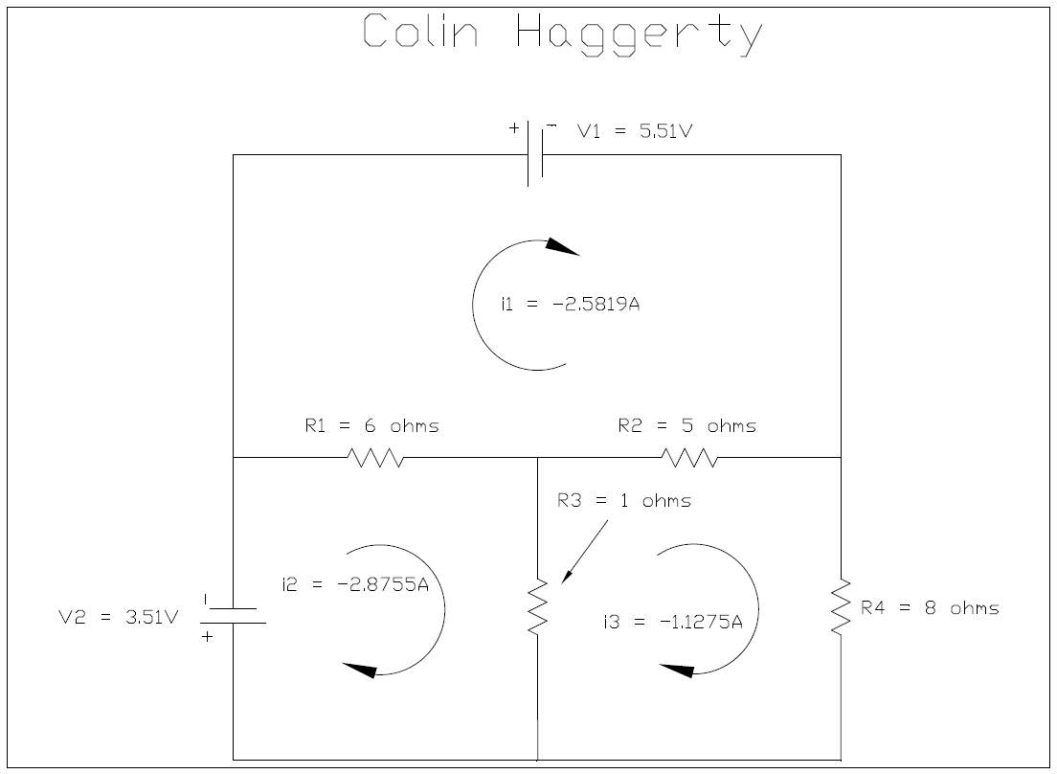

Question 6 | Code and Answer
6) | >> A=[1,0,1;0,4,0;6,5,1];  >> b=[1 2 2];  >> c=b*A*b'  c =  55  >> E=c/pi  E =  17.5070

