ECOR 1010 – Introduction to Engineering

[Type Authors¹]
Assignment #4
Assignment Title: Creo Parametric (Bearing Solid Model)
TO Marking TA:
Name: [Email]
Email: [Email]

Lab Section: [Email]
Room: ME2256 – Carleton University

FROM
Student Number: [Email]

 | Marks | Out of | Comments
Wire Frame | 1.5 | 2 | Vol does not match lab 2 (-.5)
Screen Shot | 1 | 1
3D view w/ Student # | 3 | 3
Working Drawing | 3 | 4 | Hole Locations not defined (-1), Warning don’t dim on part
Total | 9 | 10

Number of Figures and Tables (Including handwritten ones): 4
Last Date and Time of Revision: 19/10/2016 @ 09:51 (PM)

APPENDIces - Figures
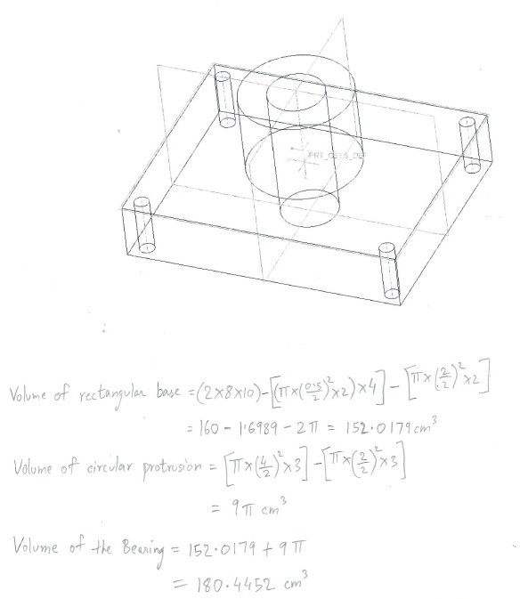
Figure 1: Creo Wireframe of the Bearing and calculated volume of the Bearing
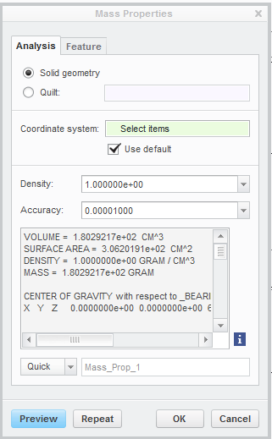
Figure 2: Mass Properties of the Bearing

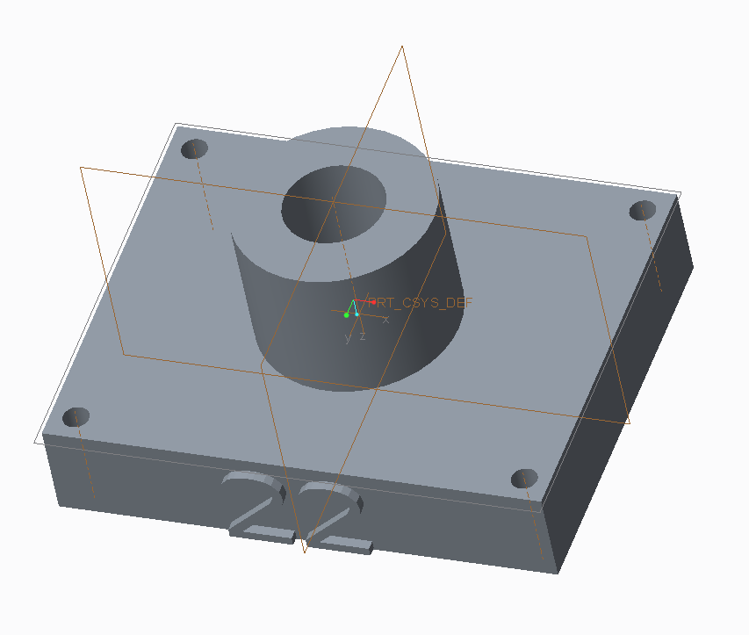
Figure 3: Bearing with a text protrusion

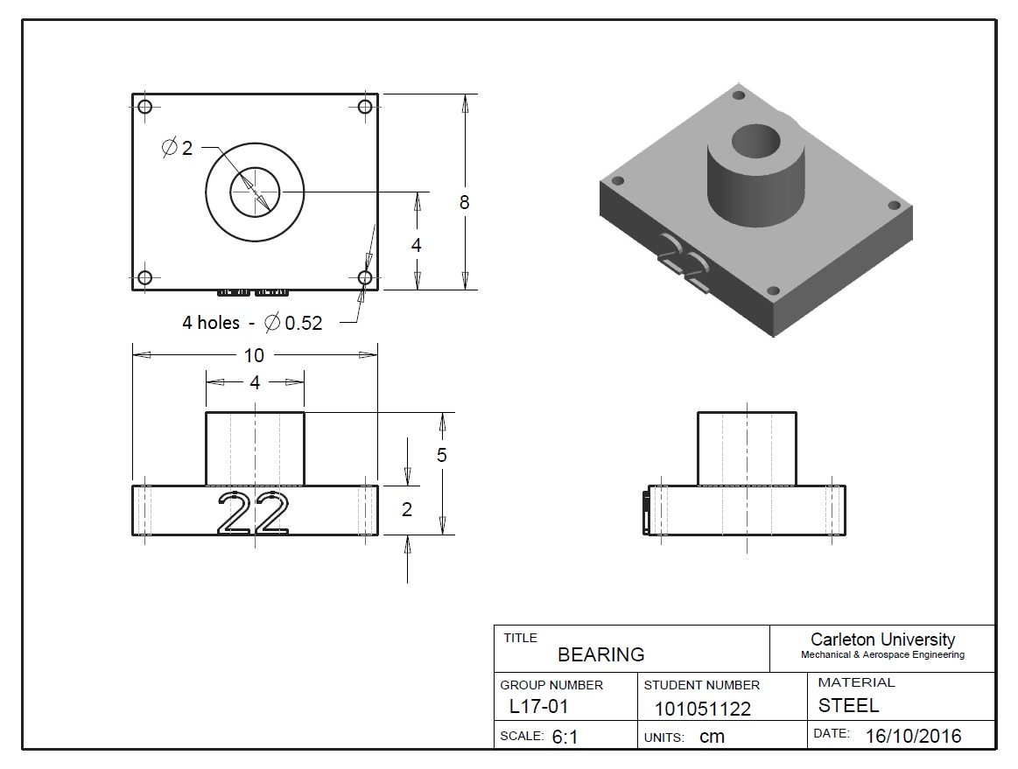
Figure 4: Dimensioned views of the Bearing

