Burger King developing a marketing mix for growth
Overview:
BK was in a virtual tie with Wendy’s and faced increasingly strong challenges, both from Sonic Drive-In (Sonic) and Jack in the Box (Jack’s) and from various fast-casual chains.
Problem:

Need to develop a marketing mix that would both distance the company from its competitors and narrow the significant gap between BK and the industry leader, McDonald’s.
Product:
- The company’s signature sandwich was still the Whopper (switched from a plain bun to a sesame seed bun in the 1970s)
(changed patty size in the 1980s)
- the Original Chicken Sandwich was featured on the menu in all markets in 2015,
- during the late 1970s, BK started serving breakfast. In 2015, the company still offered traditional breakfast fare such as hash browns; breakfast sandwiches with eggs, cheese, sausage, bacon and ham;
- In 1986, the company introduced BK Chicken Tenders to compete with McDonald’s Chicken McNuggets.
- In the early 1990s, BK established its Kids Club; however, by 2015, it no longer focused on this market.
- A value menu was still offered in 2015, and featured additional products (crispy chicken, a salad, additional drinks and desserts).
- Cultural modifications to their product: For instance, in Saudi Arabia, pork was not served. In Australia, BK featured the Aussie Burger, a burger with fried egg, beetroot and other Australian flavours. In Asian markets, the company featured dark-meat chicken.
Price
- In late 2014 and early 2015, for a limited time, BK offered its chicken tenders for half price, which resulted in a lower per-unit cost than McDonald’s.
- Prices were traditionally high
Distribution
- In 2015, RSI (Restaurant Services Inc.)(Franchise cooperative) managed BK’s distribution, identifying potential new distributors and ensuring that regional distribution centres adhered to performance standards. Further, RSI attempted to reduce logistics and distribution costs.
Market Analysis:
- 8.6% annual growth rate in the fast food industry
- Scrutiny regarding the nutritional contents of the food in the industry
- Negative image in the industry
- Another trend was rising commodity prices.
- Prices for livestock, wheat and corn increased significantly (food made up one third of costs
- Market saturation
- Emerging fast-casual chains
- They were growing fast (by 4% more than fast-food chains)
- They promised fresh food while maintaining the fast food processing
- Fast-casual chains offered greater customization and flexibility
- Offered products at almost the same prices and had an average transaction cost that was 40% higher than fast food chains
Strengths:
- Strong market position
- Strong brand equity
- Growth model not capital intensive of 90% of its restaurants are owned by franchisees
- Strong brand financial performance
- High quality products
- Wide variety of food products
Weakness:
- Heavily concentrated in the US
- Few corporately owned stores
- Narrow-based target market
- Inconsistent management and strategy
- Changing executives
- Confusing ad campaigns
- High prices
- Identity crisis differentiation problem

Opportunities
- New product development, particularly around breakfast
- Keep building its brand through ad campaign, such as the whopper virgins
- Expansion into emerging markets
- Wide-based target market
Threats
- Changing consumer habits towards healthier food choices
- Intense competition from McDonald’s, other restaurants and even retailers
- Increasing labor costs, increasing commodity prices putting pressure on bottom line margins
- The major competitor McDonald’s is very far ahead in terms of market share
ALTERNATIVE COURSES OF ACTION
1.Play it safe strategy. Make some appealing advertisement that makes fans feel important.
A market follower is a firm in a strong, but not dominant position that is content to stay at that position. The rationale is that by developing strategies that are parallel to those of the market leader, they will gain much of the market from the leader while being exposed to very little risk.
The advantages of this strategy are:
no expensive R&D failures
no risk of bad business model
“best practices” are already established
able to capitalize on the promotional activities of the market leader
no risk of government anti-combines actions
minimal risk of competitive attacks
don’t waste money in a head-on battle with the market leader
Advantages
Burger King fans will be flattered because BK management give them importance and because of that, the loyalty of the fans will be lastly. At the same time, They will attract more customers and the BK fans will be happy and feel important.
Disadvantages
Costly at the same time, it will need some time to be perfect before it will appear to the media.
2.Continue making innovative products.
Advantages
More customers will get into them and because of that, their profit/saleswill increase.

Disadvantages
It will be costly and it will take several time of brainstorming if theproduct that they will introduce will be a big boom to the customers/public.
3.Try to lower their price.
Advantages
Number of customers will increase at their sales/profit may be increase due to the volume wise buying.
Disadvantages
This is partly hard to the management because this is new to them.And it will have a fear attach.
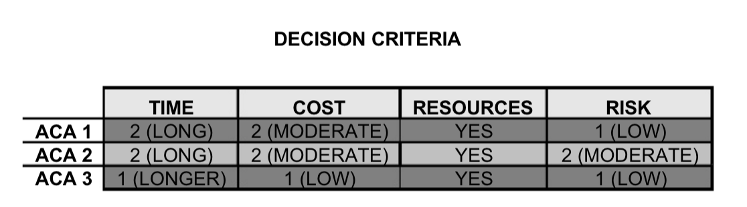
RECOMMENDATION
- ACA 1: Play it safe strategy. Make some appealing advertisement that makes fan feel included. It may the long but BK has lower risk with this strategy. BK doesn’t have to be number one, they need to build first a constant brand image and differentiation. They need to focus their ads and reduce confusion. No culturally offensive ads.

