SOC 808 Module 2
Healthy eating discourse is a particular way of understanding healthy eating that circulates through society and is reproduced (and sometimes resisted) through people’s eating practices.

They are time and place specific
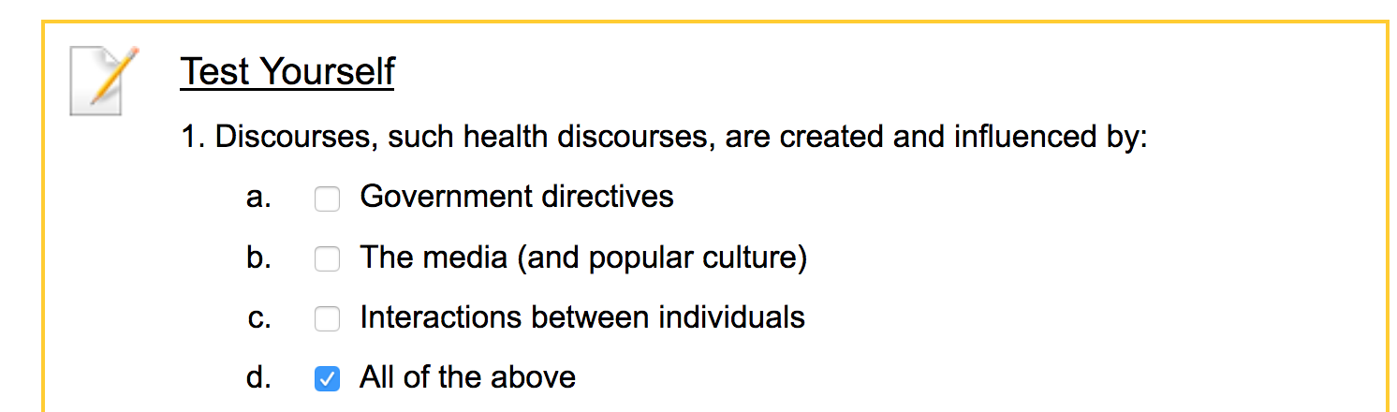

- Because there is usually more than one discourse happening at a specific time and place, they tend to compete with eachother for acceptance.
- Most popular will typically be labeled as “Mainstream”
- Less popular will typically be labeled as “Alternative”
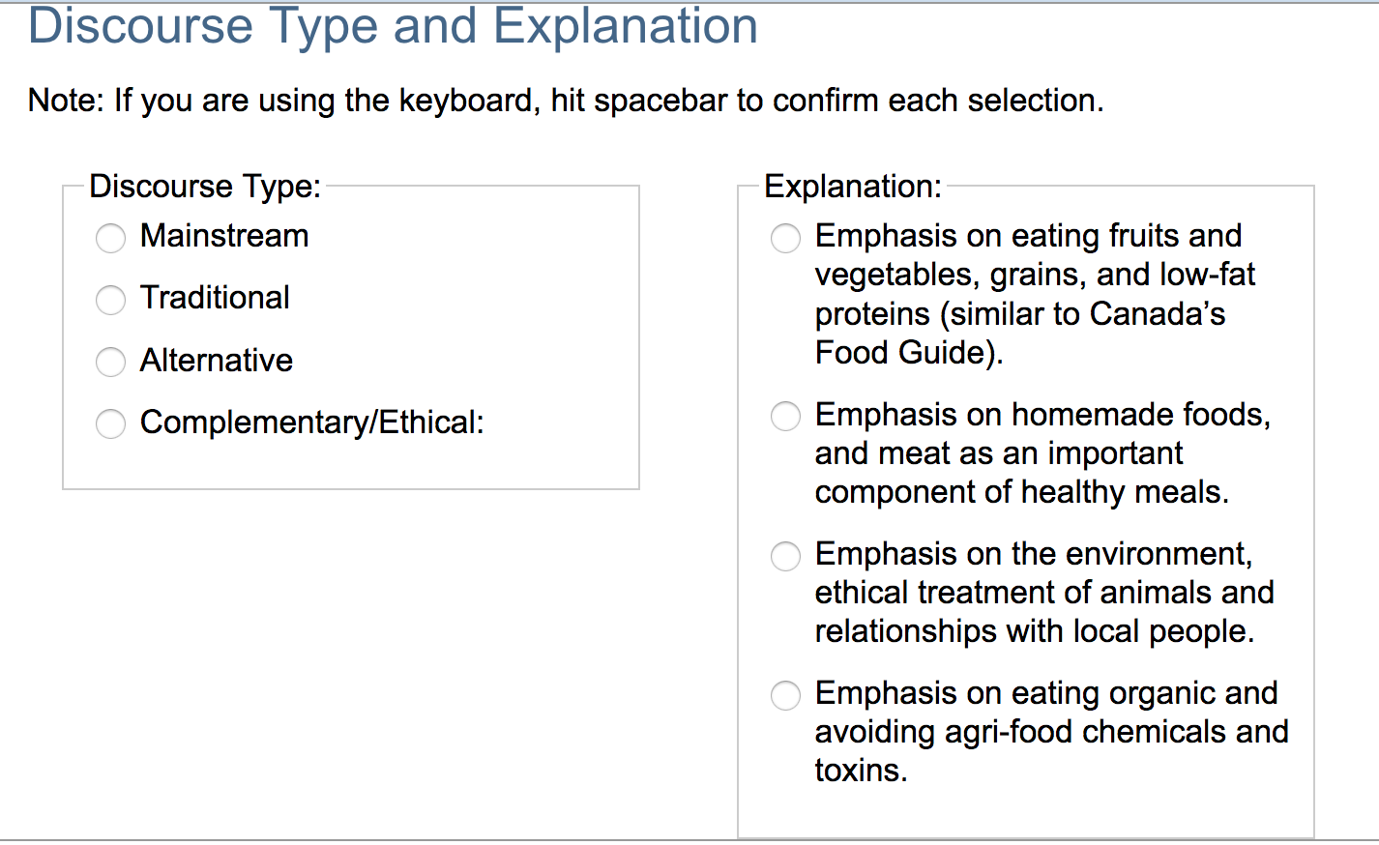
- Different discourses could be “Mainstream”, “Alternative”, “Traditional”, & “Complementary/Ethical”.

Mainstream= Emphasis on eating fruits and vegetables, grains, and low-fat proteins (similar to Canada’s Food Guide).
Traditional= Emphasis on homemade foods, and meat as an important component of healthy meals.
Alternative= Emphasis on eating organic and avoiding agri-food chemicals and toxins.
Complementary/Ethical= Emphasis on the environment, ethical treatment of animals and relationships with local people.
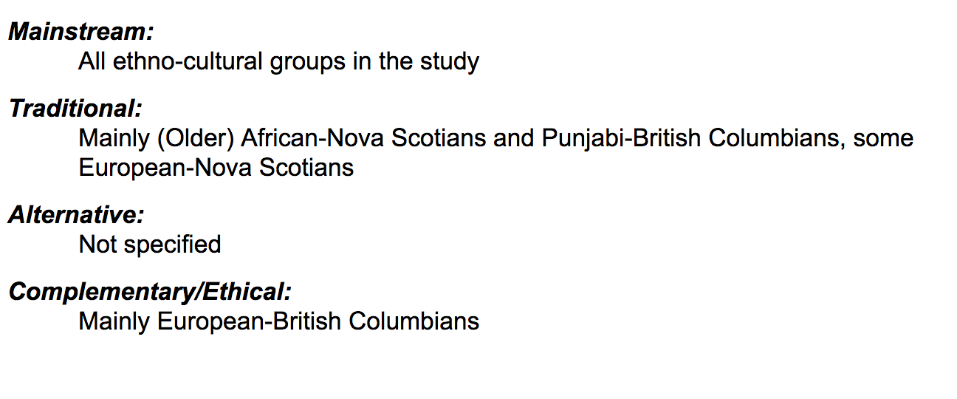

- In the earlier decades of the 20th century we thought of meals as made up of different types of foods–vegetables, meat, dairy products, etc.–in recent decades, we tend to think of meals as made up of different nutritional components–calories, fat, vitamins, etc. Most recently, we have gotten even more complex, talking about things like antioxidants, trans fats, and phytochemicals.
  - Some food journalists argue that this switch has been detrimental to our health
- Nutritionism: “a paradigm that reduces the value and benefits of food to its nutrients, assuming that we eat only to promote physical health” (Koc et al., p. 387). This term is usually used by critics of this paradigm.

- Food desert: Geographic areas with insufficient numbers of stores and other food-related facilities that provide access to fresh and healthy foods” (Koc et al. 2012, p.384).
-Food deserts are often located in low-income communities
-Food access is affected by a host of factors – including income, mobility, transportation, walkability – that create a “layering of disadvantages.”
-It’s also important to note that low-income communities are typically home to large numbers of residents of color, and that First Nations reserves are often food deserts.

-Ethno-racial identity may influence dietary health
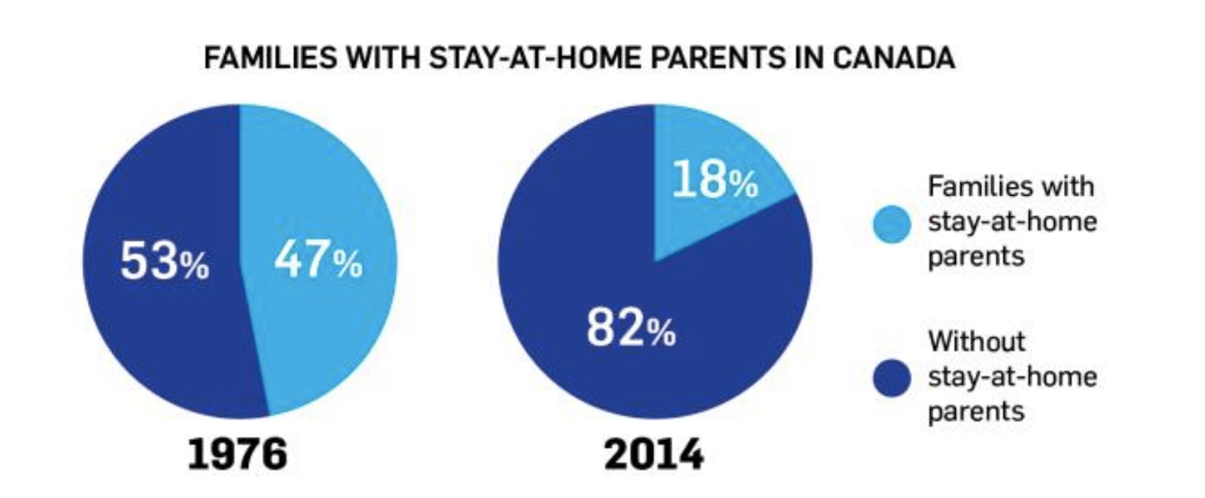
-The implication is that food habits and body shapes that are portrayed as unhealthy from some ethno-racial perspectives might not be seen as unhealthy from other ethno-racial perspectives.

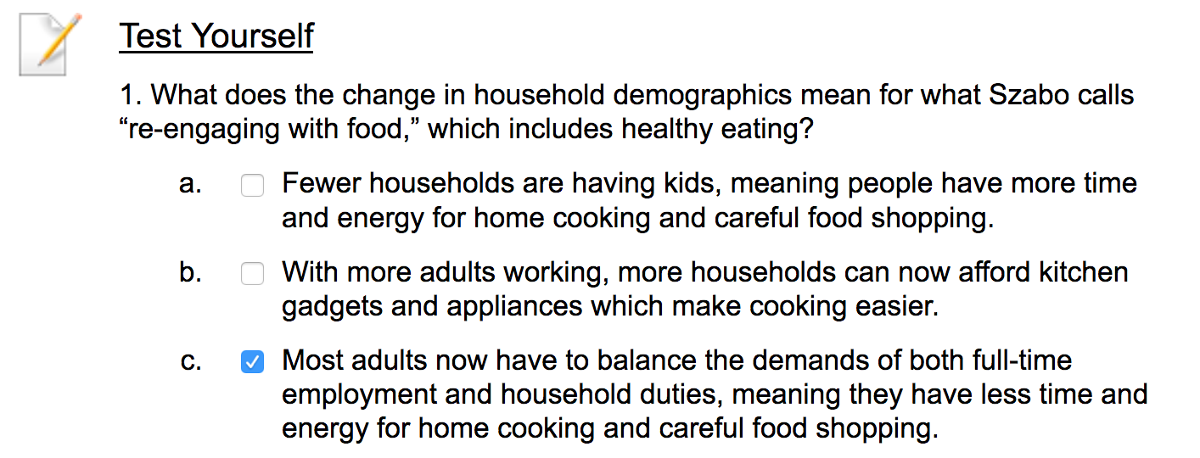

- This means that even though people want to eat healthily and have the skills to do so, they are often constrained by their job and other life responsibilities from spending much time cooking.

