CHAPTER 1 NOTES

What is Statistics?

Statistics is a tool for creating new understanding from a set of numbers. (A way to get information from data.)

Data: Facts, especially numerical facts, collected together for reference or information.
Information: Knowledge communicated concerning some particular fact.
Population: group of all items of interest to the statistics practitioner.
Ex. All the members of the Ryerson University.
Parameter: A descriptive measure of a population.
Ex. Mean number of soft drinks sold at Ryerson every week.
Sample: A set of items drawn from the population.
Ex.500 students surveyed.
Statistic: A descriptive measure of a sample.
Ex. Average number of soft drinks these students buy per week.
Variable: A characteristic of population or sample that is of interest for us.
Ex. Number of soft drinks a student buys every week.

Type of Statistics:

Descriptive statistics: A set of methods of organizing, summarizing, and
presenting data in a convenient and informative way.
Ex. - Enable meaningful interpretation
- Support decision making
- Use of graphical techniques, and numerical techniques

Inferential Statistics: A set of methods used to draw conclusions or inferences
about characteristics of populations based on data from a sample.
(Process of making an estimate, prediction, or decision about a population
based on a sample.)
Ex. – Drawing conclusions about a large group of individuals based on a smaller group.

Types of Variables

Categorical: (qualitative) variables have values that can only be placed into categories, such as “yes” and “no.”
Numerical:(quantitative) variables have values that represent quantities.
- Discrete variables arise from a counting process.
- Continuous variables arise from a measuring process.
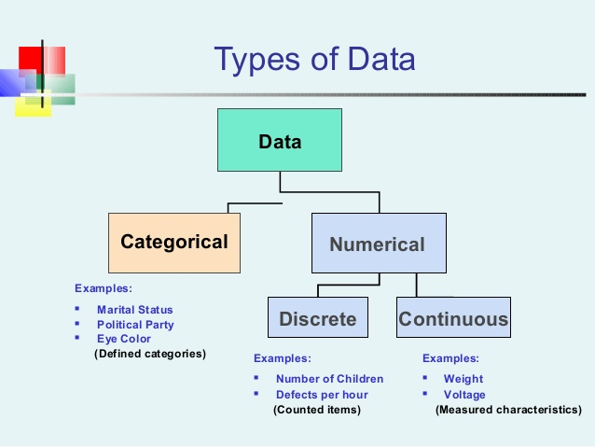

Interval data: Like ordinal except we can say the intervals between each value are equally split. (Ex. Distance, price, weight)
Ordinal: Refers to quantities that have a natural ordering. The ranking of favorite sports, the order of people's place in a line, the order of runners finishing a race or more often the choice on a rating scale from 1 to 5.

Nominal Data: Refers to categorically discrete data such as the name of your school, type of car you drive or name of a book.

Ratio data: interval data with a natural zero point. For example, time is ratio since 0 time is meaningful.

Relative Frequency: Frequency / Total # of observations

A stem and leaf display: Organizes data into groups (called stems) so that the values within each group (the leaves) branch out to the right on each row.

Stem Rules
- The number of stems should be from 6 to 13 stems
- The stem values should be consecutive numbers or repeated
numbers. The numbers may each be repeated twice or 5
times
- The stem units must be indicated if the stem is not to be taken
at face value.
- There must be at least one leaf associated with the first and
last stem.
Leaf Rules
- There is no rounding off.
- The leaf values are written in ascending order when positive
and descending order when negative.
- The leaf values must be evenly spaced.
- No commas or dashes between the numbers are allowed.

