CHAPTER 2 NOTES

Using the stem and leaf plot to detect the shape of the data distribution

The symmetry of a data distribution can be classified in three ways:
- Skewed to the left (the bulk of the data is located on the right side of the distribution; see Graph A.
- Symmetrical (the bulk of the data is located in the middle of the distribution; see Graph B.
- Skewed to the right (the bulk of the data is located on the left side of the distribution; see Graph C.
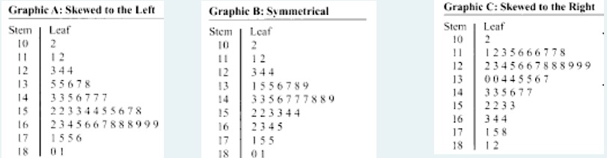
Frequency distribution: A summary table in which the data are arranged into numerically ordered classes.
General Guidelines for Constructing a Frequency Distribution

- Number of classes: You should not have too few or too many classes. For the questions you will solve in this course you should use 5 to l0 classes in your final constructed frequency distribution.
- Notation for indicating classes: There are several possible notations that are used to designate the classes. In this course we will use the "and under" notation (e.g., 260 and under 270). The numerical values used in designating the classes when using the "and under” notation are called boundaries.
- Close-ended classes: A close-ended class has both a lower and an upper boundary. An open-ended class is missing one of these boundaries. For example, the class" l00 and over” is an open-ended class because there is no upper boundary. You should avoid using open-ended classes in this course.
- Class width (denoted as CW): A class that has an upper and a lower boundary has a finite class width. The class width is determined by the following formula:
Class Width = Upper boundary -Lower boundary
It is best to select a class width that is an "easy" number to work with. The recommended class widths are shown in the following Table

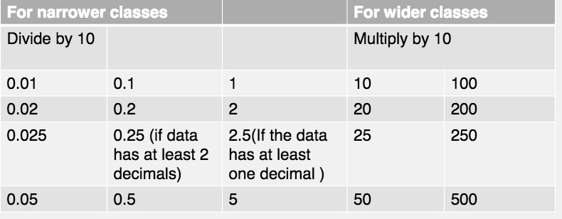
- No gaps between classes: Classes are mutually exclusive and are not overlapping. In other words, every possible value must fall into exactly one class. There must be no gaps between the classes (i.e. the upper boundary of one class will also be the lower boundary of the next class)
- All classes must have the same class width: When working with continuous data, the upper boundary of one class and the lower boundary of the following class reference the same value. Since the boundary value should fall into only one class, the wording" and under “can be used to clarify that the upper boundaries are not included in the classes. To keep it simple, use equal class width for each class.

Determining Class Width:
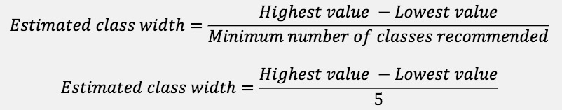
Must always check that the number of classes is between 5 and 10 classes.

Relative Frequency:


