- Hearing: Physiology and Psychoacoustics
- What Is Sound?
- Sounds are created when objects vibrate
  - Vibrations of an object cause molecules in the object’s surrounding medium to vibrate (___________and __________), which causes pressure changes in the medium
- Physical Qualities of Sound Waves
- __________: The magnitude of displacement of a sound pressure wave
  - __________: perceived intensity or magnitude
- __________: The number of sine waves in a given waveform
  - __________
  - How we can distinguish between a trombone and violin playing the same note
- __________: Number of cycles that a wave completes in a given amount of time
  - Measured in __________: Cycles per second
  - Corresponds to our perception of __________
    - Low __________: low __________
    - High __________: high __________
- Human Hearing Range
- Human hearing uses a limited range of frequencies (Hz) and sound pressure levels (dB)
  - We hear vibrations between __________ to__________hertz (cycles per second; Hz)
- Outer ear
- Sounds are first collected from the environment by the __________
- Sound waves are funneled by the __________into the ear canal
- The length and shape of the ear canal enhances certain sound frequencies
- The main purpose of the ear canal is to insulate the structure at its end—the __________
- Tympanic Membrane
- __________ __________: The eardrum; a thin sheet of skin at the end of the outer ear canal
  - Vibrates in response to sound
- Common myth: Puncturing your eardrum will leave you deaf
  - In most cases it will heal itself
  - However, it is still possible to damage it beyond repair
- Middle Ear
- Tympanic membrane is border between outer and middle ear
- Consists of three tiny bones, __________
  - __________, __________, and __________
- Function: Amplify and transmit sounds to the inner ear
- Inner Ear
- Function is roughly analogous to that of the retina
- Fine changes in sound pressure are translated into neural signals
- Consists of __________, __________canals and __________
  - Cochlea is filled with watery fluids in three parallel canals
  - __________
- Organ of Corti
- A structure on the basilar membrane of the cochlea that is composed of hair cells and dendrites of auditory nerve fibers
- Two types of hair cells
  - __________hair cells: Convey almost all information about sound waves to the brain (using afferent fibers)
  - __________hair cells: Convey information from the brain (using efferent fibers)
    - Elaborate feedback system
- Hair Cells
- __________: Hairlike extensions on the tips of hair cells
  - The tip of each __________is connected to the side of its neighbor by a tiny filament called a tip link
  - Point of juncture: __________
Tectorial Membrane
- A gelatinous structure, attached on one end, that extends into the middle canal of the ear, floating above inner hair cells and touching outer hair cells
- Vibrations cause displacement of the tectorial membrane, which bends stereocilia attached to hair cells
- Sound Transduction
- Normally, tip links slightly stretched
  - Under tension
- Movement in the direction of the tallest further stretches fibers; movement opposite direction relaxes them
- Bending causes __________
- Each insertional plaque contains a single cation channel
- Movement in the direction of the tallest increases tension on tip links and opens all ion channels
- Flow of cations (calcium; potassium) into cilium causes depolarization and neurotransmitter release
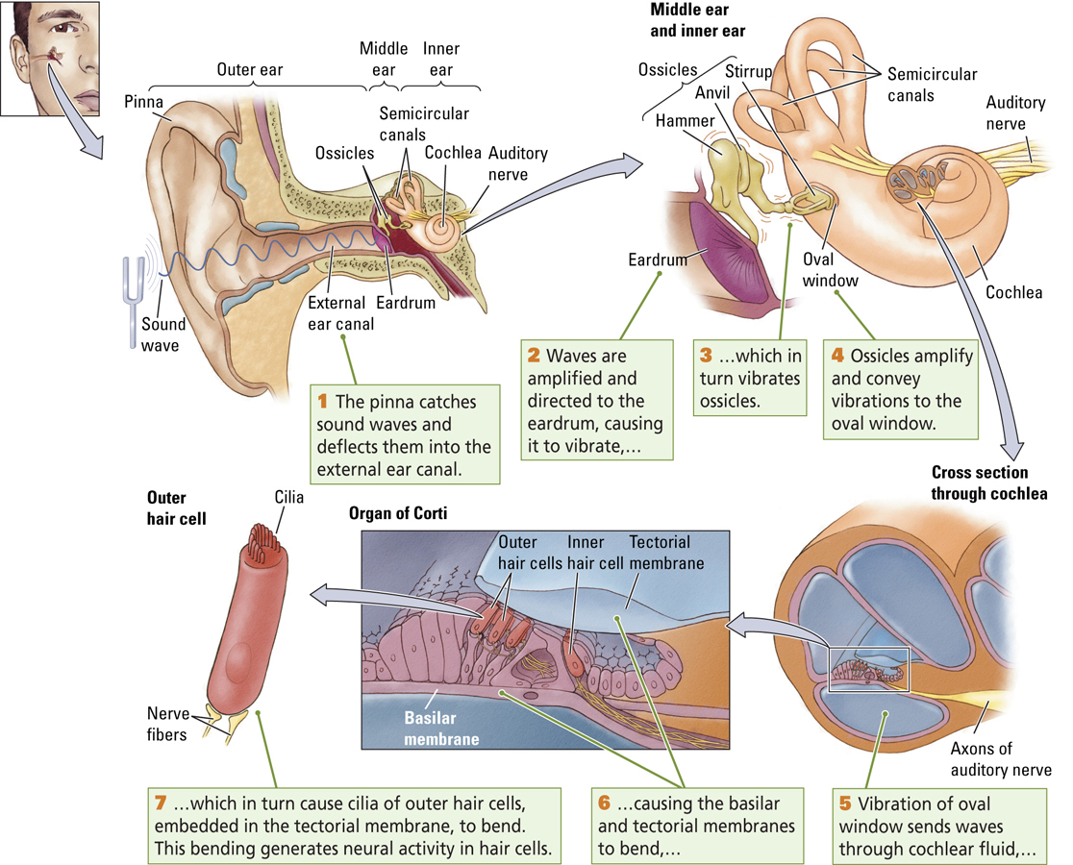
*FIGURES TO KNOW *
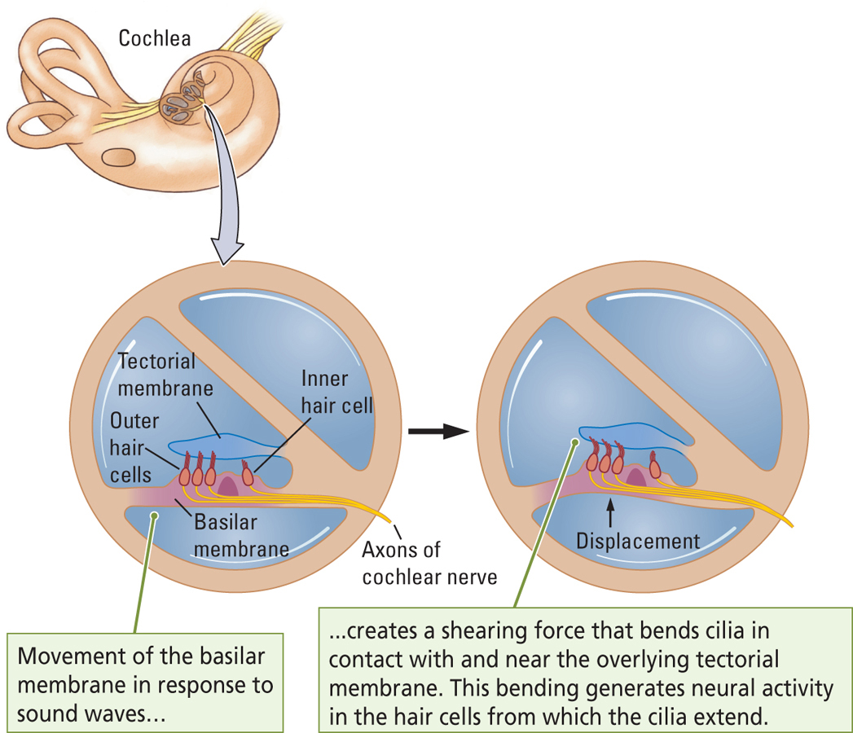
Perception of Pitch
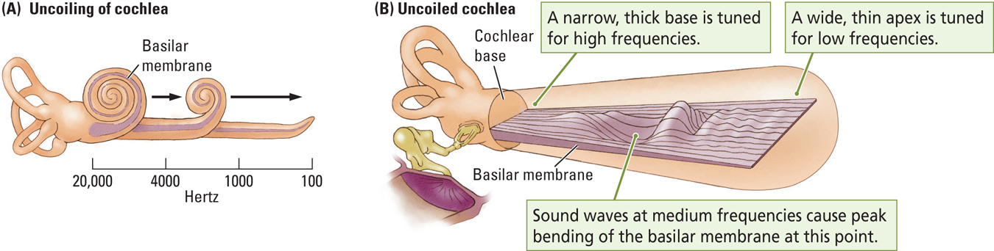
- George von Békésy (1960s)
- Sound waves produced a traveling wave that moved all along the basilar membrane
- Mapped the responsiveness of the basilar membrane to different frequencies
  - Fast wave frequencies: caused maximum displacement near the base of the membrane
  - Slower wave frequencies: caused maximum displacement near the membrane’s apex
Temporal Code for Sound Frequency
- What about very low frequencies?
  - Tonotopic theory does not explain how sounds below 200 Hz are coded
  - Sounds in this range stimulate all cells on the very apex of the basilar membrane
  - Rate of firing is proportional to frequency (temporal code)
Perception of Loudness
- Axons of cochlear nerve code for loudness by altering rate of firing
- Louder sounds produce more intense vibrations greater force on cilia more neurotransmitter release higher rate of firing
Auditory pathway
- Sensory receptors: Hair cells thalamic relay nuclei: MGN Primary sensory cortex: Heschl’s gyrus secondary sensory cortex: Belt region association cortex: parabelt region
Pathways in the auditory system
- Axons of inner hair cells form the auditory nerve (AN)
- Two distinct pathways in the auditory system
  - One for identifying objects by their sound characteristics
  - One for directing our movements by the sounds we hear
Auditory Pathway
- Auditory nerve axons first enter ipsilateral (same side) cochlear nucleus of medulla
  - Each fiber divides into two branches, going to cells in the ventral and dorsal cochlear nuclei
- Most synapse on superior olives (first place in brain that receives bilateral input), which project to inferior colliculus via lateral lemniscus
- Others go to the reticular formation (arousal!)
- Inferior colliculi then send output to the medial geniculate nuclei in the thalamus
Primary auditory cortex (A1)
- Heschl’s gyrus: Located in lateral fissure separating temporal and frontal lobes
  - Responsible for processing acoustic organization
  - Each hemisphere gets information from both ears
- Tonotopic Organization: neurons that respond to different frequencies are organized anatomically in order of frequency
  - Basal end of basilar membrane (end toward the oval window) most posterior in cortex; apical end most anterior
- Hierarchical Organization:
  - Primary (A1)
  - Belt Region - (Secondary)
    - Directly adjacent to A1, with inputs from A1, where neurons respond to more complex characteristics of sounds
    - Also: Wernicke’s area
  - Parabelt Region (Association)
    - Lateral and adjacent to the belt area; neurons respond to more complex characteristics of sounds, as well as to input from other senses
  - Primary: high frequency sound, belt region: that’s a bird, parabelt region: that’s a cardinal
Properties of Language and Music as Sounds
- Language and music both convey meaning and evoke emotion
  - Left temporal lobe analyzes speech for meaning
  - Right temporal lobe analyzes musical sounds for meaning
- Humans have an amazing capacity for learning and remembering linguistic and musical information
- Language facilitates communication
- Music helps us to regulate our emotions and affect the emotions of others
Lateralization
- Process whereby functions become localized primarily on one side of the brain
  - Analysis of speech takes place largely in the left hemisphere
  - Analysis of musical sounds takes place largely in the right hemisphere
- What about left-handed people?
  - About 70% are similar to right-handers and have language in left hemisphere
  - In the remaining 30%, speech is represented either in the right hemisphere or bilaterally
Evidence for a Genetic Basis of Language
- Chomsky, Pinker
  - Language is universal in human populations
  - Humans learn language early in life and seemingly without effort
    - There is likely a sensitive period for language acquisition that is from about 1 to 6 years of age
  - Languages have many structural elements in common
    - Examples: syntax and grammar
Localization of Language in the Brain
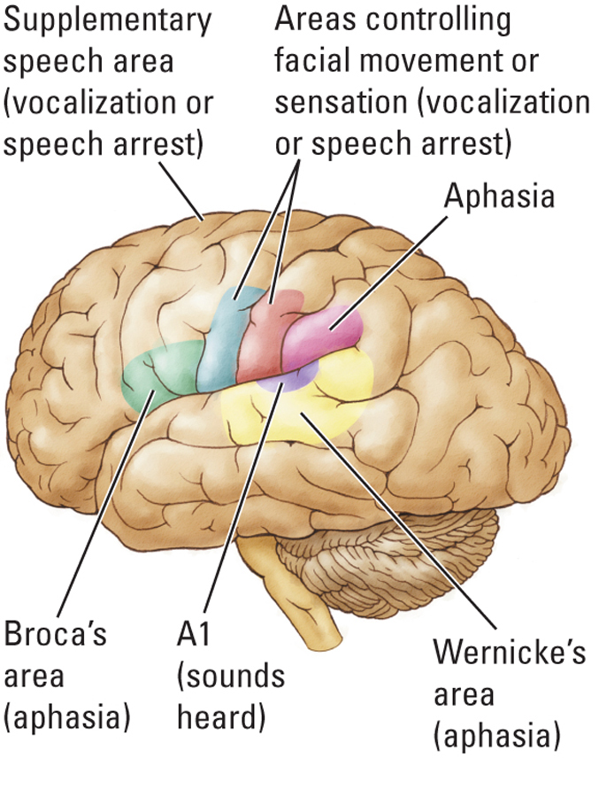
- Broca’s area
  - Anterior speech area in the left hemisphere that functions with the motor cortex to produce the movements needed for speaking
- Wernicke’s area
  - Posterior speech area at the rear of the left temporal lobe that regulates language comprehension; also called the posterior speech zone
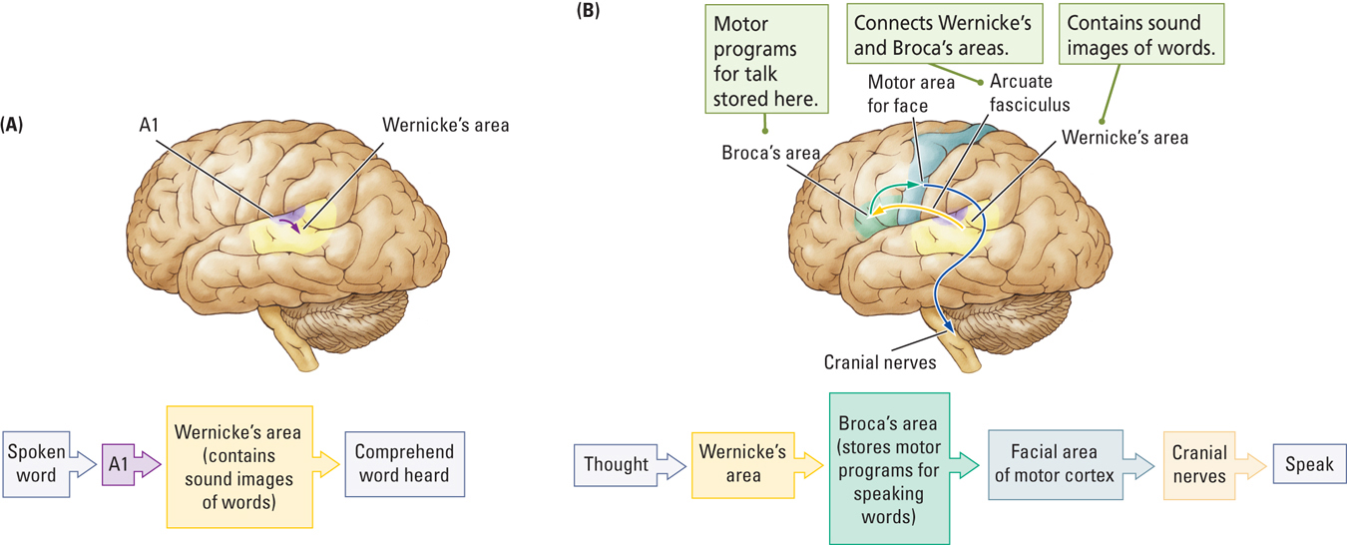
Aphasia
- Inability to speak or comprehend language despite the presence of normal comprehension or intact vocal mechanisms
  - Broca’s aphasia is the inability to speak fluently despite the presence of normal comprehension and intact vocal mechanisms
  - Wernicke’s aphasia is inability to understand or to produce meaningful language even though the production of words is still intact
Processing Language
- Auditory and speech zones mapped by brain Stimulation
- 1930s: Wilder Penfield (Neurosurgeon)
  - Four Important cortical regions for control of language
    - Broca’s area (left hemisphere)
    - Wernicke’s area (left hemisphere)
    - Dorsal areas of the frontal lobes (bilateral)
    - Motor and somatosensory areas that control facial, tongue, and throat muscles and sensations (bilateral)
- Supplementary Speech Area
  - Speech production region on the dorsal surface of the left frontal lobe
  - Stimulation could elicit vocalizations but not coherent speech (‘speech arrest’)

Anatomy of Language
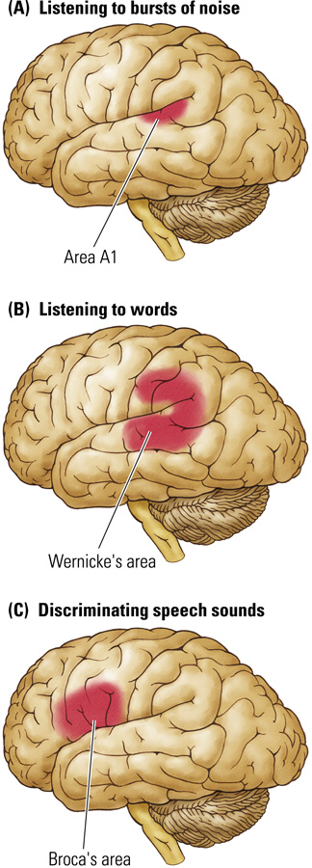
- Auditory cortex mapped by Positron Emission Tomography
- Zatorre and colleagues (1992, 1995)
  - Bursts of noise activated A1
  - Listening to words activated Wernicke’s area
  - Discriminating speech sounds activated Broca’s area
    - Speech-sound perception requires a match with the motor behaviors associated with making that sound
    - E.g., discriminating ‘bag’ from ‘pig’ … same speech sound?
Anatomy of Music
- Music processing is largely a right-hemisphere specialization
- However, the left hemisphere plays some role in certain aspects of music processing, especially those that have to do with making music (e.g., recognizing written music, playing instruments, and composing)
Processing Music
- Zatorre and colleagues (1994): PET Study?
  - Bursts of noise activated A1
  - Listening to melodies activated the secondary auditory cortex of the right hemisphere with some minor activation of same region in left hemisphere
  - Comparing pitches activated the right frontal lobe
    - Short-term memory!
Anatomy of Language and Music
Processing Music
- Like language, the capacity for music may be innate
  - Infants show learning preferences for musical scales versus random notes
  - Children and adults are very sensitive to musical errors : Biased toward perceiving regularity in rhythms?

