Why Do We Sleep and Dream?
Origins of Biological Rhythms
- Biorhythm: Inherent timing mechanism that controls or initiates various biological processes
  - Linked to the cycle of days and seasons produced by the Earth’s rotation around the sun
  - Animals living near the poles of the Earth are more affected by seasonal changes than animals living in equatorial regions
  - Human behavior is governed more by daily cycles than by seasonal cycles
Biological Clocks
- Behavior is not simply driven by external cues from the environment
- Rhythms are endogenous (control comes from within)
  - Biological Clock: Neural system that times behavior
    - Allows animals to anticipate events before they happen
      - Example: Birds migrate before it gets cold
Biological Rhythms
- Period
  - Time required to complete a cycle of activity
- Circannual Rhythm
  - Yearly (e.g., migratory cycles of birds)
- Infradian Rhythm
  - Less than a year (e.g., human menstrual cycle)
- Circadian Rhythm
  - Daily (e.g., human sleep cycle)
- Ultradian Rhythm
  - Less than a day (e.g., eating cycle)
Free-Running Rhythms
- Rhythm of the body’s own devising in the absence of all external cues
  - Without input from external cues, our bodies have their own rhythms with periods of 25 to 27 hours
    - Sleep-wake cycle shifts an hour or so everyday
  - Animals expand and contract their sleep periods as the sleep-related lighting period expands or contracts
Zeitgebers
- Environmental event that entrains biological rhythms; a “time giver”
  - Example: Light resets the biological clock
- Entrainment
  - Determination or modification of the period of a biorhythm
- Jet lag: Fatigue and disorientation from rapid travel through time zones an exposure to a changed light-dark cycle
Neural Basis of the Biological Clock
- Suprachiasmatic Nucleus (SCN)
  - Main pacemaker of circadian rhythms located just above the optic chiasm
- Retinohypothalamic Pathway
  - Neural route from a subset of cone receptors in the retina to the suprachiasmatic nucleus of the hypothalamus; allows light to entrain the rhythmic activity of the SCN
- Other pacemakers exist in the retina and pineal gland, but the SCN is the main one
Immortal Time
- Endogenous rhythm is not learned
  - Martin and colleagues: transplantation studies in hamsters
    - After lesions to the SCN, eat and sleep a normal amount, but the rhythmic nature of these behaviors disappears
    - If SCN cells from embryos are transplanted into the lesioned animals, they will reestablish circadian rhythms
Neural Basis of the Biological Clock
What Ticks?
- At least half a dozen genes and the proteins they make seem to produce the circadian rhythm of SCN cells in mammals
- Mechanism is not fully understood
Pacemaking Circadian Rhythms
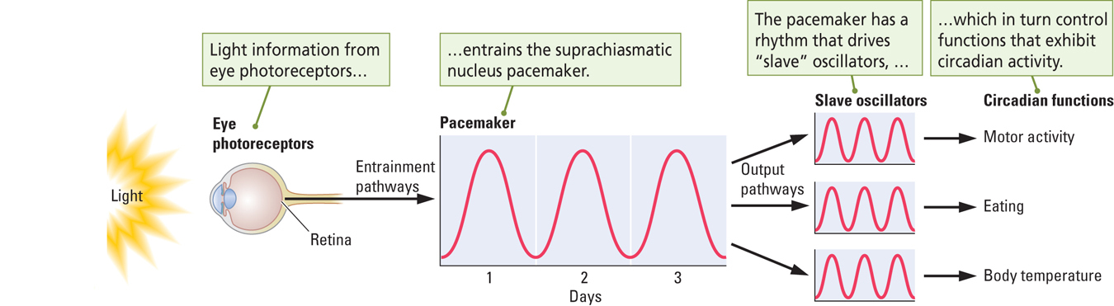
- Model for Circadian Timing System
  - Light entrains the SCN pacemaker
  - SCN pacemaker drives a number of “slave oscillators,” each of which controls the rhythmic occurrence of one behavior (e.g., body temperature)
  - SCN pacemaker may drive the slave oscillators via hormones, proteins, or neurotransmitters
Pacemaking Circannual Rhythms
- Melatonin : Hormone secreted by the pineal gland during the dark phase of the day-night cycle; influences daily and seasonal biorhythms
  - Example: Hamsters
    - In winter: melatonin levels increase, gonads shrink, testosterone levels decrease, and sexual behavior decreases
    - In summer: melatonin levels decrease, gonads grow, testosterone levels increase, and sexual behavior increases
Sleep Stages and Dreaming
Measuring How Long We Sleep
- There is considerable variation in people’s sleep-waking behavior
- People sleep more when they are young.
- Most people sleep 7-8 hours per night
- Some sleep much more or less
  - As little as 1 hour per day!
Measuring Sleep in the Laboratory
- A polygraph is used to measure the electrical activity of the brain and body
- Electroencephalogram (EEG)
  - Record of brain-wave activity
- Electromyogram (EMG)
  - Record of muscle activity
- Electrooculogram (EOG)
  - Record of eye movements
Stages of Waking and Sleeping (*NEED TO KNOW THIS!!!!!!!!!!*)
- Beta Rhythm (Waking State)
  - Fast brain-wave activity (15 to 30 Hz) pattern associated with a waking EEG
  - Low amplitude, mix of high frequency
- Alpha Rhythm (Drowsy State)
  - Large, extremely regular brain waves (7 to 11 Hz) associated with drowsiness
  - Low amplitude slightly lower frequency, more regular than Beta rhythms
- Delta Rhythm (Sleeping State)
  - Slow brain-wave activity (1 to 3 Hz) pattern associated with deep sleep (NREM sleep)
  - Lower frequency, higher amplitude
- REM Sleep (Dreaming State)
  - Fast brain-wave pattern displayed by the neocortical EEG record during sleep
  - Similar to waking amplitudes
  - Brain producing similar activity as if you were away
  - High frequency low amplitude
Sleep Stages and Dreaming
A Typical Night’s Sleep
- Four Stages of Non-REM (NREM; Slow Wave) Sleep
  - Stage 1 (most shallow)
  - Stage 2
  - Stage 3
  - Stage 4 (most deep)
NREM Sleep ** Diagram!!!!!**
- Large range of activities take place
  - Examples: decrease in body temperature and increase in growth hormone release
- Dreaming does occur in NREM sleep, but dreams are not as vivid as in REM sleep
  - Sleep talking
  - Sleep walking
  - Night Terrors
    - Brief, very frightening dreams
    - May be experienced by children
  - Inconsistent with NREM sleep being a quiet, inactive period!

