How Do We Sense, Perceive, and See the World?
Basic Principle of Sensory Processing:
- Sensory receptor organs are organs specialized to detect a certain stimulus
  - Very diverse
- Receptor cells within the organ convert the stimulus into an electrical signal
  - Sensory transduction: the conversion of electrical energy from a stimulus into a change in membrane potential in a receptor cell
Sensory Processing Begins in Receptor Cells
- Each sensory system’s receptors are designed to filter a different form of energy:
  - Vision: Light energy chemical energy
  - Auditory: Air pressure mechanical energy
  - Somatosensory: mechanical energy
    - e.g., Pacinian corpuscle
  - Taste & Olfaction: chemical molecules
Receptor Density
- Important in determining the sensitivity of a sensory system
  - Example: more tactile receptors on the fingers as compared to the arm.
  - Differences in receptor density determine the special abilities of many animals
  - Example: olfactory ability of dogs
Pathways Process Sensory Information
Sensory receptors Thalamic relay nuclei primary sensory cortex secondary sensory cortex association cortex (converging of senses)
- Each sensory system has distinct pathway
- Most pass through thalamus
- Terminate in cortex
- Association cortex: receives input from more than one sensory system
Sensory Coding and Representation
- How do action potentials code the different kinds of sensations (e.g. vision vs. touch)?
  - Carried along different nerves (e.g., optic nerve, olfactory nerve, etc.)
  - Different sensations are processed in different areas of the cortex.
  - Each system has a distinct wiring set up at all levels of neural organization
  - We learn to distinguish the senses through experience
Synesthesia
- A ‘mixing of the senses’ – physical stimuli elicit perceptions in a single sensory modality
  - e.g., ‘tasting’ shapes, ‘seeing’ sounds, seeing ‘colored’ numbers
Sensory Coding and Representation
- Topographic map
  - Spatially organized neural representation of the external world
  - How most mammals represent the sensory field of each modality in the neocortex
Sensation v. Perception
- Sensation: The registration of physical stimuli from the environment by the sensory organs
- Perception: Subjective interpretation of sensations by the brain
- Our visual experience is not an objective reproduction of what is “out there,” but rather, a subjective construction of reality that is manufactured by the brain
A Little Light Physics
- Light: A wave; a stream of photons, tiny particles that each consist of one quantum of energy
  - Light has both wave and particle properties
- Visible Spectrum: Waves of electromagnetic energy between 380 and 760 nanometers in length
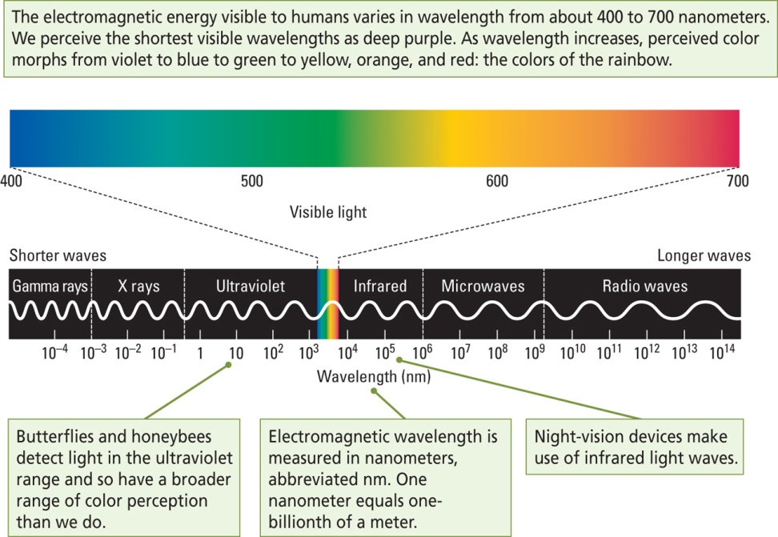
Properties of Light
- Wavelength (λ) color (hue)
- Intensity (amplitude) brightness
- Purity Saturation
The Eye
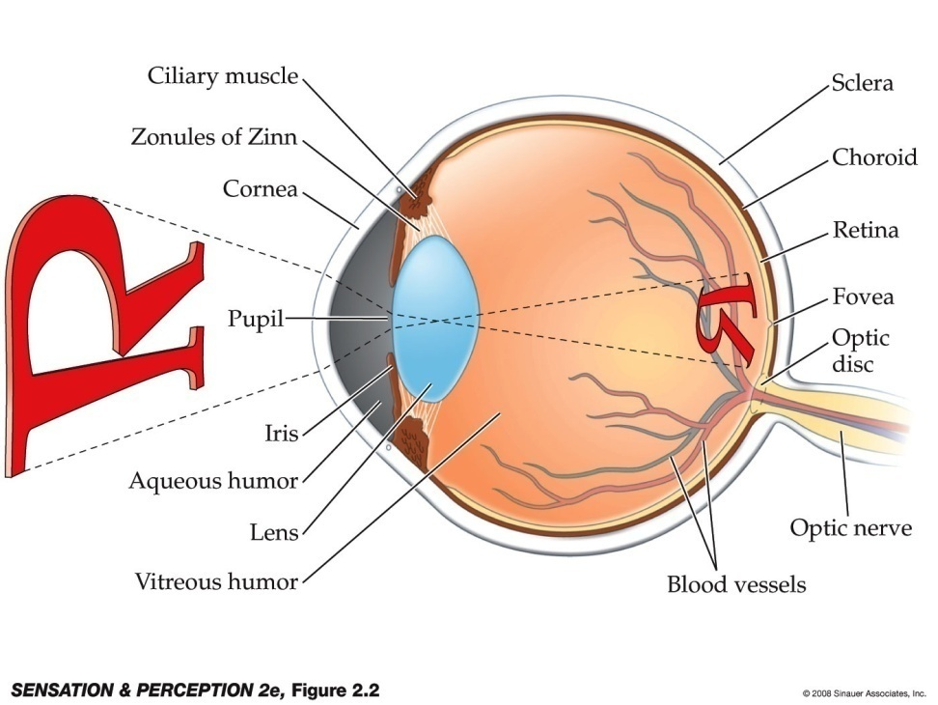
- Cornea: The transparent “window” into the eyeball
- Iris: Coloured part of the eye
  - Regulates the light entering the eye by expanding and contracting pupil
- Crystalline lens: The lens inside the eye, which allows changing focus
Retina
- A light-sensitive membrane in the back of the eye that contains rods and cones, which receive an image from the lens and send it to the brain through the optic nerve
- Fovea
  - Region at the center of the retina that is specialized for high acuity; its receptive field is at the center of the eye’s visual field
Problems of Refraction
- Sometimes the way the lens refracts light causes the point of focus of the image to be either in front of or behind the retina
  - Corrective lenses are needed to allow for normal vision
- Myopia: When the light entering the eye is focused in front of the retina and distant objects cannot be seen sharply; nearsightedness
- Hyperopia: When light entering the eye is focused behind the retina; farsightedness
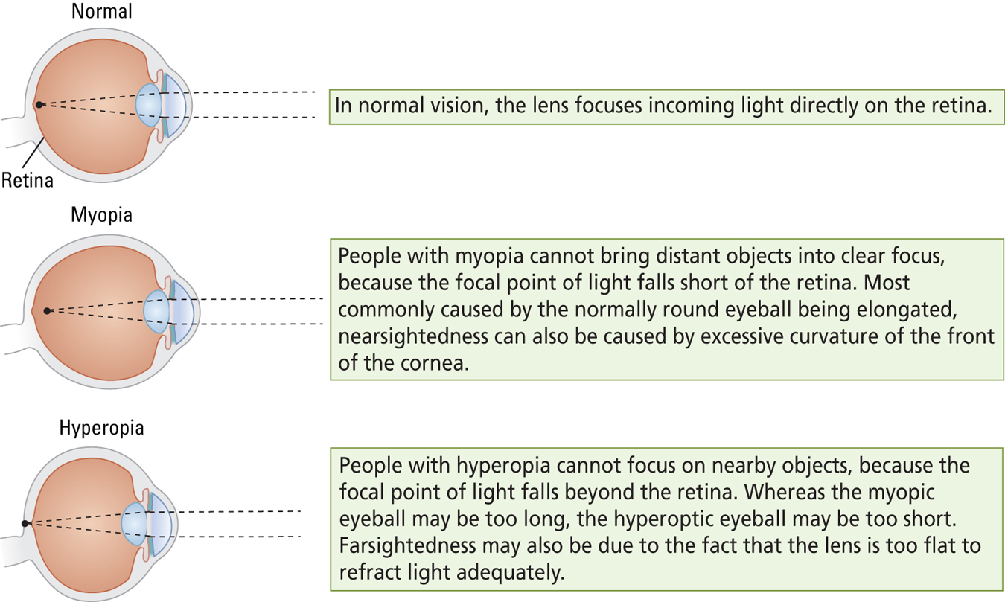
Retina
- Receptor layer is farthest from light
  - Distorts light!
  - Creates a blind spot: Bundle of retinal ganglion cell axons leaves gap in receptor layer
- Optic disk: where the optic nerve leaves the eye/ blind spot
The Layers of the Retina
- Composed of 5 layers
  - Photoreceptors: Rods and cones
  - Bipolar cells
  - Retinal Ganglion cells
  - Horizontal cells
  - Amacrine cells
The Photoreceptors
Rods
- More numerous than cones
- Sensitive to low levels of light (dim light)
- Used mainly for night vision
- One type of pigment only
Cones
- Highly responsive to bright light
- Specialized for color and high visual acuity
- Located in the fovea only
- Three types of pigment
Three Types of Cone Pigments
- Absorb light over a range of frequencies, but their maximal absorptions are:
  - 419 nm (“blue” or short wavelength)
  - 531 nm (“green” or middle wavelength)
  - 559 nm (“red” or long wavelength)
- There are approximately equal numbers of red and green cones, but fewer blue cones
The Layers of the Retina
- Composed of 5 layers
  - Photoreceptors: Rods and cones
  - Bipolar cells
  - Retinal Ganglion cells: axons form the optic nerve
    - M cells: Magnocellular
    - P cells: Parvocellular
  - Horizontal cells
  - Amacrine cells
Pathways Process Sensory Information
Sensory receptors thalamic relay nuclei primary sensory cortex secondary sensory cortex association cortex
Visual Pathway
- Axons from temporal hemiretinas remain ipsilateral
  - Ipsilateral: Referring to the same side of the body (or brain)
- Axons from nasal hemiretinas decussate via optic chiasm
  - Contralateral: Referring to the opposite side of the body (or brain)

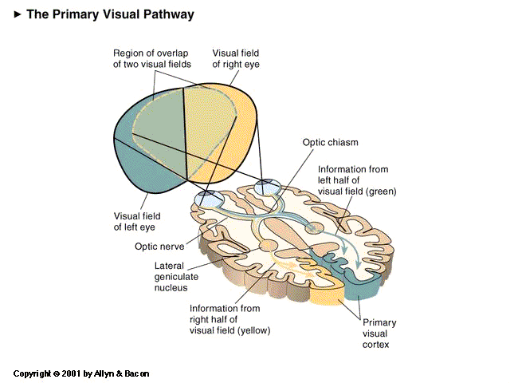
Geniculostriate Pathway
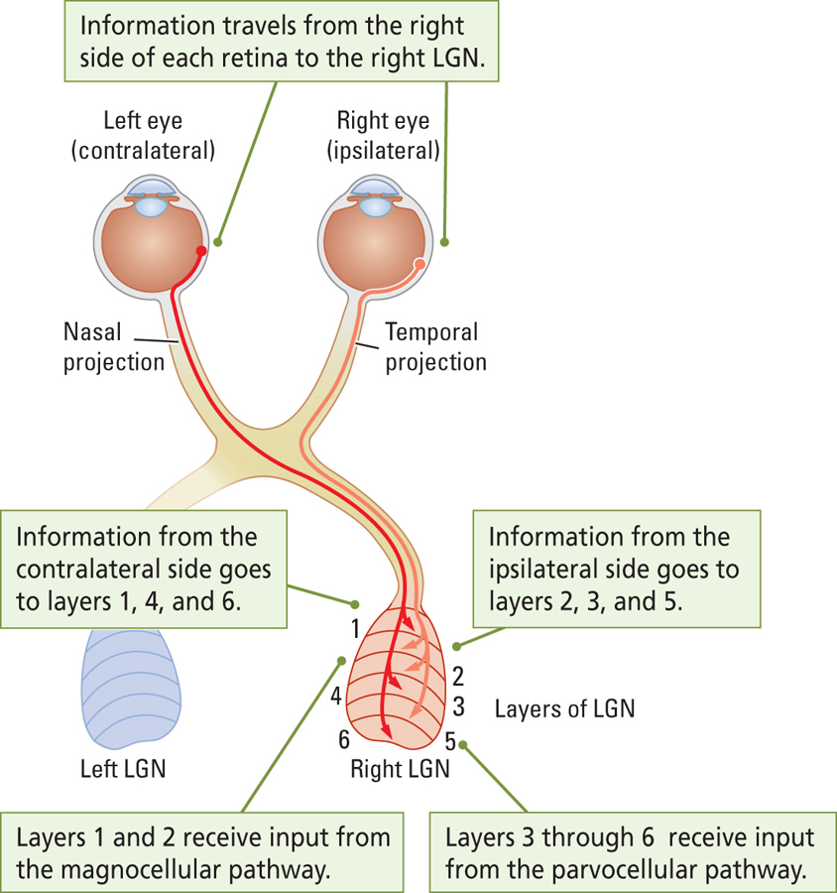
- Lateral Geniculate Nucleus (thalamus) (just general info, just understand, do not need to reproduce for exam)
  - Right LGN: Input from right halves of each retina
  - Left LGN: Input from left halves of each retina
  - Six layers
    - Layers 1, 4, and 6: Input from contralateral retina
    - Layers 2, 3, and 5: Input from ipsilateral retina
    - Layers 1 and 2: Input from magnocellular cells
    - Layers 3 to 6: Input from parvocellular cells
Visual Pathway (2)
- Striate Cortex
  - Primary visual cortex (V1) in the occipital lobe
  - Striped appearance when stained
- Information from left visual field goes to right side of brain; information from the right visual field goes to the left side of the brain
Dorsal and Ventral Visual Streams
- Dorsal Visual Stream
  - Pathway that originates in the occipital cortex and projects to the parietal cortex
  - The “how” pathway (how action is to be guided toward objects)
- Ventral Visual Stream
  - Pathway that originates in the occipital cortex and projects to the temporal cortex
  - The “what” pathway (identifies what an object is)
Primary Visual Cortex
- Cortical Columns
  - Organization that represents a functional unit of six cortical layers deep and approximately 0.5 mm square; perpendicular to the cortical surface
- From each LGN, information from each retina is sent to adjacent cortical columns, thus maintaining the separation of information from each retina
Heterogeneity of V1
- Blob
  - Region in the visual cortex that contains color-sensitive neurons
  - Revealed by staining for cytochrome oxidase
- Interblob
  - Region that separates blobs
  - Participates in perception of form and motion
Location in the Visual World
- Visual Field
  - Region of the visual world that is seen by the eyes
  - Divided into left and right halves
  - Information in left visual field goes to the right hemisphere
  - Information in the right visual field goes to the left hemisphere
Coding Location in the Retina
- Each retinal ganglion cell (RGC) responds to stimulation on just a small circular patch of the retina – the cell’s receptive field
- Coding location
  - Light shone in one place on the retina will activate one ganglion cell, and light shone in another place will activate a different ganglion cell
Location in the LGN and Cortical Region V1
- Cells in the lateral geniculate nucleus (LGN) also have visual fields
- Each LGN cell represents a particular place
- Projects to V1, forming a topographic map
  - Receptive fields of cells in the cortex are typically larger than those of RGCs
  - More cortical tissue is devoted to cells in the fovea than in the periphery


