Brain and Behavior
January 12th
Chapter 2: How Does the Nervous System Function?
Anatomical Organization of the Nervous System

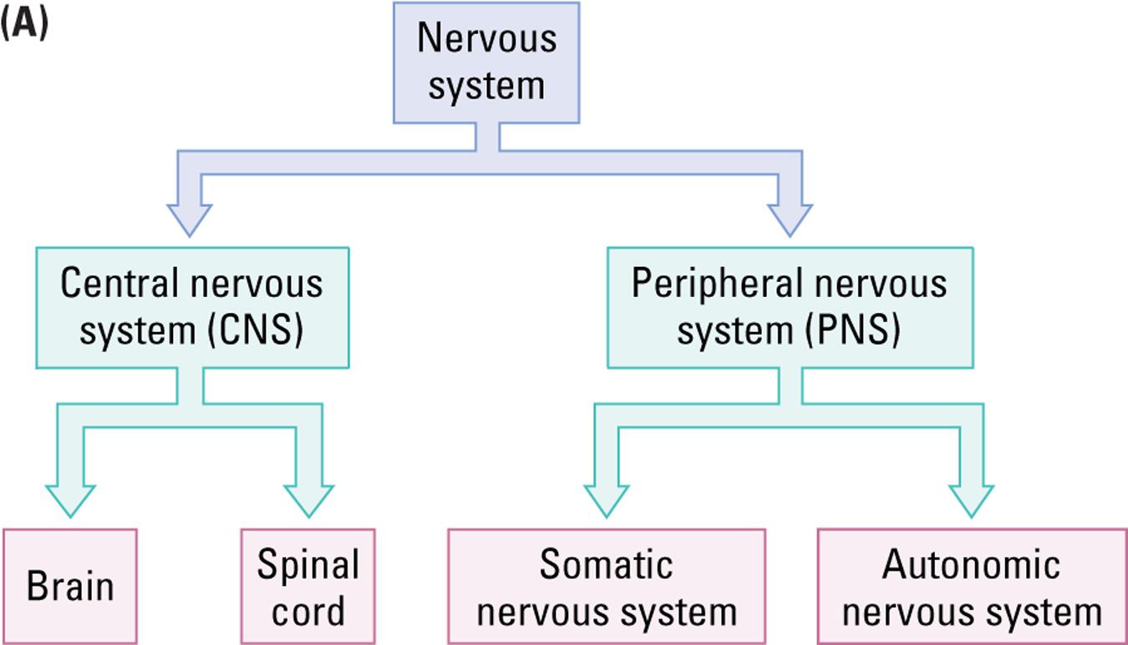

Functional Organization of the Nervous System

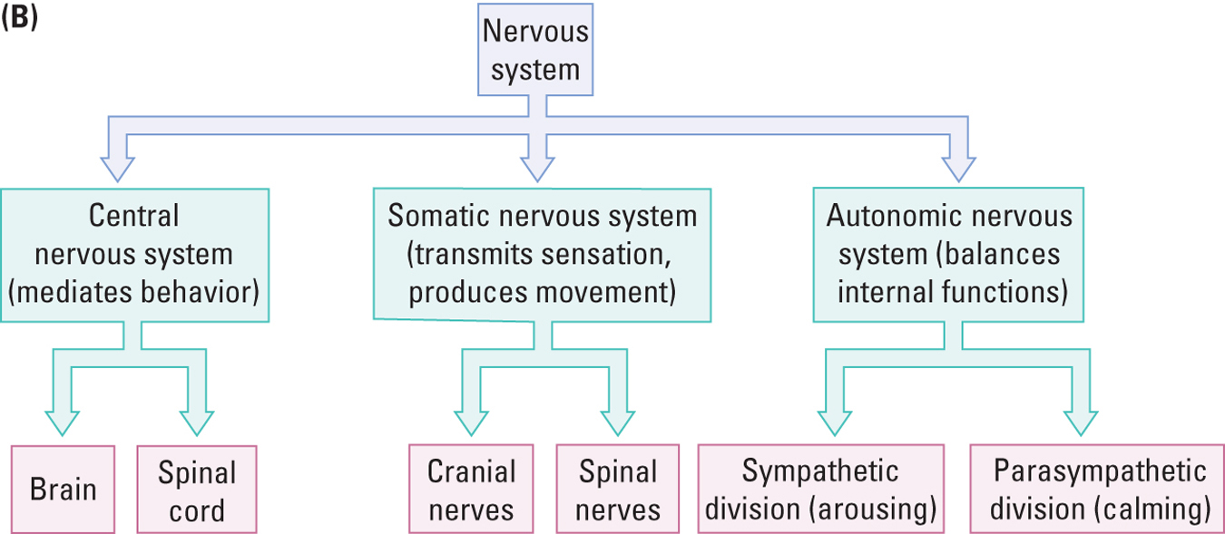

- Afferent nerves: information into the nervous system
- Efferent nerves: information out of the nervous system
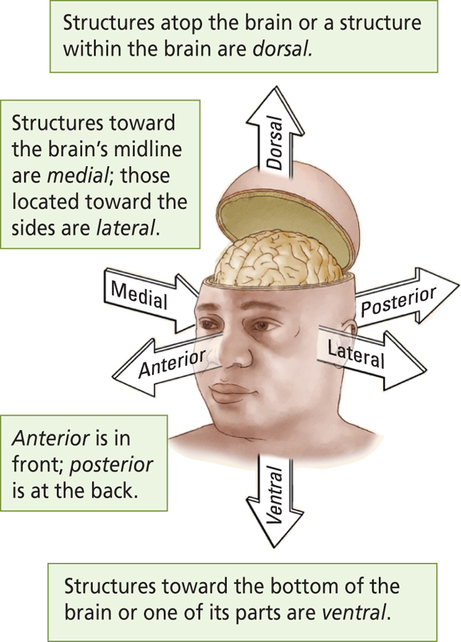

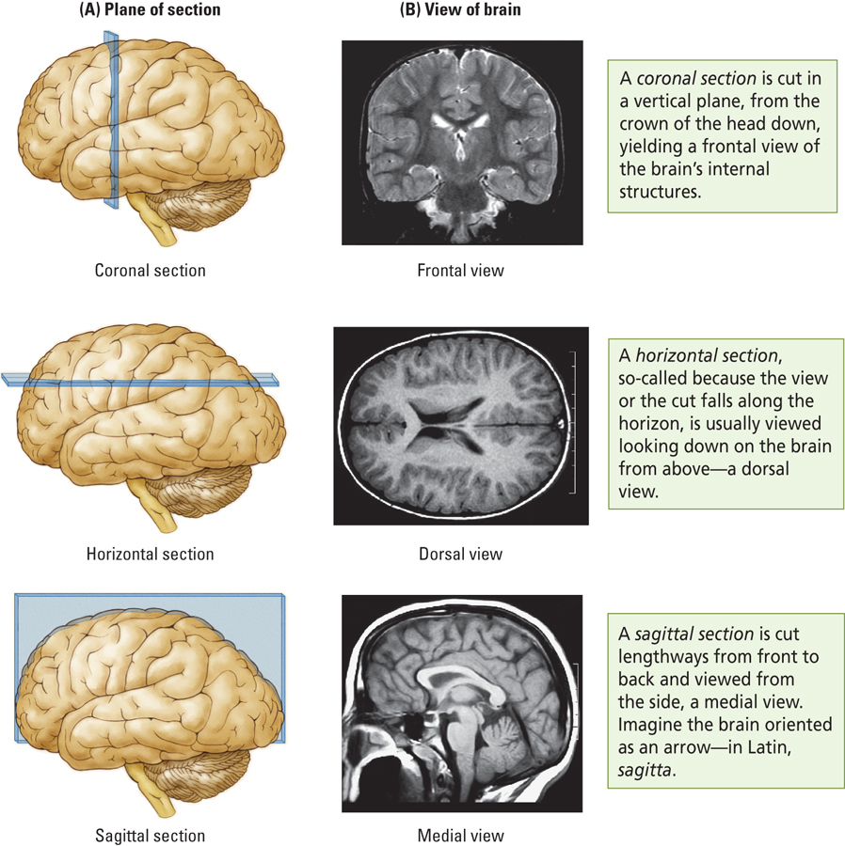

The Brain’s Surface Features
- Meninges: Three layers of protective tissue
  - Dura mater:
    - “hard mother”; tough outer layer of fibrous tissue
  - Arachnoid layer:
    - “like a spider’s web”; thin sheet of delicate connective tissue
  - Pia mater:
    - “soft mother”; moderately tough inner layer that clings to the brain’s surface
  - Between arachnoid and pia is the cerebral spinal fluid.
    - Sub arachnoid space

Cerebrospinal Fluid (CSF)
- Sodium chloride and other salts
- Fills the ventricles and circulates around the brain and spinal cord in the subarachnoid space
- Cushions the brain
- Meningitis: infection of the meninges and CSF(inflammation of meninges)
The Brain’s Surface Features
- Cerebrum
  - Major structure of the forebrain, consisting of the forebrain, consisting of two virtually identical hemispheres (left and right)
  - Most recently evolved brain structure in humans
    - Brain evolved back to front, most recently evolved are anteriorly located.
- Cerebellum: “Little brain”
  - Involved in the coordination of motor and possibly other mental processes.
- Brainstem
  - Central structures of the brain, including the hindbrain, midbrain, thalamus, and hypothalamus, responsible for most unconscious behavior.
- Gyrus (pl. gyri)
  - A small protrusion or bump formed by the folding of the cerebral cortex
- Sulcus (pl. sulci)
  - A groove in brain matter, usually found in the neocortex or cerebellum
- Fissure
  - A very deep sulcus

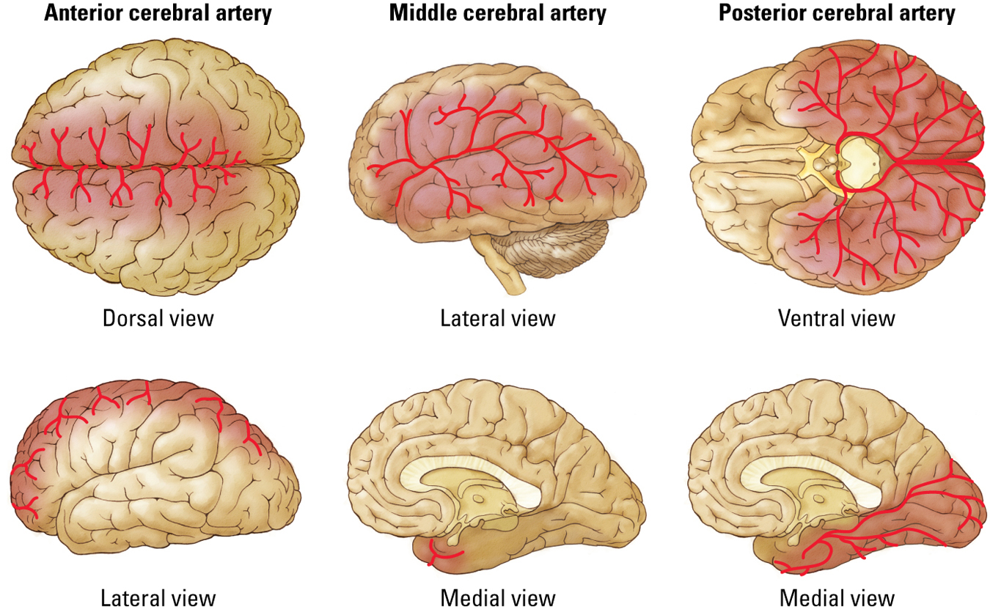

The Brain’s Internal Features – Macro View
- Gray Matter
  - Areas of the nervous system predominately composed of cell bodies and blood vessels.
- White Matter
  - Areas of the nervous system rich in fat-sheathed neural axons.
- Ventricle
  - A cavity in the brain that contains CSF.
The Ventricles
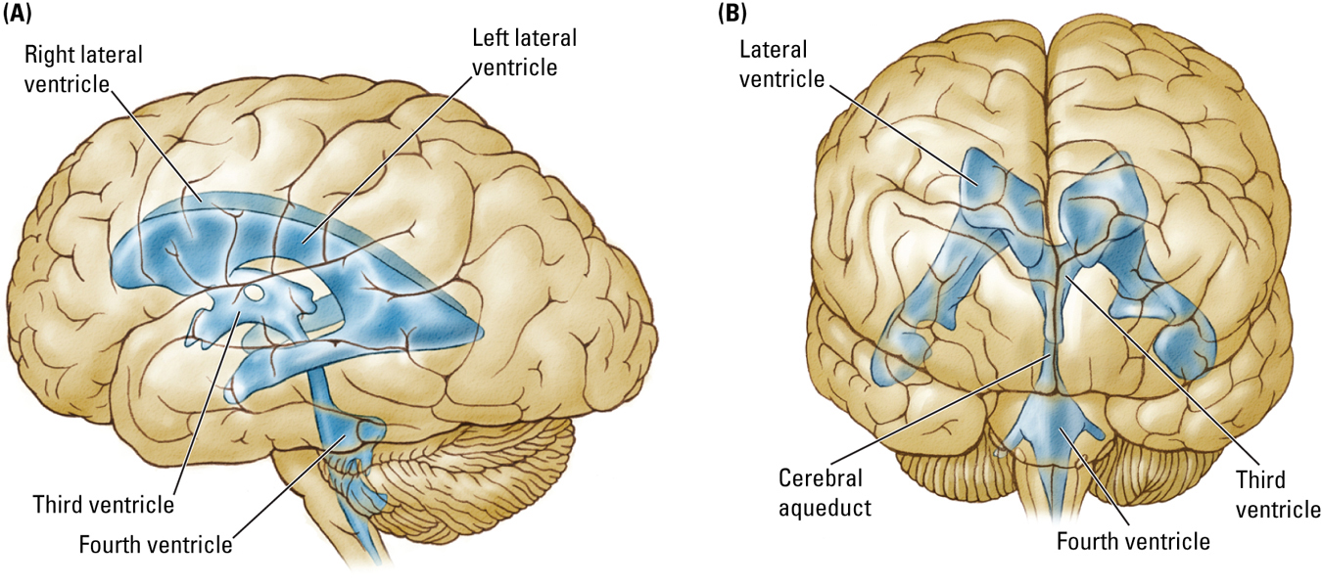
The Corpus Callosum
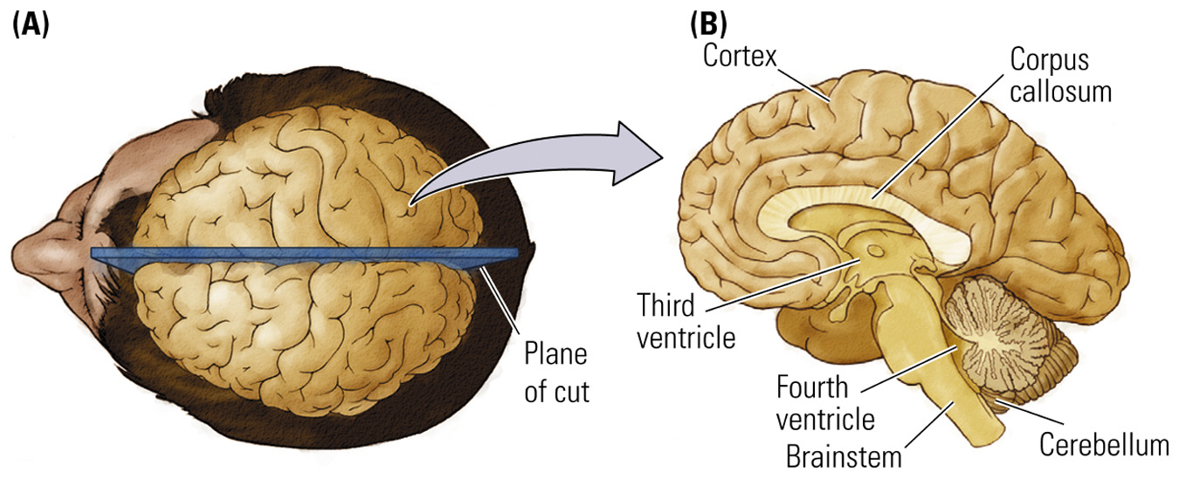
Fiber connecting the two cerebral hemispheres.

Two Main Types of Brain Cells
- Neurons
  - Carry out the brain’s major functions
  - Approximately 80 billion.
- Glial cells
  - Aid and modulate neurons’ activities
  - Approximately 100 billion.
Terminology
- Nucleus (pl. Nuclei)
  - A group of cells forming a cluster that can be identified with special stains to form a functional grouping
- Nerve
  - Large collection of axons coursing together outside the central nervous system
- Tract
  - Large collection of axons coursing together within the central nervous system
Evolutionary Development of the Nervous System
- Human brain is a complex mammalian brain, yet it still retains most of the features of other less complex mammalian brains
- Most behaviors are not the product of a single locus in the brain, but rather
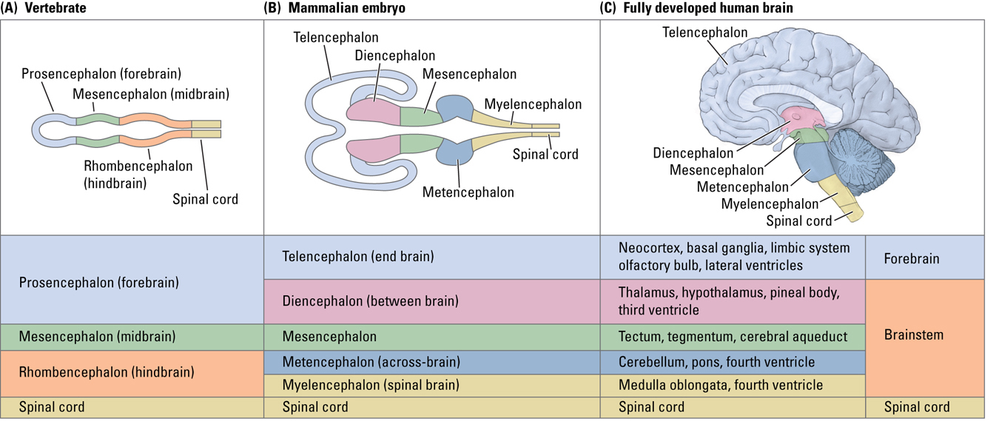

The Central Nervous System: Mediating Behavior
- Three Major Components
  - 1. Spinal Cord
  - 2. Brainstem
  - 3. Forebrain
The Spinal Cord
- Controls most body movements
- Can act independently of the brain
- Spinal reflex:
  - Automatic movements
  - Hard to prevent (brain cannot inhibit)
  - Example: Knee-jerk reflex (patellar tendon)
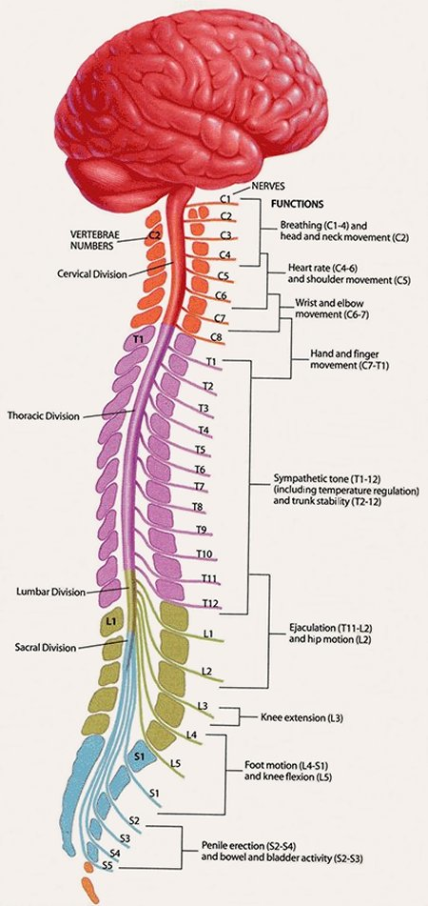
The Brainstem
- Begins where spinal cord enters the skull
- Produces movement and creates a sensory world
- Three regions:
  - Hindbrain
  - Midbrain
  - Diencephalon
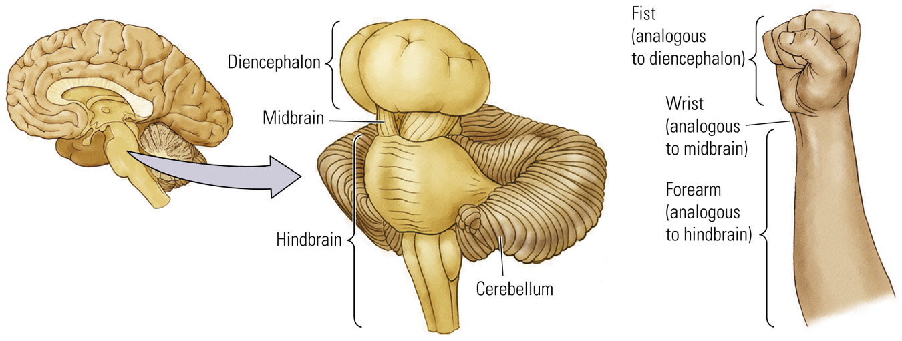
1. Hindbrain
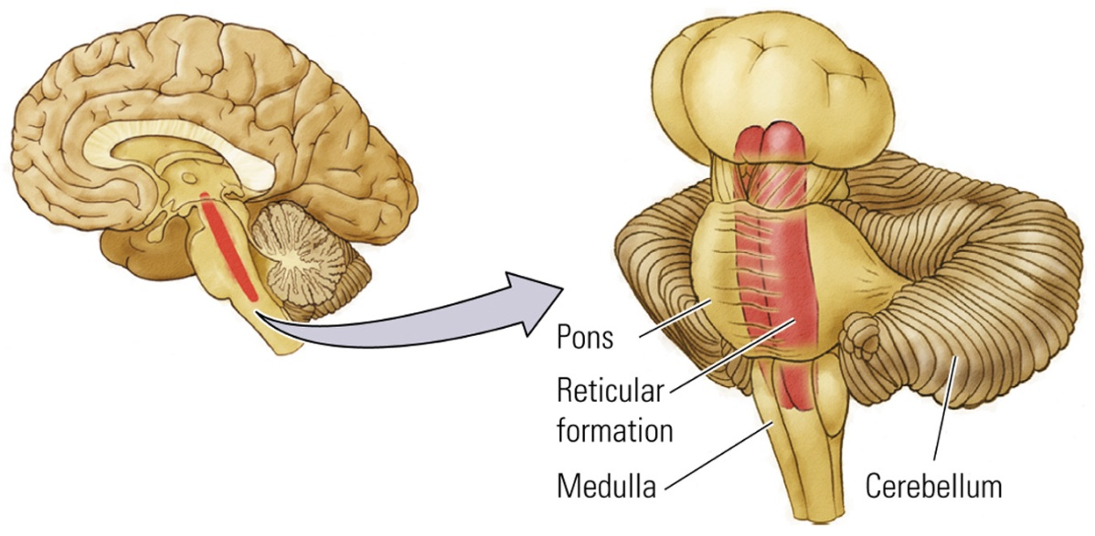
- Evolutionarily the oldest part of the brain
- Contains:
  - Cerebellum
  - Reticular Formation
  - Pons
  - Medulla (most inferior part)
- Control of movement
- Cerebellum
  - Controls complex movements and has a role in a variety of cognitive functions
  - Size of cerebellum increases with the physical speed and dexterity of a species.
- Reticular Formation:
  - Netlike mixture of neurons (gray matter) and nerve fibers (white matter)
  - Stimulates the forebrain:
    - Regulation of sleep-wake behavior and behavioral arousal
- Pons (“bridge”)
  - Connects cerebellum to the rest of the brain.
  - Controls important movements of the body
- Medulla
  - Rostral tip of spinal cord
  - Vital functions:
    - Control of breathing and heart rate.
2. (Brainstem) Midbrain
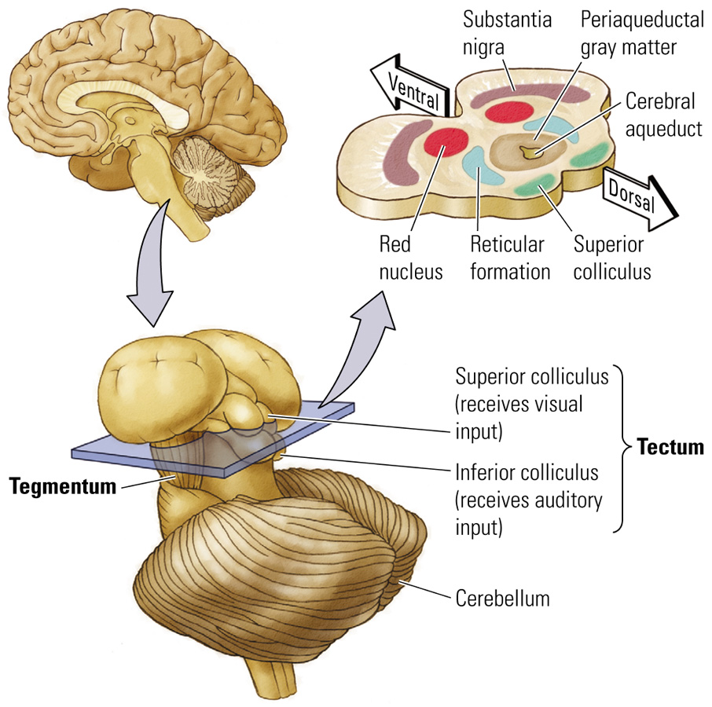
- Tectum (roof of midbrain)
  - Sensory processing (processing and auditory)
  - Produces orienting movements
- Tegmentum (floor of midbrain)
  - Eye and limb movements
  - Species-specific behaviors
  - Perception of pain
3. (Brainstem) Diencephalon
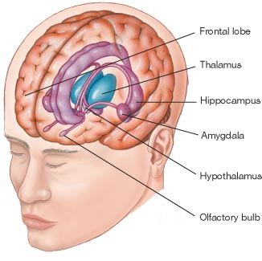
- Hypothalamus
  - Hormone function
    - Through connections with the pituitary gland.
  - Feeding
  - Sexual behavior
  - Sleeping
  - Temperature regulation
  - Emotional behavior
- Thalamus
  - Gateway for channeling sensory information into the cortex
  - Primary role is sensory processing
  - Motor processing
  - Integrative functions
The Forebrain
- Three Principle Structures
  - Neocortex:
    - Regulates various mental activities
  - Basal Ganglia:
    - Control of voluntary movement
  - Limbic System:
    - Regulates emotions and behaviors that create and require memory
The Cortex
- Neocortex (“new bark”)
  - 6 layers of gray matter.
  - Creates and responds to a perceptual world
- Limbic Cortex
  - Evolutionarily older
  - 3 or 4 layers of gray matter
  - Controlling motivational states

Cortical Layers
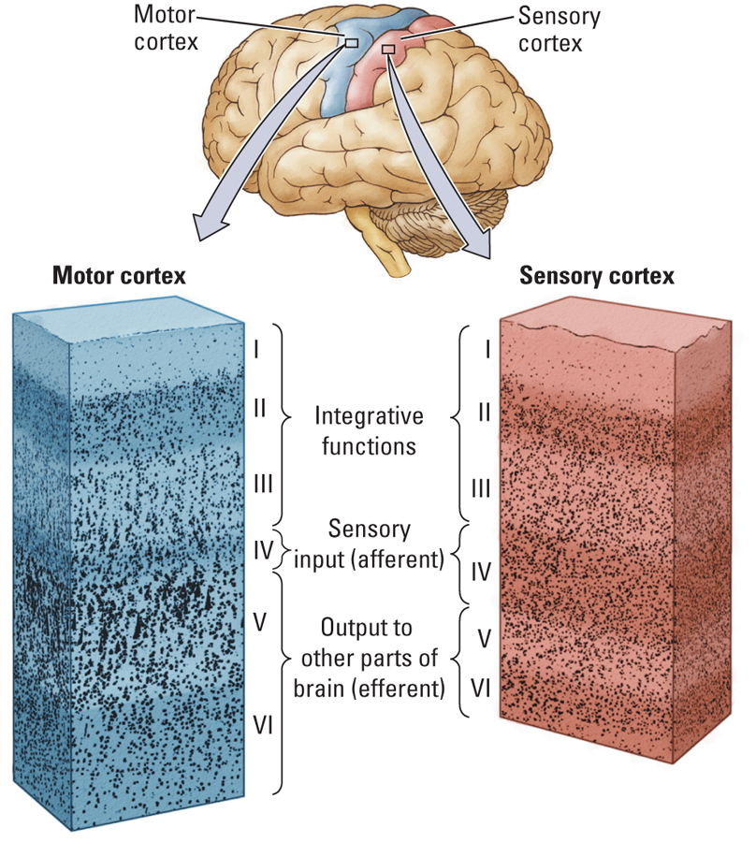
- Different layers have different cell types.
- Density of cells in each layer varies
- Differences in appearance relate to function
- Cytoarchitectonic Map
  - Map of neocortex based on the organization, structure and distribution of the cells
The Cortical Lobes
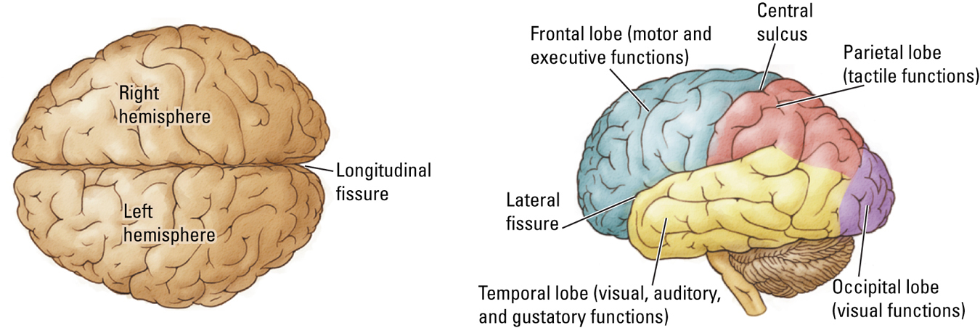
- Frontal: Motor and executive functions (personality)
- Occipital: Vision
- Parietal: Tactile functions
- Temporal: Visual, auditory, and gustatory functions. (music, memory, taste)
The Basal Ganglia
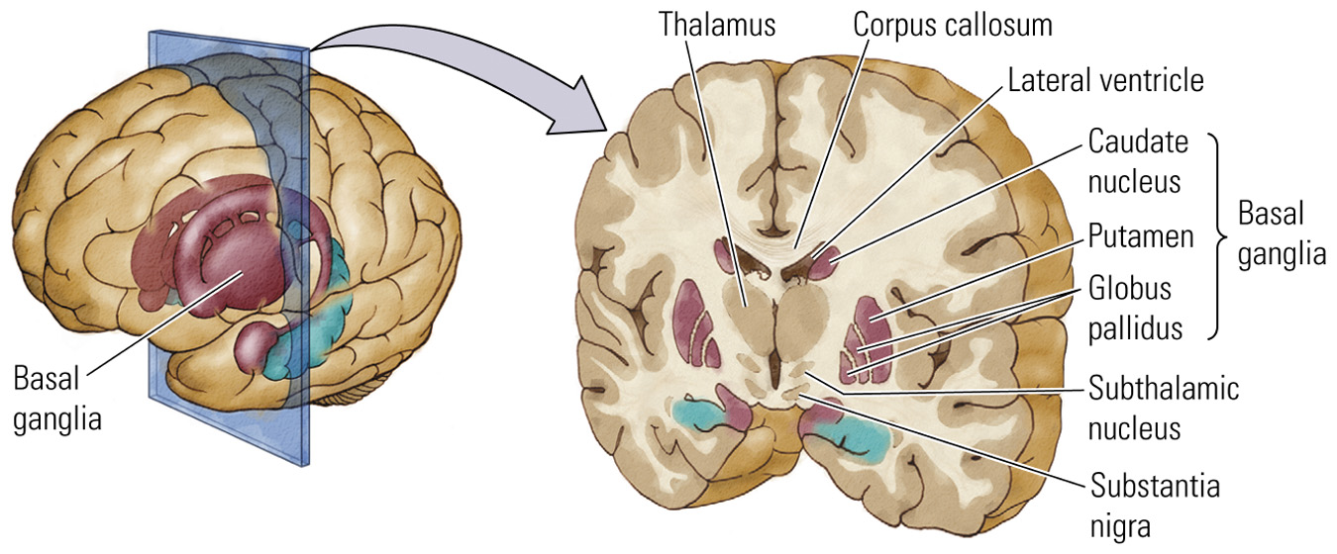
- Collection of nuclei just below the white matter of the cortex
  - 3 principal structures: caudate nucleus, putamen, and globus pallidus.
- Controls voluntary movement
- Related disorders
  - Parkinson’s disease and Tourette’s syndrome.
The Limbic System
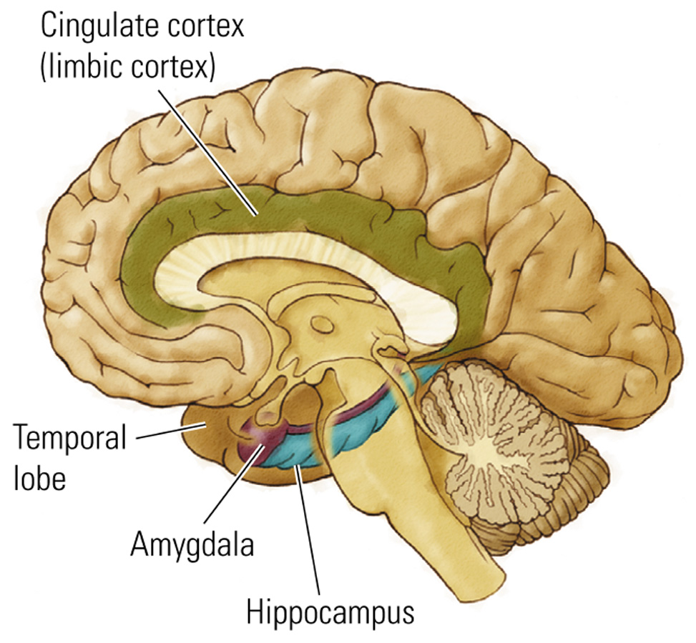
- Group of structures between the neocortex and brain stem
  - Principal structures: _______, _______, and _______
- Regulation of
  - Emotional and sexual behaviors
  - Memory
  - Spatial navigation
The Olfactory System
- Oldest sense

