Three Classes of Neurotransmitters
- Small-molecule transmitters
- Peptide transmitters
- Transmitter gases
1. Small-Molecule Transmitters
- Class of quick-acting neurotransmitters
- Synthesized from dietary nutrients and packaged ready for use in axon terminals
- Examples:
  - Acetylcholine (ACh)
  - Amines: Dopamine (DA), Norepinephrine (NE), Epinephrine (EP), Serotonin (5-HT)
  - Amino Acids: Glutamate (Glu), Gamma-aminobutyric acid (GABA), Glycine (Gly)
Acetylcholine Synthesis
- Formed from choline (good source is eggs) and acetate
  - Enzymes:
    - Acetyl CoA
    - ChAT (Choline acetyl transferaise)
- Breakdown of acetylcholine
  - Enzyme: Acetlycholineseterase (AChE)
Sequential Synthesis of Three Amines
- Rate-Limiting Factor
  - Any enzyme that is in limited supply, thus restricting the pace at which a chemical can be synthesized
  - Example: Tyrosine hydroxylase (limited supply) in amine synthesis (converts tyrosine to L-dopa)
- Note: serotonin synthesized from tryptophan
Amino Acid Transmitters
- Glutamate: main excitatory transmitter
  - Need a certain amount to survive, but too much is fatal
    - Can lead to neuronal injury or stroke
  - Receptors: NMDA, AMPA, kainate, and metabotropic glutamate receptor (slower)
- Excitotoxicity: Neural injury such as stroke causes excess release of glutamate, toxic to neurons
- GABA: main inhibitory transmitter
  - Causes hyperpolarizing currents
  - Synthesized from glutamate
- Receptors: GABAA (fast, inhibitory) and GABAB (slow, inhibitory), GABAC (ionotropic, Cl- channel).
- GABA agonists are potent tranquilizers, e.g., Valium.
2. Peptide Transmitters
- Neuropeptide
  - A multifunctional chain of amino acids that act as a neurotransmitter
  - Synthesized from mRNA on instructions from the cell’s DNA
  - Do not bind to ion channels; do not have direct effects on the voltage of the postsynaptic membrane
    - Do bind to receptors, but not with ion channels
- Examples:
  - Opioids, insulin, corticosteroids
3. Transmitter Gases
- Small molecules that diffuse through the cell membrane and stimulate second messenger production
  - Diffuse to postsynaptic cell and cause a chain of effect
- retrograde transmitter
  - can diffuse out of pre or postsynaptic cell into the cleft and have an effect on the presynaptic cell
- Synthesized in cell, as needed
- Examples: Nitric Oxide (NO) or Carbon Monoxide (CO)
Two Classes of Receptors
- Ionotropic Receptor
  - Direct
  - quicker
  - Embedded membrane protein with two parts
    - A binding site for a transmitter
    - A pore that regulates ion flow to directly and rapidly change membrane voltage
- Metabotropic Receptor
  - Indirect
  - Slower
    - Cause cascade of events
  - Can not be ion channel
  - Embedded membrane protein with a binding site for a neurotransmitter but no pore
  - Linked to a G protein that can affect other receptors or act with second messengers to affect other cellular processes
- G protein
  - Belongs to a family of guanyl-nucleotide-binding proteins coupled to metabotropic receptors that, when activated, bind to other proteins
  - Comprised of an alpha-beta-gamma subunit
- Second Messenger
  - A chemical that carries a message to initiate a biochemical process
  - Activated by a neurotransmitter (the first messenger)
    - Examples
      - Alter ion flow in a membrane channel
      - Formation of new ion channels
      - Production of new proteins
    - Influence genetic expression!
- We need to: differentiate between ionotropic and metabotropic, identify a first and second messenger, and somewhat describe the process.
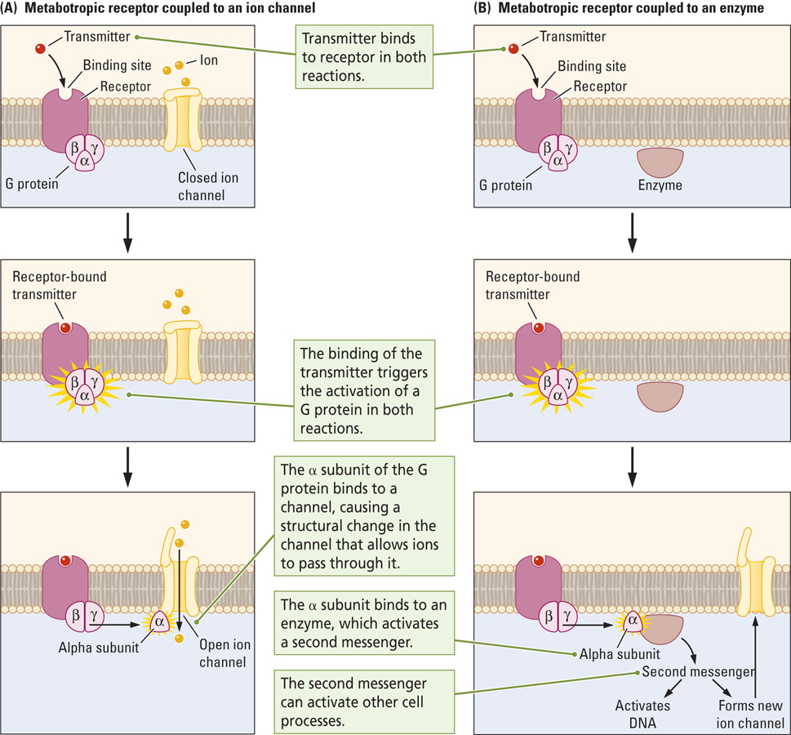

Neurotransmission in the Somatic Nervous System
- Cholinergic Neuron
  - Neuron that uses ACh as its main neurotransmitter
  - Excites skeletal muscles to cause contractions
- Nicotinic ACh Receptor
  - Ionotropic receptor at which acetylcholine and the drug nicotine act to open an pore and allow the flow of ions through the receptor pore
- Cholinergic neurons from the CNS control both divisions
  - Sympathetic (fight-or-flight response)
  - Parasympathetic (rest-and-digest response)
- Norepinephrine is also involved in the fight-or-flight response
Four Activating Systems in the Central Nervous System
- Activating System
  - Neural pathways that coordinate brain activity through a single neurotransmitter
  - Cell bodies are located in a nucleus in the brainstem and their axons are distributed through a wide region of the brain
- Four Systems
  - Cholinergic, Dopaminergic, Noradrenergic, and Serotonergic
Cholenergic system
- Acetylcholine
- In diagram: circles indicate cell bodies and arrows where their axons are going
- Two major systems
  - Cell bodies in basal forebrain to diverse areas of the forebrain
    - Learning and memory
  - Cell bodies in midbrain to
    - Arousal
- Alzeheimers is basal forebrain neurons that have died off
Dopaminergic system
- Dopamine
- Two major systems
  - Ventral tegmentum to frontal cortex and limbic system
    - Reward and reinforcement
  - Nigrostriateral pathway: substantia nigra to basal ganglia
    - motor control
    - lose of these neurons leads to parkinsons

Noradrenergic
- cell bodies in locus coeruleus to throughout the forbrain including areas of the cerebellum (project broadly)
  - emotion
  - increases lead to mania
  - decreases lead to depression
Serotonergic system
- cell bodies in raphe nuclei and broadly projected throughout brain
  - Tourette’s syndrome and schizophrenia
  - deacreases have been linked to low mood and sleep apnea and SIDS
Dysfunctional Transmitter Systems have Behavioural Consequences
- Alzheimer’s disease
  - Degenerative brain disorder that first appears as progressive memory loss and later develops into generalized dementia
  - Involves cholinergic system
- Schizophrenia
  - Behavioral disorder characterized by delusions, hallucinations, disorganized speech, blunted emotion, agitation or immobility, and a host of other symptoms
  - Involves dopaminergic system
- Major depression
  - Mood disorder characterized by prolonged feelings of worthlessness and guilt, the disruption of normal eating habits, sleep disturbances, a general slowing of behavior, and frequent thoughts of suicide
  - Involves noradrenergic/serotonergic system
- Obsessive-Compulsive Disorder
  - Behavioral disorder characterized by compulsively repeated acts (e.g., hand washing) and repetitive, often unpleasant, thoughts (obsessions)
  - Involves serotonergic system
- Learning
  - Relatively permanent change in behavior that results from experience
- Neuroplasticity
  - The nervous system’s potential for change that enhances its ability to adapt
  - Required for learning and memory
The Hebbian Synapse
- Hebb Synapse
  - “When the axon of cell A is near enough to excite a cell B and repeatedly or persistently takes part in firing it, some growth process or metabolic change takes place in one or both cells such that A’s efficiency, as one of the cells firing B, is increased.”
    - D. O. Hebb, 1949
- Learning is mediated by structural changes in synapses
The Habituation Response
- Habituation
  - Learning behavior in which a response to a stimulus weakens with repeated stimulus presentations
  - Example: Gill withdrawal response in the marine snail aplysia californica
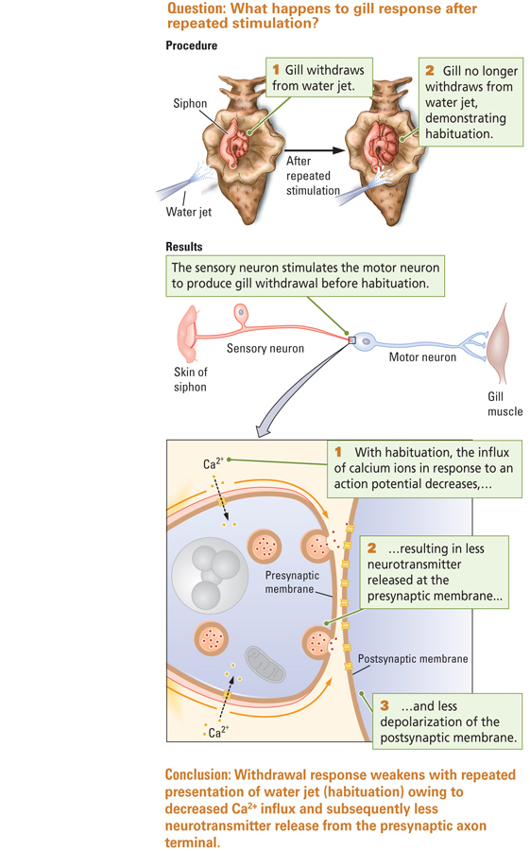

The Sensitization Response
- Sensitization
  - Learning behavior in which the response to a stimulus strengthens with repeated presentations of that stimulus because the stimulus is novel or stronger than normal
  - For example, after habituation has occurred
  - PTSD, peanut allergies,

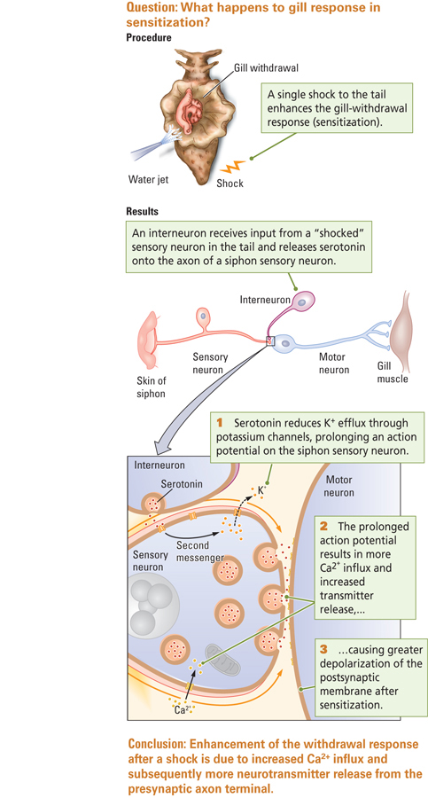

Long-Term Potentiation and Associative Learning
- Associative Learning
  - Linkage of two or more unrelated stimuli to elicit a behavioural response
    - Name and face, sight and smell of an orange
- Long-term Potentiation (LTP)
  - In response to stimulation at a synapse, changed amplitude of an excitatory postsynaptic potential that lasts for hours to days or longer
  - Plays a part in associative learning
- A strong burst of electrical stimulation applied to the presynaptic neuron produces an increase in the amplitude of the EPSP in the postsynaptic neuron
- First recorded in the hippocampus by Bliss and Lømø in 1973
  - Field Potential:
    - Measure of all the EPSPs impinging on this one postsynaptic cell
    - EPSPs from many neurons; recorded with extracellular electrodes
Neurochemistry of LTP
- Glutamate acts on two different types of receptors on the postsynaptic membrane
  - AMPA (alpha-amino-3-hydroxy-5-methylisoa-zole-4-proprionic acid)
    - Normally responds to glutamate
  - NMDA (N-methyl-D-aspartate)
    - Doubly gated channels
    - Normally blocked by magnesium (Mg2+) ions
- Two events must occur close together in time for NMDA receptors to open
  - Depolarization of postsynaptic membrane, which displaces Mg2+ from pore (strong electrical stimulus)
  - Activation by glutamate from the presynaptic neuron (weak electrical stimulus)
  - Strong and weak stimuli have been paired
- After NMDA receptors open, Ca2+ enters the postsynaptic neuron, altering the postsynaptic neuron:
  - Increased responsiveness of AMPA receptors to glutamate
  - Formation of new AMPA receptors
  - Retrograde messengers that trigger more glutamate release from presynaptic neuron
Long-Term Depression (LTD) (just know it exists and brief points below on it)
- Another form of synaptic plasticity
- Neuron becomes less active in response to repeated stimulation
- Involves NMDA receptors
- Requires Ca2+ entry:
  - Decreased responsiveness of AMPA receptors
  - Decreased numbers of AMPA receptors
Learning As a Change in Synapse Number
- What neural processes underlie the persistent, long-term changes of learning?
  - Ca2+ enters postsynaptic neuron and activates a second messenger (e.g., cyclic AMP)
  - cAMP alters gene expression in nucleus, which physically alters synapse:
    - structural changes in the synapse
      - dendritic spines
      - formation or loss of synapses

