How Do Neurons Communicate and Adapt?
A Chemical Message
- Otto Loewi (1921)
  - Frog heart experiment
  - Demonstrated that the neurotransmitter acetylcholine (ACh) slows heart rate
  - In text at end of chapter 4: first neurotransmitter discovered, in peripheral nervous system, at _______ junction
- Acetylcholine
  - The first neurotransmitter discovered in the PNS and CNS; activates skeletal muscles in the somatic nervous system and may excite or inhibit internal organs in the autonomic nervous system
- Stimulation of accelerator results in increased heart rate
- Epinephrine (EP, or adrenaline)
  - Chemical messenger that acts as a hormone to mobilize the body for fight or flight during times of stress and as a neurotransmitter in the central nervous system
  - Lots of neurotransmitters. But depending on where they are released and what they bind to they can have very unique effects
- Norepinephrine (NE, or noradrenaline)
  - Neurotransmitter found in the brain and in the parasympathetic division of the autonomic nervous system
  - Accelerates heart rate in mammals
  - NE and EP work in conjunction
What are Neurotransmitters?
- Chemical released by a neuron onto a target with an excitatory or inhibitory effect
- Outside the CNS, many of these chemicals circulate in the blood stream as hormones
- Hypothalamus pituitary gland hormones target organs and glands
Structure of Synapses
- Electron Microscope
  - Projects a beam of electrons through a very thin slice of tissue
  - Varying structure of the tissue scatters the beam onto a reflective surface where it leaves an image, or shadow, of the tissue
  - Much better resolution than the light microscope
  - 1950s: Revealed the structure of a synapse for the first time
- Presynaptic Membrane
  - Membrane on the transmitter - output side of a synapse
- Postsynaptic Membrane
- Membrane on the transmitter - input side of a synapse
- Synaptic Cleft:
  - Gap that separates the presynaptic membrane from the postsynaptic membrane
- Synaptic Vesicle
  - Organelle consisting of a membrane structure that encloses a quantum of neurotransmitter
- Storage granule:
  - Membranous compartment that holds several vesicles containing a neurotransmitter
- Majority of synapses in the mammalian nervous system are chemical, but there are others
- Electrical Synapse (a.k.a. gap junction)
  - Fused presynaptic and postsynaptic membrane that allows an action potential to pass directly from one neuron to the next ; quicker
  - Space between pre and post synaptic membranes where an electrical signal can transfer immediately
  - Ten to fuse together
  - Direct transfer of the electrical signal
    - Ion channels opening
    - Much faster than chemical transmission
    - Nervous system prefers chemical synapses because it provides a variety of signals
      - Due to lots of different neurochemicals
      - And post-synaptic receptors
- Chemical synapses allow more flexibility in neuron-to-neuron communication
Neurotransmission in Four Steps
- The neurotransmitter must be:
- Synthesized and stored in the axon terminal
2. Transported to the presynaptic membrane and released in response to an action potential
3. Able to activate the receptors on the target-cell membrane located on the postsynaptic membrane
- Inactivated or it will continue to work indefinitely
Step 1: Synthesis and Storage
- Neurotransmitters are derived in two general ways:
  - Synthesized in the axon terminal
    - Building blocks from food are pumped into cell via transporters: protein molecules embedded within the cell membrane
  - According to instructions contained in the DNA
    - Transported on microtubules to axon terminal
Step 2: Neurotransmitter Release
- At the terminal, the action potential opens voltage-sensitive calcium (Ca2+) channels
- Ca2+ enters the terminal and binds to the protein calmodulin forming a complex
- Complex causes some vesicles to empty their contents into the synapse, and others to get ready to empty their contents
  - Exam question: discuss how a neurotransmitter is released
Step 3: Receptor-Site Activation
- After being released, the neurotransmitter diffuses across the synapse and activates receptors on the postsynaptic membrane
- Transmitter-Activated Receptors
  - Protein embedded in the membrane of a cell that has a binding site for a specific neurotransmitter
- Neurotransmitter may:
  - Depolarize the postsynaptic membrane causing excitatory action on the postsynaptic neuron
  - Hyperpolarize the postsynaptic membrane causing inhibitory action on the postsynaptic neuron
  - Initiate other chemical reactions that modulate either the excitatory or inhibitory effect, or influence other functions of the receiving neuron
    - Change in ionic concentrations
- Neurotransmitter may also interact with receptors on the presynaptic membrane
- Autoreceptors
  - “Self-receptor” on the presynaptic membrane that responds to the transmitter that the neuron releases
- In most cases, do not control ion channels or produce changes in membrane potential, regulate internal processes
  - They regulate their own release and synthesis of neurotransmitters
    - Too much dopamine in synaptic cleft, then go and regulate it
- Instead, regulate internal processes
  - e.g., control synthesis and release of neurotransmitter
Step 4: Deactivation of the Neurotransmitter
- Accomplished in at least four ways:
  - Diffusion away from synaptic cleft
  - Degradation by enzymes in the synaptic cleft
  - Reuptake into the presynaptic neuron for subsequent re-use
  - Taken up by neighboring glial cells
Excitatory and Inhibitory Messages (EXAM: CONTRAST THEM)
- Excitation must overcome inhibition
  - At rest the are always being inhibited
  - Have enough excitatory input to release that inhibition
- Type I Synapse
  - Excitatory
  - Typically located on dendrites
  - Contain round vesicles
  - Dense material on membranes
    - Lots of proteins
  - Wide cleft
    - Between pre and post synaptic
  - Large active zone
    - Lots of places for binding
- Type II Synapse
  - Inhibitory
  - Typically located on cell body
    - Closer to axon hillock, more effect
    - Produces more inhibition
  - Contain flat vesicles
  - Sparse material on membranes
  - Narrow cleft
  - Small active zone
Varieties of Neurotransmitters
- ~50 different kinds have been identified
  - we are still looking, there are more
- Some are inhibitory at one location and excitatory at another
  - Helps with diversity of signaling
- More than one neurotransmitter may be active at a single synapse
  - Co-localization
    - Dopamine and serotonin at one synapse
- No simple one-to-one relationship between a single neurotransmitter and a single behavior
  - Every neurotransmitter will do a diverse host of functions
  - Every behavior is governed by a host of neurotransmitters
Four Criteria for Identifying Neurotransmitters
- The chemical must be synthesized in the neuron or otherwise be present in it
- When the neuron is active, the chemical must be released and produce a response in a some target
- The same responses must be obtained when the chemical is experimentally placed on the target
- A mechanism must exist for removing the chemical from its site of action after its work is done

Acetylcholine and the Renshaw Loop
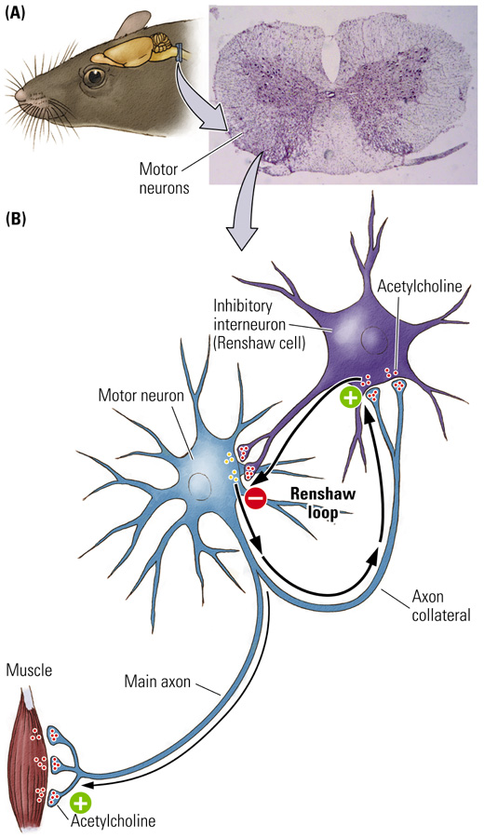
- Renshaw cells are located in the brainstem, CNS

