Neurophysiology:
- Generation, Transmission, and Integration of Neural Signals
Outline – Generation
- Measuring the membrane potential
- The ionic basis of the resting membrane potential
- Four factors determining the resting membrane potential
Review of Neural Structure
The Neuron at Rest
- Ions: Atom that has gained or lost an electrical charge:
  - Anion: Negative Ion
    - e.g., Choloride, or Cl-
  - Cation: Positive Ion
    - e.g., Potassium, or K+
- Intracellular Fluid: Cytoplasm
- Extracellular Fluid: Interstitial fluid, between cells
Giant Axon of the Squid
- Much larger in diameter than human axons
  - Humans: 1 to 20 micrometers
  - Squid: Up to 1 millimeter (1000 micrometers)
- Easier on which to perform experiments
- Used by Hodgkin and Huxley in the 1930s and 1940s
Equipment
- Oscilloscope: A sensitive voltmeter to measure the very small and rapid changes in electrical currents that come from an axon
- Microelectrode: Small electrode used to record electric potentials from living cells
- Can be used to:
  - Measure a neuron’s electrical activity
  - Deliver an electrical current to a single neuron (stimulation)

Resting Membrane Potential
- The electrical charge across a cell membrane; the difference in electrical potential inside and outside the cell
- -70 mv is the resting membrane potential
- Exists because positively and negatively charged ions are distributed unequally on two sides of the membrane
Factors Determining RMP
- Diffusive Forces: Ions in random motion move down a concentration gradient.
  - Want to move from concentrations greater, to lesser
- Differential Permeability: Ions pass through ion channels
  - Phospholipid bilayer is differentially permeable
    - Some ions can pass through, and some cannot
- At rest, membrane totally resistant to passage of protein ions, extremely resistant to passage of Na+, and slightly resistant to passage of K+ and Cl- ions
  - Critical in keeping ions in or out of the cell
- Electrostatic pressure: Like charges repel; opposite charges attract
  - Inside of cell is negative, so chloride ions on outside of cell are repelled
  - Potassium inside cell are kept in based on electrostatic pressure
- Summary:
  - Greater concentration of negatively charged ions within the cell, which cannot leave because the membrane is not permeable to them
  - Electrostatic pressure forcing negative ions out, but they cannot get out
  - Positive ions want to leave the cell, but the forces keep them in
  - Therefore: Differential Permeability and electrostatic pressure cancel each other out
  - Sodium being pushed into cell by both forces
- Sodium-Potassium Pump: Protein found in membrane of all cells that exchanges 3 Na+ ions (pumped out) for 2 K+ ions (pumped in)
  - Counters Na+ leak
The Neuron is POLARIZED
- Neurons can change their polarity
- How does this happen?
Post-Synaptic Potentials
- Change in the resting membrane potential
  - Small and local
  - Very rare that a neuron is actually at rest
- Can occur anywhere in the neuron; where the axon terminals of the pre-synaptic neuron synapse onto the post-synaptic cell
(Common) Types of Synapses
- Axo-dendritic: axon terminal synapses on a dendrite or dendritic spine
- Axo-somatic: Synapse onto cell body
  - Can be a very powerful connection if with axon hillock
- Axo-axonic between two axons, mediates presynaptic inhibition
  - Mediate pre-synaptic inhibition
- Dendro-dendritic: between two dendrites; found primarily in olfactory bulb
  - Mediate lateral inhibition
Excitatory Post-Synaptic Potentials (EPSPs)
- Depolarizations – Decrease in membrane potential caused by excitatory messages; increase probability that the neuron will fire
  - Generally caused by an influx of sodium through the sodium channels
    - The receptor will bind and open the sodium channels
    - Makes cell more positive
- NOT AN ACTION POTENTIAL
  - Can lead to an action potential if you get enough of them though
- Neurochemical that is released and binds to its receptors and has an excitatory influence
Inhibitory Post-Synaptic Potentials (IPSPs)
- Hyperpolarizations
  - Increase in membrane potential, caused by inhibitory messages; decreases probability that the neuron will fire
Pre- and Postsynaptic Inhibition
- Post-synaptic
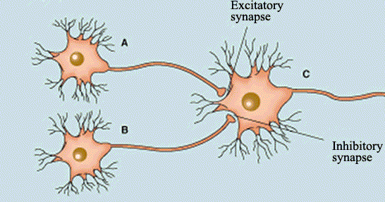
  - B inhibits excitatory effects of A synapsing on C, by hyperpolarizing C.
- Pre-synaptic
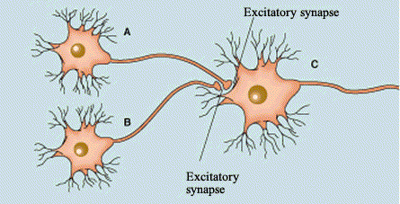
  - B inhibits excitatory effects of A on C by partially depolarizing A.
    - APs travelling down A produce smaller change in membrane potential.
Properties of PSPs (exam question: how are post-synaptic potentials different than action potentials?)
- This is not Action Potentials
- These can occur on the soma
- Graded
  - Amplitudes are proportional to the intensity of the signal
    - Strong inhibition leads to greater EPSPs and IPSPs
- Decremental
  - As the potential spreads across the membrane, the size decays as a function of the square of the distance
  - Decreases as a proportion of the distance
  - Inputs that are further away from the axon hillock have less of an impact when the neuron fires
- Rapid
  - Very fast changes
- Passive, cable properties
  - Analog as opposed to digital
Interim Summary
- Inside of cell more negative than outside: RMP
- Due to imbalance in ions, 4 factors that contribute
- Neuron is polarized
- Membrane can become more (hyper) or less (de) polarized
  - Post-synaptic potentials
  - If the sum of all the excitatory inputs (EPSPs) reaches around -50 mv this will lead to an action potential
  - Orgasm example
- If the threshold of excitation is reached (~-50mv), leads to an action potential
The Action Potential
- A sudden reversal in the membrane potential (from negative to positive) caused by a brief increase in the permeability of the membrane to NA+, immediately followed by a transient increase in the permeability of the membrane to K+
- Peak of action potential: +40-50 mv
- Generated at the axon hillock
  - Point where EPSPs are summed
Integration of PSPs
- Individual post-synaptic potentials have little effect on firing of post-synaptic neuron
  - Because neurons receive millions
- Firing depends on the integration of inhibitory and excitatory signals reaching the axon hillock
  - Rich in voltage-sensitive ion channels
  - Channels will open with a change in voltage due to sensitivity
- Neurons integrate signals over space (spatial) and over time (temporal): SUMMATION
  - Influx and efflux of ions is what is being summed
    - How much potassium and sodium is inside related to outside
Spatial Summation
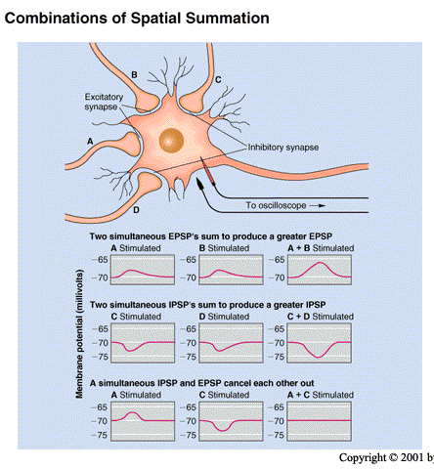
- Summing of potentials that come from different parts of the cell
  - On dendritic tree, soma, axon
- Influenced by distance
  - Closer to the axon hillock, the more likely it will generate an AP (if depolarizing current)
  - Because of detremetric property
- If overall sum (EPSPs and IPSPs) can depolarize the cell at the axon hillock Action Potential!!!
Temporal Summation
- Summing of potentials that arrive at the axon hillock at different times
- Closer in time they arrive, the greater the summation and possibility of an AP
- Cannot have EPSP + IPSP
  - Single synapse
- Spatial summation: multiple inputs
- Temporal summation: one input
  - Firing rapidly
- Temporal and Spatial summation together would have an even greater effect
  - Simultaneous stimulation
Conduction of Action Potentials
- All-or-none law: An action potential either occurs or does not occur; once triggered, it is transmitted down to the end of the axon
  - Action potential always remains the same size, without growing or diminishing, but
  - Action potentials are conducted more slowly than post-synaptic potentials
    - Properties between them!!!!!
    - In unmylenated axons
- Will not ask a diagram not in textbook.
- Rate Law: Variable information is represented by the axon’s rate of firing
  - weak stimuli will yield slower rate of firing
  - strong stimuli will yield a faster rate of firing
    - more EPSPs
    - more influx of ions
  - e.g: a high rate of firing causes strong muscular contraction, and a strong stimulus (eg. Bright light) causes a high rate of firing in axons that serve the eyes
  - Not the amplitude of the action potential that is important, but the number of times a neuron fires for a given time period
Refractory Periods
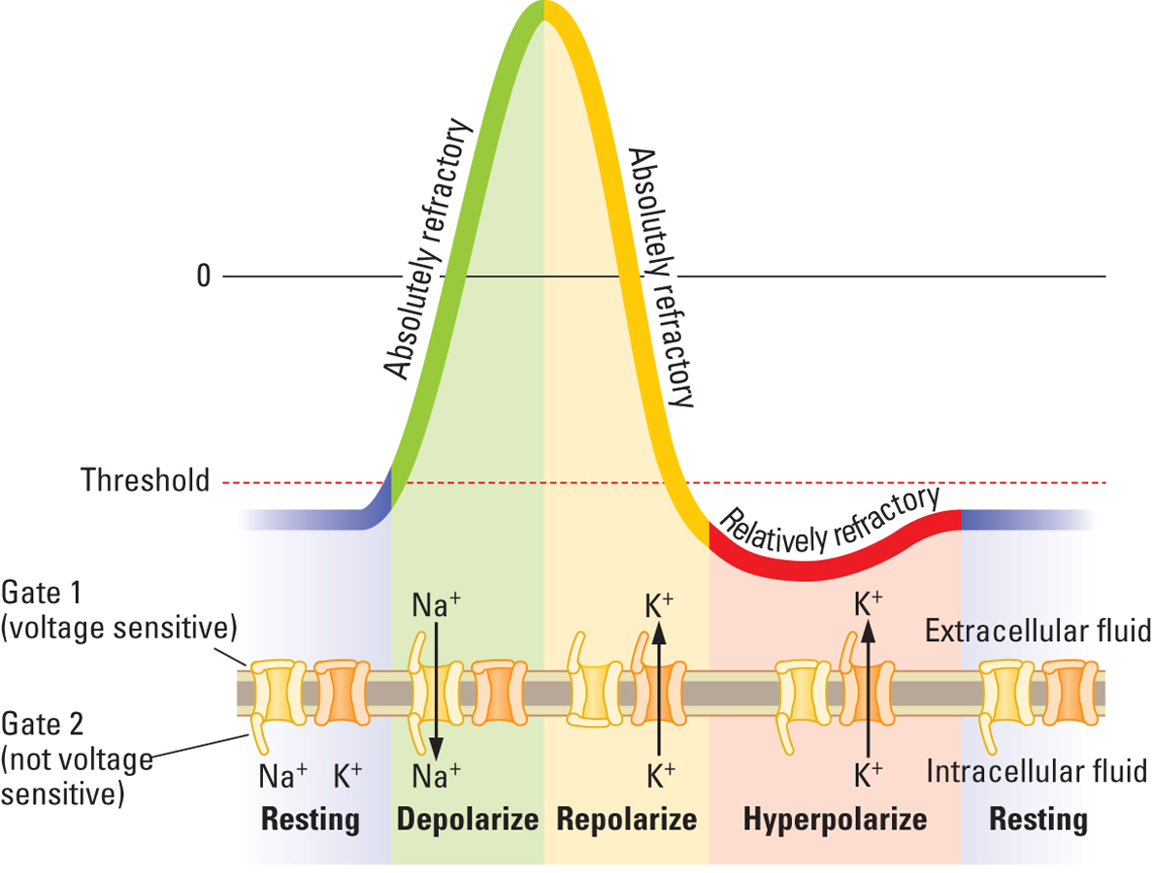
- Absolute refractory period: 1-2 ms after an action potential, another AP cannot be generated, no matter what kind of input the neuron receives
  - Neuron firing will always be limited by this
  - Followed by the:
- Relative refractory period: Action potential can only be elicited by high levels of stimulation
- Example: men after sex
Conduction in Unmyelinated Neurons
- Once an AP has been generated at the axon hillock, it travels passively along the axonal membrane to the adjacent voltage-activated sodium channels active
- In response, Na+ channels open and another full-blown potential is generated
- AP travels down axons in waves of depolarization
- Continues down the length of the axon in ‘waves’ of depolarization
  - Refractory periods create a single, discrete impulse that travels only in one direction
    - Sodium channels need time to reset
  - Relatively slow
Conduction in Myelinated Axons
- AP ‘jumps’ from node to node: Saltatory conduction
  - Myelination resists flow of K+ ions
- Faster, requires less energy
- Larger and myelinatined axons conduct faster
  - Opening fewer channels
  - Larger the axon, more mylenation, faster the AP will travel
Types of Conduction
- Orthodromic: Transmission from the hillock to the terminal buttons
  - Most common because of refractory state of the membrane after depolarization
- Antidromic: Transmission from the terminals to the hillock (occurs when terminals are stimulated)
Review: The Synapse
- The function of synapses is to cause local changes in postsynaptic membrane potentials, through neurotransmitters
- Sneak Preview: Neurotransmitters are the ‘chemical messengers’ of neurons alter the resting potential of postsynaptic cell! (PSPs)
- Most synapses are chemical
  - Can also have electrical
Sequence of Transmission
- Action potential travels down the axon to the axon terminal
- Voltage-gated calcium channels open and calcium ions (Ca2+) enter
  - Calcium is key!
- Synaptic vesicles fuse with membrane and release transmitter into the cleft
- Transmitters bind to postsynaptic receptors – cause an EPSP or IPSP
  - Lock in key
- EPSPs or IPSPs spread toward the postsynaptic axon hillock
  - After summation
- Transmitter is inactivated or removed – action is brief
  - If it would sit there for too long it would cause over stimulation
Synaptic Transmission – Summary
- Neuronal firing is a electro-chemical event
  - Neurotransmitter (chemical) binds to post-synaptic receptor
  - Causes change in local membrane potential (electrical)
  - Increase or decrease probability of cell firing
  - If action potential produced leads to neurotransmitter release re-start cycle
  - Every pre-synaptic cell is also a post-synaptic cell

