How Do Drugs and Hormones Influence the Brain and Behavior?
6. Psychomotor Stimulants
- Behavioral Stimulants
  - Increase motor behavior and elevate a person’s mood and level of alertness
- Cocaine
  - Obtained from the leaves of the coca plant
  - Addictive
  - Blocks dopamine reuptake
  - Derivatives such as Novocaine are used as local anesthetics
- Amphetamine
  - Dopamine agonist: releases dopamine into the synapse and blocks the reuptake of dopamine, as well
  - Some Uses:
    - Initially an asthma treatment
    - Study aid
    - Improvement of alertness and productivity
    - Weight-loss aid
General Stimulants
- Drugs that cause a general increase in the metabolic activity of cells
- Caffeine
  - Blocks adenosine receptor (antagonist)
- Nicotine
  - Low doses stimulate, high doses block, nicotinic receptors (acetylcholine)
  - Indirectly activates sympathetic nervous system
7. Psychedelic Drugs
- Alter sensory perception and cognitive processes and can produce hallucinations
- Four main types
  - Acetylcholine psychedelics
  - Norepinephrine psychedelics (e.g., mescaline)
  - Serotonin psychedelics (e.g., LSD, psilocybin)
  - Tetrahydrocannabinol (THC): active ingredient in marijuana
    - Similar to opioids
    - Cannabinoid receptors (analgesic and high)
Intoxication
- Set of physiological, cognitive and behavioural changes that occur as a direct result of the effects of a substance on the central nervous system (CNS)
  - Alters perception, mood, personality, decision-making, motor control, etc.
- Short-term effects (i.e, first use) different from chronic use
  - Develop tolerance
Factors that Influence Intoxication
- Pharmacological
  - Chemical properties and action on the body
  - Drug dosage: how much is consumed
  - Route of drug administration: how the drug enters the body
- Characteristics of the user (non-pharmacological)
  - Genetics
  - Gender
  - Age
  - Drug tolerance
  - Personality
  - Psychological set: knowledge , attitudes, expectations about the drug
- Setting in which a drug is used (non-pharmacological)
  - Laws pertaining to drug use
  - Immediate physical environment
  - Social environment: Whether other people are present
see lecture slide on dependence
Addiction and Dependence
- Substance Abuse
  - Use of a drug for the psychological and behavioral changes that it produces aside from its therapeutic effects
- Addiction (a.k.a. substance dependence)
  - Defined as: A syndrome at the centre of which is loss of control over a reward-seeking behaviour
  - Behaviour is compulsive
  - Associated with tolerance, withdrawal, and relapse
Drug Withdrawal
- Acute and protracted drug use leads to drug withdrawal
- Behavioural and physiological symptoms that occur upon cessation of drug use
  - Opposite to drug effects; compensation for drug effects on body
  - Severity may change with characteristics of the user, history of drug use
    - E.g., a hangover
    - Muscle aches and cramps, anxiety attacks, sweating, nausea, convulsions, death
Evidence for an Important Role of Dopamine in Drug Abuse
- Rats will press a bar to receive electrical stimulation of the mesolimbic dopamine system and stop when the dopamine system is blocked
- Abused drugs seem to be dopamine agonists: they cause the release of dopamine or prolong its availability in the synapse
- Drugs that are dopamine antagonists (i.e.,block the effect of dopamine) are not abused substances
Sex Differences in Addiction
- Females twice as sensitive to drugs on average
  - Smaller body size, hormonal differences
- Females only slightly less likely to become addicted to some drugs
  - But do show ‘telescoping’
    - Have a faster progression to disease than men
    - From point a to addiction faster than men
- Females more likely to abuse certain drugs
  - Nicotine, cocaine, amphetamine, opioids, cannabinoids, caffeine, PCP, prescription drugs
Why Doesn’t Everyone Abuse Drugs?
- Genetics?
  - Despite some evidence of a genetic contribution, no gene or set of genes related to alcoholism have been found
  - Any satisfactory explanation of drug abuse will require genetic and learning components
- Personality Traits?
  - Unusual risk-taking may be trait common to drug abusers
- Early life history?
  - Experience of trauma (abuse, neglect, etc.) early in life is one of the best predictors of adult addictions
Hormones - Introduction
- 1849: AA Berthold removed testes of a rooster
  - No longer crowed
  - No longer engaged in sexual or aggressive behaviour
- Re-implanted one testis
  - Began crowing; sexual/aggressive behaviour
  - Conclusion: must release chemical into the circulatory system
  - testosterone

Hierarchical Control of Hormones
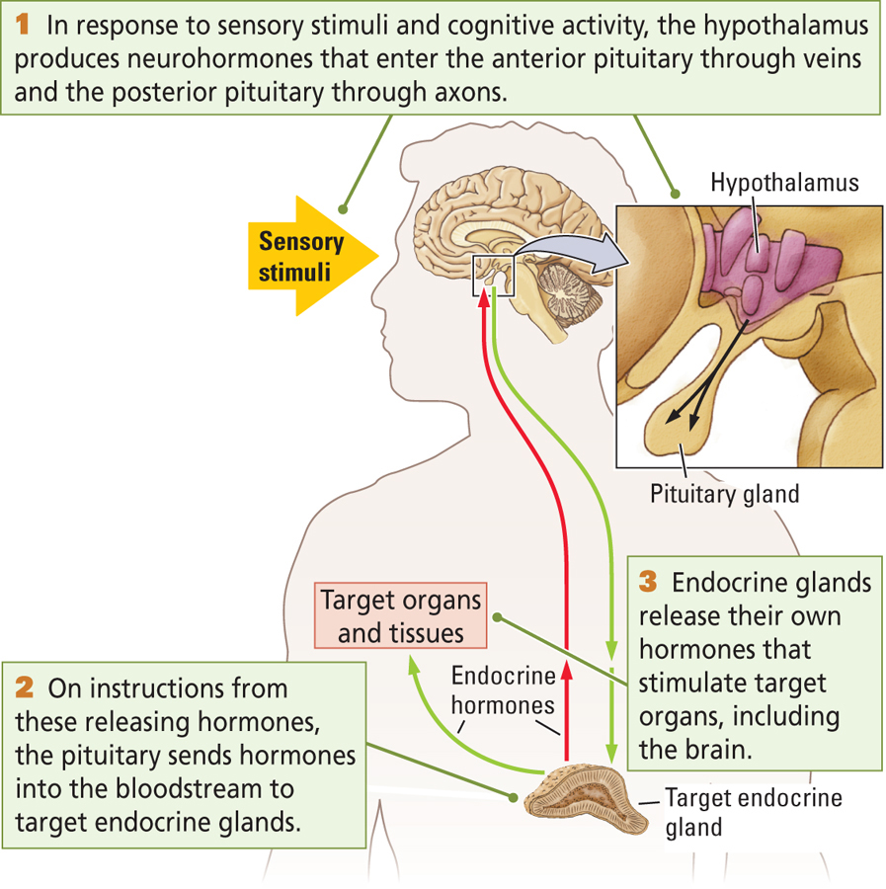
- Four Levels
  - Hypothalamus
  - Pituitary Gland
  - Target Endocrine Glands
  - Target Organs and Tissues
- Hormones affect almost every neuron in the brain
  - Can also influence genetic expression, synthesis of proteins
Classification of Hormones
by Structure
- Steroid Hormones
  - Fat-soluble chemical messenger synthesized from cholesterol
    - Examples: gonadal (sex) hormones, thyroid
- Peptide Hormones
  - Chemical messenger synthesized by cellular DNA that acts to affect the target cell’s physiology
    - Examples: insulin, growth hormone
by Function
- Homeostatic hormones
  - Maintain a state of internal metabolic balance and regulation of physiological systems
- Gonadal (sex) hormones
  - Control reproductive functions; sexual development and behavior
- Glucocorticoids
  - Secreted in times of stress; important in protein and carbohydrate metabolism
Homeostatic Hormones
- Homeostasis of intracellular and extracellular environments are essential to life
- Diabetus mellitus
  - Caused by a failure of the pancreas to secrete enough (or any) insulin
  - Hyperglycemia High blood-glucose levels; cells are not using glucose and therefore are not able to function properly
  - Hypoglycemia : Low blood-glucose levels
Gonadal Hormones
- We’ve already talked a lot about these, so just review this section in the text on your own
Anabolic-Androgenic Hormones
- Anabolic Steroids
  - A class of synthetic hormones related to the male sex hormone testosterone that have both muscle-building and masculinizing effects
- Health risks
  - Body reduces production of testosterone, reducing male fertility
  - Increased aggression
  - Increased risk of heart attack and stroke
  - Compromised liver and kidney function
  - masculinization of female users
Stress Hormones
- Stressor
  - A stimulus that challenges the body’s homeostasis and triggers arousal
- Stress Response
  - The physiological and behavioral arousal and any attempt to reduce the stress
  - Two sequences
    - Fast-acting: Activation of sympathetic nervous system; “fight-or-flight” response
    - Slow-acting: Activation of parasympathetic nervous system; “rest-and-digest” response
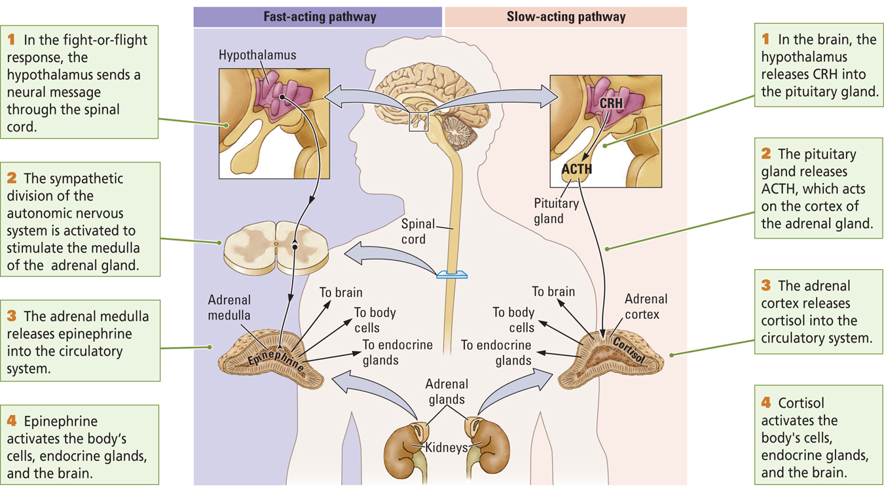

Ending a Stress Response
- Normally, stress responses are brief
- Stress responses are turned on and off in the brain
- Sapolsky (2005)
  - Hippocampus is involved in turning off the stress response
  - Too much cortisol will damage neurons in the hippocampus
  - Vicious cycle involving prolonged stress, cortisol levels, and hippocampal functioning
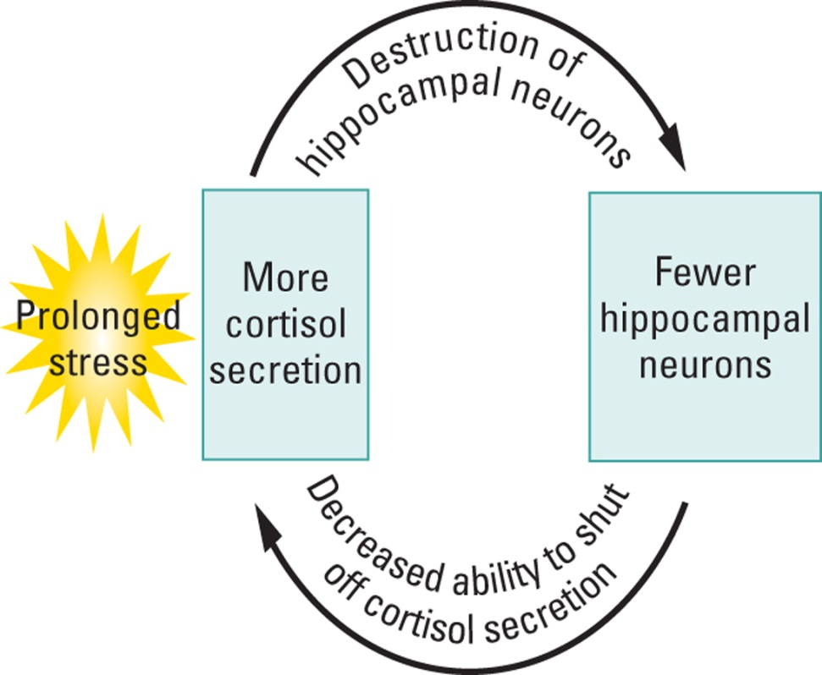
Posttraumatic Stress Disorder
- Syndrome characterized by physiological arousal symptoms related to recurring memories and dreams related to a traumatic event – for months or years after the event
- Some data showing reduced hippocampal volume and cognitive dysfunction in PTSD patients; other studies show no differences
- Individual differences in response to stress!
- Other explanations?

