Using Animals in Brain-Behavior Research
- Two important issues
  - Do animals actually contract the same neurological diseases that humans do?
  - How ethical is it to use animals in research?
Benefits of Creating Animal Models of Disease
- Some disorders are easy to model (e.g., stroke)
- Behavioral disorders are more difficult
  - Attention-Deficit/Hyperactivity Disorder (ADHD)
    - Developmental disorder characterized by core behavioral symptoms of impulsivity, hyperactivity, and/or inattention
  - Kyoto SHR (spontaneously hypertensive rat) rat
      - Develop hypertensivity extremely spontaneously
    - Proposed as a good model for ADHD
Kyoto SHR rat
- Known abnormalities in prefrontal dopaminergic innervation that correlate with behavioral abnormalities such as hyperactivity
- Dopamine agonists such as methyphenidate (Ritalin) can reverse behavioral abnormalities, both in children with ADHD and in SHR rats
Animal Welfare and Scientific Experimentation
- Most governments regulate the use of animals in research
- Universities and other research organizations have additional rules governing animal use
Guidelines of the CCAC (NOT A QUESTION YOU WILL SEE ON AN EXAM)
- The use of animals in research, teaching, and testing is acceptable only if it contributes to the understanding of environmental principles or issues, fundamental biological principles, or development of knowledge that can reasonably be expected to benefit humans, animals, or the environment
- Optimal standards for animal health can care result in enhance credibility and reproducibility of experimental results
- Acceptance of animal use in science critically depends on maintaining public confidence in the mechanisms and processes used to ensure necessary, human, and justified animal use
- Animals are used only if the researcher’s best efforts to find an alternative have failed
  - Researchers who use animals employ the most humane methods on the smallest number of appropriate animals required to obtain valid information
Animal Welfare and Scientific Experimentation
- Considerable controversy remains over using animals in scientific research
- The debate centers on issues of law, morals, custom, and biology
- Because you, as students, encounter many experiments on animals in this course, these issues are important to you as well

How Does the Nervous System Develop and Adapt?
Growth and Development of the Brain Are Orderly Processes
- The mature human brain has about 100 billion neurons
- The developing nervous system relies on genetic information and its environment
- One measure of brain development is brain weight
Three Perspectives on Brain Development
- Neuroscientists study the relation between brain and behavioral development from three perspectives:
  - Structural development can be studied and correlated with the emergence of behavior
    - E.g., Development of frontal lobe should correspond with social development
      - Tower of Hanoi (goal directed planning in frontal lobe)
  - Behavioral development can be analyzed and predictions made about what underlying circuitry must be emerging
    - E.g., development of language development of language regions
  - Factors that influence both brain structure and behavioral development, such as hormones, genes, experience, or injury, can be studied
    - E.g., abnormal hormonal levels influence given behaviour and brain structure
    - Conclude structure implicated must play a role in behaviour normally

Neurobiology of Development
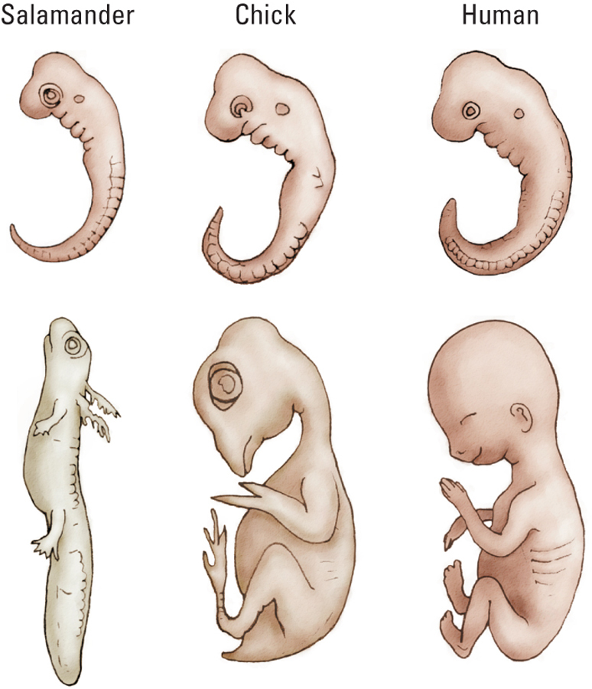
ontogeny recapitulates phylogeny

Embryonic Vertebrate Nervous System
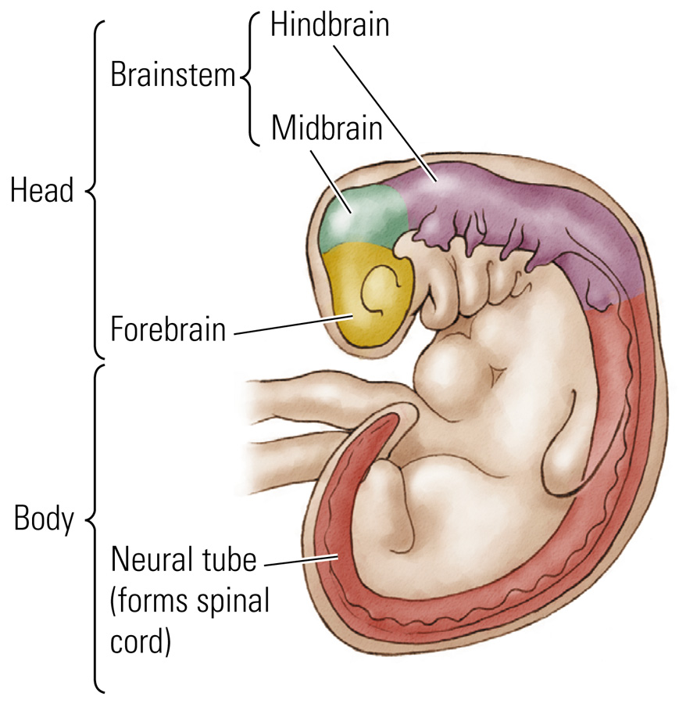
Gross Development of the Human Nervous System
- Prenatal Stages
  - Zygote: Fertilization to 2 weeks
  - Embryo: 2 to 8 weeks
  - Fetus: 9 weeks to birth
- By day 21: Neural Plate
  - Thickened region of the ectodermal layer that gives rise to the neural tube
  - Folds to form neural groove
  - Curls up to form…
- Neural Tube
  - Structure in the early stage of brain development from which the brain and spinal cord develop
- Major Events
  - Day 49: Embryo begins to resemble a miniature person
  - Day 60: Sexual differentiation
    - Genitals and brain regions
  - Day 100: Brain looks distinctly human
  - 7 Months: Gyri and sulci begin to form
  - 9 Months: Brain looks like an adult brain
Origins of Neurons and Glia
- Neural Stem Cell
  - A self-renewing multipotential cell that gives rise to neurons and glia
  - Line the neural tube
  - When divide, one lives to divide again, the other dies
- Subventricular Zone
  - Lining of neural stem cells surrounding the ventricles in adults
- Stem cells give rise to progenitor cells:
  - Precursor cell derived from a stem cell; it migrates and produces a neuron or glial cell
- Neuroblast
  - Product of a progenitor cell that gives rise to different types of neurons
- Glioblast
  - Product of a progenitor cell that gives rise to different types of glial cells
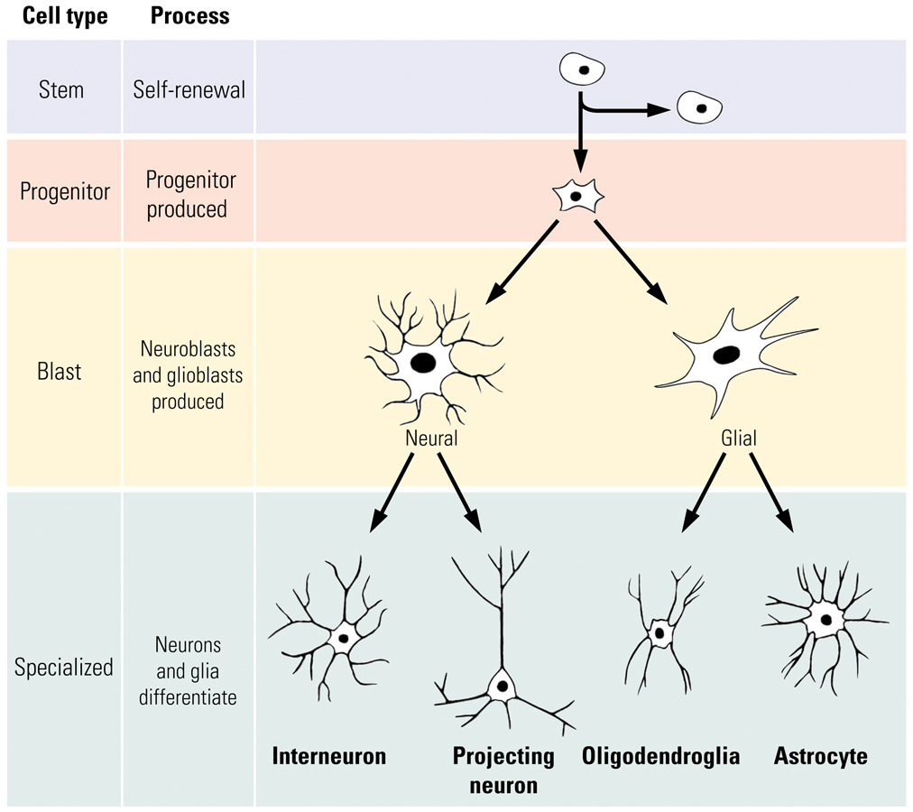

How do stem cells know what to become?
Chemical Signal Turn on gene specific proteins made specific cells
Origins of Neurons and Glia
- Neurotrophic Factor: A chemical compound that acts to support growth and differentiation in developing neurons
  - May help keep certain neurons alive in adulthood
- Epidermal Growth Factor (EGF)
  - Stem cell Progenitor cell
- Basic Fibroblast Growth Factor (bFGF)
  - Progenitor cell Neuroblast
Stages of Brain Development
- Cell Birth: neurogenesis; gliogenesis
- Cell Migration: cells move to establish distinct populations
- Cell Differentiation: cells become distinctive neurons or glial cells
- Cell Maturation: dendrite and axon growth
- Synaptogenesis: formation of synaptic connections
- Cell Death and Synaptic Pruning: selective death of some nerve cells; fine-tuning
- Myelogenesis: formation of myelin
1. Cell Birth
- A chemical compound acts to support growth and differentiation in developing neurons; begins about 7 weeks after conception
- Largely complete by 5 months
  - Exception: Hippocampus makes new cells throughout life
- Brain can more easily cope with injury during this time (first 5 months of gestation)
  - More neurons can be made to compensate for cell death
2. Cell Migration
- Begins approximately 8 weeks after conception
- Largely complete by 29 weeks
- Damage has more serious consequences
  - Susceptible to teratogens
    - E.g., alcohol, heavy metals, certain diseases
- Radial Glial Cell
  - Path-making cell that a migrating neuron follows to its appropriate destination in the cortex
  - Layer VI formed first (innermost layer); top layer (I) formed last
3. Cell Differentiation
- Begins after cells have begun to migrate
  - When cells reach their destinations they begin to express genes to make the proteins they need
  - This cell differentiation allows a cell to acquire its specific appearance and function
  - Dependent upon genetic instructions, timing, and signals from other cells in the local environment
- Largely complete by 29 weeks
- Essentially complete at birth
4. Neural Maturation
- Begins about week 20 and continues long after birth
- Mature in 2 ways:
  - Dendritic Growth and Axonal Growth
- Dendritic Growth
  - Arborization (branching)
  - Growth of dendritic spines where most synapses occur
  - Slower (micrometers/day) than axonal growth (millimeters/day)
- Axonal Growth
  - Growth cone: Growing tip of an axon
  - Filopod: Process at the end of an developing axon that reaches out to search for a potential target or to sample the intercellular environment
  - Respond to chemical cues:
    - Cell-adhesion molecule (CAM): A chemical to which specific cells can adhere, thus aiding in migration
    - Tropic molecule: Signaling molecule that attracts or repels growth cones
    - Theoretical
5. Synaptic Development
- 10¹⁴ synapses in the adult human cerebral cortex!
- Combination of genetic programming and environmental cues and signals
- 5th gestational month: Simple synaptic contacts
- 7th gestational month: Synaptic development of deep cortical neurons
- After birth: synaptic development increases rapidly during the first year of life
  - Visual cortex: density doubles between 2 months and 4 months!
6. Cell Death and Synaptic Pruning
- We are born with an overabundance of neurons and synaptic connections
- Neural Darwinism
  - Hypothesis that cell death and synaptic pruning are, like natural selection in species, the outcome of competition among neurons for connections and metabolic resources in a neural environment
- Apoptosis
  - Genetically programmed cell death
- Synaptic connections that are not part of a functional network are pruned away in an experience-dependent manner
- Change in volume of gray matter up until the early 20s (decreases in caudal-rotral gradient) (cortex become thinner)
  - More mylentation of the brain

