Neurobehavioural Disorders
Causes of Abnormal Behavior
- Evidence for brain abnormalities in organic-neurological disorders is straightforward, and the causes are generally known
  - Genetic errors (e.g., Huntington’s disease)
  - Progressive cell death (e.g., Alzheimer’s disease)
  - Rapid cell death (e.g., stroke)
  - Loss of neural connections (e.g., multiple sclerosis)
- Far less is known about the causes of behavioral/psychiatric disorders, but there must be some abnormality in brain structure or activity
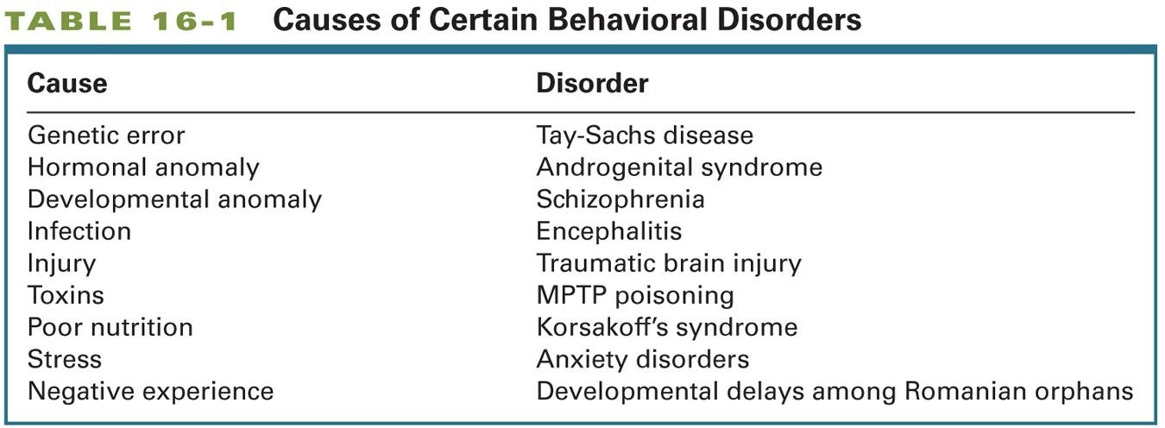
(micro macro (going down))
Investigating the Neurobiology of Behavioral Disorders
- Phenylketonuria (PKU)
  - Behavioral disorder caused by elevated levels of the amino acid phenylalanine in the blood
    - Results from a defect in the gene for the enzyme phenylalanine hydroxylase
  - Major symptom: severe mental retardation
  - Fix: change in diet to not consume phenylalanine
  - Unlike PKU, most disorders do not involve a single genetic abnormality and the underlying causes are largely conjectural

Challenges in Diagnosis
- It is difficult diagnose behavioral disorders
  - People are seldom objective observers of their own behavior or that of a loved one
    - The patient and their loved ones may be selective in what they notice
  - People are seldom specific in identifying symptoms
    - Memory deficits?
  - Evaluators have their own conceptual biases, which may influence the questions that they ask and the information that they gather
    - GPm social worker, neurologist
Investigating the Neurobiology of Behavioral Disorders
- The complexity of the nervous system makes it very difficult to research
- Heninger (1999)
  - There is no clear evidence of a single receptor system with a specific relation to a specific behavior
- Animal models of behavioral disorders are useful, but they provide an oversimplified view of the neurobiology of such disorders
Identifying and Classifying Mental Disorders
- Epidemiology
  - The study of the distribution and causes of diseases in human populations
- DSM
  - The Diagnostic and Statistical Manual of Mental Disorders, the American Psychiatric Association’s classification system for psychiatric disorders (see Table 16-3)
  - Current edition is DSM-IV-TR, DSM-V slated for 2012
- Psychiatric disorders are to some extent arbitrary and depend on prevailing cultural views
The Use of Brain Imaging
- Brain imaging techniques are currently not used to diagnose mental disorders
- To be clinically useful, imaging tools must be sensitive enough to detect unique features of brain disorders and specific enough to rule out similar conditions
- Still, imaging is shedding new light on behavioral disorders
- Early onset schizophrenia; loss of grey matter
Treatments for Disorders
- The long-term prospects for curing organic or behavioral disorders on the macro level depend on the ability to treat structural and biochemical abnormalities at the micro level
- Ultimate clinical problem:
  - Apply the knowledge of behavioral neuroscience to generate treatments that can restore a disordered brain (and mind) to the range of normalcy
  - Nosology precedes etiology : how do we treat a disorder when we don’t know what causes it?
    - Nosology: naming of a disorder
    - Etiology: cause of a disorder
Neurosurgical Treatments
- Either damage or stimulate some dysfunctional area of the brain
- Deep Brain Stimulation
  - Neurosurgery in which an electrodes implanted in the brain stimulate a targeted area with a low-voltage electrical current to facilitate behavior
  - Used to treat Parkinson’s and Depression
- Stem Cell Therapy
  - Aims to return a dysfunctional brain region back to its embryonic state and regrow a normal region
  - Using fetal cells for implantation has had limited success; multipotential stem cells from other areas of the body (e.g., bone marrow) may be a more effective source of stem cells
  - The challenge will be to ensure that the cells differentiate correctly and form the proper connections
Electrophysiological Treatments
- Electroconvulsive Therapy (ECT)
  - Using electrical current to produce seizures as a treatment for severe depression
  - Stimulates the production of neurotrophic factors
  - Problems
    - Need to medicate person to avoid the caused by the electrical stimulation
    - ECT leads to memory loss, which can show a cumulative effect with repeated ECT treatments
- Trans-cranial Magnetic Stimulation
  - An alternative to ECT for treating depression
  - TMS is far less drastic than ECT
  - Fewer side effects than ECT because the magnetic stimulation can be applied narrowly, to a focal area, rather than diffusely, as in ECT
Pharmacological Treatments
- Commonly used drugs for behavioral disorders
  - Neuroleptics for schizophrenia
  - Anxiolytics agents for anixety
  - Selective serotonin reuptake inhibitors (SSRIs) for depression
  - L-dopa for Parkinson’s disease
- However, behavioral disorders cannot be reduced to a single chemical abnormality
- Drugs do not provide the behavioral tools needed for coping – “A pill is not a skill”
- Some drugs have negative side effects
  - Tardive Dyskinesia
    - Inability to stop the tongue from moving
    - Motor side effect of neuroleptic drugs
    - Can last long after person stops taking the drug
Behavioral Treatments
- Psycotherapy
  - Talking therapy derived from Freudian psychoanalysis and other psychological interventions
- Behvioral Therapy
  - Treatment that applies learning principles, such as conditioning, to eliminate unwanted behaviors
- Cognitive Therapy
  - Psychotherapy based on the perspective that thoughts intervene between events and emotions, and thus the treatment of emotional disorders requires changing maladaptive patterns of thinking
- It is often useful to combine pharmacological and psychotherapies
- Not only does altering the brain change our behavior, but altering our behavior also changes the brain
Traumatic Brain Injury
- Head injuries are the most common form of brain damage in people younger than 40
- Two important factors:
  - Age
    - Children (and older adults) are more likely to suffer head injuries due to falls
  - Sex
    - Males between 15 and 30 are more likely to suffer head injuries, especially from automobile and motorcycle accidents
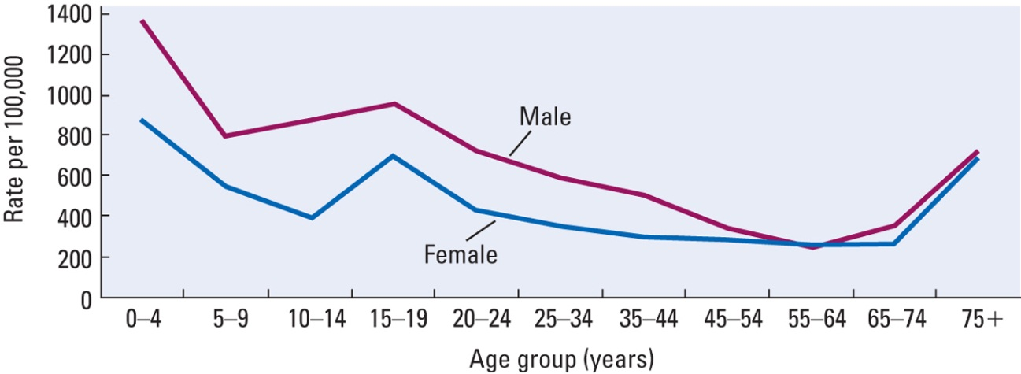

Traumatic Brain Injury: Effects
- Trauma can disrupt the brain’s blood supply, induce bleeding, cause swelling, expose the brain to infection, and scar brain tissue
- Unconsciousness : brief or prolonged (coma)
- Two behavioural effects:
  - Specific impairments may be the result of the coup( site of impact) and countercoup (opposite side) lesion
  - More generalized impairments may be due to widespread damage throughout the brain
Traumatic Brain Injury
- Often misdiagnosed; no abnormal MRI or CT scan
- Most cognitive recovery occurs within the first 6 to 9 months
  - Cognitive abilities tend to make a good recovery, but social skills and normal personality typically do not show significant change
Stroke
- Stroke
  - An interruption of blood flow either from the blockage of a blood vessel or from bleeding of a vessel
- Ischemia
  - Lack of blood to the brain as a result of stroke
  - Sets off a cascade of cellular events that cause the real damage to the initial site and surrounding areas
- Diaschisis
  - Neural shock that follows brain damage in which areas connected to the site of damage show temporary arrest of function
Stroke - Treatment
- Administer anti-clot drugs
  - E.g., t-PA (tissue plasminogen activator)
  - Must be administered within 3 h of stroke!
- Nueroprotectant
  - Drug used to try to block the cascade of poststroke neural events
  - No good ones available yet
- Therapies (e.g., speech or physical) are often used to facilitate plastic changes in the brain following a stroke
Epilepsy
- Recurrent seizures accompanied by loss of consciousness
- Sympotomatic Seizure
  - Identified with a specific cause, such as infection, trauma, tumor, vascular formation, toxic chemicals, very high fever, or other neurological disorders
- Idiopathic Seizure
  - Appears spontaneously and in the absence of other diseases of the central nervous system
  - A variety of factors may precipitate a seizure
- Three common symptoms of seizures
  - An aura, or warning of impending seizure – a sensation (odor or noise) or a “feeling”
  - Loss of consciousness often followed by a period of amnesia that can include the seizure itself
  - A motor component that can vary from shaking to automatic movements such as hand-rubbing or chewing
Two Types of Epileptic Seizures
- Focal Seizure
  - Category of seizure that begins locally (at a focus) and then spreads out to adjacent areas
  - “Jacksonian march”
- Complex Partial Seizure
  - Type of focal seizure
  - Originate mostly in the temporal lobe
  - Not often associated with loss of consciousness
    - Can if severe, but not usual
  - Characterized by:
    - Subjective experiences that presage the attack (e.g., hallucinations)
    - Automatisms or repetitive stereotyped movements (e.g., lip smacking)
    - Postural changes (e.g., a catatonic or frozen posture)
  - Two Types of Epileptic Seizures
- Generalized Seizures
- Lack focal onset; occur on both sides of the body
  - Grand Mal Seizure
    - Characterized by loss of consciousness and stereotyped motor activity; 3 stages:
      - Tonic stage: body stiffens and breathing stops
      - Clonic stage: rhythmic shaking
      - Postictal depression: postseizure state of confusion
  - Petit Mal Seizure
    - Of brief duration, characterized by loss of awareness with no motor activity except for blinking, turning the head, or rolling the eyes
Epilepsy: Treatment
- Anticonvulsant medications
  - Examples: diphenylhydantoin or phenobarbital
  - Work by stabilizing the neuronal membrane, especially inhibitory neurons
- Surgical removal of the abnormal tissue that is the focus of the seizures is sometimes performed in severe cases
Multiple Sclerosis
- Disease characterized by a loss of myelin, largely in the motor tracts but also sensory nerves
- Relapses and remissions are common
- Brain imaging reveals discrete lesions
- Cause is unknown, but proposed causes include: bacterial infection, a virus, environmental factors (e.g., pesticides), and an immune response of the central nervous system
Dementia
- Acquired and persistent syndrome of intellectual impairment
- Diagnostic features (DSM):
  - Memory and other cognitive deficits and
  - Impairment in social and occupational functioning
- Two broad categories:
  - Nondegenerative dementias are a heterogeneous group of disorders with diverse etiologies
    - E.g., vascular dementia, Korsakoff’s.
  - Degenerative dementias are presumed to have a degree of genetic transmission
    - E.g., Alzheimer’s, Huntington’s, Parkinson’s.
Parkinson’s Disease
- Related to the degeneration of the substantia nigra and to the loss of the neurotransmitter dopamine
- Despite a common site of damage, symptoms vary enormously among people
- Many symptoms resemble the changes in motor activity that take place as a normal consequence of aging

- Positive Symptoms
  - Tremor at rest
  - Muscular rigidity (increased muscle tone)
  - Involuntary movements
    - Akathesia : Small, involuntary movements or changes in posture; motor restlessness
    - Occulogyric crisis: involuntary turns of the head and eyes to one side
- Negative Symptoms
  - Disorders of posture (fixation and equilibrium)
  - Disorders of righting (e.g., standing up)
  - Disorders of locomotion
    - Festination: tendency to engage in a behavior, such as walking, at faster and faster speeds
  - Speech disturbances (e.g., loss of prosody)
  - Akinesia (poverty or slowness of movement)
- Also: Cognitive symptoms
  - Impoverishment of feeling, libido, motive, and attention; cognitive slowing
Parkinson’s Disease: Causes
- Loss of cells in the substantia nigra, which may be caused by diseases such as encephalitis, syphilis, drugs (e.g., MPTP), or unknown causes
  - Environmental pollutants? Insecticides?
  - Increasing incidence among individuals <40…suggests environmental toxins
Parkinson’s Disease: Treatment
- Behavioral
  - Example: physical therapy is often helpful
- Pharmacological
  - Increase levels of dopamine (e.g., dopamine agonists such as L-dopa)
  - Suppress the activity of structures that show heightened activity in the absence of adequate dopamine action (e.g., anticholinergic drugs)
- Surgical
  - Electrical stimulation or lesioning of the internal global pallidus reduces rigidity and tremor
- Transplantation
  - Transplant embryonic dopamine-producing cells or multipotential stem cells into the basal ganglia
  - Highly experimental (as of yet, limited success)
Alzheimer’s Disease
- Approximately 65% of dementia cases
- Cause is unknown, but proposed causes include:
  - Genetic predisposition
    - APOE4 gene, related to production of cholesterol
    - Seems to be a link between this gene and alzeimers
  - Environmental toxins (aluminum)
  - Autoimmune response
  - A slow-acting virus
  - Reduced blood flow to the hemispheres
Alzheimer’s Disease: Anatomical Correlates
- Neuitic (amyloid) plaques
  - Located mostly in the cerebral cortex
  - Also found in non-Alzheimer dementia patients
  - Amyloid is a precursor to certain proteins, when it is not broken down it forms plaques
- Neurofibrillary tangles
  - Paired helical filaments found in the cerebral cortex and hippocampus
  - Also found in patients with Down syndrome, Parkinson’s disease, and other types of dementia
- Cortical Degeneration
  - Most affected areas are the limbic cortex, inferior temporal cortex, and posterior parietal cortex
  - The entorhinal cortex (link between neocortex and hippocampus) shows clearest evidence for cell loss, which may explain why memory problems occur early in the disease
  - The primary sensory and motor areas are spared
- Cerebral atrophy may be due in large part to the loss of neurotransmitters
  - Loss of neurotransmitters
    - Acetylcholine
      - Used to think this was the only one
    - Noradrenaline
    - Dopamine
    - Serotonin
    - NMDA and AMPA glutamate receptors
- One treatement is to give drugs that upregulate acetycholine
Understanding and Treating
Psychiatric Disorders
- A wide range of psychiatric disorders are listed in the DSM
- Three General Categories
  - Psychotic Disorders
  - Mood Disorders
  - Anxiety Disorders
Schizophrenia
- Six diagnostic symptoms:
  - Delusions
  - Hallucinations
  - Disorganized speech
  - Disorganized behavior
  - Catatonic behavior
  - Negative symptoms (e.g., blunted emotions, facial masking)

Two Types of Schizophrenia?
- Type I
- Positive symptoms
  - Hallucinations
  - Agitated movements
- Likely due to a dopaminergic dysfunction
- Associated with acute onset, good prognosis, and a favorable response to neuroleptics
- Type II
  - Negative symptoms
    - catatonia
    - negative effect
  - Enlarged ventricles and cortical atrophy, particularly in the frontal cortex
  - Associated with chronic affliction, poor prognosis, poor response to neuroleptics, cognitive impairments,
- 20-30% of patients show mixed
Schizophrenia:Neuroanatomical Correlates
- Memory deficits: Large ventricles and thinner cortex in the medial temporal regions and abnormal dendritic fields in the dorsal prefrontal area, hippocampus, and entorhinal cortex
- Deficits in executive functioning: Abnormal blood flow in the dorsolateral prefrontal cortex
- Aditory hallicinations : Abnormalities in the auditory regions of the temporal lobes
- Thought disorders: Abnormalities in Wernicke’s area
- Dopamine
  - One of the first neurotransmitters to be implicated in schizophrenia
  - Neuroleptics are dopamine antagonists
  - Dopamine agonists can produce psychotic symptoms
- Dopamine theory appears too simple
  - Many other neurochemical abnormalities are associated with schizophrenia
Mood Disorders
- Depression
  - Prolonged feelings of worthlessness and guilt, disruption of normal eating habits, sleep disturbances, a general slowing of behavior, and frequent thoughts of suicide
- Mania
  - Disordered mental state characterized by excessive euphoria
- Bipolar Disorder
  - Mood disorder characterized by alternating periods of depression and mania
Depression: Neurobiology
- Antidepressant drugs act to increase levels of norepinephrine and serotonin
- There is little evidence, however, that low levels of these neurotransmitters cause depression
  - Lowering levels of these neurotransmitters in normal people does not produce depression
  - Antidepressant medications alter the levels of these neurotransmitters within days, but it takes weeks for the drugs to start relieving depression
- Duman (2004)
  - Suggested that depression may involve low levels of ______________ factors
  - Brain-derived neurotrophic factor (BDNF) is down-regulated by ______________ and up-regulated by ______________ medications
  - Antidepressant medications may increase levels of BDNF via altering intracellular signalling
- Is there a relationship between mood and reactivity to stress?
  - HPA Axis
    - Hypothalamic-pituitary-adrenal circuit that controls the production and release of hormones related to stress
  - Chronic stress can lead to oversecretion of cortisol , associated with depression in adulthood
    - 45% of adults with depression lasting more than 2 years experienced abuse, neglect, or parental loss as children
Depression: Treatment
- The best treatment need not be direct biological intervention
  - Cognitive-behavioral therapy (CBT)
    - Problem-focused, action-oriented, structured treatment for eliminating dysfunctional thoughts and maladaptive behavior
    - At least as effect as ______________ as a treatment for depression
Anxiety Disorders
- Six Different Types (see Table 15-9)
  - Generalized Anxiety Disorder
  - Panic Disorder
  - Post-Traumatic Stress Disorder
  - Social Phobia
  - Specific Phobias
  - Obsessive-Compulsive Disorder
Anxiety Disorders: Neural Correlates
- Brain Imaging Studies
  - Increased activation in the cingulate cortex and parahippocampal gyrus
  - Enhanced response to anxiety-provoking stimuli in the ______________ and ______________ cortex
- Excessive excitatory neurotransmission may enhance anxiety
  - ______________ drugs are effective at reducing anxiety
- Anxiety disorders may be caused by ______________ experiences early in life
  - What does the diagram I show tell you about anxiety disorders?
Gene x Environment Interactions
- Here I show a diagram. Take some notes
Anxiety Disorders: Treatment
- Pharmacological
  - Benzodiazepines were once the primary treatment for anxiety disorders, but SSRIs (______________ ) are now commonly used treatments for anxiety
- Cognitive-Behavior Therapy
  - Focuses on challenging the reality of patients’ ______________ and the behavioral necessity for their compulsions
  - As effective as ______________ in treating chronic anxiety disorders
Is Misbehavior Always Bad?
- Miller and colleagues (2000)
  - Loss of function in one brain area (e.g., frontal or temporal regions) sometimes can release new functions elsewhere
    - E.g., case of ______________
- ______________ Enhancement
  - Brain-function enhancement by pharmacological, physiological, or surgical manipulation
  - Raises a number of moral and ethical issues
Final Exam: Format
- 40 multiple choice = 40
- 16 definitions (1 mark each) = 16
- 12 short answer (varying marks; 1-3 marks / question) = 25
- 2 figures to label = 9
- Total : 90 marks
- Worth 40% of your final grade
- Not cumulative (although some concepts are cumulative!)
- 3h in length
- Office hours posted on WebCT announcements section
- If you’re sick for the final, contact the registrar’s office to arrange makeup exam
- Thanks for an awesome term!
- It’s been great teaching you and getting to know (some of) you
- Have a great summer!

