Chapter 1: Overview of marketing

What is marketing?
- is a set of business practices designed to plan for an present an organizations products or services in ways that build effective customer relationships

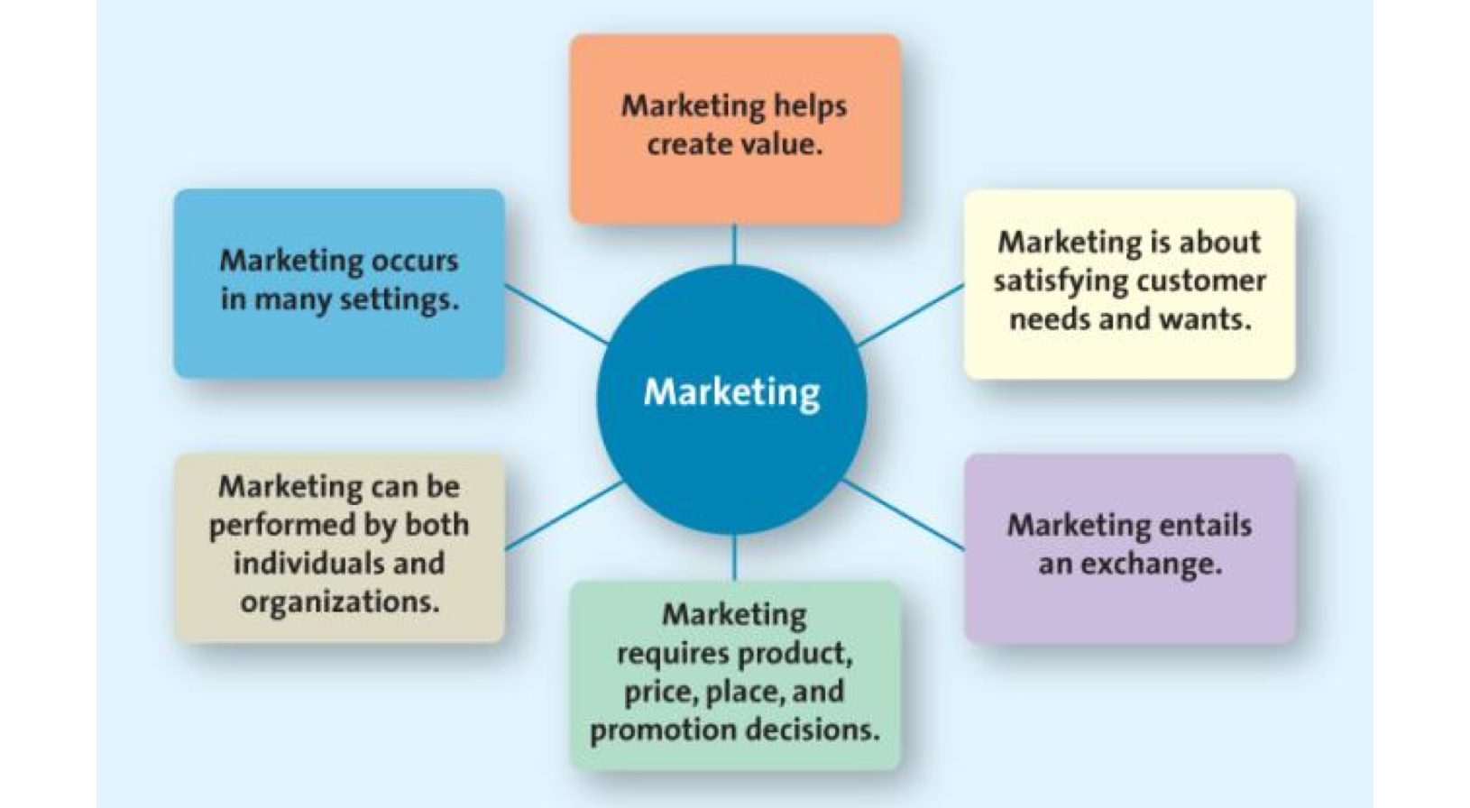
Figure 1-1 Core aspects of marketing

Core One: Satisfying customer needs and wants
- Begins with understanding their needs and wants
- Developing products and services
- Need: basic necessities such as food, clothing, shelter and safety.
- Want: particular way in which a person chooses to satisfy a need, which is shaped by a person’s knowledge, culture and personality.
- Market: refers to the groups of people who need or want a company’s products or services and have the ability and willingness to buy them.
- Target market: customer segment or group to whom the firm is interested in selling its products and services.

Core two: Marketing entails exchange
- The exchange can occur between any two parties
- Not simply a buyer and seller exchanging money for a good or service
- Can be an exchange of information convenience
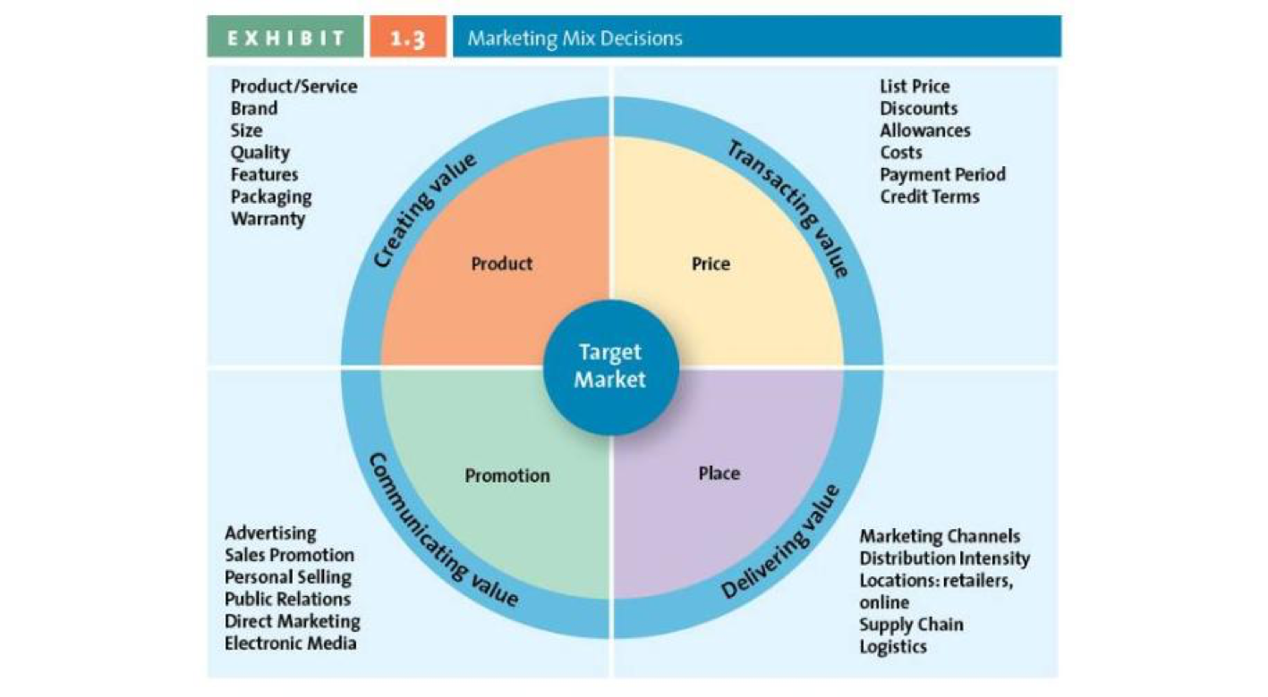
- Exchange: trade of things of value between the buyer and the seller so that each is better off as a result.

Core three: Marketing requires product, price, place and promotion decisions

Marketing mix (4 P’s): product, price, place, and promotion-the controllable set of activities that a firm uses to respond to the wants of its target markets

1. Product: Creating value
o Goods: items that can be physically touched
o Services: intangible customer benefits that are produced by people or machines and cannot be separated from the producer
o Ideas: thoughts, opinions, philosophies and intellectual concepts
2. Price: Transacting value
o Price: is everything a buyer gives up in exchange for the product (money, time, energy)
3. Place: delivering value
o All activities necessary to get the product to the right customer when that customer wants it.
o Supply chain management is the field that examines these activities.
o Where would you find this product in the store?
4. Promotion: communicating value
o All activities necessary to get the product to the right customer when that customer wants it.
o Supply chain management is the field that examines these activities.
o Where would you find this product in the store?

Core four: Marketing can be preformed by both individuals and organizations
- B2B (business to business): selling merchandise from one business to another
- B2C (business to customer): business to customer selling
- C2C (customer to customer): customer to customer (kijiji, ebay)

Core five: Marketing occurs in many settings
- Both profit and non profit entities
- Developing economies
- Entire industries

Core six: marketing helps create value (four orientations of marketing)
1. Product orientation: develop and distribute innovative products
2. Sales orientation: tries to sell as many products
3. Market orientation: focus on what customer’s want
4. Value based orientation: providing greater value than their competitors
¬ Value: reflects the relationship of benefit to costs, or what the consumer gets for what he or she gives

How do firms become more value driven?
- Constantly changing consumer perceptions
- Firms must constantly monitor the marketplace in order to create value

Value based marketing
- something in excess of that being offered by the competitors.
- understand how each aspect of their product/service creates value for customers.

Balancing benefits and cost
- Understand key benefits
- Focus on key benefits
- Eliminate cost of less strategic benefits

Building relationships with customers
- Take a long term view of customer relationships
- Use data to assist in maintaining the relationship
- Relational orientation: a method of building a relationship with customers based on the philosophy that buyers and sellers should develop a long term relationship
- Customer relationship management (CRM): business philosophy and set of strategies, programs and systems that focus on identifying and building loyalty among the firms most valued customers

Why is marketing important?

- Marketing expands firm’s global presence
- Marketing is pervasive across marketing channel members
o Supply chain: group of firms and set of techniques and approaches firms use to make and deliver a given set of goods and services.
- Marketing enriches society
- Marketing can be entrepreneurial

