The Frontal Lobe and Short-Term Memory
- All sensory systems project to the frontal lobes
- During tasks in which monkeys must keep information in short-term memory over a delay, certain cells in the frontal cortex will fire throughout the delay
  - Animals that have not learned the task show no such cell activity
Reciprocal Connections for Explicit Memory
- The neocortex projects to the entorhinal cortex, which projects back to the neocortex
  - Benefits:
    - Signals from the medial temporal regions back to the cortical sensory regions keep the sensory experience alive in the brain:
    - Pathway back to the neocortex means it is kept apprised of the information being processed in medial temporal regions
Korsakoff’s Syndrome
- Indirect cause of chronic alcohol consumption; direct cause of malnutrition.
  - Poor diet: Lack of vitamin B1 (thiamine)
  - Chronic alcoholism compromises thiamine absorption from GI tract, impairs thiamine storage
- May also result from dietary deficiencies, prolonged vomiting, or eating disorders
- Results in permanent loss of ability to learn new information (anterograde amnesia) and retrieve old information (retrograde amnesia)
  - Explicit-memory disturbances (some implicit)
  - These individuals show a great degree of confabulation
    - Lack awareness that they have a memory deficit
    - Tell stories to compensate that they don’t have the memories (trying to fill holes but no awareness of such)
Proposed Neural Circuit for Explicit Memory
- Mishkin and colleagues (1982, 2000)
  - Temporal Lobe Structures
  - Frontal Lobe Structures
  - Medial Thalamus
  - Basal Forebrain-Activating Systems
  - Snesory areas medial temporal regions medial thalamus and prefrontal cortex
  - Basal forebrain keeps activity in forebrain high
  - Frontal cortex important for short-term (explicit) memory and order of explicit events
  - Temporal lobe = LTM (long term memory)
Proposed Circuit for Implicit Memory
- Mishkin and colleagues (1982, 1997)
  - Basal Ganglia
  - Ventral Thalamus
  - Substantia Nigra
  - Premotor Cortex
  - Take in same way and goes to neocortex.
  - Then goes to the basal ganglia (neurons in the substansia nigra (dopamine) are used. Keeps basal ganglia active)
  - To make the implicit memories expressed the need to be sent to the vetral thalamus
  - Signal then sent to premotor cortex (memory of how you ride a bike, how to dial the phone, important on actions of the memories)
  - Lots of inputs, not a lot of connections going back
- Unconscious nature of implicit memory
  - Mishkin believes that implicit memories are unconscious because the connections between the basal ganglia and cortex are unidirectional
    - Basal ganglia receives information from the cortex, but does not project back to the cortex
      - For memories to be conscious, there must be feedback to the cortex
Neural Circuit for Emotional Memories
- Emotional Memory
  - Memory for the affective properties of stimuli or events
  - Could be implicit or explicit
  - Amygdala is critical for emotional memory
    - Damage to amygdala abolishes emotional memory but has little effect on implicit or explicit memory
- Circuitry:
  - Amygdala
  - Medial temporal cortex (explicit memory)
  - Brainstem (autonomic arousal)
  - Hypothalamus (hormones)
  - Periaquaductal Gray Matter (PAG) (pain) (releases endorphins when stimulated)
  - Basal Ganglia (implicit memory)
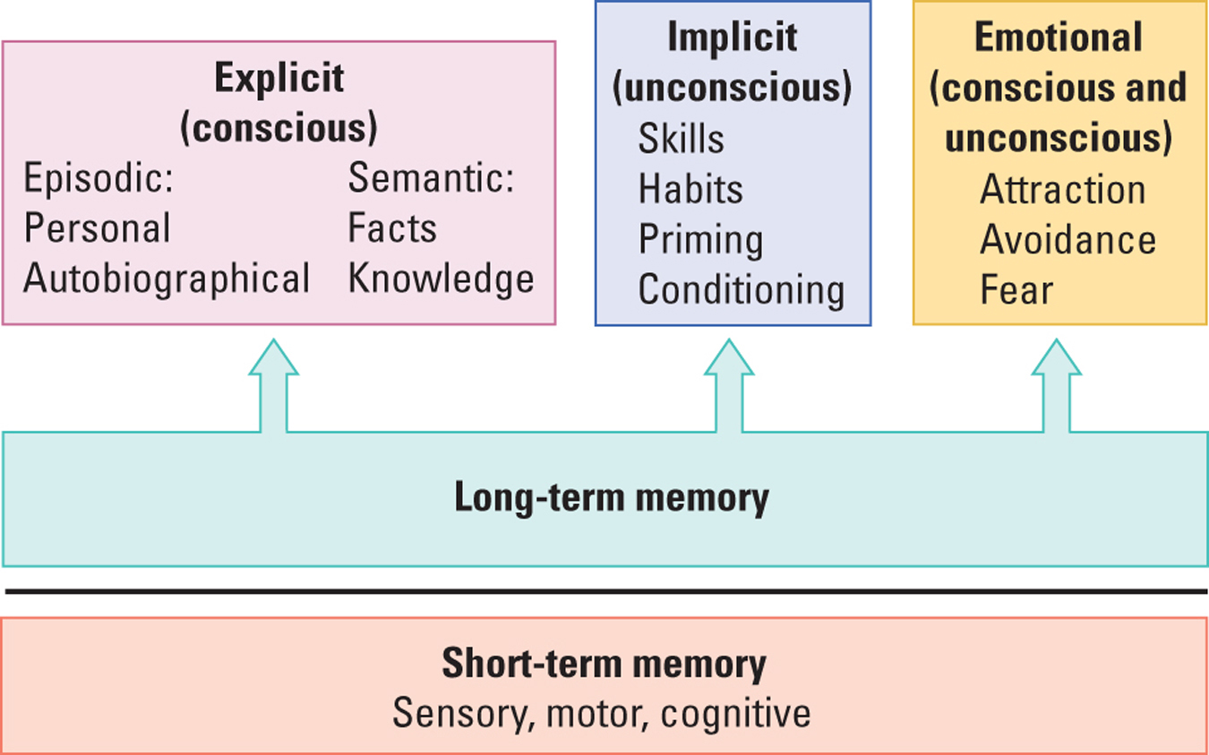
MULTIPLE MEMORY SYSTEMS

Structural Basis of Brain Plasticity (some questions repeated from midterms 1 and 2 (neural plasticity!!!!))
- At the neural level, memory is associated with changes that take place at the synapse
  - The synapse is where one neuron influences another neuron
- Two research approaches
  - Synaptic changes in the nervous system of “simple” organisms
    - Example: Aplysia
  - Synaptic changes in the mammalian brain
Structural Basis of Brain Plasticity
Measuring Synaptic Change
- Modifying existing circuits
  - Neurons change their structure in response to their changing experiences
  - Changes in the number of dendrites can be used to infer synaptic changes
    - More dendrites = more connections = change in synaptic organization
- Creating Novel Circuits
  - Predominant view prior to the mid-1990s:
    - The mammalian brain does not make new neurons in adulthood
  - There is now evidence that neurogenesis does occur in the mammalian brain
    - Olfactory bulb, hippocampal formation, and possibly the neocortex
    - Reason for neurogenesis is still unclear
Enriched Experience and Plasticity
- Raising rats in enriched enclosures is associated with:
  - Increased brain weight
  - More dendrites
  - More astrocytes
  - More blood capillaries
  - More synapses per neuron
  - Increased mitochondrial volume
    - Marker of greater metabolic activity
Sensory or Motor Training and Plasticity
- Chang and Greenough (1982)
  - Placed patches over one eye of each rat so that the contralateral hemisphere was deprived of visual input (cut corpus collosum so input was unable to cross to opposite site of the brain, only inputs that stayed on the same side were able to be processed)
  - Trained rats on a maze
  - The visual cortex of the “trained hemisphere” (that received input from the eye without the patch) had more extensive dendrites
- Nudo and colleagues (1997)
  - Had monkeys retrieve food from small or large food wells
    - Small wells required dexterous movements of one or two fingers, whereas the monkeys could put their entire hand in the large wells
  - The digit representation on the motor cortex was larger for animals that had to retrieve food from the smaller wells
- Ramachandran (1993)
  - Indirectly measured the cortical maps in individuals with limb amputations
  - When the face was stroked softly with a cotton swab, amputees reported sensations of being touched in the amputated hand
  - May explain “phantom limb” pain
Experience-Dependent Changes in the Brain
- Is there a relationship between neuronal structure and education?
  - Wernicke’s area more dendritic branching with more education
- Scheibel and colleagues (1993)
  - Relationship between the complexity of dendritic branching and the nature of the computational tasks performed by a brain area
    - Example: Neurons receiving input from fingers versus the chest wall
  - Life experience alters dendritic morphology
    - Example: Career word processors have greater differences between finger and trunk neurons than salespersons.
Hormones and Plasticity
- High levels of estrogen
  - More dendritic spines in the hippocampus
- Low levels of estrogen
  - More dendritic spines in neocortex but fewer dendritic spines in the hippocampus (related to memory decline in middle-aged females?)
- Low levels of testosterone
  - More dendritic spines in neocortex (related to decrease in spatial ability?)
- Glucocorticoids
  - Released from the adrenal cortex in times of stress
  - Assist in the metabolism of proteins and carbohydrates and the control of sugar levels in the blood and cells
  - Steady levels of glucocorticoids that are seen with prolonged stress may be neurotoxic
    - Stress can kill hippocampus cells
Neurotrophic Factors and Plasticity
- Nerve Growth Factor
  - Neurotrophic factor that stimulates neurons to grow dendrites and synapses and, in some cases, promotes the survival of neurons
- Brain-Derived Neurotrophic Factor
  - May enhance plastic changes, such as the growth of dendrites and synapses
  - Increased levels when animals learn to solve problems
Psychoactive Drugs and Plasticity
- Drug-Induced Behavioral Sensitization
  - Escalating behavioral response to the repeated administration of a psychomotor stimulant, such as amphetamine, cocaine, or nicotine; also called behavioral sensitization
  - Sensitization is associated with an increased number of receptors, synapses, and dendrites
  - These changes were localized to regions (e.g., prefrontal cortex, nucleus accumbens) that receive a large dopamine projection
Some Guiding Principles of Brain Plasticity
- Behavioral change reflects change in the brain
- All nervous systems are plastic in the same general way
- Plastic changes are age specific
- Prenatal events can influence brain plasticity throughout life
- Plastic changes are brain-region dependent
  - Some more susceptible than others
- Experience-dependent changes interact
- Plastic events are not always a good thing
  - Drugs, PSTD.
Recovery from Brain Injury
- Three possible ways to recover from brain injury
  - Learn new ways to solve problems
  - Reorganize the brain to do more with less
  - Generate new neurons to produce new circuits
Three-Legged Cat Solution
- When a cat loses a leg, it is usually able to compensate, not by growing a new leg, but rather, by learning how to walk with only three legs
- The same ability to compensate is also present in humans
  - If someone loses a certain ability, such as being able to write with their right hand, they may be able to compensate by learning how to write with their left hand
New-Circuit Solution
- In response to injury, the brain can form new connections and “do more with less”
- The amount of recovery is increased significantly if the person also engages in some form of intervention
  - Behavioral Therapy
    - Examples: speech or physiotherapy
  - Pharmacological Therapy
    - Examples: nerve growth factor, amphetamine
Lost-Neuron-Replacement Solution
- Fetal Tissue Implantation
  - Limited success to date; more suited for situations where only a small number of cells are needed
    - Example: Dopeamine-producing cells in the substantia migra for Parkinson’s disease patients.
- Replace Lost Cells
  - Epidermal Growth Factor
    - Neurotrophic factor that stimulates the subventricular zone to generate cells that migrate into the striatum and eventually differentiate into neurons and glia
  - It is possible that, in the future, trophic factors may be useful in the treatment of brain injury

