CHEM – 1001A
What is chemistry?
- Study of the structure of matter
- From the smallest (electrons, protons) to the largest (materials)
- How atomic or molecular properties affect material properties
- Study of the changes matter undergoes (reactions)
Chemistry and other sciences
Biology: chemistry came first, life later
Biochemistry: it’s not “chemobiology”
Geology: rocks are made of chemicals
Types of Chemistry (and chemists)
Organic – C containing molecules
Inorganic – often metal containing molecules
Physical – mechanisms, energy flow
Analytical – identification and measurement
Bio – chemistry of life
Gases
- Pressure- volume- temperature (pVT) relationships
- Gas laws
- The kinetic molecular theory
- Chemistry of the Atmosphere

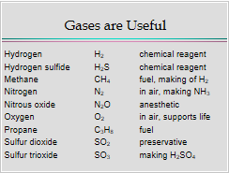
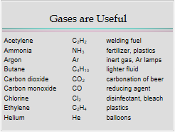
Gases are useful

Air – a mixture of gases
N₂ 78.1% by volume, O₂ 21.0%, H₂O 0~4%, Ar 0.9%, CO₂ 0.040%
Molecules have many ways to store energy
- Translational energy – energy of motion of molecules through space
- Vibrational energy –
- Rotational energy –
- Electronic energy –
(2,3,4 will be in later chapters)
Temperature of a gas
Is a measure of the average translational kinetic energy of the gas molecules
KE=1/2 mv²
Translational velocity
Put heat into a system
|
Molecules move faster
|
T is higher
Gases Exert Pressure
N
Pressure (P) = force
Area m²
1 Pa = 1 N m⁻²
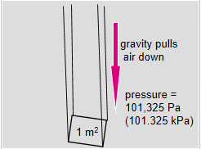
Pressure units
1 Pa = 1N/m²
1 bar = 100.000pa
1 atm = 101325 Pa
1 atm = 14.69 lb/in²
1 atm = 760mm Hg = 760Torr
Measuring Gas Pressure
Liquids are not compressible but gases are.
According to Boyle V_{gas} inverse 1/p
Or pV = k (at constant n.T) P= pressure V =volume
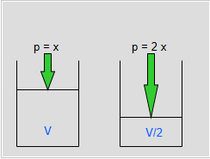
If the pressure is doubled, we can predict the volume by halving it.

For example, A cylinder of oxygen has V= 50L and p = 2500lb/in² at 20C. What will be the volume of the fas at atmospheric pressure (14.7lb/in² ) and 20C?
Before expansion, p_{initial} V_{initial} = k
After expansion, p_{final} V_{final} = k
Thus, p_{initial} V_{initial} = k = p_{final} V_{final}
V_{final} = p_{initial} V_{initial} = 2500lb in⁻² x 50L
P_{final} 14.7 lb in⁻²
= 8500L
Another example
A weather balloon has V=10.0m³ on the ground where p = 99.7kPa V=20.2 m³ at an altitude of 5300m what is p at 5300m?
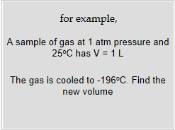
P₂ = p₁V₁
V₂
= 99.7kPa x 10.0m³
20.2m³
=49.4kPa
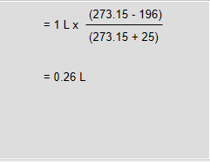
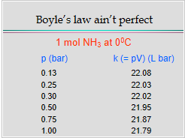
Gases expand with temperature for example warmer air rises since it is less dense.

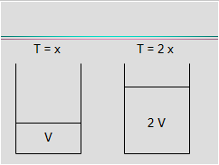
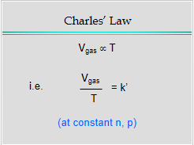
As the temperature expands, the volume also expands with the same amount with temperature

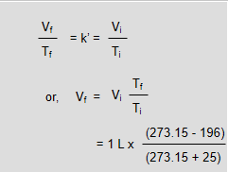
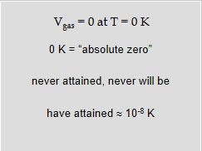
According to Avogadro
Volume is proportional to the number of molecules (moles) of gas at constant T,p
V inverse n
Or , V=k’n

What’s in a Gas?
How many molecules are there in the air in this room?
V= 15m x 15m c 3m = 675m³ = 675000 L
675000L/22.4L/mol = 30133mol x 6.123x10²³ molecules/mol
= 1.8x 10²⁸ molecules
1N₂ or O₂ molecule has a volume of approximately 3 x 10⁻³⁰m³/molecule
=0.054m³
Empty space = 675m³-0.054m³/675m³ x 100% = 99.992% empty space
The combined gas law
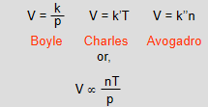
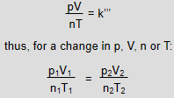
For example, A container of gas initially has n = 10mol V=4L
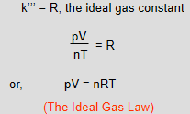
P=75bar T=92.5C Find the pressure when V is reduce to 3L and T is raised to 150C
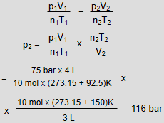
K is the same for all gases

Use the right units for R! Always Use K for T, mol for n
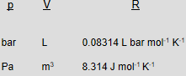
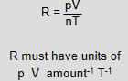

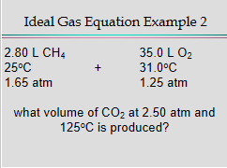
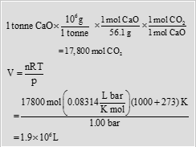
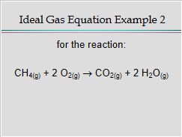
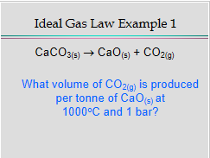

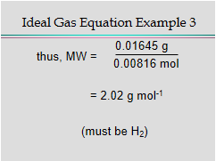
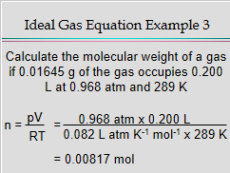
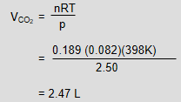
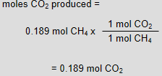
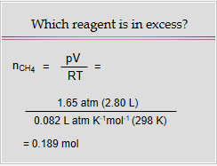
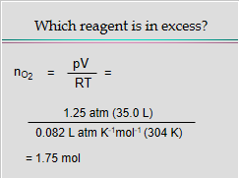
Importance of Gas Densities
- Bhopal, India
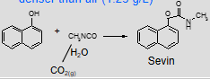
- Methyl isocyanate (CH₃NCO)-denser than air (1.25 g/L)
- Lake Nyos, Cameroon
- CO₂ is denser than air (1.96 g/L)
- Los Angeles
- Smog, a denser mixture of gas
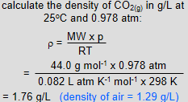
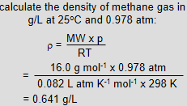
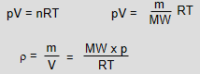
Gas densities
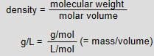
dd

