A Cult Called Veganism
SOCI 1001C
Omar Ahmed
Student Numer:101038568
Submitted to: Professor William Flynn
Date submitted: Oct 4th
TA: Adam Christianson
AdamChristianson@cmail.carleton.ca

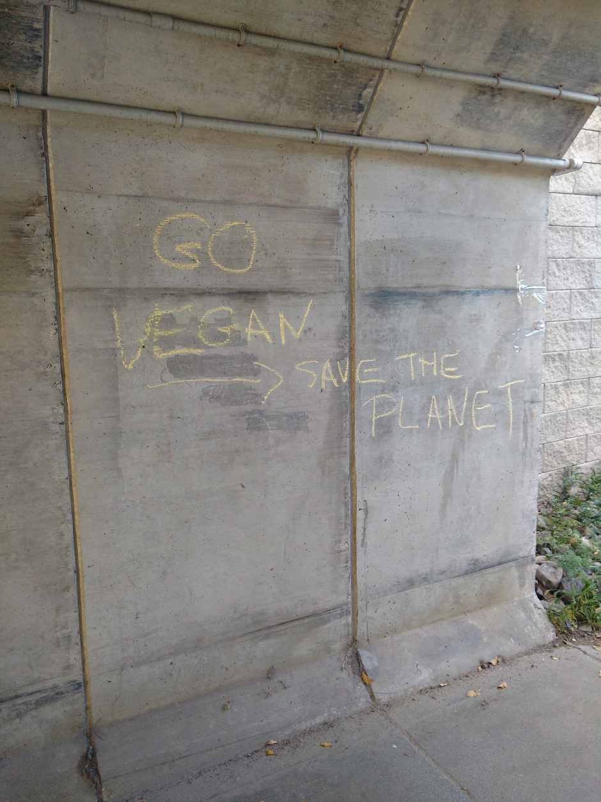

A Cult Called Veganism
The sign I chose was actually not a sign but rather I picked something some people might call graffiti and some might call a helpful message. The message is located on campus near the Otrain station. The reason I chose it was because of a video a couple days before. The video was a PETA ad that showed a disturbing protest where the protesters would pretend to be abused animals and the abusers would do things like chain them, beat them, and worst of all they would brand their skin with red hot metal. This video reminded me of a cult and a question popped into my head that drove me to expand on this topic in the form of this essay. Veganism is the practice of abstaining from using animal products. Veganism usually concerns diet but there can be cases where people abstain from using anything related to an animal, for example a wool hat. Initially the term ‘vegan’ meant non-dairy vegetarian but as time went on the term vegan can to mean: humans living without exploiting animals. This “motto” spread around the world but it really reached popularity around 2010, where the term vegan had spread worldwide and amassed thousands of followers. A lot of people disagree with veganism but if you think about it veganism is not the worst idea, as it promotes a healthy lifestyle but as usual there will always be people who take things too far. Now days, veganism is still a strong way of living, and can be considered a subculture and a counterculture but a question that could be asked is: What makes a cult a cult and can veganism be considered a cult?
According to William Little in his textbook, cults “are usually informal, transient, religious groups or movements that deviate from orthodox beliefs….” (Little, 2013) Now according to this definition, what I watched that day definitely was cult behavior. All the participants were wearing the same clothes, they all believed in this radical idea that to be a vegan they had to do extreme things like brand themselves. The message on the wall says “go vegan, save the planet”. Whoever wrote this probably believes that being vegan could save the world. My interpretation of this is that the person thinks that using animal products is leading to the end of the world and that by being vegan you can stop that. To me this sounds very similar to a cult, however it is just my interpretation. The textbook says that cults are considered to be a type of counterculture as they can be rejected from society because of the fact that they defy societies norms and values (pg. 95). Veganism definitely falls into the counterculture category and as seen through my example certain groups that practice veganism, do fall into the category of a cult.

Veganism is not a bad thing but rather it could actually be a good thing. Veganism is good for the body but like all ways of life, it is not for everybody. It is especially not for the types of people who like to take things to far just to make a point. That message on the tunnel near the O-train is defiantly an eye catching one. It can make people scoff or stop to take a picture of it. The message of it is very open to interpretation and that is a good thing as discussions are entertaining. When it comes to me I’m fine with my normal diet but if I ever decided to change my lifestyle up, who knows I might even consider going vegan.

Works Cited
C. (2013, June 28). Crazy Tel Aviv PETA Want To Be Idiots Get Branded With Red Hot Steel. Retrieved September 27, 2016, from https://www.youtube.com/watch?v=ZTFt5mI_w44
Little, W., & McGivern, R. (2013). Introduction to Sociology (1st ed.). Houston, Texas: Openstax College.
VanPopta, M. (2016, June 13). Veganism – A Cult of Intolerance Founded on a Lie. Retrieved September 27, 2016, from http://www.thepathoftruth.com/falsehood-exposed/veganism.htm

