Summary:
The main purpose of the lab was to demonstrate the simple harmonic motion and establishing a strong concept of the formula y = A sin (2πft + φ). The experiment was conducted in two distinct parts. The experiment potentially only consisted of a vertical stand that had a spring attached to it, and motion detector connected to logger pro which recorded all the movement of the spring and displayed them as a graph. The lab is of great importance for students since oscillations are a big part in every field of physics. Therefore a student must develop a high level understanding of vibrations and harmonic motions in order to advance. In the first part of the lab the spring was attached to the vertical stand over the motion detector interfacing with logger pro. The mass hanging from the spring was 200 g and the data was recorded from equilibrium and different amplitude, after the data was recorded the mass was changed to 300g and the same procedure was repeated. In the second part of the experiment, the instruments were setup in the same manner except the results were used to calculate and determine kinetic and elastic energy. The 300g mass was oscillated from 10 cm amplitude; the graph was plotted on the computer. The results were used to determine the conservation of mechanical energy in the overall system.

Objective
There are several objectives of this lab since there are separate experiments performed, each demonstrating different properties of the simple harmonic motion. The position and velocity of the oscillating spring and motion were calculated with respect to time using derivatives and the mass and motion of the spring were compared to the model of the simple harmonic motion. In the second the part, the aim was to use the principle of conservation of energy and determine the energies involved in the experiment.
Materials
- computer
- slotted mass set, 50 g to 300 g in 50 g steps
- Vernier computer interface
- slotted mass hanger
- Logger Pro
- spring, 1-10 N/m
- Vernier Motion Detector
- vertical stand
- wire basket

Procedure
Part I
The first part of the lab had the aim to use the results to calculate velocity and position of a simple harmonic motion. Along with the velocity and position of the oscillating spring, the amplitude, period and phase constant were also calculated. The first step of the experiment was to set up the instruments in the correct position. The motion detector was connected to the computer using logger pro. A wire basket was placed above the motion detector. A spring was attached to a vertical stand over the detector. A trial run was executed to indicate whether the positioning of all instruments was in place. The spring was released, if a perfect sinusoidal graph appeared on the computer monitor, it was assured that everything was in position. The following step was to measure the position of equilibrium which was done by letting the spring hang recording the data as a graph. Using the graph and the program we can determine the average distance from detector which then becomes the y0. The amplitude was then altered to 5 cm and the mass was 200g. The spring was released and again the data was collected. Later the mass was changed from 200g to 300g and the same procedure was repeated and the data was recorded.

Part II
In the second part, the apparatus was setup in the same manner with a minor change that the objective was to obtain the kinetic and potential energy of the spring. The goal was achieved by first calculating the spring constant. First a 50g mass was hung from the spring, 0.49 was entered into the program as the weight in newtons and each trial the mass went up 50 up to 300 and the weight in newtons increased every time by 0.49. Once the data has been collected a graph appears on the screen and a line of best fit is added. The slope of the graph was the spring constant. By making some adjustments to the program, the energies and velocities were plotted as a graph by releasing the mass from 10cm amplitude. The data was then recorded and the results were conclusive.

Results
After performing the experiment, the first part of it dealt with a certain mass oscillating up and down on a spring, while only measuring the position and velocity using the logger pro graphing results. In the first trial, we used a 200 g mass and made the amplitude of the oscillation approximately 10 cm. This determined the frequency to be 1.11 Hz, and period to be 0.90 seconds. In the second trial we used the same 200g, and changed the amplitude from 10 cm to 5 cm and using that the period resulted to be the same at 0.9 seconds, and as a result the frequency stayed the same as well. In the third trial the amplitude stayed the same at 5 cm but the mass used was 300 g. This cause both periods to change from 0.9 s to 1.10 s, and the frequency changed from 1.11 Hz to 0.91 Hz. For every trial the y kept on decreasing and the angle changed in every single trial with no certain pattern. In the second part of the experiment, the same mass was used but instead of velocity and position being measured, potential energy and kinetic energy were being observed. From these observations we concluded that the spring constant was -9.535 N/m.

Discussion
The results of the lab were quite conclusive since factors that affect simple harmonic motion were discovered through observation and analysis. First discovery made was the fact that the amplitude had no significant affect on the period or frequency. The frequency remained 1.11 Hz, however there may have some change due to the amplitude but due to its little affect it is negligible. The small change caused in the period was due to experimental error present during the experiment. The only change the amplitude caused mostly was the change in the angle each trial and change of y0. The results also concluded that the mass did have an effect on the frequency and period. The mass was inversely related to the frequency since when the mass was increased to frequency lower from 1.11 Hz to 0.91 Hz. In the second part, using the potential and kinetic energy, a graph was plotted and the slope was determined. The slope of the graph represented the spring constant, which was determined to be -9.535 N/m.

Analysis
- There are many similarities and differences between the 2 graphs, because of their sinusoidal form. Some similarities between the 2 graphs are that both are sinusoidal functions, they both look similar to the cosine function; since their initial starting points do not start near 0, they start above or below the 0. The velocity vs. time graph is similar to the position vs. time graph except that it looks more shifted to the left by a certain number of units. The amplitude of both graphs is roughly about 0.3, which is constant through the cycles. The period is the same roughly about 1 sec for both graphs. The differences between the 2 graphs are more difficult to observe, For instance, the position vs. time graph does not touch the x axis it stays above zero. As for the velocity vs. time graph, its crosses the x axis near the middle of its cycles. Also, their starting positions are different as the position vs. time graph starts around 0.62 and the velocity vs. time graph starts around -0.3.

- Whenever the velocity reaches zero, the mass appears to go from a maximum point to a minimum point on the position vs. time graph. When the velocity first hits zero, the very first is a minimum then it alternates from there going to a maximum and then a minimum. Whenever the velocity is at a maximum, the position of the mass is at equilibrium. It goes from the minimum to the original position, then to the maximum and back to the original position for every maximum velocity.

- When conducting the experiment and changing the amplitude from trial 1 to trial 2 the amplitude did not affect the frequency at all. We changed the amplitude from 10 cm to 5 cm but from the results the frequency stayed at 1.11. Therefore from the results frequency does not depend on the amplitude.

- When changing the mass in trial 3 from trial 2, the frequency did get affected from this change. In trial 2 we had the mass set to 200g and the amplitude to 5cm, in trial 3 we set the mass to 3oo g and the amplitude to 5 cm. The frequency went from 1.11 to 0.91. Therefore from the results frequency does depend on the mass that’s being used.

- If the parameter of A is doubled, which is the amplitude, the graph would be just double its size. The reason would be since from the results that we had received, doubling the amplitude did not change any of the other results except for the angle and the y0.

- The graph would change drastically, because most parts of the equation
y = y0+ Asin(2πft + φ ) depend on the frequency. From the results we saw that the
frequency affect the period, the angle, the y0. So the graph would actually change
both vertically and horizontally.

Conclusion
After carrying out the complete experiment, the results were convincing. Subsequent to the analysis and observation it was established that the change of amplitude has no effect on the frequency and period. However, in comparison to that it had also been discovered that the mass is inversely related to the frequency, as in one of the trials when the mass was increased the frequency was decreased. Also after the plotting the energy graph, the slope was determined which represented the spring constant. The spring constant seemed fitting as it was in the range from 1-10 N/m. Although the results came out as expected, the little variations were due to the amount of experimental error present. An example would be the fact that when the spring was released, the amplitude was measured using a metre stick and it was not absolutely precise. That may have caused a change in the frequency and period. Another error that was present was the fact that the positioning of the detector easily altered the result. If the detector was even a little misplaced, the plotting would change drastically, hence changing the overall results.

References
Chan, Dr.V. "Lab Reports Project Reports Engineering Drawings." Ryerson.ca. Ryerson University. Web. 27 Sept. 2011. <http://www.ryerson.ca/content/dam/mie/MechIndStandardReportF2010.pdf>.

Serway, Raymond A., and John W. Jewett. Physics for Scientists and Engineers. Belmont, CA: Thomson-Brooks/Cole, 2004. Print.

Appendix A
(Data Tables/Observations)

Table 1: Change in Mass and Amplitude

Run | Mass (g) | Y₀ (cm) | A (cm) | T (s) | F (Hz) | Φ (rad)
1 | 200 | 0.69080 | 10 | 0.90 | 1.11 | 3.14
2 | 200 | 0.00041 | 5 | 0.90 | 1.11 | 4.89
3 | 300 | -0.00036 | 5 | 1.10 | 0.91 | 3.82

Table 2: Slope of Energy Graph
Spring Constant | -9.535 N/m

Table 3: Equations
Equations | Use
y = Asin(2πft + φ) | This equation is used for simple harmonic motion
KE= ½ mv² | Used to determine the kinetic energy in the spring
PE=1/2 ky² | Used to determine the potential energy in the spring
F=-kx | To find the spring constant K or to find the total force exerted by the spring

Appendix B
(Diagram)

Retort Stand Mass
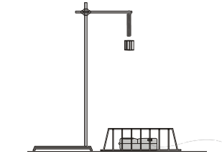 Sensor and Cage
Figure 1: Setup of all experiments

Appendix C
(Graphs)
Part I
Trial 1
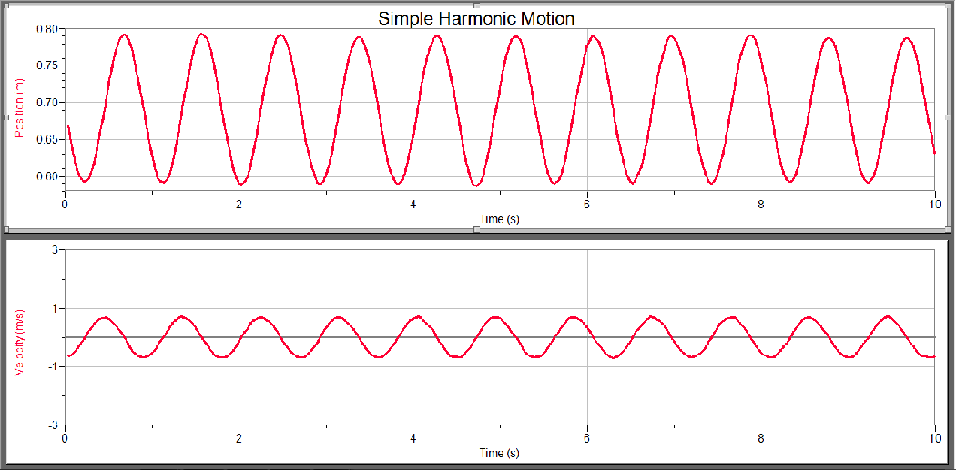

Trial 2
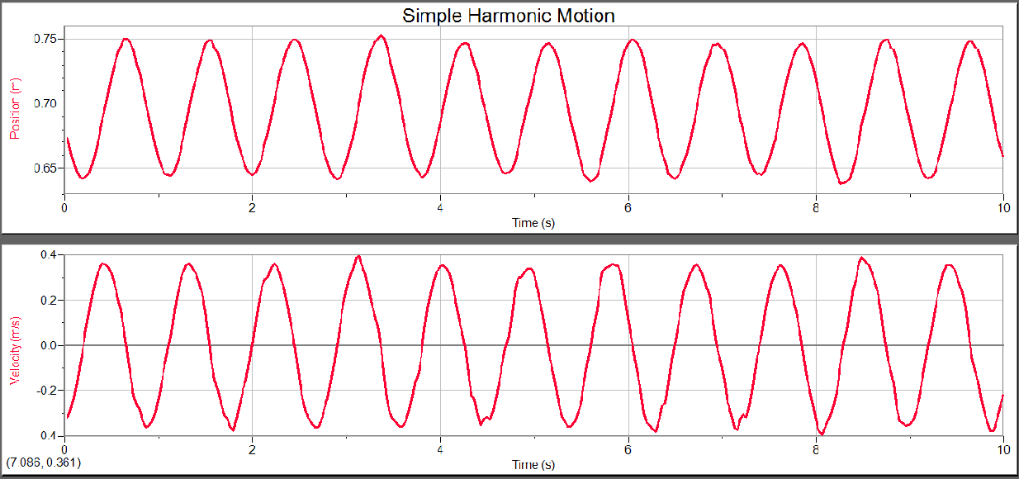
Trial 3
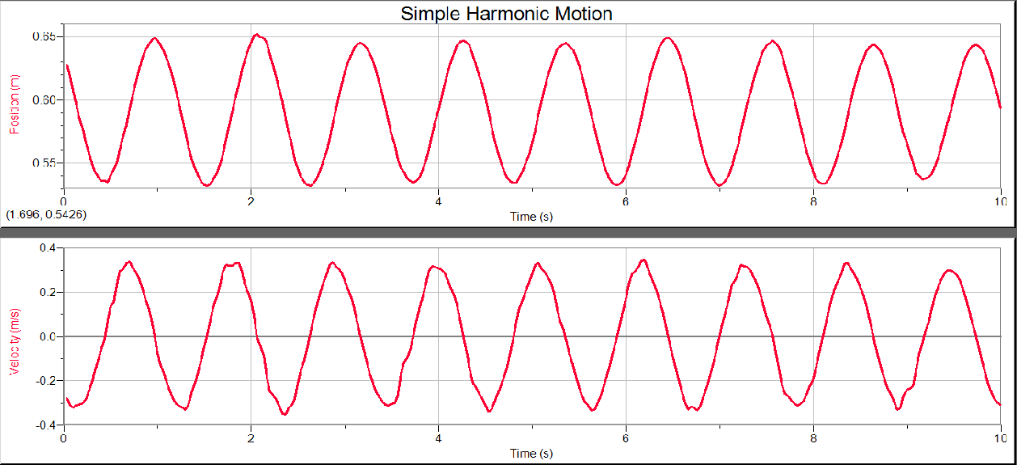

Part II
Graph 1: Getting Spring Constant
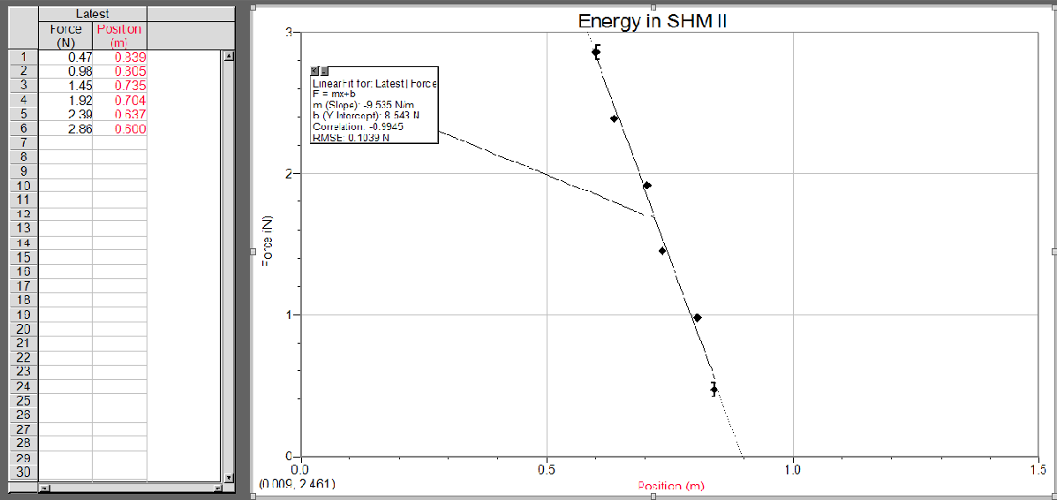

Graph 2: Displays Energies


