CHANGE IN POPULATION IN TORONTO
Duc Anh Nguyen
1002213570
University of Toronto
Tutorial: T0201
TA’s name: Mary-Kay

Introduction
Over the years, population in the world has been shifted due to the war, economy, opportunity for jobs, living standard,etc... Canada, one of the largest countries in the world, has been seen to have lots of change in population not only the number of people but also where people live. More specifically, this paper will focus only in Toronto and its municipals. From 1961 to 2011, the Toronto Census Metropolitan Area (CMA) and its municipalities have suffered the change in the amount of population and many researchers tried to figure out the reasons behind this shift. Urbanization which is the shifting population balance between urban and rural area or deurbanization which demonstrates the balance shifting towards peripheral/ rural areas are two possible reasons for the distribution of population in Toronto ( Dupuy, 2016). The paper also considers other factors such as housing or immigration. The question is: How did the population change and why did that happen? In order to answer this question, the relationship between urbanization, housing and immigration will be considered carefully. This paper will have three parts: describing population change, interpreting population change and future challenges
Discussion.
Describing population change.
According to the Table provided in Appendix B, Toronto (Central City) is the largest region with the most number people living there ( 740,456 residents in 1961), however, in the period from 1961 to 2001, the population declined about 9.5% of the total people and it reached 676352 in 2001. Meanwhile, the number of resident living in other municipalities increased. Inner suburb included East York, North York, Etobicoke, Scarborough and York all had more population in 2001 compared to the data in 1961. North York had a biggest change with a jump from 223162 people to 608288 people in 2001 (increased 1.7% of the whole population). The data in 2006 and 2011 for the inner suburb were not available since Toronto included all inner suburb as well as Toronto itself. Outersurb area’s population had been shown to be increase in all municipalities from 1961 to 2001 as well as from 2006 to 2011. Some area had grown up faster than other areas such as Brampton, Markham, Mississauga, Vaughan with an increase of 1159%, 722%, 758%, 1716% of the total population respectively. Rural Fringe area’s number of resident increased, too but it increased in a slower rate compared to other regions in CMA. Overall, the population of all municipalities except Central City increased during the period of time from 1961 to 2001. However, from 2001 up until 2011, Toronto’s population had increased a lot since Toronto merged Innersuburb and counted it as Toronto itself.
Interpreting population change.
Immigration. Canada is one of the countries which have highest rate of immigrants according to the report from UN which reported trends in international migrant stock in 2015 (1) and Toronto- one of the biggest cities in Canada- is said to be “a truly multinational city” by Anna Danielova ( professor at McMaster University). Foreigners came to Toronto to work because they found out that there were lots of job opportunities provided here in Toronto which made this city to become the largest foreign-born Census Metropolitan Area (CMA) in Canada (Canadian immigrant, 2016). The table for Toronto Immigrants Top Source Countries in 2011 is provided in the Appendix. Based on the table, there were 2,537,410 immigrant people who were living inside Toronto which accounted for 46% of the total population of this city and 20.1% of the total population of Ontario (Canadian immigrant, 2016). The Toronto government stated that South Asia and China all had big role in immigration with the percentage relative to the total population of Toronto was 12% and 11.4%, respectively in which Indians, Chinese and Filipinos were the largest group of foreign-born population. Toronto’s immigrant population had been seen to increase about 25% from 2001 to 2011. The urbanization occurred in Toronto has influenced strongly in the growth of the population in Toronto since 2001 as stated before. The impact was not only on Canadians but also on foreign-born people, which means immigrant people also contributed to the growth of population in Toronto. Toronto was successful in creating more jobs available for everybody and it became an attractive city for many people in and out of Canada. Even though the population in Greater Toronto Area (GTA) had increased more than 5 millions people, the rate of unemployment had decreased nearly 4% (Ghost, 2013). Foreign-born population were attracted to Toronto, they came here to do work, they helped Toronto to improve its economy, they created their own culture, their own business here in order to help other people from their countries to get jobs. This loop keeps continuing to happen up until now in 2016, more people come, study, work and live in Toronto which lead to the increase not only in population but also in economy. Compared Toronto to some other cities in the world, it can be seen that there were not many cities can be successful like Toronto. Detroit, for example, was seen to have a decrease in population and amount of jobs as well. This was a consequent of the booming in poverty, violent crime, drug abuse, poor education, etc.. and also the appearance of highway also gave people in Detroit a chance to live in the suburbs rather than inside the city itself (Ghosh, 2013).
Housing. After the Second World War came to an end in 1945, there appeared lots of change in population’s distribution in Toronto when people started leaving the inner cities because of the increasing in crime, unemployment, drugs, poverty after the war.. However, inner-suburbs have regained the investment and population in the 1960s, 1970s and 1980s ( Doucet, 2010). Meanwhile, the outer-suburb regions also gained more attractions from people in the urban area. People had a dream of having a big house with multiple garages, safe places or playground for their children. As a result, money was invested into these areas and businesses, jobs, leisure and rental opportunities appeared, too. That was the reason why the population in inner-suburb and outer-suburb areas increased while the Central City revealed a decrease in population according to the table of population in the Toronto CMA provided in the appendix.
Future challenges.
In the future, the population in any area in Toronto will keep continuing to increase. The reason is the increasing in the rate of immigration when more and more people from other countries will come here to live and study or work. That leads to the housing problem when more houses are needed to adapt to this trend. More houses will be built in the Central City than other areas because of the effect of development charges (Kayla, 2013). Investors will probably invest more money in the downtown where they can earn back more fund than in the suburbs when they still have to pay the same development charges for wherever they build houses. Also, the development of different culture is a problem that the government should deal with. It is not a big problem right now but they have to make sure all cultures can live together to help Toronto become bigger and wealthier.
Conclusion.
Overall, the population in Toronto has been changed throughout the period of time from 1961 to 2011. Inner-cities and outer-cities is developing as well as the Central City, however, they still have many problem to face up with such as: transportation, housing, economy, etc... If government in Canada can cope with those problems, the city will become bigger and wealthier. If not, Toronto will have to deal with a serious problem of the explosion in population when the facilities can not adapt to that change.

Appendix A
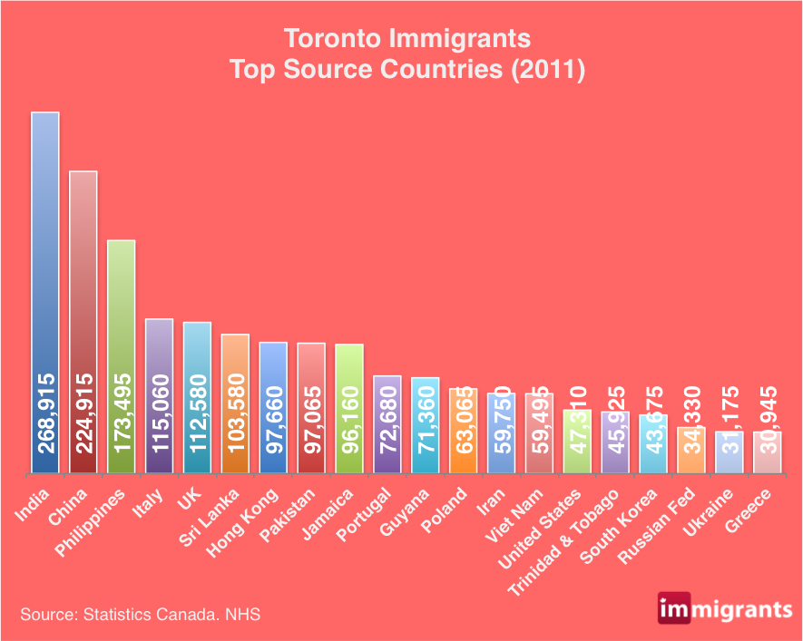
Figure 1: The bar chart shows the amount of foreign-born coming to Toronto all over the world.

Appendix B
Figure 2: Population in Toronto CMA, 1961 -2011.

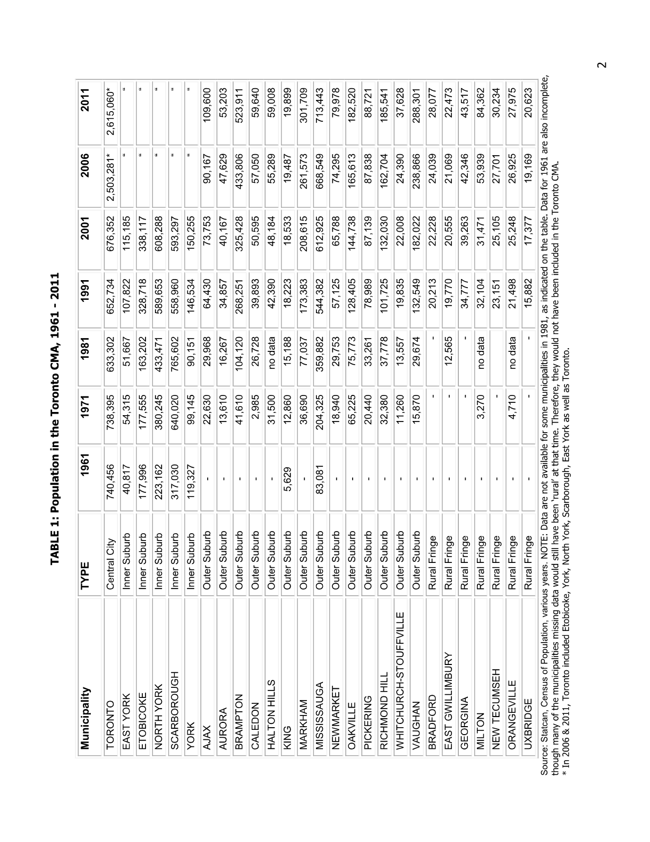

Bibliography
Apostolides, K. (2013). The problem with development in Toronto - Spacing Toronto. Retrieved from:

http://spacing.ca/toronto/2013/11/26/problem-development-toronto/.

Doucet, B. B. (2010). GeographyJobs.ca. Retrieved from:

http://www.geographyjobs.ca/articles/inner_cities_inner_suburbs_outer_suburbs_geographies_changing_preferences.html

Dupuy, D. (2016). Defining Basic Concept. Lecture, Toronto.

Ghosh, P. (2015). Can Immigrants Save America's Decaying Rust Belt Cities? Retrieved from:

http://www.ibtimes.com/tale-three-cities-detroit-toronto-pittsburgh-post-industrialized-world-1417742

Immigrants in Toronto.(2016). Retrieved from: http://canadaimmigrants.com/immigrants-in-toronto/

United Nations Population Division | Department of Economic and Social Affairs. (2016). Retrieved from:

http://www.un.org/en/development/desa/population/migration/data/estimates2/estimates15.shtml.

