BEHAVIOUR IS DETERMINED BY MULTIPLE FACTORS:
Behaviour is Determined by Multiple Factors:
Chapter 3: Biological Foundations Summary
- Synesthesia a type of disorder where sensory experiences are crossed – colours may evoke smells
What is the Genetic Basis of Psychological Science?
- Genetics: used to describe how characteristics such as height, hair colour and weight are passed along to offspring through inheritance and also refers to processes involved in turning genes “on” and off”
- To understand ourselves fully, we need to…
  - Understand how basic physiological processes such as genetics, affect thoughts and behaviour
  - Understand how these processes interact with the environment Nature vs. Nurture
- Genome:
  - The complete set of genetic material
  - The master blueprint – entirety of an organisms hereditary information
- Within each cell are things called chromosomes, which are structures made up of genes
- A typical human being has 23 pairs of chromosome, half of each pair coming from each parent
- Each chromosome is made up of a protein and single strand of DNA
  - The sequence of these DNA strand specifies an exact instruction to manufacture a particular type of protein (proteins make up structure of cells)
- Gene:
  - Unit of heredity that determines a particular characteristic in an organism and is a segment of DNA which is involved in producing proteins
  - A female has two X chromosomes while a male has X, Y
Human body cell chromosomes DNA Genes
- Human Genome Project purpose was to identify all genes in the human body
Mendel:
- Mendel developed an experimental technique called selective breeding
- He discovered that in determining an offspring’s features, some part genes are dominant while others are recessive
- Dominant: a gene that is expressed in the offspring (physically visible)
- Recessive: not always physically visible
- Genotype: an organisms genetic constitution
- Phenotype: observable physical characters that result
- Zygote: when one sperm and one egg combine during fertilization
Twins:
- Monozygotic twins identical twins; occurs when one zygote divides into two and share same genes
- Dizygotic twins fraternal twins; not identical and result from two separately fertilized eggs developing in the mother’s womb simultaneously
Heredity vs. Heritability:
- Heredity: transmission of characteristics from parents to offspring by
- Heritability: how much of the genetic portion varies in a particular environment
  - How much does height or weight vary in the population
Nature vs. Nurture:
- They are inextricably entwined (they work together to determine human behaviour and cannot be separated)
Epigenetics: study of changes in gene expression that are not related to “epi” “outer” influences
- Behaviour is governed by a network of factors they are interconnected
  - Heredity – the genetic makeup
  - Biology – nervous and endocrine system
  - Environment – the current/past circumstances
  - Culture – where you grew up
- All those factors determine behaviour
The Nervous System:
- Central Nervous System (CNS) - brain and spinal cord – also contains 99% of the nerve cells
- Peripheral Nervous System (PNS) – complex network of neurons
  - Somatic Nervous System – things that happen that you have controlled; mainly movement
  - Autonomic Nervous System – things that happen automatically; maintains the internal environment of the body and targets many important organs
    - Sympathetic Nervous System – Fight or Flight
    - Parasympathetic Nervous System – Rest or Digest
Neurons:
- They are the basic unit of the nervous system that operates through electrical impules and communicates with other neurons through chemical signals
- Three types of neurons:
  - Sensory Neurons (AFFERENT NEURONS) – carry information to the brain
  - Motor Neurons (EFFERENT NEURONS) – transmit signals from the brain to the muscles
  - Interneurons – “inside” – they communicate info in short-distance circuits
  - SAME (Sensory Afferent, Motor Efferent)
  - Ex: brain sends message to your finger via motor neurons so the muscles move a certain way. The receptors then send messages back through sensory neurons to help determine how much pressure is needed to hold the pen
- Neurons have three main functions:
  - Taking information from neighbouring neurons (reception)
  - Integrating those signals (conduction)
  - Passing signals to other neurons (transmission)
Neuron Structure:
- Four main structural regions: Dendrites, Cell Body, Axon, Terminal Buttons
- Dendrites:
  - Kind of look like appendages that detect and receive signals from neighbouring neurons
- Cell Body:
  - Integrates all the incoming information from thousands of other neurons
- Axon:
  - After the information has been integrated, it is then transmitted along a long narrow outgrowth which propagates the nerve impulses; “Nerve” bundle of axons that carry information
- Terminal Buttons:
  - Small nodules at the end of the axon that receive the electrical impulses and then releases chemical signals from the neuron to an area called the synapse
- Synapse:
  - The space between two neurons – the site for chemical communication between neurons
- Myelin Sheath:
  - It allows the electrical impulses to travel quickly along the axon
When do Neurons Fire:
- When a neuron receives a chemical signal through the dendrites, and these signals tell the neuron whether to fire or not; these signals do this by affect the polarization of the cell;
  - Excitatory signals depolarize the cell membrane and increase the likelihood that the neuron will fire
  - Inhibitory signals hyperpolarize the cell and decrease the likelihood that the neuron will fire
- All-or-none principle: a neuron fire with the same potency each time (so it either fires or it doesn’t fire) BUT how frequently it fires can vary
- Action Potential: the impulse that causes the release of chemicals from the terminal buttons; it is only passed when the excitatory input from the other neurons surpasses the receiving threshold
How do neurons fire?
- When a neuron is not active, the inside and outside of it differ electrically known as resting membrane potential; the ratio of (-) to (+) ions is greater inside the neuron than outside so the electrical charge inside is slightly more (-) than the outside
- Polarization when the electrical chargers inside and outside the neuron are changed; polarization creates the electrical energy to fire the neuron
- Sodium and potassium ions are the main ones
- Ions pass through the cell membrane at ion channels and each type of ion is only allowed to enter from that specific channel
- As a result of selective permeability (only allows some ions to enter) – there are more potassium ions inside the neuron than sodium.
- When a neuron fires, the sodium ions rush into the neuron causing a more (+) charge inside and then immediately the potassium ions rush out (depolarization)
- The neuron only fires as it becomes positive INSIDE the cell (when sodium in and potassium out)
- THE WHOLE SYSTEM:
  - Sodium channels open (sodium goes in) depolarization occurs potassium channels open (potassium goes out) repolarization occurs ACTION POTENTIAL OCCURS sodium channel close (sodium ions stop entering) potassium channels start to close (potassium ions stop exiting) Threshold reached neuron fires
Neurotransmitters:
- The neuron that sends the signal is the presynaptic and the one that receives it is known as the postsynaptic…
- Neurotransmitters (stored in vesicles inside the terminal buttons) are chemical substances that carry signals from one neuron to the other neuron; these can only be received by specific receptors on the postsynaptic neuron
- Neurotransmitters are in vesicles and the action potential causes these vesicles to release its contents into the synapse
- Three major important events that determine the neurotransmitters performance in the synapse:
  - Reuptake – when the neurotransmitter is taken back up into the presynaptic neuron
  - Enzyme deactivation – when an enzyme basically destroys the neurotransmitter
  - Autoreception – when too many neurotransmitters have been released, autoreceptors signal the presynaptic neuron to stop
Common Neurotransmitters:
- Epinephrine, norepinephrine, serotonin and dopamine are MONOAMINES – they regulate states of arousal and motivate behaviour
- Acetylcholine (motor control b/w nerves and muscle, learning, memory, sleeping); the terminal buttons release acetylcholine into synapses and after moving across the synapses, it binds with receptors on muscle cells – causing the muscle to contract or relax
  - We want steady heart rate so ACh inhibits heart muscles so they contract less and excites skeletal muscles overstimulates the brain and nervous system and depresses the functions of the heart
  - Botulism (form of food poisoning), inhibits the release of ACh from terminal buttons which leads to difficulty breathing and chewing; botulism (botox) has the ability to paralyze muscles that produce wrinkles but it is dangerous
  - Since it also relates to memory/learning – drugs that are antagonists (inhibits the release of neurotransmitters) can cause amnesia – associated with Alzheimer’s
- epinephrine (energy);
- norepinephrine (arousal);
  - it fine tunes the clarity of attention – it strengthens or maintains responsiveness
- serotonin (emotional state, depression);
  - low levels are associated with sad and anxious moods, food cravings, aggressive behaviour
  - SSRIs block the serotonin reuptake and are used to treat depression
  - OCD, eating disorders, obesity are also treated with blocking the reuptake
- dopamine (reward/motivation, motor control over voluntary movement);
  - primary neurotransmitter that communicates with activities that may be rewarding
  - eating when hungry, drinking when thirsty, having sex when aroused
  - also involved in motor control and planning. – it guides behaviour toward things that will lead to reward
  - Parkinson’s disease
- GABA (anxiety and intoxication);
  - Helps induce relaxation so it is an inhibitory neurotransmitter
  - Without GABA excitation might get out of control (epileptic seizures might be related with low levels of GABA)
  - GABA agonist drugs are used to treat anxiety disorders
  - Alcohol is typically experienced as relaxing due to GABA reception
- glutamate (enhances action potential);
  - excitatory neurotransmitter (produces a lot of excitement) and has fast acting transmission throughout the brain
  - too much can cause damage and even memory loss
- endorphins (pain reduction); substance p (pain perception)
  - natural pain reduction and reward
  - endorphins are brain’s natural defence against pain – but pain is also very important and if pain was eliminated all the time then competitive behaviours will have catastrophic results
How Drugs Work:
- Agonisits: Enhance neurotransmitters
  - Increase the release of neurotransmitters – so more are received as well
  - Blocking the re-uptake
  - Mimicking a neurotransmitter so it will fit on to a receptor and the receptor will think it is the real neurotransmitter and then will start doing its thing
  - Ex: Cocaine
- Antagonists: Inhibit neurotransmitters action
  - Block the release of neurotransmitters
  - Destroying neurotransmitters in the synapse
  - Negatively mimicking a neurotransmitter so it blocks the receptor so the actual one cannot bind
  - Ex: Botox
BRAIN
Parts of the Brain from Bottom to Top:
- Quick info: The most important function of the spinal cord is to carry sensory information up to the brain and then carry signals from the brain to the body parts; it is made up of two types of tissue: Grey matter the cell bodies of neurons; White matter consists of axons and fatty sheaths
- Brain Stem: Survival; section of the bottom of the brain – contains the nerves responsible for the basic survival functions (breathing, swallowing…)
- Cerebellum: Motor Function; located at the back of the brain stem
- Subcortical Structures: Emotion & Basic Drives; located under the cortex
- Cortical Structures: Complex Mental Activity
Brain Stem:
- Controls life sustaining functions of the autonomic nervous system such as breathing, swallowing, urination, vomiting, orgasm
  - Medualla oblongata
  - Pons
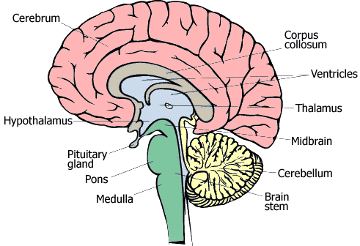
  - Midbrain
- Also important for alertness and sleep
- Brain stem to head is like spinal cord
To the body
- Also contains network of neurons that
Are called RETICULAR FORMATION
Affects general alertness and sleep
The Cerebellum:
- Basically coordinated movement and balance
- Connected at the back of the brain stem
- “Belly Dance” Bellum…movement
- Damage to the nodes cause balance problems
And eye position during head movement
- Other damages would affect walking, loss of
limb coordination (cant pick up pen);
- Motor learning - its main function and
operates independently and unconsciously
but also relates to making plnts, remembering events, using language, experiencing emotion and even experience of empathy
Subcortical Structures: “sub” meaning they lie under the cortex – controls emotions and basic drives

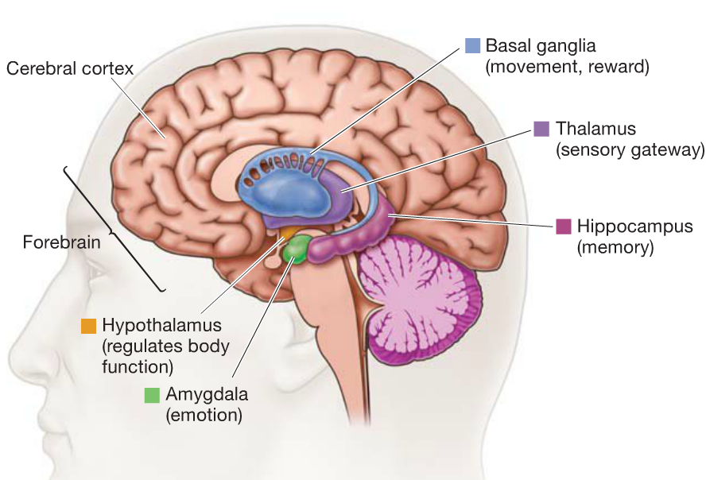

- Hypothalamus:
  - Master regulatory system
  - Receives input from almost everywhere in the body and it connects the endocrine system and nervous system
  - Regulates body temp, body rhythms, blood pressure, sexual behaviour
  - Fighting, Fucking, Feeding, Fleeing
- Thalamus:
  - Gateway to the brain
  - Receives all sensory information before that information reaches the cortex but NOT SMELL
  - While sleeping it does not receive any info
  - Regulates motivation, emotion, awareness and attention
  - The conjoined twins who share a bridge between the thalamus – they can share thoughts
- Hippocampus: looks like a seahorse
  - New Memories
  - Creates new memories by making interconnections within the cerebral cortex
  - “Hippo on Campus” never forget seeing that…
  - Taxi drivers in London have a big hippocampus – the volume of grey matter is correlated with the number of years of experience
- Amygdala: looks like an almond
  - Located in front of the hippocampus and below the hypothalamus
  - Associate things in the world with emotional response – unpleasant food and disgust
  - Emotional responses and emotional information
  - Intensifies memory function during times of emotional stress 9/11
  - Intensifies sexual arousal when people view porn their the amygdala increases
- Basal Ganglia:
  - It’s a collection of nuclei found on both sides of the thalamus
  - Important for the initiation of planned movement; they project information to the motor centres of the brain stem
  - Cortex basal ganglia motor centres back to the cortex VIA thalamus
  - Damage to this can impair habitual movements (automatically looking both ways before your cross the street)
  - System of subcortical structures
    - Caudate nucleus – informs us that something is not right and we should do something about it – OCD might be caused by an overactive caudate; underactive caudate cause depression
    - Putamen – automatic behaviour – riding a bike/car
    - Globus pallidus – receives input and provides input
    - Nucleus accumbens – important for experiencing reward so it activates dopamine neurons in this structure
Cerebral Cortex: CORTICAL
Frontal – At the front
Parietal – near the middle
Occipital – at the very back above the neck
Temporal – at the sides the near ears
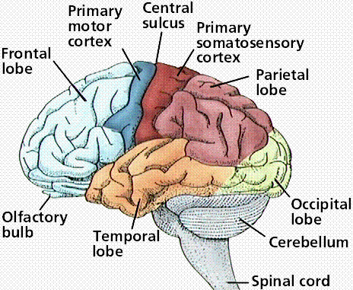

- Outer layer of the brain and contains 4 lobes: Occipital, parietal, temporal, frontal
- Corpus Callosum – the bridge of axons between the two hemisphere and allows information to flow between them
- Occipital: Back of the brain
  - Primary visual cortex – basically important for vision
  - Visual information is organized in such a way that it preserves spatial relationships
  - An image is “projected” onto the primary visual cortex – two objects are near one another
- Parietal: in front of the occipital but behind the frontal
  - Mainly important for touch…
  - Primary somatosensory cortex – a strip running from the top of the brain to the sides: the left hemispheres receives info from the right and vice-versa; sensations are also grouped in this part so sensations of the fingers are near the sensations of the palm connected areas of the brain tend to be beside each other
  - Phantom limb system
  - Stroke/hemineglect – if the right portion is damages then the left side of the body is kind of worthless…
- Temporal: Hearing
  - Primary auditory cortex – brain region responsible for hearing
  - Within this lobe are also specialized visual areas that focus on detail, such as looking at a face; hippocampus and amygdala are also located here
  - Fusiform face area – located at the intersection of the temporal and occipital cortex – it is activated when people look at faces than when they look at other things
- Frontal Lobe: Planning and Movement
  - the rearmost portion of the frontal lobe are the motor areas
    - Premotor cortex & primary motor cortex – its responsibilities are divided down the middle of the body – so the left hemisphere controls the right arm and vice versa
  - The rest of the frontal lobe consists of the prefrontal cortex
    - Occupies 30% of the brain in humans
    - The complexity of this portion differentiates humans from other organisms
  - Lobotomy – a type of surgery that purposely damaged the prefrontal cortex of mental patients and left them emotionally flat so they were easier to control
  - Phineas Gage – damaged his prefrontal cortex but did not die – he did however have major personality changes and stuff
  - Broca’s area – left frontal region of the brain responsible for the production of language
Synesthesia:
- Certain letters are associated with certain colours or smells
Plasticity:
- the brain is able to change and can be reorganized – ex: Phineas Gage
- the brain recognizes which parts are used slightly and which are used heavily
- Ex: Rats raised in enriched versus impoverished environment
  - The neurons in the brains change – in the enriched more complicated cuz there are more connections
- cortical remapping – patient feels cotton swab touching his cheek as touching his missing hand – this may occur because the hand and face are near each other in somatosensory space
- Somatosensory Cortex – face features fingers, hand arm head, shoulder, neck trunk, hip knee, leg, foot, toes, genitals
- Brain can recover from injury – hemispherectomy – remaining hemisphere eventually takes on most of the lost hemisphere’s functions, and the children regain almost complete use of their limbs – procedure not possible in adults
- “Fire together, wire together” – when one neuron fires, another fires too
- Neurogenesis – grow new neurons

Peripheral Nervous System:
- The spinal cord connects the brain to the PNS – the spinal cord has a reflex arc that allows you to move your hand without instructions from the brain
  - Somatic nervous system: external environment; voluntary control; motor neurons which send signals from the brain to the muscles; sensory neurons – send signals TO the brain; basically it is important for voluntary moments that are in our control and helps to adjust with the external environment
  - Autonomic: internal environment; glands and internal organs; automatically maintains the internal environment of the body the nerves in the ANS CARRY somatosensory signals to the CNS which provide info about how full you are and how anxious you are; two types of signals:
    - Sympathetic: fight or flight – prepares you to deal with the thing that is causing you stress: pupil dilates, slows down digestion because it is not vital and loosens the bronchi in the lungs so u can breathe better chronic activation can lead to HBP, heart/kidney failure
    - Parasympathetic: rest or digest returns things back to normal – does things the opposite way: contracts pupils and makes sure the digestive system works again: chronic activation can lead to LBP, depression, withdrawal
    - Even though they are opposite they work in complementary with each other
Endocrine System:
- Governs the release of hormones
- Both the nervous system and the endocrine system influence thoughts, behaviours and actions
- Both systems work together to regulate psychological activity
  - Ex: Hypothalamus also stimulates or inhibits the release of hormones
  - Neural activity causes the hypothalamus to be activated causes pituitary gland to release a hormone hormone travels to the bloodstream reaches target site
- Glands:
  - Both: Pineal, hypothalamus, pituitary, thyroid, parathyroid, thymus, adrenal, pancreas; Men have testis and women have ovaries
- Gonads: the main endocrine gland involved in sexual behaviour : androgen vs. estrogen

