ECOR 1010 – Introduction to Engineering

Prince Kamunga
Assignment #2
Assignment Title: – Units, Dimensions & Significant Figures
TO Marking TA:
Name: ...
Email: ...@....ca

Lab Section: L11
Room: ME2556 – Carleton University

FROM:
Email: princekamunga@cmail.carleton.ca
Student Number: 101036011

Number of Figures and Tables (Including handwritten ones): ...
Last Date and Time of Revision: 04 October 2016

Introduction
The main goal of this laboratory is to convert units and finding their dimensions based on the three pumps that we have to calculate. With the conversion rates and significant figures, we can efficiently calculate the efficient of each pump and compared them. Lastly, this laboratory introduces the aspects that we need to use intelli CAD in which we have analyse the three brackets and to outline every single dimensions.

Materials and Methods
Materials: Pen, calculator and the intelli CAD software
We have to calculate the efficiency of the pumps based on this equation$n=\frac{QΔP}{input power}$ to find the percentage of each pump. Also we need to add or subtracts each surface area and the volume to find
out the smaller components of each figures. Likewise, we had to draw a figure by using intelli CAD based
on the textbook of introduction to engineering.

Results AND DISCUSSION
After calculating each pump percentage, we end up finding that pump 1 is the most efficient pump out of all three with a percentage of around 69%. Pump 2 was the closest pump with 63% and the third pump had the least with 46%. Also, we determined that the bracket with the most significant advantage is the first one with 92 cm^3. The second one end had 275cm^3 and the last one had 328cm^3.

Conclusions
- In conclusion, the first pump is the most efficient pump with a percentage of around 70%
- The most effective bracket based on intelli CAD with lease amount of expensive coating is bracket number 1
- I ended up having the knowledge to do a drawing based on the intelli CAD software.

APPENDIces- Figures and Tables
Calculations:
Pump 1:
Input power = 16
$$=16 HP×\frac{550lbf.ft/s}{1HP}=8800lbf/ft/s$$

Pressure
$$= 34\frac{lbf}{in^{2}}×\frac{1 in^{2}}{6.94×{10}^{-3}ft^{2}}=48 99lbf/ft^{2}$$

Cross-sectional area
$$2.111\frac{m^{3}}{min}×\frac{35.315 ft^{3}}{1m^{3}}×\frac{1min}{60s}=1.24249ft^{2}/s$$

$$n=\frac{QΔP}{input power}= \frac{1.24249ft^{3}×4899lbf/}{8800lbf/ft/s}=0.6916×100\%=69\%$$
Pump 2:
Input power
$$211kw\frac{550lbf/s}{07457kw}×\frac{12 in}{1ft}=1867507.04bf/in/s$$

Pressure
$$153 mm Hg\frac{0.13333kpa}{1 mm Hg}×\frac{1000N/m^{2}}{1kpa}×\frac{6.45×{10}^{-4} m^{2}}{1in^{2}}×\frac{0.2248lbf}{1N}=2.957lbf/in^{2}$$

Cross-sectional area
$$11811\frac{in/m^{2}}{min}×\frac{1 550 in^{2}}{1m^{2}}×\frac{1 min}{60s}=305.118 in^{3}/s$$

$$n=\frac{QΔP}{input power}=\frac{305.118×2.957lbf/in^{2}}{1867507.04lbf/in/s}=4.381×{10}^{-4}×100\%=48\%$$
Pump 3:
Input power
$$29 011\frac{Btu}{hr}×\frac{778.169lbf/ft}{1 btu}×\frac{12in}{1ft}×\frac{1hr}{3600s}=75 251lbf/in/s$$

Pressure
$$0.911 atm×\frac{101.325kpa}{1 atm}×\frac{1000N/m^{2}}{1kpa}×\frac{6.45×{10}^{-4} m^{2}}{1in^{2}}×\frac{0.2248lbf}{1N}=13.384 lbf/in^{2}$$

Cross-sectional area
$$55 061 \frac{Us gal}{hr}×\frac{231in^{3}}{1 Us gal}×\frac{1hr}{3600 s}×3 533\frac{in^{3}}{s}=75 251 lbf/in/s$$

$$n=\frac{QΔP}{input power}=\frac{3533in^{3}/s×13.384lbf/in^{2}}{75 251lbf/in/s}=0.6283×100\%=63\%$$

Part 2
Figure 1
Area
= (4× 2) + (2×2) + 2(1×1) +(8×1)
+ (8× 2) + 2(1×4) + 2(4×6) +2(1×4)
+ (4× 2) + (4×2) + (6×2) +(6×8)
+ (2× 4) + (1/2×2×2) + ($(\sqrt{8 ×2))}$ +(8×1)
+ (4× 6) + (2×2) + (1/2×2×2) -2(π×r^2)
+ -2(1/2×2×2) + (2 πrh)
= 187.7984cm^2
Volume
= (8×4×2) – (6×1×4) + (4×8×2) – (1/2×$\sqrt{8}$ ×2×2) – (πr^2×2)
= 92.05996 cm^3

Figure 2
Surface area
= 2(72) +60 +20
2(40.5664) +2(52)
+ 12 +12+ 4(12.5864)
= 483.3984cm^2
Volume
= (72×6) – (52×2)
= 328.000cm^3
Figure 3
Volume = (3×3×10) + (4 π ×5) – $4\left\{{\left(0.78\right)}^{2} ×π×\left.2\right\} \right.$– (5× π ×3^2)
=216.4385cm^3
Area
= (8×10) - $\left\{4(π({0.34))}^{2}\right.+(1^{2}π\left.)\right\}$
+ 2(3×8) +2 (3×10)
+ (8×10) - $\left\{(4(\right.π 2158)+(2^{2} π\left.)\right\}$
+ $\left\{\left(2^{2}π\right)-(1^{2}π)\right.\left.)\right\}$
+ (3× π×2×2)
+ 4(π × 2×2×0.25)
+ (π×2×1×5)
275.1792cm^2

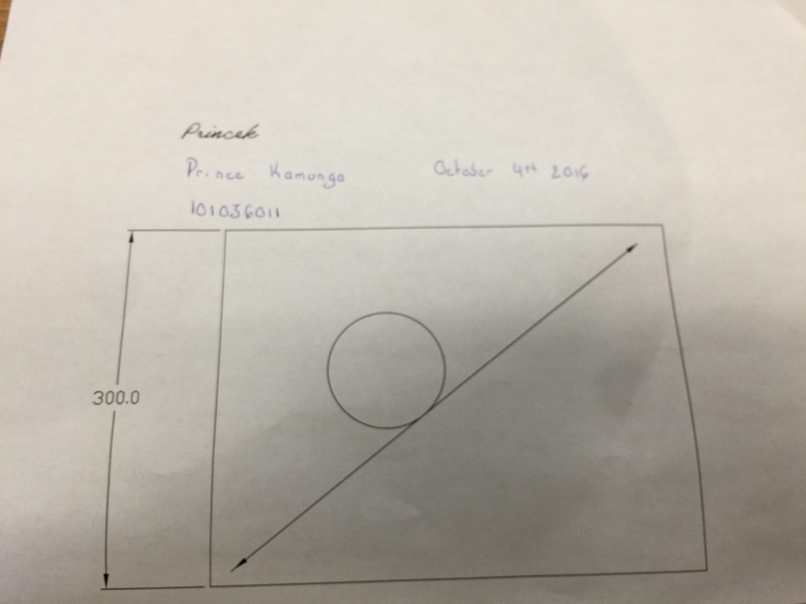
Figure:15.25

