PASS MOCK EXAM – FOR PRACTICE ONLY

Course: Phys 1007 Facilitator: Richie Citta Dates and locations of mock exam take-up: Dec 7th 18:30-21:30 Southam Hall 405

IMPORTANT:

It is most beneficial to you to write this mock midterm UNDER EXAM CONDITIONS. This means:

- • Complete the midterm in 3 hour(s).
- • Work on your own.
- • Keep your notes and textbook closed.
- • Attempt every question.

After the time limit, go back over your work with a different colour or on a separate piece of paper and try to do the questions you are unsure of. Record your ideas in the margins to remind yourself of what you were thinking when you take it up at PASS.

The purpose of this mock exam is to give you practice answering questions in a timed setting and to help you to gauge which aspects of the course content you know well and which are in need of further development and review. Use this mock exam as a learning tool in preparing for the actual exam.

Please note:

- Come to the PASS session with your mock exam complete. There, you can work with other students to review your work.

- Often, there is not enough time to review the entire exam in the PASS session. Decide which questions you most want to review – the facilitator may ask students to vote on which questions they want to discuss.

- Facilitators do not bring copies of the mock exam to the session. Please print out and complete the exam before you attend.

- Facilitators do not produce or distribute an answer key for mock exams. Facilitators help students to work together to compare and assess the answers they have. If you are not able to attend the PASS session, you can work alone or with others in the class.

GOOD LUCK!

Multiple Choice Questions. Answer by circling the answer closest to the correct one.

1. A satellite is in a circular orbit above the Earth with a radius 2.5 x 10⁷ m. Given the mass of Earth to be approximately, M_{E} = 6.0 x 10²⁴ kg, and G = 6.67x10⁻¹¹ m³ kg⁻¹ s⁻¹, what is approximately its period of revolution around the Earth?
- 11 seconds
- 11 minutes
- 11 hours
- 11 days
- None of the above

2. An object is rolling on a horizontal surface at 2.45 m/s when it starts up a 22.5° incline. How far up the incline does it reach?
- 0.8 m
- 0.9 m
- 1.6 m
- 2.3 m
- It is not possible to calculate without the radius and mass of the hoop.

3. You observe that only 10% of a cube of ice is visible above the surface of fruit punch being served at your Christmas party. Knowing the density of ice to be 917 kg/m³, what do you estimate the density of the punch is?
- 825 kg/m³
- 1000 kg/m³
- 1009 kg/m³
- 1018 kg/m³
- It is not possible to determine without knowing the fruit mass and density

4. Normal atmospheric pressure is 1.013 × 10⁵ Pa. The approach of a storm causes the height of a mercury barometer to drop by 20.0 mm from the normal height. What is the atmospheric pressure? (The density of mercury is 13.59 g/cm³.)
- 0.986 x 10⁵ Pa
- 0.999 x 10⁵ Pa
- 1.027 x 10⁵ Pa
- 1.040 x 10⁵ Pa
- 1.013 x 10⁵ Pa – Atmospheric pressure is always constant at the surface of the earth – the height of mercury drops because of the expansion of the barometer glass due to temperature rise.

5. The diameter of a pipe is tripled. The volume flow rate of the pipe increases by a factor of
a) 3 b) 9 c) 27 d) 81

6. Pendulum A has period 2 seconds. Pendulum B is four times as long as pendulum A. What is the period of pendulum B?
a) 1 second b) 2 seconds c) 4 seconds d) 8 seconds

7. A flexible chair is supported by metal tubes. When a 600 N person sits on the chair, the chair bends downward 4 cm. What is the chair's spring constant?
a) 600 N b) 4 cm c) 150 N/cm d) 2400 N*cm

8. A rigid cylinder is filled with a gas at a temperature of 300 K and pressure 100000 Pa. The temperature of the gas is then raised to 330 K. What is the new pressure?
a) 100000 Pa b) 110000 Pa c) 130000 Pa d) Need more information.

9. For a given force, doubling the lever arm will change the torque by a factor of
a) 4 b) 2 c) 1 (no change) d) ½

10. A rock is dropped from a great height. Ignore air resistance. If the acceleration due to gravity is 32 ft/s², then after 3.0 s the rock's speed is
A) 32 ft/s² B) 96 ft/s C) 144 ft/s D) 288 ft/s

11. A rock is dropped from a great height. Ignore air resistance. If the acceleration due to gravity is 32 ft/s2 then after 3.0 s the rock has fallen
a) 32 ft b) 96 ft c) 144 ft d) 288 ft

12. The longest vertical pipe water (density of water = 1000 kg/m³) can be lifted through by suction on Earth’s surface is approximately
a) 1 m b) 10 m c) 100 m d) It depends on the pump.

13. What is the frequency of a vibration with period 0.02 second?
a) 0.02 Hertz b) 0.02 second c) 50 Hertz d) 50 seconds

14. A baseball is thrown vertically upwards. The acceleration of the ball at its highest point is:
(a) zero (b) 9.8 m/s² upward (c) 9.8 m/s² downward
(d) changing suddenly from 9.8 m/s² upward to 9.8 m/s² downward

15. A freely falling body (neglect air resistance) has an acceleration of 9.8 m/s² downward. This means that:
(a) the body falls 9.8 meters during each second
(b) the body falls 9.8 meters during the first second only
(c) the speed of the body increases by 9.8 m/s during each second
(d) the acceleration of the body increases by 9.8 m/s² in each second
(e) the acceleration of the body decreases by 9.8 m/s2 in each second

16.A pile driver is pounding a steel beam into the ground. The hammer (the falling object) has mass 500 kg and falls from a height of 2 m onto the beam, starting at rest. The kinetic energy of the hammer just before it hits the beam is:

Hammer
Beam
(a) 9800 Joules (b) 4900 Joules (c) 1000 Joules (d) 500 Joules

17. In the situation described in Question 16, the beam then penetrates 10 cm into the ground.
What is the average force the ground exerts on the beam as it is forced downward?
(a) 5000 N (b) 98000 N (c) 4900 N (d) 49000 N

Please solve three of the five offered problems. You must have diagrams and show all important details of the solution for full marks. Be sure all answers are clearly labeled, with units. Show all work clearly. Answers with no clear reasoning will receive little or no credit.

Problem 1:

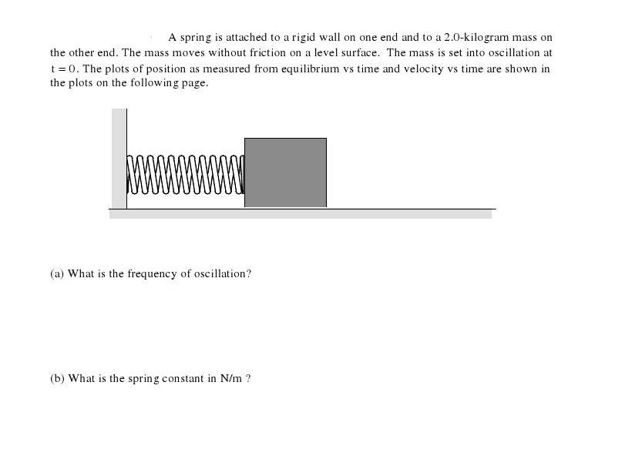

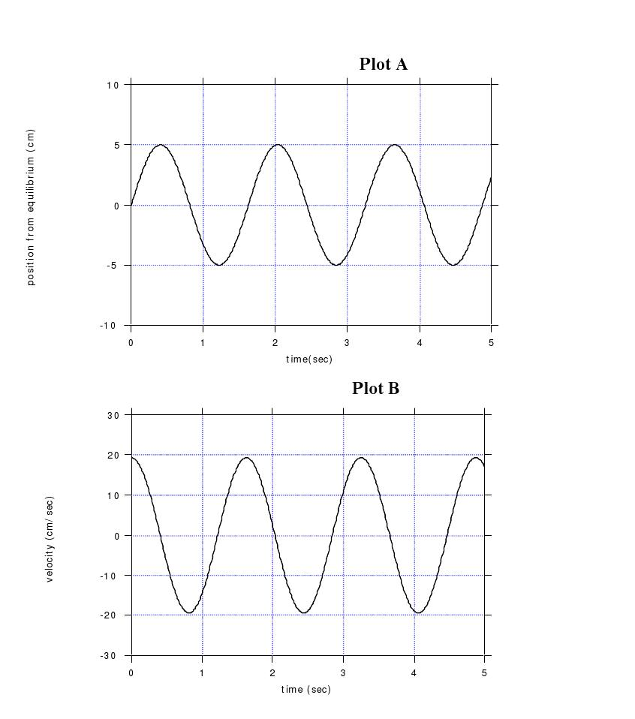
(c) What is the initial potential energy?

(d) What is the initial kinetic energy?

(e) On plot A, sketch the acceleration of the mass vs time and be sure to indicate the units and numbers on the vertical axis on the right of the plot.

Problem 2:

A satellite is in geosynchronous circular orbit above a point on the Earth’s equator. The satellite is equipped with rockets which can provide a thrust parallel to or anti-parallel to its direction of motion. The radius of the Earth is 6.4 × 10³ km. M_{E} = 6.0 x 10²⁴ kg and G = 6.67x10⁻¹¹ m³ kg⁻¹ s⁻¹.

(a) How high above the Earth’s surface is the satellite?

(b) What is the velocity of the satellite?

(c) The thrusters are fired for a period of time anti-parallel to the direction of motion and the satellite is now in a new circular orbit which is lower, i.e. the radius of the orbit is now 3/4 of the radius for the goesychronous orbit. What is the new velocity?

Problem 3:

1. In the figure below, a stone is projected at a cliff of height h with an initial speed of 42.0 m/s, directed 60⁰ above the horizontal. The stone hits point A 4.5 s after it is launched.
(a) Find the maximum height H of the stone.
(b) Find the speed of the stone just before impact.
(c) Find the height h of the cliff.

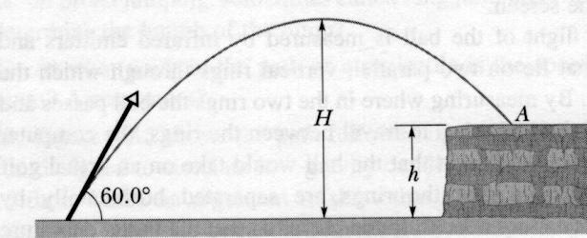

Problem 4:
Consider a board held up by a fulcrum and a force F1, as shown below. The total
length of the board is 2.0 m and its weight is 120 N. Determine (a) the force F1, and(b) the force exerted by the fulcrum (c) What would the force F1 be if you raised the right end of the board so that it made a 30◦ angle with the horizontal, and F1 still pointed straight up? (d) What if you did this and F1 pointed perpendicular to the board?
F1

0.40m

Problem 5

A simple pendulum has a period of 2.00 seconds on the Earth. (a) What is the length of this pendulum? (b) If the amplitude of the swing is 5.00◦, what is the maximum speed of the pendulum bob? (c) What is the maximum acceleration of the pendulum bob, and at what positions does this occur? Find this value in two different ways (d) What would the angular frequency and the period of this pendulum be on the moon, where the acceleration of gravity is 0.165 that of Earth?

