ECOR 1010 – Introduction to Engineering

sanah
Assignment #1
ENGINEERING REPORT: COMPARISON OF FUEL CONSUMPTION AND CO2 EMISSIONS BETWEEN VEHICLES

TO Marking TA:
Zelig Li
zeligli@cmail.carleton.ca

Lab Section: L8
Room: ME 2256 – Carleton University

FROM:
sanah

Number of Figures and Tables (Including handwritten ones): 10
Last Date and Time of Revision: 27 September 2016

Introduction
Present-day consumers are more concerned with the impact their travel has on the environment than they’ve ever been before, which is motivating vehicle manufacturers to make claims about the environmental impact their vehicles have. An aircraft manufacturer claims that each passenger will use less fuel compared to one person driving a minivan, while an automobile manufacturer claims that per passenger, a car uses less fuel and produces fewer emissions. These claims need to be put to the test, so consumers can make informed decisions. Testing three vehicles to see which consumes the least fuel, and produces the least CO₂ per passenger will prove which vehicle is the most environmentally-friendly.

Method
The “BlueSky” E-1010 airplane, 4-passenger sedan, and 7-passenger minivan were compared in terms of fuel consumption and CO₂ emissions, both overall and per passenger. Other factors, including fuel cost, travel time, and the number of trees needed to offset each passenger’s CO₂ emission were also calculated, in order to prove or disprove the manufacturers’ claims. In order to calculate emissions and consumption, data from tables 1 and 2 were used. Calculated results were input into table 3. Calculations can be seen in figures 2 through 7, and assumptions can be found in figure 1.

Results
According to the calculated data in Table 3, the E-1010 aircraft holds 250 passengers and uses 1.95L of fuel per passenger, and there are 366.41kG of CO₂ produced for each passenger. This means that in order to offset the emissions for one passenger, 17 trees must be planted. The sedan, however, holds 4 passengers, and uses 1.54L of fuel per passenger, and the emissions for one passenger are 210.14kG, meaning only 10 trees are needed to offset the emissions for each passenger. Lastly, the minivan, which holds 7 passengers, uses just 1.16L of fuel per passenger, and each person’s emissions are only 159.13kG of CO₂. There only need to be 8 trees planted for each person in the minivan.

Discussion
From these comparisons, it is easy to conclude that per passenger, the minivan is the most efficient mode of transportation for this trip. However, the aircraft manufacturer claims that for each passenger in the plane, only half the fuel of a car with one driver is being used. Since one passenger in an aircraft uses 1.95L of fuel, and a minivan with just one person in it would use 474.004L of fuel per passenger, the aircraft is technically more efficient if there is only one passenger in the car. Therefore, both manufactures are right; the aircraft manufacturer’s claim is based on the minivan having just a driver, and no other passengers.

Conclusions
- If both the aircraft and the minivan have their maximum number of passengers in them, the minivan is more efficient, using just 1.16L of fuel per passenger, and needing just 8 trees to offset a passenger’s emissions (table 3).
- If the aircraft is full but the van has just a driver in it, the plane is much more efficient, as each passenger uses 1.95L of fuel, as opposed to the 474L the car would use (table 3).

APPENDIces- Figures and Tables

Table 1: “BlueSky” model E-1010 airplane specifications.
Aircraft model | Max. no. of seats | Max. range* | Max. takeoff weight | Max fuel capacity** | Cruise speed @ 35,000 feet ***
E-1010 | 250 | (Km) | (Kg) | (kg) | (Km/h)
E-1010 | 250 | 4 755 | 67 775 | 32 389 | 895

Table 2: Useful Information
Automobile fuel price | 1.05 | $/L
Fuel density (aircraft and automobile) | 0.80 | kg/L
Aircraft reserve fuel | 10.50 | %
Automobile average speed | 85.00 | km/hr
Aircraft fuel price | 0.81 | $/L
Automobile CO2 emission | 2.35 | kg/L
Airplane CO2 emission | 3.16 | kg CO2/kg Fuel
Halifax to Vancouver distance by car | 5 816 | km
CO2 fixed by the average tree per year | 50.0 | lb CO2/tree/year

Table 3: Calculation Summary Table

 | Fuel Consumption L/100 km | Fuel Cost for the vehicle to travel the distance ($) | Fuel Consumption per person: 100% occupied seats L/100 km | Fuel Cost per person: 100% occupied seats ($) | CO2 Emission (kg) |  | Total Travel Time (hr) | Total Travel Time |  | No. of trees to offset CO2 emission /yr/person
 |  |  |  |  | Total | per person: 100% occupied seats | Total Travel Time (hr) | hr | min | No. of trees to offset CO2 emission /yr/person
E-1010  250 passengers | 487.71 | 18 552.00 | 1.95 | 74.21 | 91 602.57 | 366.41 | 5.9 | 5 | 54 | 17
Car– Sedan 4 passengers | 6.15 | 375.57 | 1.54 | 93.89 | 840.56 | 210.14 | 140.42 | 140 | 25 | 10
Minivan 7 passengers | 8.15 | 497.70 | 1.16 | 71.10 | 1113.91 | 159.13 | 140.42 | 140 | 25 | 8

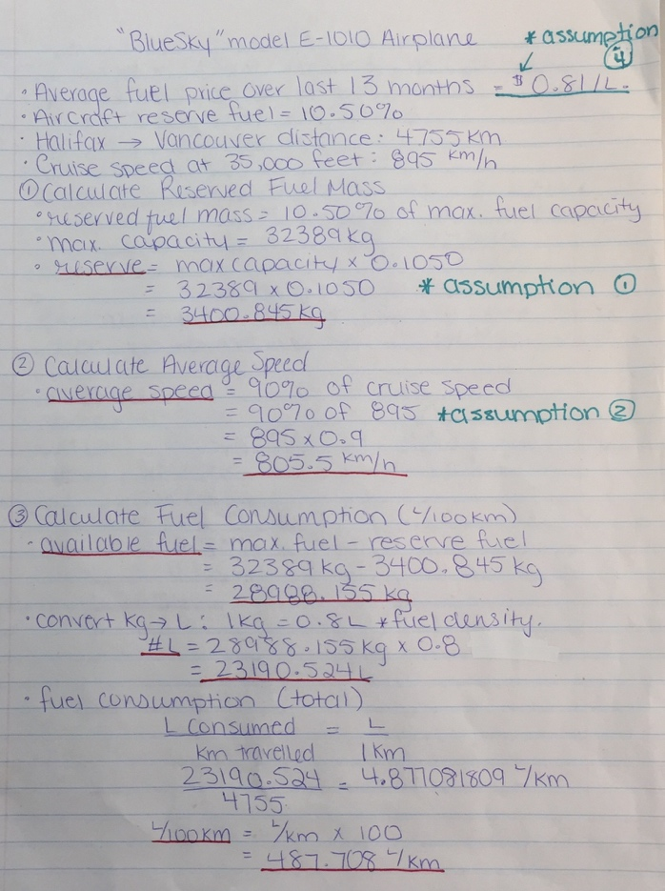
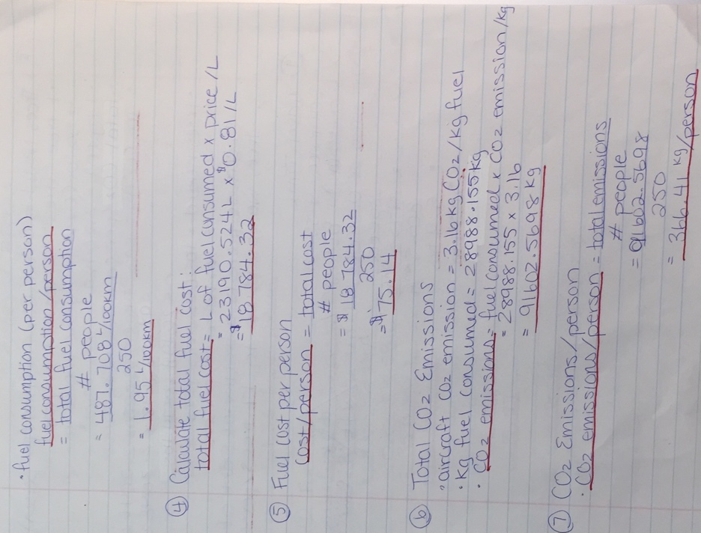

Figure 2: continuation of figure 1
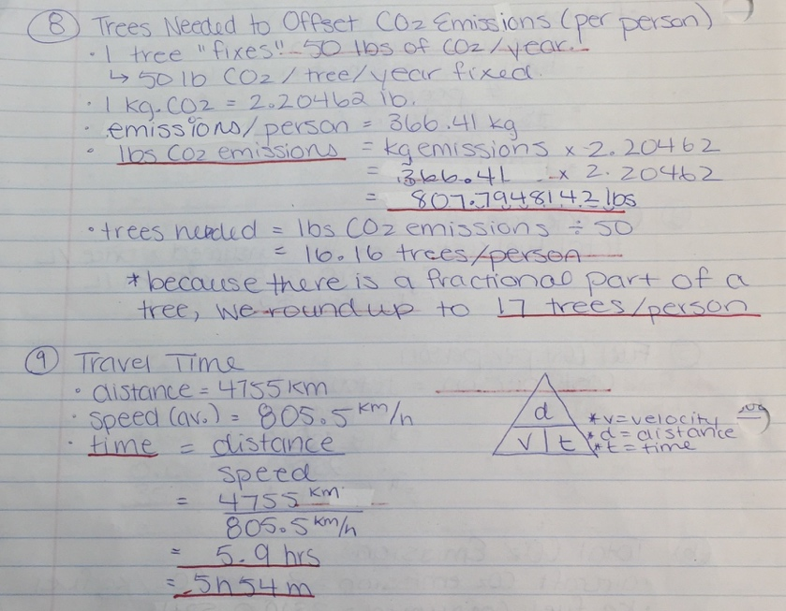
Figure 1: Calculations for “BlueSky” E-1010 Aircraft

Figure 3: continuation of figures 1 and 2

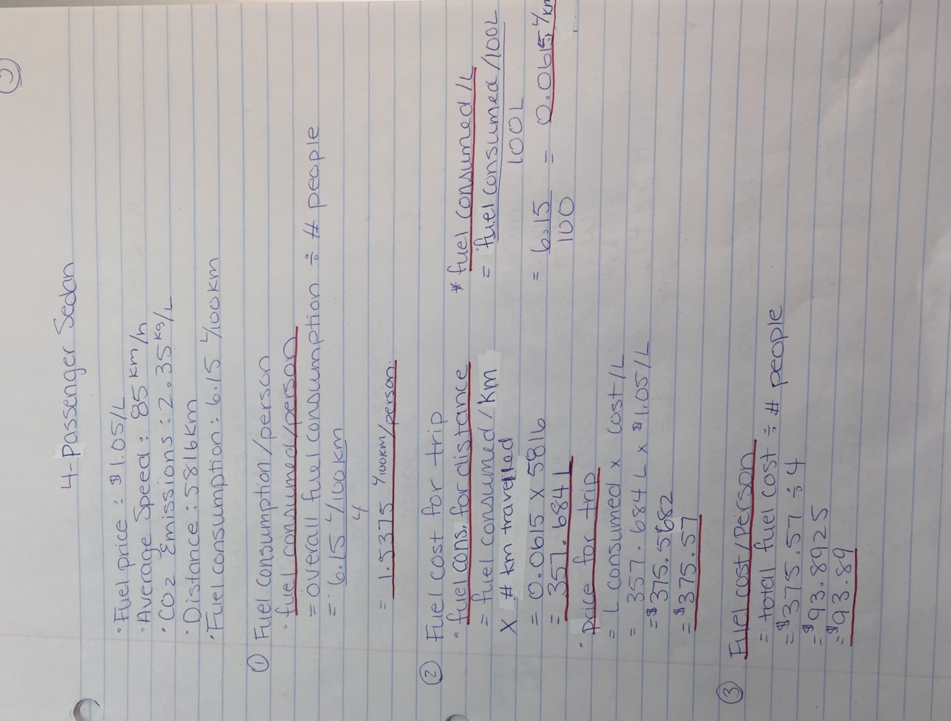
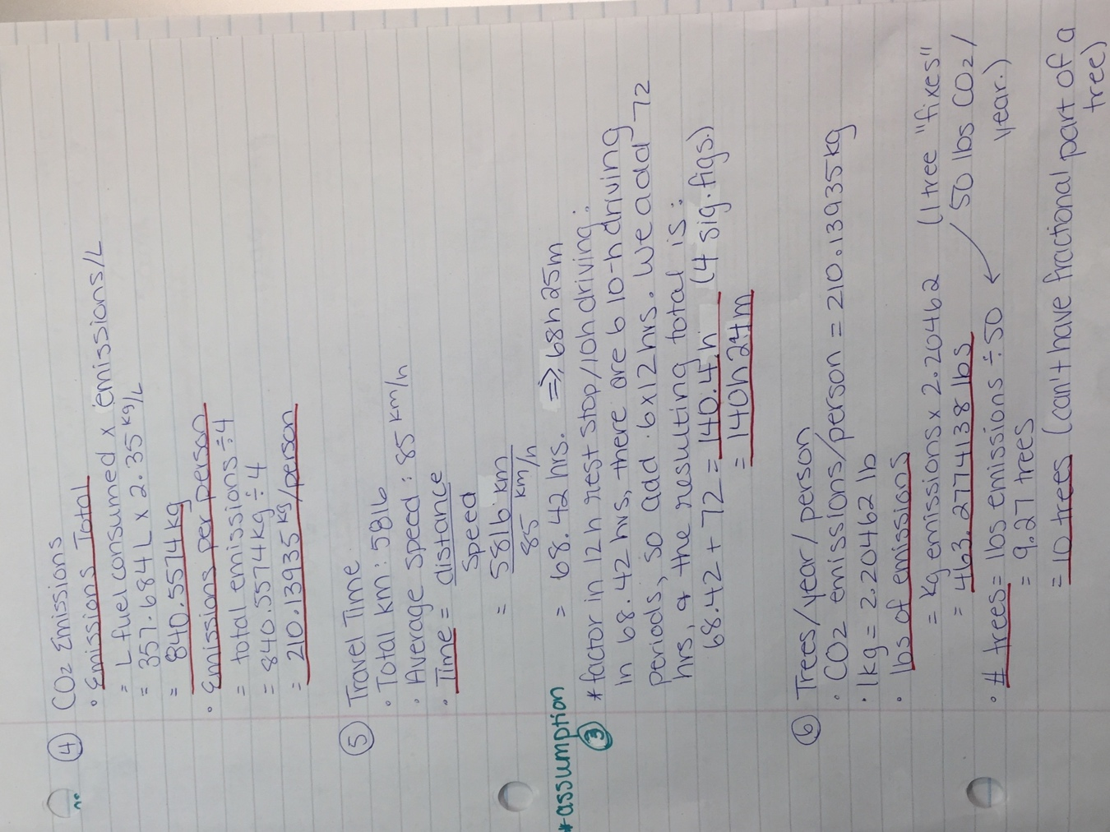

Figure 4: calculations for a 4-passenger sedan Figure 5: continuation of figure 4

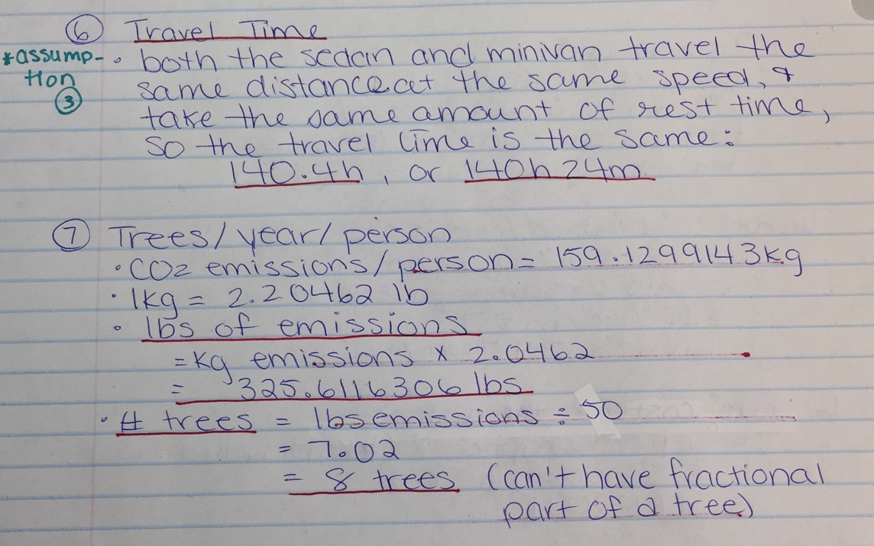
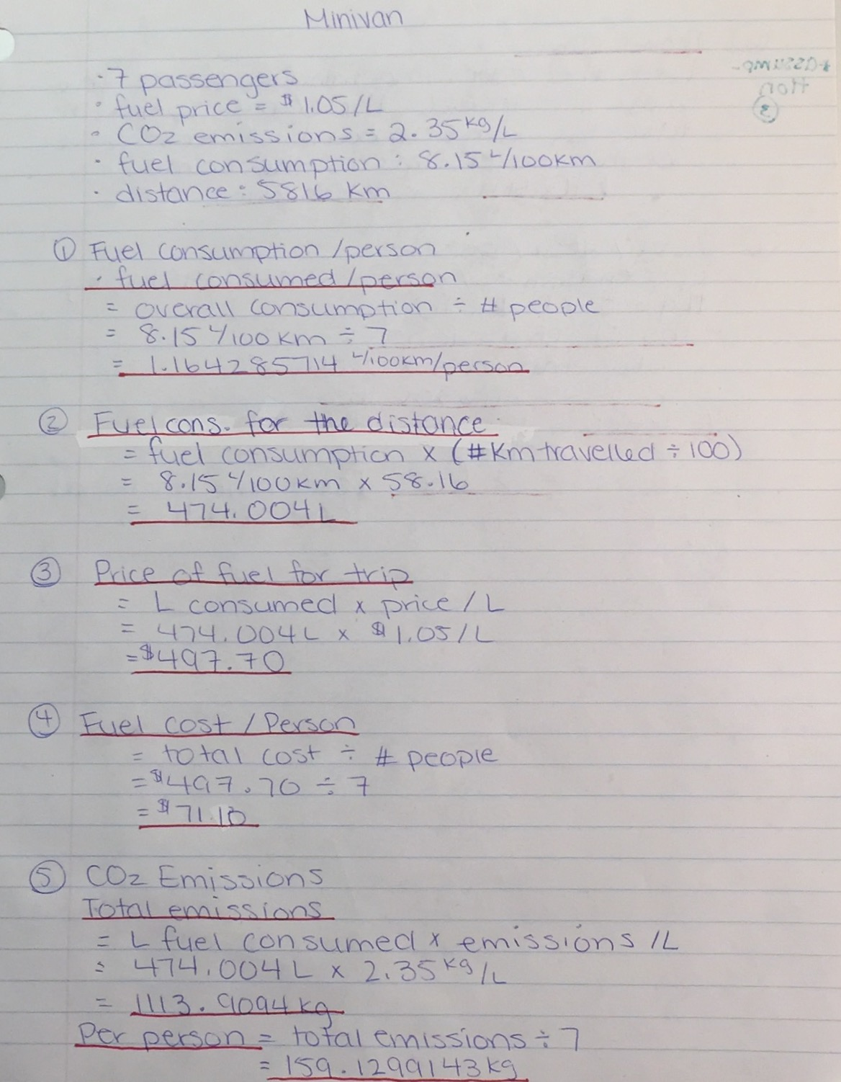
Figure 6: calculations for a 7-passenger minivan Figure 7: continuation of figure 6

