Corrosion and Degradation of Materials

Metals:
- Loss by dissolution
- Film formation (Oxide)

Polymers:
- Loss by Dissolution (In solvent)
- Absorption and Swelling (In solvent)
- Structural Change Due to Electromagnetic Radiation (Example: Ultraviolet)

In Metals:
Corrosion is destructive and an unintentional attack of a metal.
(Example: Rusting, Autobody Panels, Radiator, Exhaust Components)

Useful Corrosion Processes:
- Metal Etching (Example: Microscopy)
- Dry Cell Batteries

Electrochemical Considerations
Half Reactions
Oxidation: Metal giving up electrons
Reduction: Metal gaining electrons

Oxidation:
M M^{n+} + ne⁻ M
Fe Fe²⁺ + 2e⁻
Al Al³⁺ + 3e⁻
Happens at anode (Anodic Reaction).

Reduction:
M^{n+} + ne⁻ M
2H⁺ + 2e⁻ H₂(gas)
Happens at cathode (Cathodic Reaction).

O₂ + 4H⁺ + 4e⁻ 2H₂O
Dissolved oxygen in acid solutions.

O₂ + 2H₂O + 4e⁻ 4(OH⁻)
Dissolved oxygen in neutral or basic solutions.

Rusting
Oxidation Stage 1
Fe oxidized to Fe²⁺ (and then to Fe(OH)₂)
Fe + ½O₂ + H₂O Fe²⁺ + 2OH⁻ Fe(OH)₂

Oxidation Stage 2
2Fe(OH)₂ + ½ O₂ + H₂O 2Fe(OH)₃

Metal ions go into corroding solution as ions. *(Example: Zn Zn²⁺ + 2e⁻).
They may form an insoluble compound with non-metallic elements (Fe(OH)₃, rust).

Electrode Potentials
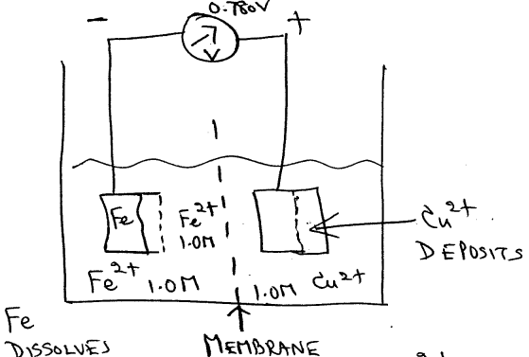

Half Cells
Fe Fe2+ + 2e- Oxidation
Cu2+ + 2e- Cu Reduction

Galvanic Couple:
Two metals electically connected in a liquid electrolyte.
One metal anode corrodes (oxidizes), the other metal-cathode enables reduction.

Cu-Fe Galvanic Cell:
25$°$C (77$°$F): Fe + Cu2+ Fe2+ + Cu 0.780 V
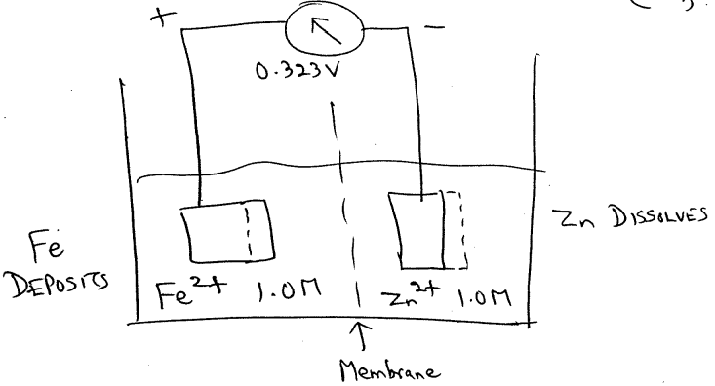

Fe2+ + Zn Fe + Zn2+ IM solution

Fe2+ + 2e- Fe
Zn Zn2+ + 2e-
0.323 V

Different voltages for different pairs of electrodes.

Molarity (M): The number of moles of solute per million cubic mm (106mm3 or 1000cm3) of solution.

Magnitude of Voltage: Driving force for electrochemical oxidation-reduction reaction.

emf Series: Rating of metallic materials as to their tendency to experience oxidation when coupled to other metals in solution of respective ions.

Mole: Quantity corresponding to 6.023 x 1023 atoms or molecules.

Standard Half-cell: Pure metal immersed in IM solution of its ions and at 25$°$C (77$°$F).

The Standard emf Series

Reference cell to which other half-cells are compared

