Chapter 13: Ceramics and Properties of Ceramics

Root: keramikos (Greek for “burnt stuff”)

Traditional Ceramics: china, porcelain, bricks, tiles, glasses and high temperature ceramics

New generation ceramics: (Since better understanding of the fundamental character of ceramics, and parameters influencing their unique properties)

Impact: electronic, computer, communication, aerospace and other industries.

CERAMIC STRUCTURES: composed of electrically charged ions; not atoms. Partial or total ionic bonding.

Cations: metallic ions, positively charged, since they have given up valence electrons to non-metallic ions.

Anions: non-metallic ions, negatively charged

CRYSTAL STRUCTURES: Influenced by two characteristics:
- Magnitude of the electrical charge on each of the component ions. The crystal must be electrically neutral. ie., balancing of positive and negative charges.
- Relative sizes of Cations and Anions. Ionic radii: rc_{cation} and ra_{anion}

Since they give up electrons, Cations are usually smaller than Anions. : r_{c}/r_{a} <1
Each ion desires to have as many nearest neighbours of the opposite charge. Stable when anions are touching a cation.

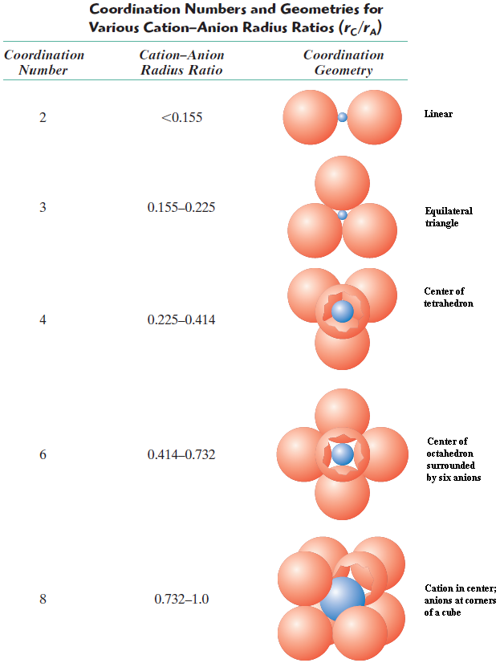
Coordination No: number of anion nearest neighbours of a cation. P. 378-379 Table 13.1:

Example:

Show that the minimum cation to anion radius ratio for the coordination number 3 is 0.155.

AP=r_{A}
AO= r_{A} + r_{C}
cos (30º)=AP/AO= $\frac{r_{A}}{r_{A}+r_{C}}$ =$\frac{√3}{2}$
$$\frac{r_{C}}{r_{A}}=\frac{1-√3/2}{√3/2}=0.155$$

Types of Structures

AX-Type Crystal Structure
- Equal number of cations and anions
- Several different crystal structures for AX compounds

- AX-Rock Salt Structure: NaCl/Rock salt
- Coordination number for anions and cations: 6
- cation/anion ratio: 0.414-0.732

FCC arrangement of anions
Two interpenetrating FCC lattices
FCC arrangement of cations

Examples: NaCl, MgO, MnS, LiF and FeO

- AX - Cesium Chloride Structure: CsCl
- Coordination number for both ions: 8
- Anions at centres of cube
- Cation at body (cube-centre)

- AX – Zinc Blende Structure: ZnS/sphalerite/Zinc Blende
- Coordination number: 4
- S atoms: at cube corners and face positions
- Zn atoms: interior tetrahedral positions, Each Zn atom is bonded to four S atoms and vice versa. Often highly covalent. eg. ZnS, ZnTe, SiC

- Type Crystal Structures
- m and/or p ≠ 1
- eg. AX₂: CaF₂/Flourite
- Coordination Number: 8 r_{c}/r_{a} = 0.8
- Similar to CsCl structure. But, only half as many Ca²⁺ as F⁺ ions so, only half the centres cube positions are occupied by Ca²⁺ ions.
- Examples: UO₂, PuO₂ and ThO₂

- AmBnXp Type Crystal Structure ("Two types of cations”)
Examples: BaTiO₃/Barium Titanate

Ceramic Density Calculations

From page 36,

$=\frac{nA}{V_{C}N_{A}}$

Where:
n = number of atoms associated with each unit cell
A = atomic weight
Vc = Volume of the unit cell
Na = Avagadro’s number (6.023 x 10^23 atoms /mole)

$$=\frac{n'\left(\sum{A_{c}+\sum{A_{A}}}\right)}{V_{C}N_{A}}$$

Where:
n' = the number of formula units within the unit cell (eg.BaTiO₃: 1, 2 ,3)
A_{C} = the sum of the atomic weights of all cations in the formula unit
A_{A} = the sum of the atomic weights of all the anions in the formula unit
V_{C} = the unit cell volume
N_{A} = Avagadro’s number

Example:

Compute the theoretical density of NaCl on the basis of crystal structure.
How does this compare with its measured density?

n' = 4/unit cell

ΣA_{C} = A_{Na}
= 22.99 g/mol

ΣA_{A} = A_{cl}
= 35.45 g/mol

V_{c} = a³

a = 2(r_{Na} + r_{cl})

r_{Na} ₌ 0.102 nm

r_{cl} = 0.181nm

$$=\frac{n'(A_{Na}+A_{Cl})}{{(2r_{{NA}^{+}}+2r_{{Cl}^{-}})}^{3}N_{A}}$$

$$=\frac{4(22.99+35.45)}{{(2(0.102×{10}^{-7})+2(0.181×{10}^{-7})}^{3}N_{A}}$$
$$=2.14 g/cm^{3}$$
Expected value: 2.16 g/cm³

Ceramic Phase Diagrams

The Al₂O₃-Cr₂O₃ System
Isomorphous (density similar to Cu-Ni)
- Fig. 13.24: Al₂O₃-Cr₂O₃ Substitution Solid Solution. (Al³⁺ substitutes for Cr³⁺), same charge.
- Similar radii: 0.053nm (Al³⁺) 0.063 nm (Cr³⁺)
- Same crystal structure

The MgO-Al₂O₃ System (similar to Pb-Mg)
- Intermediate phase: MgAl₂O₄ spinel (ie., MgO-Al₂O₃)
- Fig.13.25: Distinct compound, single phase field (not a line as for Mg₂Pb)
- Spinel nonstoichiometric (range of compositions)
- Differences in charge: Mg²⁺ Al³⁺
0.072 nm (Mg²⁺) 0.053 nm (Al³⁺)
- MgO is virtually insoluble in Al₂O₃; so no terminal solid solution at RHS
- Two eutectics
- Constant melting of spinel at 2100°C

The ZrO2-CaO System (zirconia/calcium)
- Three reactions: eutectic, pertectic and eutectoid.
- Three different crystal structures: tetragonal, monoclinic, cubic
- Pure ZrO₂: tetragonal to monoclinic at 1000°C

a= b ≠ c a ≠ b ≠ c
α = β = γ = 90° α = γ = 90° ≠ β

Results in cracking so, “stabilize” by adding 3 to 7 wt.% CaO to ZrO₂. This eliminates cracking,
as no such phase change occurs.

The SiO₂-Al₂O₃ System
- SiO₂ and AL₂O₃: Not mutually soluble
- No terminal solid solutions at both extremities
- Si0₂: cristobalite (most stable form)
- 3Al₂O₃-2SiO₂: Mullite
- Simple eutectic at 1587 ºC

Plastic Deformation

Crystalline Ceramics:
- Why are crystalline ceramics hard and brittle?
- Few slip systems for the movement of dislocations (due to the electrically charged nature of ions).
- Electrostatic repulsion of like charges eliminates several possibilities of slip (disloc. motion)
- Deformation by motion of dislocations
- Hard and brittle :difficulty in dislocation motion (slip)
- Bonding: ionic; therefore few slip systems (planes and directions) for dislocation motion, due to electrically charged nature of ion.
- For slip in some direction, ions are brought close to one and other; but this type of motion is restricted due to electrostatic repulsion
- For ceramics with covalent bonding, slip is difficult because:
- Covalent bonds are strong
- Limited no. of slip systems
- Dislocation structures are complex

Noncrystalline Ceramics (glassy)
- Deformation is not by dislocation motion
- But by viscous flow
- Rate of deformation ∝ applied stress
- Atoms/ions slide past one another by breaking/reforming bonds
- Viscosity: measure of resistance to deformation

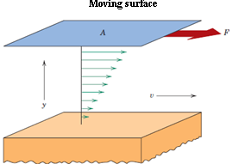

$$τ=F/A$$
$$η=\frac{τ}{dv/dy}=\frac{F/A}{dv/dy}$$

Where:
η, viscosity. Poises (P) pascal-second
τ, Applied shear stress
dv, change in viscosity
dy, distance in direction perpendicular to and away from plates.

1Poise

1 P =1 dyne-second/cm²
1Pa-s =1N-sec/m²
10 P =1 Pa-s
Water: 10⁻³ Pa-s

Glass: very large (since strong interatomic bonding). As temperature increases, the magnitude of bonding is diminished, sliding motion or flow of atoms or ions is facilitated, then there is a decrease in viscosity.

