Chapter 9: Phase Diagrams

Introduction
Phase Diagrams are road maps

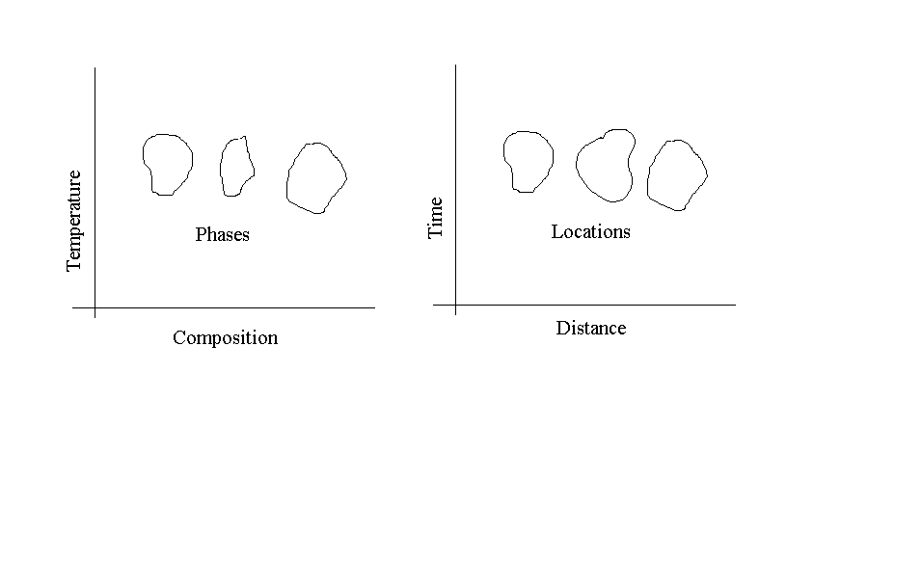

Component:
Pure metals/compounds of which an alloy is composed

System:
Alloy system,
Example: Iron-Carbon alloy system, copper-nickel alloy system

Solid solutions
- Substitutional
- Interstitial

Solubility Limit:
Max concentration of solute atoms that may dissolve in the solvent to form a solid solution.

Phases:
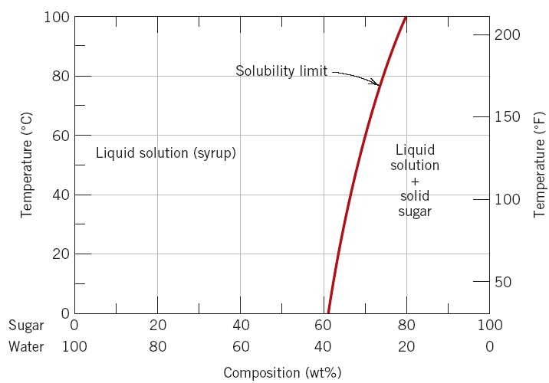
Homogenous portion of a system that has uniform physical and chemical properties

Each phase has different phase physical properties

Microstructure
- Characterized by number of phases, proportions and the manner of distribution of phases.
- Depends on: Alloying elements, concentrations, heat treatment (temp, heating/cooling rate etc.)

Phase equilibria
- Free energy
- Equilibrium
- Phase equilibrium
- Non-equilibrium state: State of equilibrium is never reached since the rate of approach to equilibrium is very slow.

Equilibrium phase diagram
- Represents the relationships between temperature and compositions, and the quantities of phases in equilibrium
- Binary Alloy: two components

Binary Isomorphous Systems
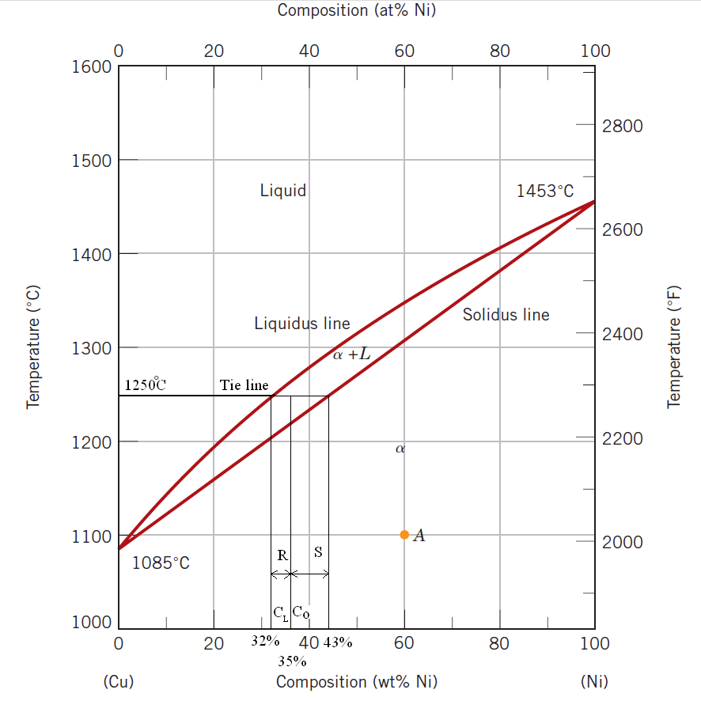

Isomorphous: Complete solubility in both liquid and solid states
Three kinds of info:
- Phases,
- compositions,
- percentages/fractions of phases
At 1250$°$C and C_{o} = 35% Ni,

$$W_{L}=\frac{S}{S+R}=\frac{C_{∞}-C_{0}}{C_{∞}-C_{L}}$$
$$W_{L}=\frac{43-35}{43-32}=0.73=73\%$$

Where:, W_{L} = weight fraction of liquid

$$W_{∞}=\frac{R}{R+S}=\frac{C_{0}-C_{L}}{C_{∞}-C_{L}}$$
$$W_{∞}=\frac{35-32}{43-32}=0.27=27\%$$

Inverse lever rule
- Draw tie-line across the two phase region
- Locate the overall composition (e.g., C_{o}=35%Ni)
- To compute the fraction of one phase, take the length of the tie-line from the overall composition to the opposite phase boundary and divide by the total tie line length
- Repeat above procedure for the other phase.

$$W_{∞}+W_{L}=1$$
$$W_{∞}C_{∞}+W_{L}C_{L}=C_{0}$$
$$W_{L}=\frac{C_{∞}-C_{0}}{C_{∞}-C_{L}}$$
$$W_{∞}=\frac{C_{0}-C_{L}}{C_{∞}-C_{L}}$$
Where $C_{s}$ and $C_{∞}$ both are the same.

Development of microstructures

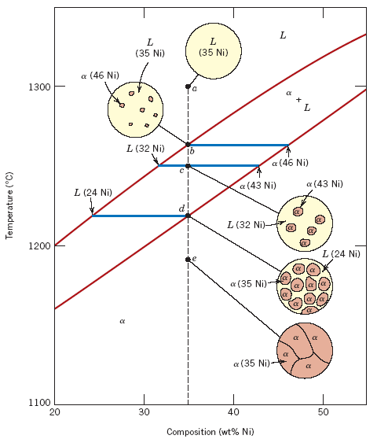

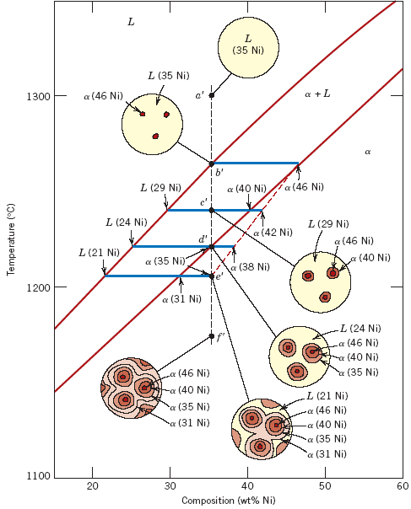

The compositions readjust with changes in temperature. These changes occur through the process of diffusion.

Because diffusion is time-dependent, much more time is required, at each temperature for compositional adjustments. Diffusion rates decrease with temperature. In reality, cooling rates are so fast that there is little time to enable equilibrium cooling.

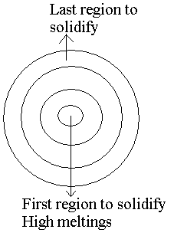
Non-Equilibrium Solidification
Because of fast cooling, there is a non-uniform distribution of the two elements for isomorphous alloys

“Segregation”

In the centre of each grain, the high melting element solidifies first. At the periphery, the low melting element solidifies.

Coring
Cored Structure: Concentration contours
- Undesirable less than optimal properties due to inhomogeneity.
- Coring is eliminated by a homogenization treatment. At a temperature below the solidus point for the composition; atomic diffusion causes homogenization.

Mechanical Properties of Isomorphous Alloys

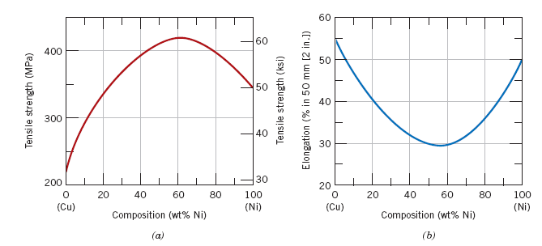

- Solid solution hardening or an increase in strength and hardness by the addition of the other component
- At an intermediate composition, the curve (TS Vs Comp) passes through a maximum
Binary eutectic systems

α: Solid Solution of Ag in Cu-Rich solvent
β: Solid solution of Cu in Ag-Rich solvent
Technically, α: Pure Cu
β: Pure Ag
Below BEG, only limited solid solubility takes place

CEA: (solid) solubility limit for Ag in α– phase (Cu-Rich)
HGF: Solubility limit for Cu in β-phase (Ag-Rich)

CBA is between α/(α+β) and α/(α+L) phase regions
- Max. at 7.9% Ag (780°C)
- Decrease to zero at 1085°C (Melting point of pure Cu)

For α–phase CB: Solvus line: α/(α+β)
AB: Solidus line: α/(α+L)

HGF is between ____________________________________________________

For β-phase HG: Solvus line:_____________
GF: Solidus line:_____________

Three two-phase regions:
- α+L
- β+L
- α+β
E: Eutectic invariant point
CE: 71.9 wt% Ag
Cu-Ag system: TE: 780°C
Eutectic Reaction:

Liquid Solid 1 + Solid 2

At E,

L α + β
L (C_{E}) α (C _{αE}) + β (C _{βE})

For Cu-Ag system,
L(71.9 wt% Ag) α (7.9 wt% Ag) + β (91.2 wt% Ag)

Solidus line at 780°C: Eutectic isotherm

Phase volume fractions represent proportions seen in the microstructure; so they can be estimated from microstructures, and the mechanical properties can be estimated as well.

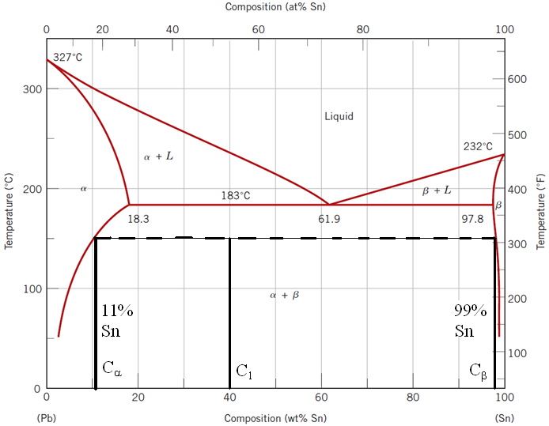

Example:

For Pb-Sn system at 150°C, calculate relative amounts of each phase by
(a) Mass fraction
(b) Volume fraction

Given:
$$ρ_{∞}:11.2 gm/cm^{3}$$
$$ρ_{β}:7.3 gm/cm^{3}$$

Solution:
$W_{∞}=\frac{C_{β}-C_{1}}{C_{β}-C_{∞}}=\frac{99-40}{99-11}=0.67$ 1.00 – 0.67 = 0.33

$$W_{β}=\frac{C_{1}-C_{∞}}{C_{β}-C_{∞}}=\frac{40-11}{99-11}=0.33$$

$$v_{∞}=\frac{67gm}{\frac{11.2gm}{cm^{3}}}=5.98 cm^{3}$$
$$v_{β}=\frac{33gm}{\frac{7.3gm}{cm^{3}}}=4.52 cm^{3}$$

Volume Fraction
$$V_{∞}=\frac{V_{∞}}{V_{∞}+V_{β}}=\frac{5.98}{5.98+4.52}=0.57$$
$$V_{β}=\frac{V_{β}}{V_{∞}+V_{β}}=\frac{4.52}{5.98+4.52}=0.43$$

