Chapter 5: Diffusion

Introduction
- Material transport by atomic motion
- Diffusion couple:
Example: Cu-Ni in close contact; hold at elevated temperature for extended period and cool to room temperature.

Before

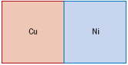
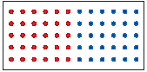
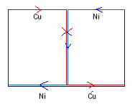
After
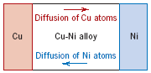
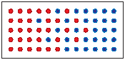
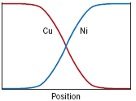

- Interdiffusion or impurity diffusion
- Self diffusion: same type of atoms; no composition change
Diffusion mechanisms

Vacancy diffusion
Interstitial diffusion

- Vacancy Diffusion
Atom from normal lattice position changes position with an adjacent vacancy (vacancy lattice site). So, the atoms and vacancies travel in opposite directions. Both self-diffusion and inter (impurity)-diffusion can occur thus
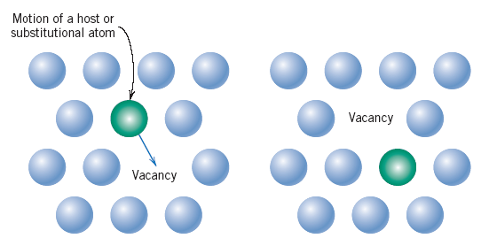

- Interstitial Diffusion
Atoms move from one interstitial site to another (vacant) interstitial site.
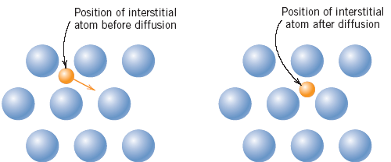

Steady state Diffusion

$$J=\frac{M}{At}$$

If J is constant, steady-state diffusion exists.

Where,
J = rate of mass transfer with time, kg/m²-sec or atoms/m²-sec
A = Area across which diffusion is occurring
t = elapsed time, sec

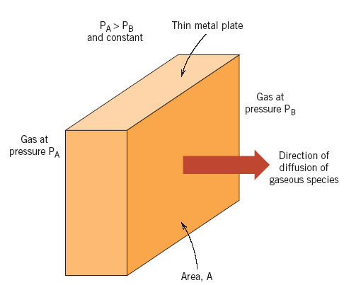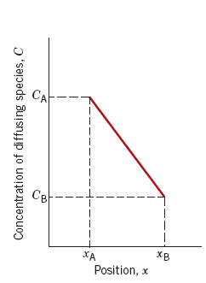

Steady-state Diffusion Concentration Profile

C: Concentration of diffusing species, kg/m³ or gm/cm³
x: Position
Hydrogen gas across palladium plate
Concentration Gradient: Slope at a particular point on the curve

$$=\frac{dC}{dx}$$
$$=\frac{∆C}{∆x}$$
$$=\frac{C_{A}-C_{B}}{X_{A}-X_{B}}$$

Fick’s first law of diffusion
$$J= -D\frac{d_{c}}{d_{x}}$$
Where:
D = Diffusion coefficient, m²/sec
Dc/dx = Concentration gradient is the main driving force for diffusion
(-) = Concentration gradient decrease
Example

Carbon diffusing through a plate of iron

5mm
10mm
Carbon
Deficient
Carbon
Rich
Concentration: 1.2 kg/m³ 0.8 kg/m³

Diffusion coefficient: 3 x 10⁻¹¹ m²/sec

$$J= -D\frac{C_{A}-C_{B}}{X_{A}-X_{B}}$$
$$= -\left(3x{10}^{-11}\frac{m^{2}}{sec}\right) \frac{1.2-0.8}{\left(5x{10}^{-3}\right)-\left(10x{10}^{-3}\right)}$$
$$=2.4 x {10}^{-9}kg/m^{2}sec$$

Non-steady state Diffusion
- Diffusion flux and concentration gradient vary with time; net accumulation or depletion of diffusing species results

Fick’s Second Law
$$\frac{∂C}{∂t}=\frac{∂}{∂x} \left(D\frac{∂C}{∂x}\right)$$

Modified Fick’s Second Law
$$\frac{∂C}{∂t}=D\frac{∂^{2}C}{∂x^{2}}$$

Semi-Infinite solid

Surface concentration at the other end is constant. eg, Bar of length, l > 10Dt , i.e., none of the diffusing atoms reach the bar end during the time-period of diffusion

Assumptions:
- C_{o} = Concentration before diffusion
- x = Distance; at surface it is 0. It increases into the solid
- t = Time; zero(0) at the instant diffusion starts

For t=0 and 0≤x≤∞ C=C_{o}
For t>0 and x = 0 C=C_{S} (Constant surface concentration)
At x=∞ C= C_{O}

$$\frac{∂C}{∂t}=D\frac{∂^{2}C}{∂x^{2}}$$

$$\frac{C_{x}-C_{0}}{C_{s}-C_{0}}=1-\operatorname{erf}\left(\frac{x}{2\sqrt{Dt}}\right)$$
This equation shows relationship between concentration, position and time.
erf = Error Function
C_{X}=Concentration at depth x after time t.

$$\operatorname{erf}\left(\frac{x}{2\sqrt{Dt}}\right)=\operatorname{erf}\left(2\right)$$

- Concentration at distance x, C_{X} is a function of $\frac{x}{2\sqrt{Dt}}$
- If time (t) and position (x) are known and C_{O}, C_{S} and D are given, C_{X} can be determined

If C_{X}=C₁ at a specific concentration of solute,
$$\frac{C_{1}-C_{0}}{C_{s}-C_{0}}=constant$$

Therefore,
$$\left(\frac{x}{2\sqrt{Dt}}\right)=constant$$
$$\frac{x^{2}}{Dt}=constant$$

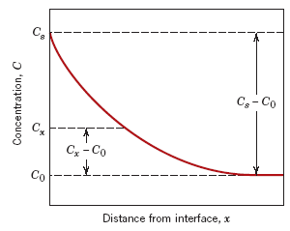

Surface concentration

Concentration C at
distance x

Concentration before
diffusion

Example
Carburization of steel using methane (CH4) at 950°C (1750°F)

Steel:
0.25 wt% Carbon. Using CH₄, carbon at surface is suddenly brought to and maintained at 1.2 wt% carbon. How long will it take to achieve a carbon content of 0.80% carbon at a position 0.5 mm below the surface?

D= 1.6 x 10⁻¹¹ m²/sec

$$\frac{C_{x}-C_{0}}{C_{s}-C_{0}}=\frac{0.80-0.25}{1.20-0.25}=1-\operatorname{erf}{\frac{5x{10}^{-4}m}{2\sqrt{1.6x{10}^{-11} m^{2}/sec}}}$$
$$0.4210=\operatorname{erf}{\frac{62.5\sqrt{s}}{\sqrt{t}}}$$
z | erf (z)
0.35 | 0.3794
z | 0.4210
0.40 | 0.4284

$$\frac{z-0.35}{0.40-0.35}=\frac{0.4210-0.3794}{0.4284-0.3794}$$

Or

$$z=0.392$$

Therefore,
$\frac{62.5\sqrt{s}}{\sqrt{t}} =0.392$

And solving for t,
$$t={\left(\frac{62.5\sqrt{s}}{0.392}\right)}^{2}=25400 seconds=7.1 hours$$

Example
The diffusion coefficients for copper in aluminum at 500 and 600 C are 4.8x10⁻¹⁴ and 5.3x10⁻¹³ m²/s, respectively. Determine the approximate time at 500 C that will produce the same diffusion result (in terms of concentration of Cu at some specific point in Al) as a 10-h heat treatment at 600°C.
To produce the same effect at 500°C, how long will it take?

Dt = constant

$$D_{500}t_{500}=D_{600}t_{600}$$
$$t_{500}=\frac{D_{600}t_{600}}{D_{500}}=\frac{\left(\frac{5.3x{10}^{-13}m^{2}}{s}\right)\left(10 h\right)}{\frac{4.8x{10}^{-14}m^{2}}{s}}=110.4 hours$$

Factors in diffusion

- Temperature
- Time
D increases 5 orders of magnitude with temperature.

$$D=D_{o}\exp\left(-\frac{Q_{d}}{RT}\right)$$
Where:
D_{o} = temperature independent pre-exponential (m²/sec)
Q_{d} = the activation energy for diffusion (J/mol,cal/mol and ev/atom)
R = gas constant, 8.31 J/mol-K or 8.62 eV/atom-K
T = absolute temperature (K)

$$\ln{D=\ln{D_{o}-\frac{Q_{d}}{R} \left(\frac{1}{T}\right)}}$$
Where:
From the equation $y=mx+b$,
y = ln D
mx = 1/T
b = ln D_{o}

Summary
- Self Diffusion
- Inter-Diffusion
- Steady state J=M/At Fick’s First law
- Non-steady state Fick’s second law
- Temperature effect
- Activation energy

