Chapter 4: Imperfections in Solids

Introduction
- Metals
- Alloys
- Solid solutions
- New/second phase
- Solute (the guest)
- Solvent (the host)

Solid solutions
Substitutional solid solutions
Interstitial solid solutions

Cu | Ni | Substitutional
Dia:  1.28$Å$ | Dia:  1.25$Å$ | Atomic size factor (difference in atomic radii: $±$15%)
 |  | Electrochemical factor (must be close in periodic table otherwise intermetallic compound)
+1 | +2 | Relative valencies factor (higher valence metal dissolves in lower valence metal)
FCC | FCC | Same crystal structure, solid solution

Defect: Irregularity

Point defects:
- Vacant lattice site: vacancy
- Addition atom crowding
- into an interstitial site
- Self-interstitial: same type of atom

No. of vacancies, $N_{v}=N\exp{ (-\frac{Q_{v}}{kT})}$
Where:
N = no. of atomic sites
Q_{V} = Activation energy to form vacancy
T = Absolute temperature, K
k = Boltzmann constant
= 1.38 x 10⁻²³ J/atom-K
= 8.62 x 10⁻⁵ ev/atom-K
R = 8.31 J/mol-K (gas constant)
= 1.987 calories/mol-K
Example:
Calculate the number of vacancies per cubic meter of copper at 1000°C. The activation energy for vacancy formation is 0.9 ev/atom; the atomic weight and density (at 1000°C), for copper are 63.5 gm/mol and 8.4 gm/cm³ respectively.

Solution
N = No. of atomic sites/ cubic meter of copper
A_{Cu} = Atomic weight of copper
= 63.5 gm/mol
ρ_{Cu} = Density of copper
= 8.4 gm/cm³
N_{A} = Avogadro’s no.
= 6.023 x 10²³ atoms/mol
N = N_{A} ρ_{Cu}/A_{Cu}
= 8.0 x 10²⁸ atoms/m³

No. of vacancies at 1000 °C (1273 K)
$$N_{v}=N\exp{ (-\frac{Q_{v}}{kT})}$$

Q_{V} = 0.9 ev/atom
N = 8.0 x 10²⁸ atom/m³
k = 8.62 x 10⁻⁵ ev/K
T = 1273 K

Therefore,
N_{V} = 2.2 x 10²⁵ vacancies/m³

Interstitial solid solutions
- Fill voids/ interstices
- For high APF, interstitial positions are small. So, atomic diameter of interstitial impurity must be very small (relative to host atoms)
- Max. allowable concentration: <10%

Even very small impurities distort the lattice ---> lattice strains
- Carbon atom: interstitial in Fe
max 2%
Atomic radius of carbon, C: 0.71 Å
Atomic radius of iron, Fe: 1.24 Å

Specification of Composition

A and B atoms
$$Wt\%A=\frac{m_{A}}{m_{A}+m_{B}} x 100 m,\frac{weight}{mass}$$

$$Atom\%A=\frac{\frac{m_{A}}{A_{A}}}{\frac{m_{A}}{A_{A}}+\frac{m_{B}}{A_{B}}} m_{A}:mass of A A_{A}:atomic weight of A$$

Dislocations- Line defects
- Edge dislocation
- Screw dislocation

Edge dislocation:
Extra half plane of atoms terminates within the crystal
- Dislocation line/extra half plane causes lattice to pull apart.
- Where the extra half plane is not there, the lattice is squeezed together

Screw dislocation:
- Shear stress to distort the lattice
- Upper region is shifted one atomic distance relative to bottom
- Associated spiral or helical ramp

Mixed dislocation: Neither edge perpendicular (⊥) or screw ( )

Burger’s vector
Close-failure of a dislocation, b (extent of distortion).
Dislocation and b are perpendicular in edge.
They are parallel in screw.
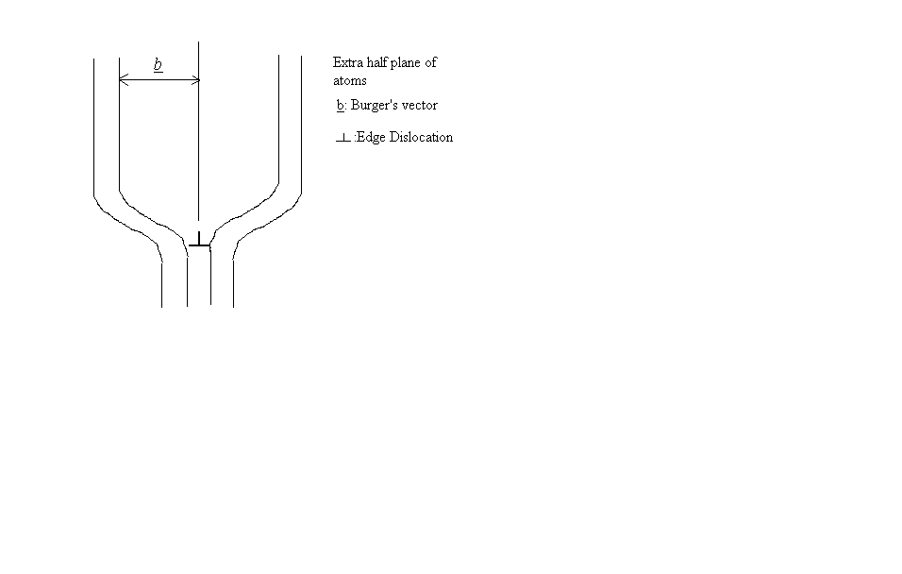
Extra half plane of atoms
b: Burger’s vector
⊥: Edge Dislocation

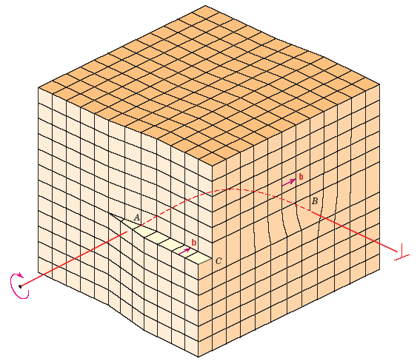
Edge Dislocation
Screw Dislocation
b points in a closed-packed direction and is equal to atomic spacing(s)

Grain boundaries
- Grain boundaries are regions of impurity concentration
- Light mismatch between grains: small angle grain boundary
Example: tilt boundary
- Grain within a grain: sub-grain; sub-grain boundary

c
Twin Boundary:
Across a grain: mirror-lattice symmetry
- Due to atomic displacement from applied shear forces. e.g., mechanical twins seen in BCC, HCP
- Due to annealing after deformation.
Example: annealing twins seen mostly in FCC

Tilt Boundary

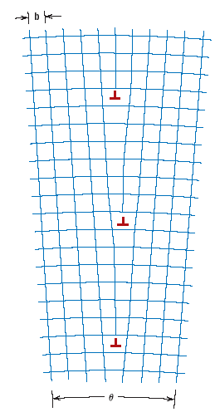
Edge dislocation Series of edge dislocations
- Array of edge dislocations.
- Similar to small angle grain boundary

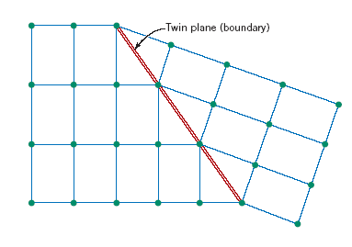

Both sides are mirror images of each other.

Volume defects
- Pores
- Cracks
- Inclusions
- Other phases

Microscopy
- Microscopy: Macro/Microstructure photomicrographs
- Optical/light microcopy: 2000x
- Transmission electron microscopy: 1,000,000X, very thin foil; fluorescent screen
- Scanning electron microscopy: 50,000X, good depth of field
- Scanning Probe: 3D topography 10⁹ X possible

Grain size
ASTM grain size number
N = 2^{n-1}
n = grain size number
N = Average No. of grain/square inch at 100X
Larger grain size number Smaller grains

Summary

- Point defects
- Line defects
Edge
- Dislocation Screw Mixed
- Volume defects
High angle
- Grain boundary Low angle
Twin
- Microscopy
- Grain Size

