Chapter 3: The Structure of Crystalline Solids

Fundamental Concepts

Crystalline: Repeating/periodic array of atoms; each atom bonds to nearest neighbor atoms.
Crystalline structure: Results in a lattice or three-dimensional arrangement of atoms

Unit cells
- Smallest repeat unit/entity of a lattice.
- Represents symmetry of the crystal structure.
- Basic structure unit/building block of crystal structure
- Defines the crystal structure by its geometry and atom positions

Co-ordination number
For each atom, it is the number of nearest-neighbors or touching atoms
Example: FCC:12, HCP:12, BCC:8

Atomic packing factor (APF):

$$APF=\frac{Volume of atoms in a unit cell}{Total unit cell volume}=\frac{V_{s}}{V_{c}}$$
$$=0.74 \left(for FCC or HCP\right)$$
$=0.68 (for BCC)$

Atoms per unit cell
FCC Face atoms= 6 x ½ =3 4
Corners atoms = 8 x 1/8 =1
Examples: Al, Ni, Cu, Au, Ag, Pb, Gamma (γ)-Iron

BCC Body atom=1 2
Corners atoms = 8 x 1/8 =1
Examples: Cr, W, Alpha (α)-Iron, Delta (δ)- Iron, Mo, V, Na

SC Corners atoms = 8 x 1/8 =1 1

Metallic crystal structure
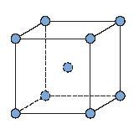
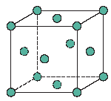
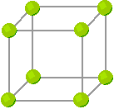

SC (Simple Cubic)
BCC
(Body-Centered Cubic)
FCC
(Face-Centered Cubic)

Where:
R = Radius of the atom
a = cube edge
a² + a² = (4R)²
2a² = (4R)² = 16R²
a = 2R √2
$$APF=\frac{Volume of atoms in a unit cell}{Total unit cell volume}=\frac{V_{s}}{V_{c}}$$
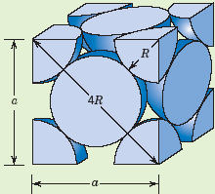

$$Unit cell volume (V_{c})=a^{3}$$
$$={\left(2R\sqrt{2}\right)}^{3}$$
$$=16 \sqrt{2}{ R}^{3}$$

$$V_{s}=\frac{4}{3}π R^{3}*4 4 atoms per unit cell$$
$$=\frac{16}{3}π R^{3}$$

$$Total cell voleume \left(V_{c}\right)=16 \sqrt{2} R^{3}$$

$APF=\frac{V_{s}}{V_{c}}=\frac{\left(\frac{16}{3}\right)πR^{3}}{16\sqrt{2} R^{3}}=0.74$

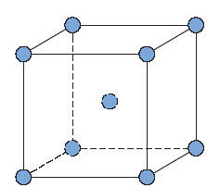
Body Centered Cubic

a√3
a√2

All sides are equal to dimension “a”
a² + a² = 2a²
(a√2)² + a² = 3a² = (4R)²
a√3= 4R

The Hexagonal Close-Packed
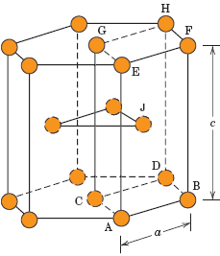
6 Atoms at top 12
6 Atoms at bottom

2 Centre face atoms
3 Midplane atoms

12 x 1/6 = 2
2 x 1/2 = 1 6 atoms/unit cell
Midplane 3

Co-ordinate number: 12 (HCP or FCC)
Atomic packaging factor (APF): 0.74
Examples: Cd, Zn, Mg, Ti

Density Computations

Density, $ρ=\frac{nA}{V_{c}N_{A}}$

Where,
N = No. of atoms/unit cell
A = Atomic weight
V_{c} = Volume of unit cell
N_{A} = Avogadro’s number (6.023 x 10²³/mole)

Example:

Copper has an atomic radius of 0.128 nm, an FCC crystal structure, and an atomic weight of 63.5 g/mol. Compute its theoretical density and compare the answer with its measured density.

Given:
Atomic radius = 0.128 nm (1.28 Ǻ)
Atomic weight = 63.5 g/mole
n = 4
A_{CU} = 63.5 g/mol

Solution:
Unit cell volume = 16 R³√2
R = Atomic Radius

= 8.89 g/cm³

Close to 8.94 g/cm³ in the literature

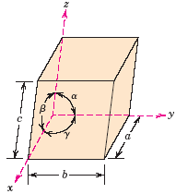
Crystal system

x, y, z : Coordinate systems
a, b, c : Edge lengths
α, β, γ : Inter axial angles

Cubic system: a=b=c α=β=γ=90°

Lattice parameter (e.g., a,b,c, α, β, γ)
determine the crystal system. There are seven
crystal systems which are Cubic, Tetragonal, Hexagonal, Rhombohedral (Trigonal), Monoclinic, Triclinic.

Crystallographic Direction

Steps:
- Choose a vector of convenient length
- Obtain vector projection on each of three axes (for the direction to be drawn, if necessary)
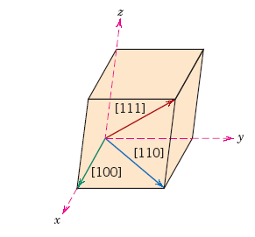
- Divide the three numbers by a common factor (if the indices are to be assigned) to reduce to the smallest integer values
- Use square brackets [ ]

Crystallographic Planes

Miller Indices (hkl)
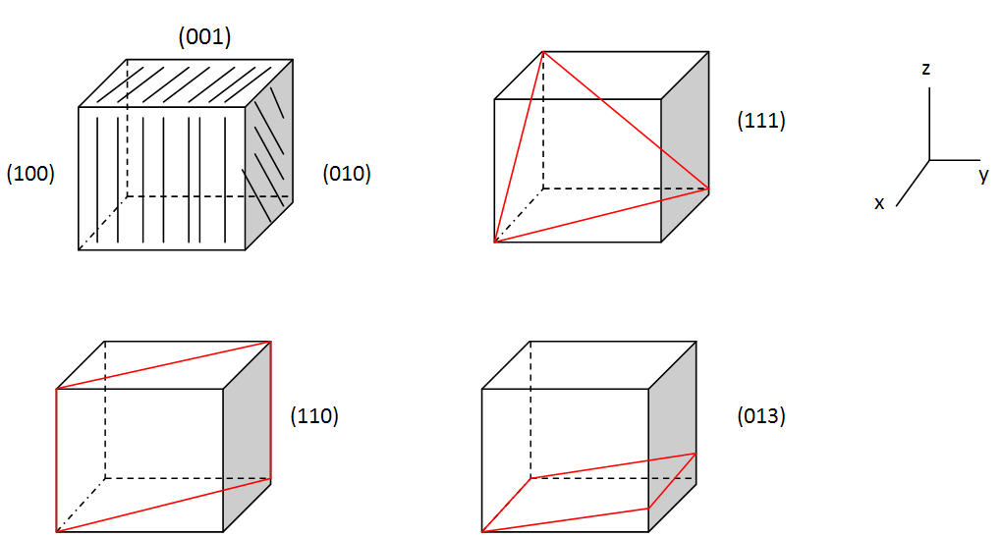

Steps:
- Obtain lengths of planar intercepts for each axis.
- Take reciprocals
- Change the three numbers into a set of smallest integers (use a common factor )
- Enclose within parenthesis e.g., (012)

Tips:
1. Parallel planes have the same indices
2. An index 0(zero) implies the plane is parallel to that axis.

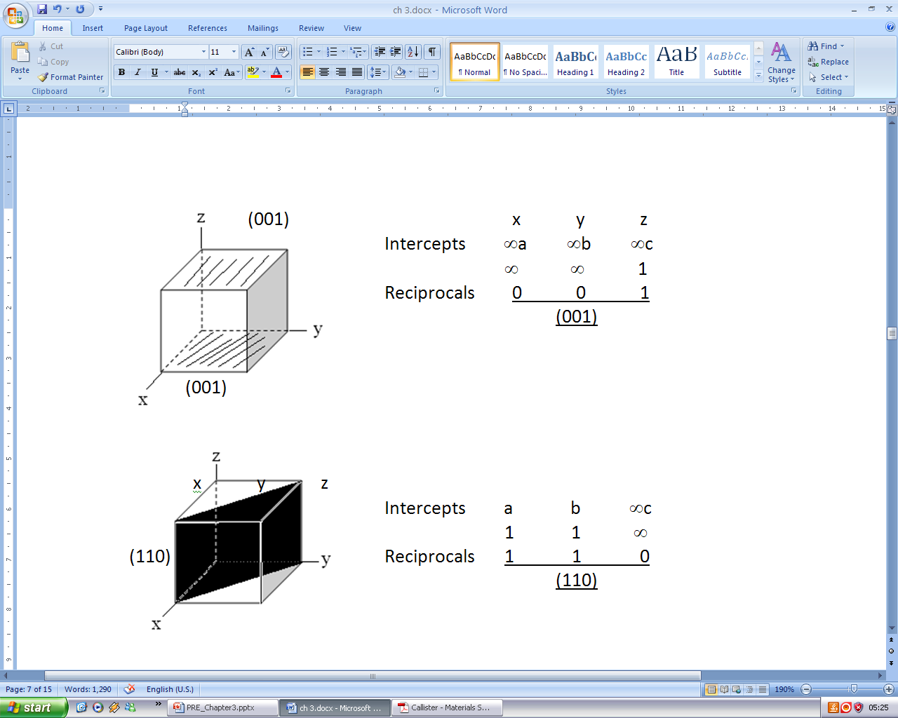

Cubic Crystal system
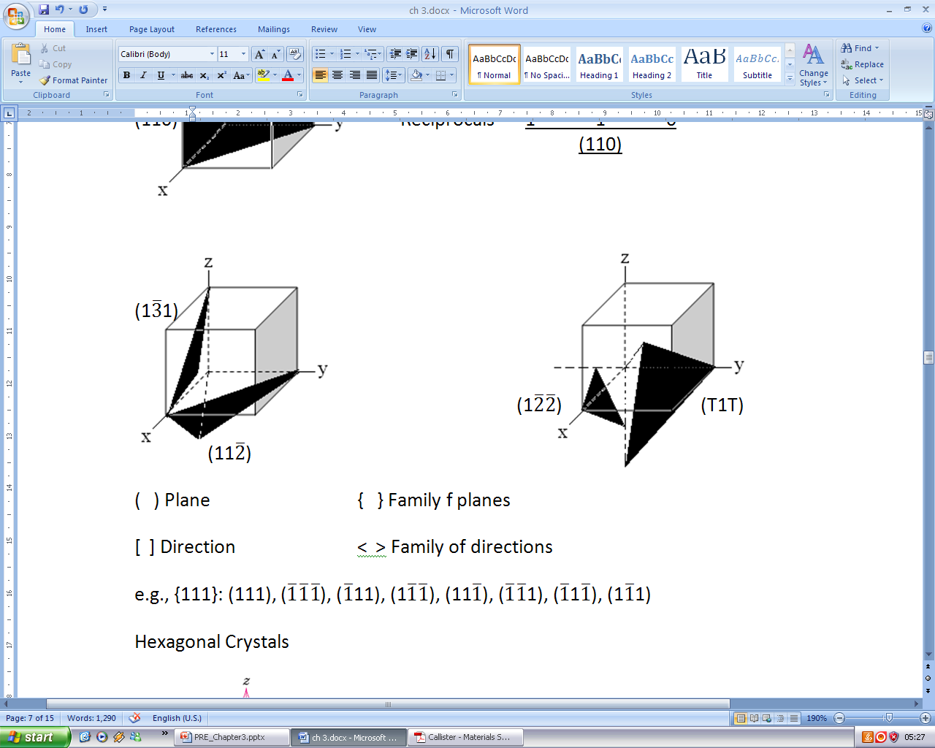

( ) Plane
{ } Family of planes
[ ] Direction
< > Family of directions

Example:
{111}:

Hexagonal Crystal system
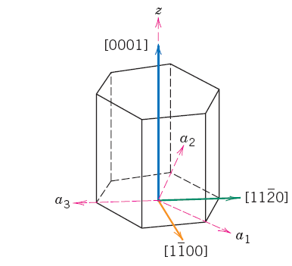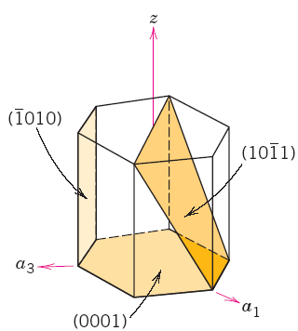
[u’v’w’] -------> [u v t w]

[0 1 0] ------->

u = n/3 (2u’ – v’)
e.g., u = n/3 (2 x0 – 1)
Where, n=factor to convert into indices = 3

u= = n/3 (0 -1)

v = n/3 (2v’ – u’)
Example: v = n/3 (2 x 1 -0)
= n/3 (2)
Where:
n = factor to convert into indices = 3
v = 2

t = - (u’ + v’) u v t w =

Example: t = -(0 + 1)
= -1 =
w = w’

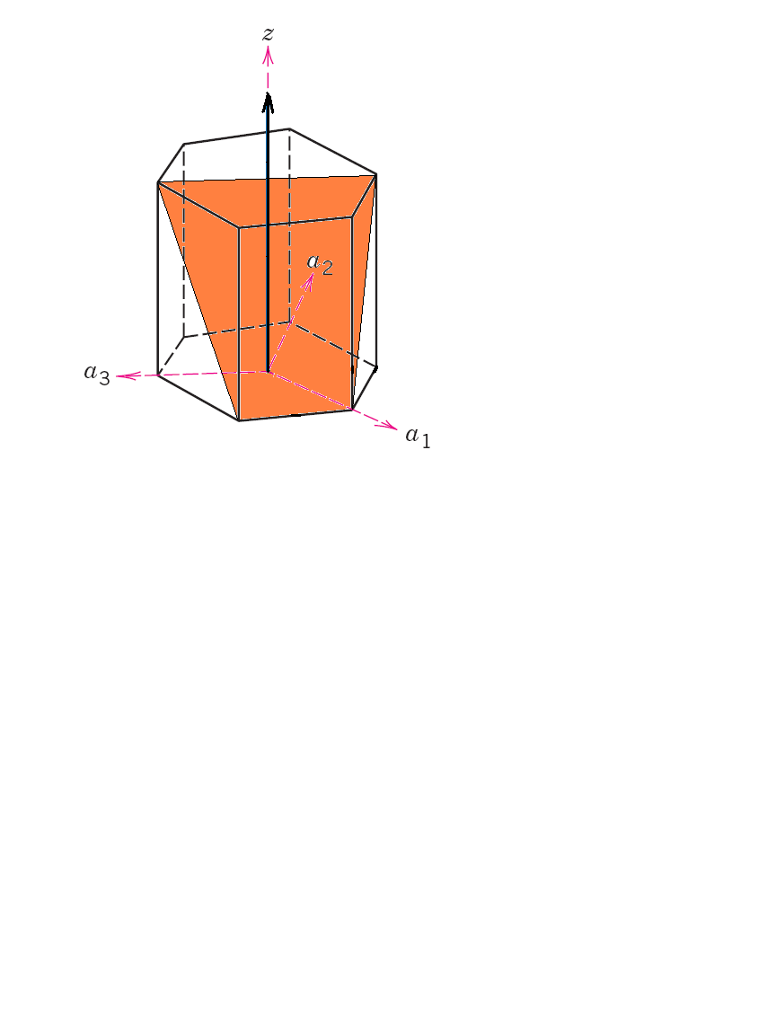
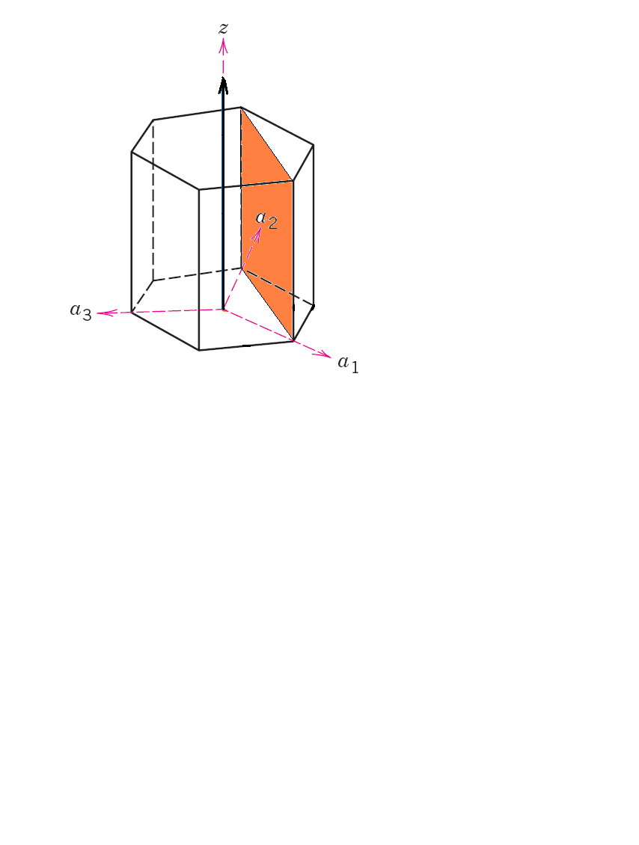

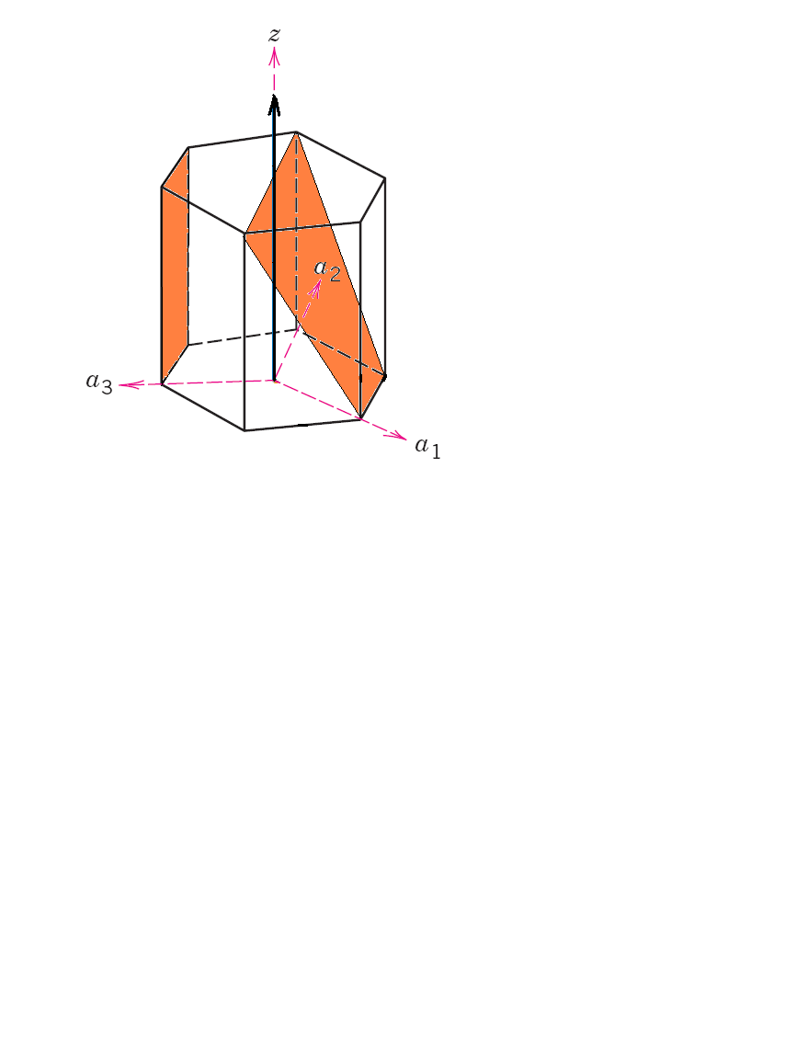

c
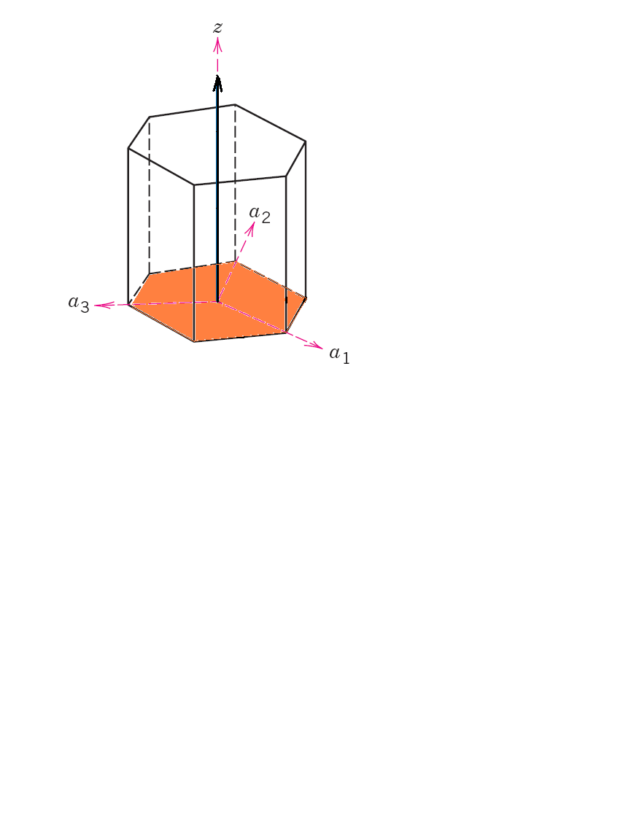

a₁, a₂, a₃ axes: all in basal plane (at 120° to each other)
Z-axis: Perpendicular to basal plane

[u’v’w’] -------> [u v t w]
a b c a b z c
Miller -------> Miller-Bravais
u = n/3 (2u’ – v’) [0 1 0] ------->

v = n/3 (2v’ – u’) u’v’w’ ----> u v t w
t = - (u’ + v’) u = (0 -1), t = -(1), v = 2, w = 0
w = nw’
n=factor to convert into indices

Linear and Planar Atomic Densities

Linear density 4R = a√3
BCC a = 4R/√3

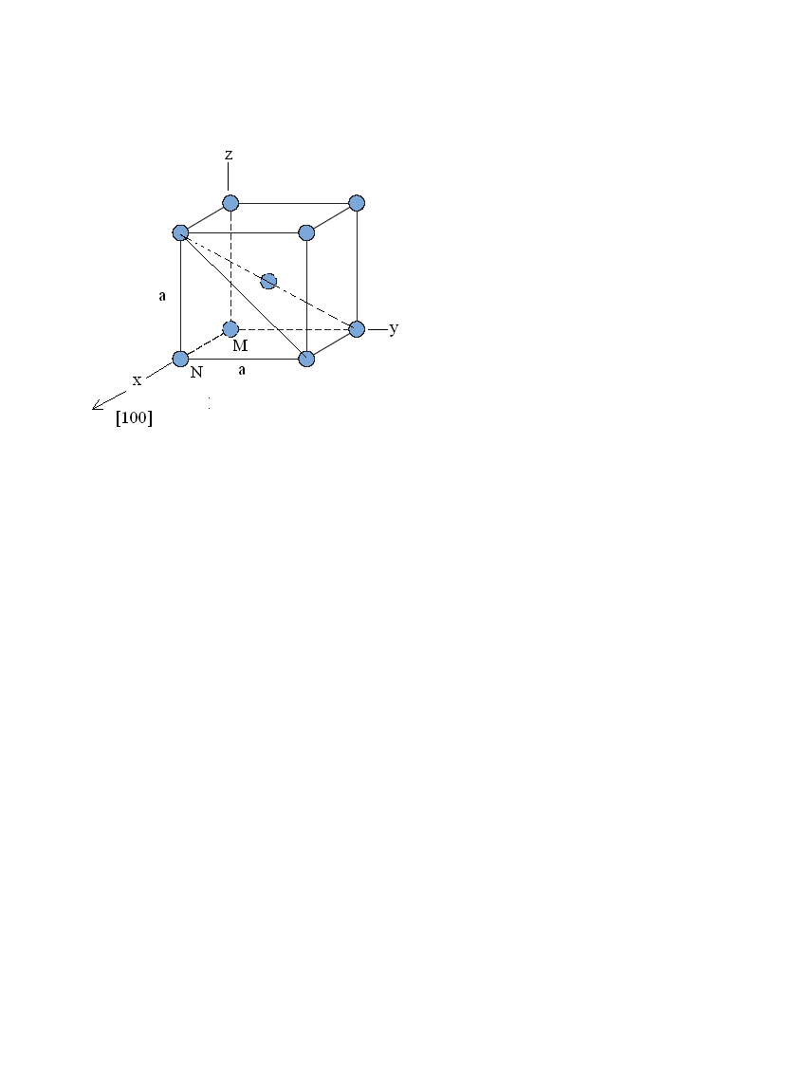
a√3
a√2

a
N
M

$$BCC LD \left[100\right]=\frac{Distance occupied}{distance available}$$
$$=\frac{2R}{a}$$
$$=\frac{2R}{\frac{4R}{\sqrt{2}}}$$
$$=0.866$$

X- Ray Diffraction

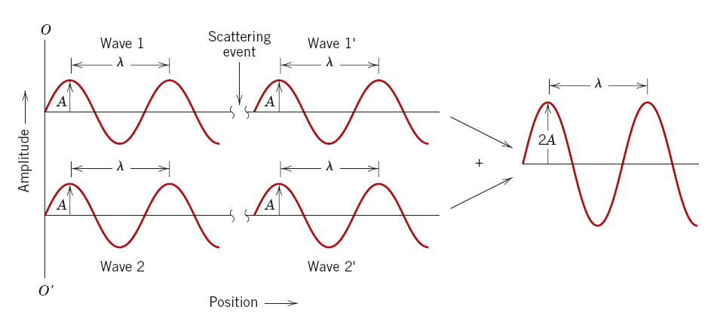

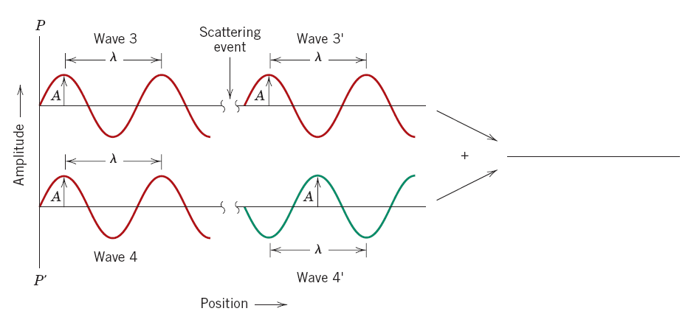

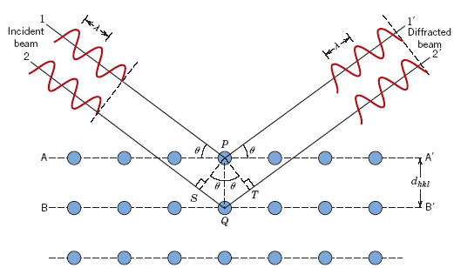

Interplanar
spacing

$nλ=$

Where,
n = an integer, order of reflection
= 1 (unless stated otherwise)

Bragg’s law of diffraction
nλ = d_{hkl} sinθ + d_{hkl}sinθ
= 2d_{hkl} sinθ

For cubic system, a²/d² = h² + k² + l²

X-Ray Diffraction

nλ =
= path difference where n = integer = 1
= d_{hkl} sinθ + d_{hkl}sinθ
= 2d_{hkl} sinθ

a²/d² = h² + k² + l²

(h + k + l) must be even: BCC 2, 4, 6, 8, 10, 12……

h k l: all odd or all even FCC 3, 4, 8, 11, 12, 16……..

If the ratio of the sin²θ values of the first two diffracting planes is 0.75, it is FCC structure. If it is 0.5, it is BCC structure.

$$λ=2d sinθ$$
$$=\frac{2a sinθ}{\sqrt{h^{2}+k^{2}+l^{2}}}$$

$$\sin^{2}{θ}= {(λ}^{2} (h^{2}+k^{2}+l^{2}))/(4a^{2})$$

$$(\sin^{2}{θ_{1})/(\sin^{2}{θ_{2})=\frac{h_{1}^{2}+k_{1}^{2}+l_{1}^{2}}{h_{2}^{2}+k_{2}^{2}+l_{2}^{2}}}} \text{λ} and a are constants$$

Example

Givens:
{211} Planes
a_{Fe} = 0.2866 nm (2.866Å)
λ = 0.1542 nm (1.542Å)
n = 1

Determine d_{hkl}, 2θ (diffraction angle)

  - d_{hkl} = a/ √ (h² + k² + l²)
= 0.2866 nm /√ (2² + 1² + 1²)
= 0.1170 nm (1.170Å)

- $\sin{θ=\frac{nλ}{2d_{hkl}}=\frac{1*0.1542}{2*0.1170}}$
$$θ=sin^{-1}\left(0.659\right)=41.22°$$
$$2θ=82.44°$$

Crystalline and Non-crystalline materials

Single crystal: No grain boundary
Polycrystalline: Several crystals
Anisotropy: Directionality in properties
Isotropy: No directionality

Modulus of elasticity (E), psi x 10⁶ (MPa x 10³)
 |  | [100] | [110] | [111]
FCC | Al | 9.2 | 10.5 | 11.0
FCC | Al | (63.7) | (72.6) | (76.1)
FCC | Cu | 9.7 | 18.9 | 27.7
FCC | Cu | (66.7) | (130.3) | (191.1)
BCC | Fe | 18.1 | 30.5 | 39.6
BCC | Fe | (125) | (210.5) | (272.7)
BCC | W | 55.8 | 55.8 | 55.8
BCC | W | (384.6) | (384.6) | (384.6)

Non-Crystalline
- Amorphous
- No systematic arrangement (regular) of atoms

Summary
- Crystalline –lattice
- Crystal system: BCC, FCC, HCP
- Planes, directions, packing
- X-Ray diffraction



