Chapter 2: Atomic Structure and Interatomic Bonding

Fundamental Concepts

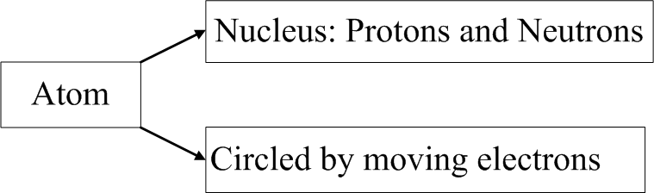

Electrons: Positive
Protons : Negative
Neutrons: Neutral

Atomic Number (Z): Number of protons in nucleus or number of electrons for electrically neutral or complete atom

Atomic Mass (A): Sum of the masses of protons and neutrons within nucleus

Number of neutrons (N) may vary for different atoms of an element. So, some elements may have two or more atomic masses. “Isotopes”.

Atomic weight: Weighted average of the atomic masses of the atom’s naturally occurring isotopes.

Atomic mass unit (amu): 1⁄12 of the atomic mass of the carbon i.e., A=12.000

A ≈ Z + N

One mole: 6.023 x 10²³ Atoms or Molecules

Electrons in Atoms

Bohr’s Model
Quantum Mechanics
Set of principles and laws governing system of atomic and subatomic entities
Bohr’s Atom And Orbitals
Nucleus surrounded by electrons in discrete orbitals

Orbital
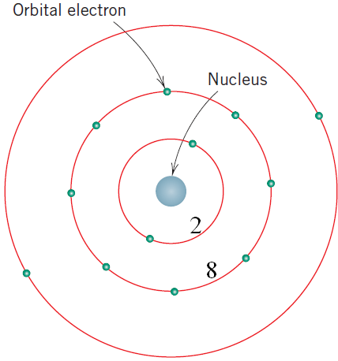

Energy Levels/States
- Quantization of energies of electrons. i.e, each electron has only specific level of energy.
- If energy of an electron changes, it jumps to a lower or higher level of energy
- Ground state: Lowest possible level of energy.

Wave Mechanical Model
To overcome deficiencies in Bohr’s Model:
- Electron is both wave-like and particle-like
- Electron is no longer a particle in a discrete orbital
- Electron can be at various locations in a discrete orbital (uncertainty of location)

Quantum Numbers

- To describe size, shape and distribution of electron-density
- Four Quantum numbers
- Bohr’s energy levels separate into electron subshells
- Quantum numbers dictate the number of states within each subshell

First or Principal Quantum Number (n)
Table 2.1
n | K | L | M | N | O | P | …
n | 1 | 2 | 3 | 4 | 5 | 6 | …
- Specifies shells
- Integral numbers

Second Quantum number (l)
Table 2.2
Subshell | s | p | d | f
Energy State | 1 | 3 | 5 | 7
- Specific subshells

Third Quantum number (m_{l})
- Number of energy states for each subshell

Fourth (Spin) Quantum number (m_{s})
- Up +1/2
- Down -1/2

Table 2.3
#1 Principal Quantum No. n | Shell | #2 Subshell l | #3 No. of States | Number of Electrons
 |  |  |  | Per Subshell | Per Shell
1 | K | s | 1 | 2 | 2
2 | L | s | 1 | 2 | 8
2 | L | p | 3 | 6 | 8
3 | M | s | 1 | 2 | 18
3 | M | p | 3 | 6 | 18
3 | M | d | 5 | 10 | 18
4 | N | s | 1 | 2 | 32

- Smaller n, means smaller energy level
- Within each shell, energy of a subshell level increases with the value of l
- Overlap in energy of a state in one shell with states in adjacent shell e.g. 3d>3s

Electron configurations

Pauli exclusion principle:
No two electrons can have all the four Quantum numbers identical, i.e., at least the spins have to be opposite (+1/2, -1/2)

s p f d
2 6 10 14 electrons ie, they have pairing with +1/2 and -1/2

Ground state: All electrons in an atom are at the lowest energy level.

Examples of notations:
Hydrogen, H

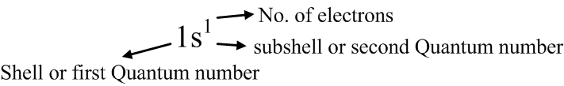

Table 2.4
He | Na
1s² | 1s² 2s² 2p⁶ 3s¹
2 (Z*) | 11 (Z*)

Stable electronic configuration: Outermost shell is completely filled with electrons

Table 2.5: Inert Gases
Ne | Ar | Kr
1s² 2s² 2p⁶ | 1s² 2s² 2p⁶ 3s² 3p⁶ | 1s² 2s² 2p⁶ 3s² 3p⁶ 3d¹⁰ 4s² 4p⁶
10 (Z*) | 18 (Z*) | 36 (Z*)

Reason for inertness: No incompletely filled outermost shell

The periodic table of elements
- Arranged in order of increasing atomic number
- Seven horizontal rows: periods
- Column(s) or group(s): similar valence electron structure. Similar chemical and physical properties.
- Across each period (e.g., left to right) the properties changes gradually and systematically
- Group 0 (zero): Right-most group, Inert gases: He, Ne, Ar, Kr, Xe, Rn

Groups VII A and VI A: Electrons have one and two electrons deficient from having a stable structure.
Oxygen (O) : 8 1s² 2s² 2p⁴ : 2 deficient
Fluorine (F) : 9 1s² 2s² 2p⁵ : 1 deficient

Group VII A: Halogens

Group I A: Li, Na, K, Rb, Cs, Fr Alkali

Group II A: Be, Mg, Ca, Sr, Ba, Ra Alkaline earth

Group III B and II B: Transition metals
- Partially filled d electron states
- In some cases two electrons in the next higher energy shell
Example:
(Group III B) Sc: 21 1s² 2s² 2p⁶ 3s² 3p⁶ 3d¹ 4s²

Group III A, IV A, V A: Intermediate between metals and non-metals

LEFT : Electropositive RIGHT: Electronegative
(e.g, Alkalis) (e.g, Halogens)

Atomic bonding in solids
- Net force between two atoms: F_{N} = F_{A} + F_{R}
where: F_{A}: attractive force
F_{R}: repulsive force
- No net force if F_{A} + F_{R} = 0 (state of equilibrium)
- At a state of equilibrium (r₀: equilibrium spacing), the two atoms will counteract any attempt to separate them by a repulsive force, or to push them together by an attractive force (E₀: equilibrium net potential energy)

Energy, $E= ∫F*dr$ where, $F=force$

Net energy, $E_{N}= ∫F_{N}*dr$
$$= ∫F_{A}*dr + ∫F_{R}*dr$$
$$= E_{A}+E_{R}$$
**Integrals are from ‘r’ to infinity.

Net energy = Attractive energy + Repulsive energy

Then, E_{o} = Bonding energy (Energy at minimum point)

Primary Interatomic Bonds

Ionic (Electrovalent Bonds)
- In compounds which have metallic and non-metallic elements
- Due to transfer of electrons

Left Extreme: Na (IA)
Right Extreme: Cl (VIIA)

Na: 2, 8, 1: 1s² 2s² 2p⁶ 3s¹ -1 electron

11 1s² 2s² 2p⁶ Neon, Ne

Cl: 2, 8, 7: 1s² 2s² 2p⁶ 3s² 3p⁵ +1 electron
17 1s² 2s² 2p⁶ 3s² 3p⁶ Argon, Ar

Attractive Bonding Forces: Coulombic forces
- Positive and negative ions attract each other
Na⁺ Cl⁻ Na⁺ Cl⁻
- Ionic bonding is non-directional (magnitude of the bond is equal in all directions around the ion)
Example: Ceramic materials exhibit ionic bonding

Covalent Bonding
- Sharing of electrons between adjacent atoms. (Example: CH₄)

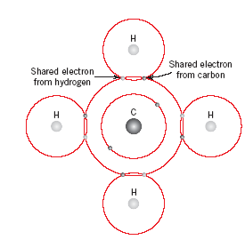

C: 4 valence electrons
H: 1 valence electron
Directional: Between special atoms and only in the direction of participation.
Example: H₂O, HNO₃, HF

N: no. of valence electrons
- An atom can bond with (8-N) other atoms

Cl: N=7 8-N=1 Cl + Cl = Cl₂
C: N=4 8-N=4 carbon can bond with four hydrogen atoms

Attractive Bonding Forces
- Covalent bonds are strong
e.g, Diamond melting point>3550°C (6400°F)
or, covalent bonds can be weak
e.g, Bismuth melting point: 270°C (518°F)
- Polymers: Covalent bonds
- Partially ionic + partially covalent: possible
- Wider separation in the periodic table: Ionic
- Closer together in the periodic table: Covalent

Metallic Bonds
- Metals have 1, 2 or 3 valence electrons
- Valence electrons are not bound to an atom, but are free to drift through the entire metal. i.e, forming an “electron cloud” (-ve)
- Remaining non-valence electrons and the atomic nuclei form the ionic core (+ve)
- Free valence electrons shield the +ve ion core
- Non-directional
- Free valence electrons hold the ion core together
- Good conductors
- Bonding may be weak.
e.g, Hg: 6.8 KJ/mole (0.7 ev/atom)
- Bonding may be strong
e.g, W: 850 KJ/mole (8.8 ev/atom)

Secondary or Vander Waal’s bonding
Example: Hydrogen bond
Fluctuating induced dipole bonds

Summary

Atomic Structure
- Bohr and wave mechanical models
- Electron energy states
  - Quantum number
- Periodic table

Primary Bonds
- Ionic
- Covalent
- Metallic

Secondary Bonds

